The week of Sept. 18-25
Sun Worship 8:30 & 10:30 am
Mon Library reserved 6-8 pm
Tues Men’s Bible Study 6:15am / 7am
Wed WOW 3:15 pm
Confirmation Meal 5:30-6:20 pm
Confirmation 6:30-7:30 pm
Church Council Meeting 7:30 pm
Sat Worship 5:30 pm
Sunday Worship 8:30 & 10:30 am
**Activities and times change periodically. **

Sept. 18 Congregation Meeting at 9:40 am
Sept. 21 Council Meeting at 7:30
Sept. 25 Baptism
Sept. 26 Ruth Bible Study (Parkview at 1:30 pm)
Sept. 28 Altar Guild Meeting at 7:30 pm

Emergency/Pastoral Care - Please have a family member or friend notify the church. You may also request hospital staff to call on your behalf. Call day or night at 523-1574. Never feel as though you are bothering Pastor or the staff. We are here to serve as a comfort and as a resource.
No one was able to answer your call? 320-523-1574
-Wait for the extension of the staff member you want to contact.
-Call the cell number given. They will pick up the call if able.
-Leave a message on their cell phones. Staff can check cell messages while
out of the office and are more likely to return your call faster.
-If you prefer, leave a message on the church answering system.

PRAYERS OF HEALING & STRENGTH
Prayer for | Submitted by | Prayer for | Submitted by
Roxie Fliflet | Sandy Whited | Diana Adkins | B Hennen
Vonna Ledeboer | A Ledeboer | Jill Revolinski | C Mallek
Family of Edward Winslow McNeal | Dawn Matti, Stan Matti | Greg & Evelyn Rosenow | Teeny Kadelbach
Abbie McGregor | Aaron & Heather Thompson | Ann Orth | Don Orth

CHECK THE BOARD
***Fliers are posted at the East entrance***
Caregiver Support program is offering respite care to caregivers, which is provided by volunteers. October 1st marks the start of our new AmeriCorps year and I am looking for individuals who may be interested in volunteering with our AmeriCorps program. Sarah Doering - Caregiver Support and Respite Coordinator
sarah.doering@lssmn.org | 320.221.4513 - Lutheran Social Service of Minnesota
www.lssmn.org
Celebration of Life Banquet: Hope Pregnancy Center invites you to our Annual Celebration of Life Event that will be held at the Willmar Conference Center on September 27th, 2016. Shawn Carney, co-founder and campaign director for 40 DAYS FOR LIFE, will be our featured speaker. The social hour and Silent Action will begin at 5:30, and Dinner & Program, including a Live Auction, at 6:30. No tickets are required but an RSVP is necessary to reserve YOUR place at a table: Call 320-235-7619.
Scenic Valley Partnership to South Africa Fundraising for Trip to South Africa: The event will be held Saturday, October 1st from 9am-3pm at Shooters Sporting Clays, Marshall. Cost is $35.00/person and includes 1 round of 50-Bird Sporting Clays (you can purchase shells or bring your own) and lunch.
Bingo Time: Senior Bingo will be held on Tuesday, September 20 at 1:30 pm at Park View Village in Olivia.
Adult Grief Support: The group will meet on Monday, Oct. 3-Nov. 7, 2016 from 2-4 pm in the Redwood Area Hospital education room. There is no cost to participate.
Annual Harvest Festival: Our Savior’s of Sacred Heart will be hosting their Annual Harvest Festival on Wednesday, September 21 from 4:30-7:00 at 400 1st Ave., Sacred Heart. They will have a General Store and a Meatball Supper.

Cross of Calvary Women’s Bible Study: The bible study will be changing from Tuesday nights to Mondays at 6:00 pm, Sept. 12th. Topic: 12 Fascinating Bible Study #59 memories. The leaders are looking into a different study. (Stay tuned)
Camp GK Bear is offering a camp on October 8, 2016 from 10:00 am to 3:00 pm at Rice Hospital. For more information and a registration form, see the board. Cost is free!!

Confirmation Meals:
Sign-up sheet is on the Youth Board! Thank you in advance for helping!!
(24 students and about 6 adults)

SPECIAL CONGREGATIONAL MEETING
When: Sunday, September 18th, 2016 Will be held after the first service so approximately 9:40 a.m.
Reason: Presentation and voting to ordering and install a new sign near Highway #71 to replace the existing one.
The sign committee members worked on ideas these past several months and at the August Church Council meeting presented their proposed sign and estimated costs. The Council passed the motion to have a Congregational meeting to vote on its approval and to organize the fund raising for this special project.
We hope you can be part of this discussion as we continue to be good stewards of our church property

Thank you!!!
It is with a very humble and grateful heart that I write this letter. I would like to first and foremost start out by thanking those involved in organizing the benefit which was held for me last month at Cross of Calvary. To say I am overwhelmed by the outpouring of love and support from my church family and community is a huge understatement. All the work that went into planning, organizing, cooking, set up, cleaning and taking care of all the little details is deeply appreciated. From the donation of time, money and silent auction items I am reminded that people really do care – and show it in so many ways.
Thank you seems inadequate; but to all who worked, stopped by and donated, THANK YOU! The funds raised will go to help with medical expenses related to my breast cancer diagnosis and treatment.
God bless.
Michelle

Ryan, Maddi & McKenna Jensen

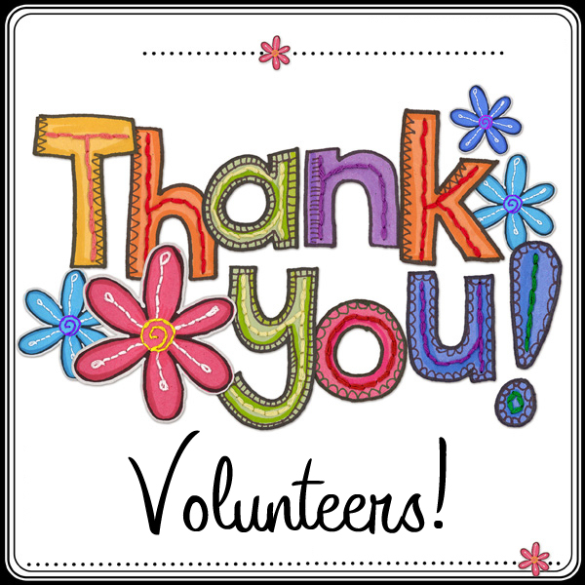

SEPTEMBER WORSHIP VOLUNTEERS
Communion - 8:30 Eric Skeie/10:30 Natashia Johnson
Altar Guild – Marlys Klinghagen & Barb Wertish
Acolytes - Ashley Trongard & Brenna Weis
Ushers - 8:30 - Dan Gross, Brian Kingery, Tom Osthus
10:30 – Doug Steffel, Duane Senger

Altar Flowers: Thank you Holland family for placing the flowers on the altar in Memory of those who died by suicide and in Honor of suicide survivors.
September is Suicide Awareness month!

Congratulations and blessings to Rod & Tina (Beckler) Garberich who were married here at Cross of Calvary yesterday, Sat, Sept 17. Additional flowers in the sanctuary are in honor of their marriage.

Missions
Paraguay Missionaries – The Kevin and Rebekah Howell family
Bolivia Missionaries – Paul and Jay Mikaelson

Prayer Garden
The Prayer Garden is in the process of dividing plants. Please call Betsy Hennen at 523-5717 if you would like day lilies, hosta, bee balm, sedum, heliopsis and/or iris.

Church Library Books: Everyone is welcomed to browse through and take any book(s) from the library, both in boxes or on shelves. They have been sorted into categories for your convenience. If you choose to make a freewill offering, such may be put into the box next to the office door.

September 18, 2016

Devotion: Use this resource at home to guide your household’s daily devotions. You can do this alone or with others; in the morning, during the day, or at night. Find a routine that works best for you.

Pray: Light a candle and open your devotion time with a prayer.

O God, our faith can be shaky and temperamental. Show us your steadfastness and restore our hope in you. In Jesus’ holy name, Amen.

Reflect: Reflect on the key verses from Sunday’s reading.

He brought him outside and said, “Look toward heaven and count the stars, if you are able to count them.” Then he said to him, “So shall your descendants be.” And he believed the Lord; and the Lord reckoned it to him as righteousness. Genesis 15:5-6

Study: Study the reading and consider the background.

After years of no discernible fulfillment to God’s promise of descendants, Abram is losing heart. What will it take to restore his faith?

Consider: Consider this theme for the week’s text.

Sometimes we think we know best. But God always knows better.

Read: Read the following daily readings to deepen your understanding of Sunday’s text. After the reading, ask the follow-up questions.

Sunday: Abraham’s Descendants, Genesis 15:1-6
Monday: Abraham’s Sacrifice, Genesis 22:1-19
Tuesday: Isaac and Rebekah, Genesis 24:1-67
Wednesday: Jacob Steals Esau’s Blessing, Genesis 27:1-29
Thursday: Jacob Marries Leah, then Rachel, Genesis 29:9-30
Friday: Jacob Wrestles an Angel, Genesis 32:22-32
Saturday: The Rape of Dinah, Genesis 34:1-31

How do the people in these stories try to take matters into their own hands?

Connect: Connect in conversation with others in your household. Discuss the following questions, or simply check in with “Highs” and “Lows.”

What was a high point of your day? What was a low point?

Where do you see people in your community trying to take matters into their own hands? Where do you see God acting on their behalf?

Observe the ways in which you experience shame. Observe too, ways in which God’s forgiveness offers you new opportunities for life.

Do: By acting on what we learn we make God’s word come alive. Do the following activity this week.

Go outside at night. Watch the stars. Imagine that those stars represent the people God promised to bless through Abram. Which ones shine brightest? Why?

Bless: Close your devotion with a blessing

May God bless you as abundantly as God created stars. Amen.

