Prayer Concerns
Prayer Matters! Please take your bulletin home and pray for those listed. Prayer concerns are listed for one month. Please write another prayer request and drop it in the offering plate or in the office mailbox to ensure your request gets extend on the prayer concerns list.
Prayer for | Submitted by | Prayer for | Submitted by
Roxie Fliflet | Sandy Whited | Diana Adkins | B Hennen
Vonna Ledeboer | A Ledeboer | Jill Revolinski | C Mallek
Abbie McGregor | Aaron & Heather Thompson | Greg & Evelyn Rosenow | Teeny Kadelbach
Roger Schultes | Lynnette Blem | Family of Ann Orth | Family of Ann Orth
Ian Nelson | Becky Nelson | Carol Senkyr | Pastor Matt
Amy Senger | Duane Senger | Caryn Jandl | Karen Barta
Lesley Sagedahl | Daren Sagedahl
Emergency/Pastoral Care - Please have a family member or friend notify the church. You may also request hospital staff to call on your behalf. Call day or night at 523-1574. Never feel as though you are bothering Pastor or the staff. We are here to serve as a comfort and as a resource.

OCTOBER WORSHIP VOLUNTEERS
Communion - 8:30 Jon Hawkinson
10:30 DeeAnne Newville
Altar Guild – Eleanor Ziesmer, Edith Vogt, Sheila Pietig
Acolytes - Hannah Larson, Olivia Hanson
Ushers -8:30 – Dick & Gladie Hagen
10:30- Steve Johnson, Lynn Johnson

The week of Oct. 9 – Oct. 16 Calendar for October
Sun Worship 8:30 & 10:30 am Oct. 12 Church Council Meeting
Mon Library reserved 6-8 pm Oct. 19 No WOW of Confirmation
Tues Men’s Bible Study 6:15/7:00 am Outreach Meeting at 5:30
Wed WOW 3:15 pm Oct. 23 No Sunday School
Confirmation Meal 5:30-6:20 pm Oct. 24 Ruth Bible Study
Confirmation 6:30-7:30 pm Oct. 26 No WOW
Church Council Mtg. 7:30 pm Confirmation Banquet
Sat Worship 5:30 pm Oct. 27 Dorcas Bible Study
Sun Worship 8:30 & 10:30 am Oct. 30 Confirmation Sunday

COMMUNITY BOARD
CHECK THE EAST BULLETIN BOARD
***Fliers are posted at the East entrance***
Roast Beef Dinner: Faith United Methodist Church of Olivia will be hosting their dinner on Wednesday, October 12 from 5:00 -7:00 pm. Menu: Roast Beef, Real Potatoes, Homemade gravy, buttered corn, coleslaw, rolls, pumpkin dessert & beverage.
Adult Grief Support: The group will meet on Monday, Oct. 3-Nov. 7, 2016 from 2-4 pm in the Redwood Area Hospital education room. There is no cost to participate.
Lutheran Marriage Encounter Weekend: October 21-23, for more information see Community Board.
Scandinavian Smorgasbord: You are invited to attend out smorgasbord at First Lutheran Church of Renville, 316 SW 3rd Street. Sunday, October 16th from 11:15 to 1:00 pm. Yummy Scandinavian meal!!
Renville County Food Shelf: The food shelf is low on items, any donation would be greatly appreciated!!
Hayride tonight starting at 5:00 pm
Fundraising for the new sign at
Cross of Calvary on Highway #71
The Church will be starting a fundraising campaign with the first $3,000 raised matched by Thrivent choice dollars .There are envelopes placed by the sign for donation. Please either put the envelope in the offering tray or the church office mailbox.
The sign will certainly complement our church design. Your gift is greatly appreciated!
Thank you!!!!!
.

Goal: fill in all the letters!!!
More information on the board in the Narthex

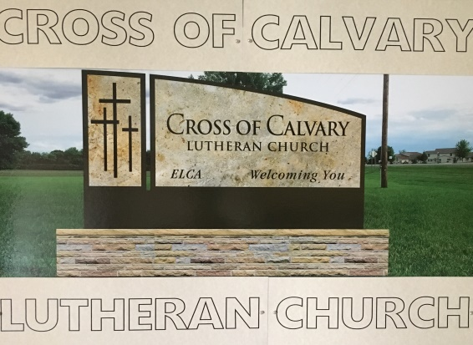

Devotion: Use this resource at home to guide your household’s daily devotions. You can do this alone or with others; in the morning, during the day, or at night. Find a routine that works best for you.
Pray: Light a candle and open your devotion time with a prayer.
Your patience, O God, is never ending and your wrath quick to subside. Teach us to cast aside all that is false and turn to you alone, for the sake of Jesus, Amen.
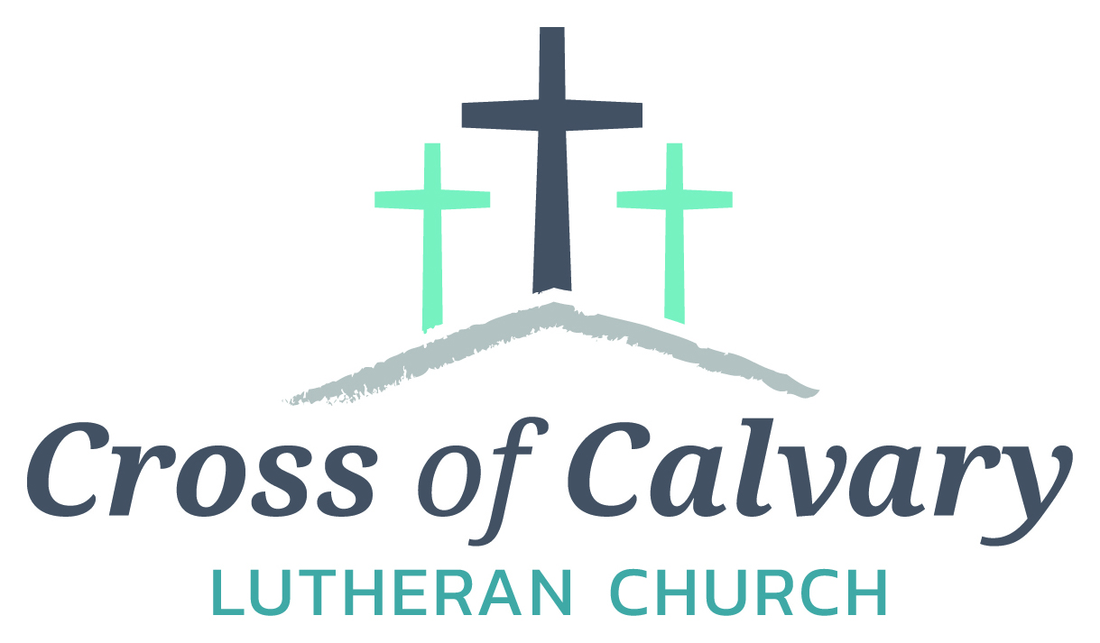
WorshipTimes
Saturdays: 5:30 pm
Sundays: 8:30 & 10:30
Coffee Hour
Sunday at 9:30 am
Sunday School
Sunday at 9:30 am
Building Hours
Mon-Thurs 8:30-7:00
Fri-Sun 8:30-2:00
Our Mission
That all may know the love of God

Matt Hausken
Pastor
hauskenmatt8@gmail.com
Ashley Schmidt
Minister of Faith Formation
cofcyouth@gmail.com
Sue Altmann
Office Administrator
crossofcalvary@gmail.com
__________________
320-523-1574
Web:crossofcalvay.net

Reflect: Reflect on the key verses from Sunday’s reading.
“Remember Abraham, Isaac, and Israel, your servants, how you swore to them by your own self, saying to them, ‘I will multiply your descendants like the stars of heaven, and all this land that I have promised I will give to your descendants, and they shall inherit it forever.’” And the Lord changed his mind about the disaster that he planned to bring on his people. Exodus 32:13-14
Study: Study the reading and consider the background.
Impatient people sometimes make very foolish choices. In an absurd response to Moses’ delay, the Israelites are persuaded to melt down their jewelry and form a golden calf to worship. Hmmm...what might God think of that?
Consider: Consider this theme for the week’s text.
God is passionate, pliable, and loving.
Read: Read the following daily readings to deepen your understanding of Sunday’s text. After the reading, ask the follow-up questions.
Sunday: Golden Calf, Exodus 32:1-14 Thursday: Gideon Tests God, Judges 6:36-7:23
Monday: God Calls Joshua, Joshua 1:1-11 Friday: Samson and Delilah, Judges 16:1-31
Tuesday: Rahab Helps God’s People, Joshua 2:1-24, 6:1-27 Saturday: Ruth and Naomi, Ruth 1:1-22
Wednesday: Deborah Helps Barak, Judges 4:4-10

How did the people move from the wilderness to the promised land?
Connect: Connect in conversation with others in your household. Discuss the following questions, or simply check in with “Highs” and “Lows.”
What was a high point of your day? What was a low point?
How does a peaceful crowd become a rebellious riot? How can we lead groups of people to behave faithfully and peacefully?
What kinds of things take God’s place in your life? How can you rid yourself of false idols and follow only God?
Do: By acting on what we learn we make God’s word come alive. Do the following activity this week.
Attend a peaceful protest for something you feel strongly about. Work hard to keep the protest peaceful. Reflect afterwards on how the event affected you and the people around you.
Bless: Close your devotion with a blessing
May God love you with passion and forgiveness. Amen.
Welcome to Cross of Calvary Lutheran Church
1103 W. Chestnut Ave. Olivia, MN 56277 October 9, 2016

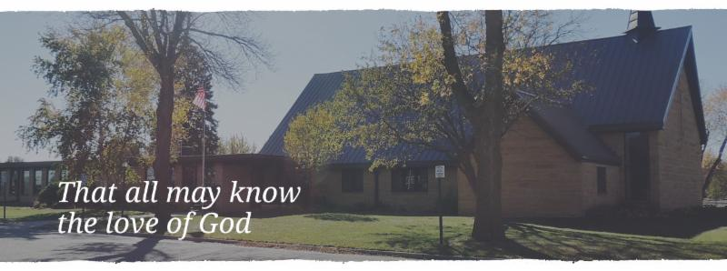
Cross of Calvary is the ELCA church in Olivia. We are an intergenerational (fancy word for young and old) community that follows Jesus out the building to where we live. We are all learners (disciples) here. This is a safe place to practice worship. And, believe us, it takes practice. Your questions, critical thinking, doubts and imperfect lives are welcome here.
Holy Communion
Holy Communion is open to all who are baptized and trust that Christ is present in the meal, regardless of your tradition or affiliation. Wine (red)/grape juice (white).
Participation
Bold type means all of us read or pray together. Out loud.
* Please stand as you are able.
Children in Church
They belong here! They are hearing God’s Word, music and prayers. We don’t mind fidgeting and chatter, really! If you like, there are activity bags available in the entry.
Announcements
They are as printed or any new information please give to Pastor Matt prior to worship, please hand a note to Pastor with any announcements, including prayer requests.
Restrooms
They are located in the hallway to the left of the stairs. Changing table located in the Women’s bathroom.
Mission
Paraguay Missionaries-The Kevin and Rebekah Howell family
Bolivia Missionaries – Paul and Jay Mikaelson

