Prayer Concerns
Prayer Matters! Please take your bulletin home and pray for those listed. Prayer concerns are listed for one month.
Please write another prayer request and drop it in the offering plate or in the office mailbox to ensure your request gets extend on the prayer concerns list.
Pray for: | Submitted by: | Pray for: | Submitted by:
Sonja Fostvedt | Pastor Matt | Diana Adkins | B Hennen
Vonna Ledeboer | A Ledeboer | Jill Revolinski | C Mallek
Abbie McGregor | A & H Thompson | Greg & Evelyn Rosenow | Teeny Kadelbach
Roger Schultes | Lynette Blem | Sara Selander | Sharon Alton
Ian Nelson | Becky Nelson | Carol Senkyr | Pastor Matt
Amy Senger | Duane Senger | Caryn Jandl | Karen Barta
Lesley Sagedahl | Daren Sagedahl | Red Fostvedt | Pastor Matt
Luella Norberg | Lynette Blem
Emergency/Pastoral Care-Please have a family member or friend notify the church. You may also request hospital staff to call on your behalf. Call day or night at 523-1574. Never feel as though you are bothering Pastor or the staff. We are here to serve as a comfort and as a resource.
The week of Nov. 6 – Nov. 13
Sun Worship 8:30 & 10:30 am
1st Communion Sunday
Reformation Event: Potluck after 10:30 service
Swimming at BOLD from 1-2
Mon Library reserved 6-8 pm
Tues Men’s Bible Study 6:15/7:00 am
Wed WOW 3:15
Confirmation 6:30 pm
3rd Grade Bible Class 3:15
Sat Worship 5:30 pm
Sun Worship 8:30 & 10:30 am
Baptism at 10:30 service

November WORSHIP VOLUNTEERS
Communion - 8:30 Keith Larson
10:30 Michelle Jensen
Altar Guild – Jill Hanson, Dawn Gluesing
Acolytes – Brady Ridler, Maddie Jensen
Ushers -8:30 – Ron Nelson, Margaret Flemming,
Craig Flemming
10:30- Tom & DeeAnne Newville

FYI: Carpet Cleaning: November 7th
The Snowflake Bazaar Committee is once again asking for your help with this year's event. It will be held on SUNDAY, December 4th, from 9:30 am to 12:30 pm. Once again, we are making a change to the menu as it's always nice to see what would work the best and be easiest on our service workers. We will be having a scrambled egg/sausage brunch and will need food donations. We also ask that you think of us when doing your holiday baking as the bake sale is an important part of the morning.
The Raffle this year has a deadline of NOVEMBER 9th. This is important so that we may start selling tickets on Nov. 13th. Last year, a few items came in just days prior to the event and it just made more work for the committee, so we thank you in advance for your promptness in this! We also would appreciate any craft donations for our craft room. On Nov. 13th, after the 9:30 service, anyone that would like to help us paint a few items is welcome to join us in the fellowship hall during coffee... we promise it is VERY easy and a lot of fun! Thanks for all your help - we plan on making a sizable donation to the new sign fund and the success of our bazaar is because of our great congregation.
Dana Boen, Cathy Helin, Jen Kingery, Sandy Gay and Jody Steffel

COMMUNITY BOARD
CHECK THE EAST BULLETIN BOARD for more information /details
Cross of Calvary Church Christmas Decorating will be Wednesday, Nov. 30th starting at 4:00 pm. Pizza and pop will be provided!
Adult Grief Support: The group will meet on Monday, Oct. 3-Nov. 7, 2016 from 2-4 pm in the Redwood Area Hospital Education room. There is no cost to participate.
Annual Grief Support Opportunity: “Good Grief” is sponsored by Renville County Hospice. The sessions will be held on Monday evenings November 7, 14, 21 and December 5, 2016 from 5:30 to 7:30 pm at Renville County Hospital (Willette Room), 100 Healthy Way in Olivia. All are welcome and invited. Please call Dawn at 320-523-34512 to register.
Harvest Fest at Blomkest Baptist: Please join us for the annual Harvest Fest on Sunday, November 13 at 7 pm. The evening will include a musical presentation be Norma Watson and auto-harp. A free-will offering will go to the Ridgewater Campus Ministry as directed by our interim pastor, Jeffrey Schmitz, and for supplies of the Legacy House for those in need. There is no charge for the pie social following the program.
Turkey Supper: Our Savior’s Lutheran Church in Bird Island will be hosting their annual supper, Nov. 16th starting at 5:00 pm Details are on the Community Board.
Harvest Brunch: Sunday November 6th from 8 am – 12. Sponsored by Olivia Lions, place: American Legion. Free will offering, proceeds to Olivia Cub Scouts, Boy scouts and BOLD FFA. Menu: pancakes, sausages, scrambled eggs.
The women of St. John’s Catholic Church in Hector are holding their annual Craft and Bake Sale on Saturday, Nov. 12 from, 8-1 at the Buffalo Lake High School, Hector campus small gym. See board for more details.
21st Annual Lutheran Men in Mission Lutefisk & Meatball Supper: Thursday, Nov. 17 from 4:30-6:30 at Gloria Dei Lutheran Church in Redwood Falls. See board for more details.
Beef Commercial Dinner: Olivia Kiwanis/Santa’s Closet of Renville County invites you to BE A WINNER!!!!
When: Election Day, Tuesday, November 8th from 4-7 pm at the CCOC in Olivia.
Question? There is a set of Halloween Dishes at the church. Does anyone know who they belong too?? Contact the office with any information. Thank You
RCW Area Friends of the Arts presents “The Cemetery Club” Come & enjoy some great entertainment on November 11/12 at 7:30 pm; November 13 matinee at 2:00 pm (directed by Bev Raske). It will be held at the RCW small gym/stage – wheelchair accessible. Tickets sold at the door: $15 (adults); $10 (students).
Holy Family CCW: They will be having their annual Craft, Bake & Gently Used Toy Sale. Saturday, Nov. 19 from 8 am – 3:30 pm. Church of the Holy Family in Silver Lake, MN
Lutefisk/Swedish Meatball Supper at Zion Lutheran Church in Buffalo Lake: Sunday, November 20th from 4:30-6:30 pm. Family style with take outs available.

Devotion: Use this resource at home to guide your household’s daily devotions. You can do this alone or with others; in the morning, during the day, or at night. Find a routine that works best for you.
Pray: Light a candle and open your devotion time with a prayer.
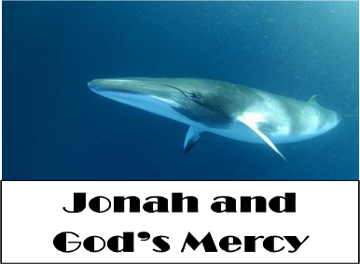
You see our failings, Lord, and know the weakness of our hearts. Set us right and fill us with love and zeal for the people whom you love, just as Jesus has shown us. Amen.
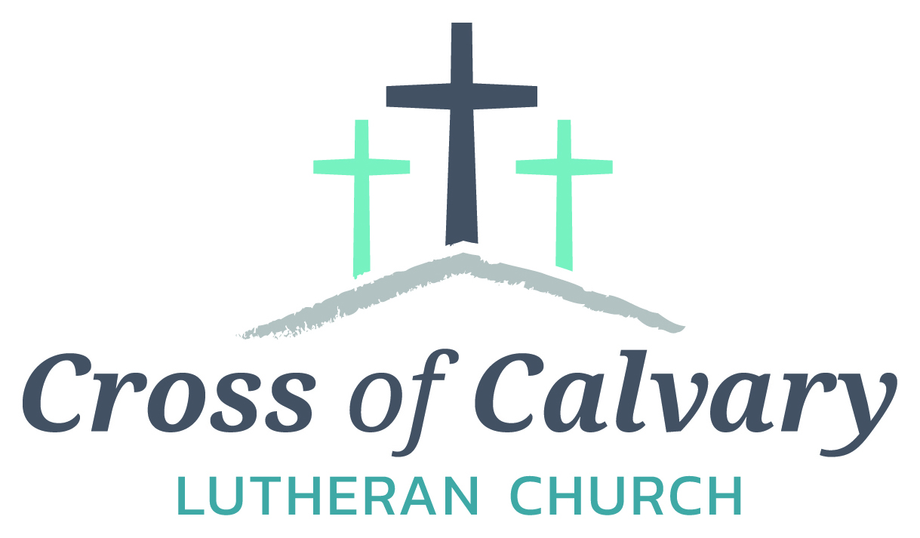
WorshipTimes
Saturdays: 5:30 pm
Sundays: 8:30 & 10:30
Coffee Hour
Sunday at 9:30 am
Sunday School
Sunday at 9:30 am
Building Hours
Mon-Thurs 8:30-7:00
Fri-Sun 8:30-2:00
Our Mission
That all may know the love of God
Matt Hausken
Pastor
hauskenmatt8@gmail.com
Ashley Schmidt
Minister of Faith Formation
cofcyouth@gmail.com
Sue Altmann
Office Administrator
crossofcalvary@gmail.com
__________________
320-523-1574
Web:crossofcalvay.net

Reflect: Reflect on the key verses from Sunday’s reading.
When the news reached the king of Nineveh, he rose from his throne, removed his robe, covered himself with sackcloth, and sat in ashes.
When God saw what they did, how they turned from their evil ways, God changed his mind about the calamity that he had said he would bring upon them; and he did not do it. Jonah 3:5, 10
Study: Study the reading and consider the background.
If you want a job done, don’t send Jonah. Chances are he’ll end up on a cruise heading in the opposite direction, or putting his fellow sailors in mortal peril. And when he finally (reluctantly) relents to the task at hand, he regrets his own success. Is God’s mercy great enough even for the resistant prophet?
Consider: Consider this theme for the week’s text.
God offered mercy to Jonah’s enemies and to Jonah. Neither was more deserving than the other.
Read: Read the following daily readings to deepen your understanding of Sunday’s text. After the reading, ask the follow-up questions.
Sunday: Jonah and God’s Mercy, Jonah 1:1-17; 3:1-10 [4:1-11]
Monday: Zephaniah Prophesies Against the Kingdoms, Zephaniah 1:14-18
Tuesday: Nahum Prophesies of God’s Wrath, Nahum 1:1-11
Wednesday: Habakkuk Prophesies and Prays, Habakkuk 3:1-19
Thursday: God Calls Jeremiah, Jeremiah 1:1-19
Friday: Ezekiel Sees a Vision, Ezekiel 1:1-28
Saturday: The Valley of Dry Bones, Ezekiel 37:1-14
How does God show mercy in these readings?
Connect: Connect in conversation with others in your household. Discuss the following questions, or simply check in with “Highs” and “Lows.”
What was a high point of your day? What was a low point?
What countries or cultures do you most dislike? Why? How will you treat these neighbors knowing that God has asked you to love and serve people there?
When have you been angry with God for being generous with a someone you felt deserved punishment? What could you do to show love, rather than anger or hatred?
Do: By acting on what we learn we make God’s word come alive. Do the following activity this week.
Do some research on a country or culture that you find it difficult to appreciate. Learn about what they eat, what holidays they celebrate, where and how they worship, what they wear, and more. Does your increased understanding make it easier or harder to love them?
Bless: Close your devotion with a blessing.
May God bless you. May God bless your enemies. Amen.
Welcome to Cross of Calvary Lutheran Church
1103 W. Chestnut Ave. Olivia, MN 56277 November 6, 2016
Altar flowers are from Alvina Beckman’s family – Blessed be her memory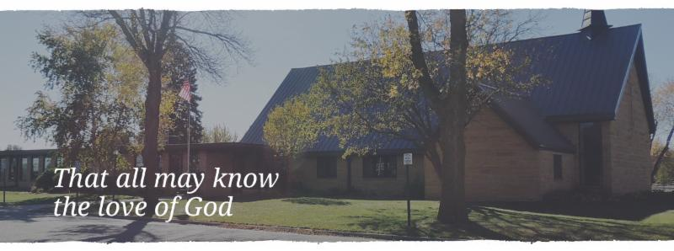Cross of Calvary is the ELCA church in Olivia. We are an intergenerational (fancy word for young and old) community that follows Jesus out the building to where we live. We are all learners (disciples) here. This is a safe place to practice worship. And, believe us, it takes practice. Your questions, critical thinking, doubts and imperfect lives are welcome here.
Holy Communion
Holy Communion is open to all who are baptized and trust that Christ is present in the meal, regardless of your tradition or affiliation. Wine (red)/grape juice (white).
Participation
Bold type means all of us read or pray together. Out loud.
* Please stand as you are able.
Children in Church
They belong here! They are hearing God’s Word, music and prayers. We don’t mind fidgeting and chatter, really! If you like, there are activity bags available in the entry.
Announcements
They are as printed or any new information please give to Pastor Matt prior to worship, please hand a note to Pastor with any announcements, including prayer requests.
Restrooms
They are located in the hallway to the left of the stairs. Changing table located in the Women’s bathroom.
Mission
Paraguay Missionaries-The Kevin and Rebekah Howell family
Bolivia Missionaries – Paul and Jay Mikaelson
First Communion at Cross of Calvary - November 6, 2016
Leo Matthew Adamski Matt & Cassandra Adamski
Rylee Marie Boen Craig & Chrissy Boen
Rylan Robert Gass Erik Gass & Shelby & Amanda Pendleton
McKenna Rian Jensen Ryan & Michelle Jensen
Craig Michael Lothert Jr. Craig Lothert Sr.
McKenzie Rose Lothert Reggie & Jessica Lothert
Tatum Diane Mages Craig & Becky Mages
Laila Ann Ridler Roger & Tonia Ridler
Landon Taylor Robideau Zach & Jennifer Robideau
McKenna Rose Siems Tina Beckler
Madison Jo Van Vleet Shauna Wagner
MacKenzie Rose Visser Shannon & Jennifer Visser

2016 Confirmation Class – Sunday, October 30, 2016
Jake Jaron Evenson Baptized 12/02/2000
Son of Shad & Jennifer Evenson
Hayli Garcia Baptized
Daughter of George & Alisha Garcia
Spencer Reinhold Helmer Baptized 09/01/2001
Son of Steve & Dawn Helmer
Trey Michael Mertens Baptized 07/23/2000
Son of Greg & Dawn Mertens
Joseph Robert Mikosch Baptized 08/12/2000
Son of Danna Mikosch & Jeff Mikosch
Cade Aldon Morse Baptized 11/18/2001
Son of Mark & Jaime Morse
Danny James Newville Baptized 05/13/2001
Son of Tom & DeeAnne Newville
Alexandra Lila Revier Baptized 08/12/2001
Daughter of Dave & Chris Revier
Megan Elise Ridler Baptized 11/01/2000
Daughter of Roger & Tonia Ridler
Makenna Rae Steffel Baptized 11/19/2000
Daughter of Randy & Tami Steffel
Shelby Lynn Stovern Baptized 06/03/2001
Daughter of Derek & Tami Stovern
Emma Maureen Thompson Baptized 10/07/2001
Daughter of Aaron & Heather Thompson

Reformation Event – Sunday, Nov. 6th

