The Follower
November 2016
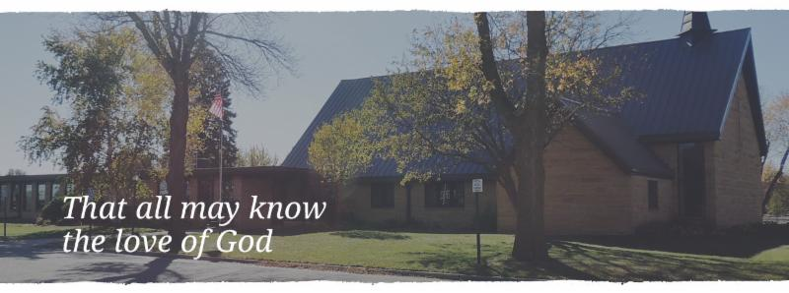

Be joyful always; pray continually;
give thanks in all circumstances,
for this is God’s will for you in
Christ Jesus.
1 Thessalonians 5:16-18

PASTOR’S CORNER

We have now entered into our month of thanksgiving. We begin it with All Saints Day and Sunday. Then we continue on to remember and give thanks to all who have served our country on November 11th. Then it all culminates with that National Day of Thanksgiving. Thanksgiving is one of those acts that appear to be for the good of the one we are giving thanks for. However, in giving thanks we are profoundly affected in a very positive way.

When we give thanks we realize how well taken care of we are and how much of it isn’t our own doing. When we say thank you we realize that someone has done something for us. Many times this thing is something we could not have done on our own. It is a humbling thing to say “Thank you”. But, it is also a joy to see how well we are taken care of by God. We discover the many ways that God takes care of us through other people and events in our life.

I think that election years are particularly good to have these celebrations of Thanksgiving. We are bombarded by how bad things are and it starts to create a sense of scarcity that eats away at us. It erodes our faith. But, we are then drawn into these events where we look face to face with a generous God who blesses us beyond measure. May we use each day this blessing of thanksgiving to rediscover this ever present heavenly Father and learn to trust him above all else.

Blessings for a wonderful month of November!

In Christ

PRAYERS OF HEALING AND STRENGTH

Prayer for: Submitted by:
Vonna Ledeboer A. Ledeboer
Diana Adkins B. Hennen
Jill Revolinski C. Mallak
Greg & Evelyn Rosenow T. Kadelbach
Family of Ann Orth Don Orth
Roger Schultes …………………………………………………………………………………………………….. Lynnette Blem
Abbie McGregor…. ……………………………………………………………………………Aaron & Heather Thompson
Carol Senkyr.............................................................................................................Pastor Matt Hausken
Ian Nelson..............................................................................................................................Becky Nelson
Red Fostvedt............................................................................................................................Pastor Matt
Joan Novak ......................................................................................................................Jan Rauenhorst
Sonja Fostvedt ........................................................................................................................Pastor Matt
Sara Selendar........................................................................................................................Sharon Alton
◄ | November 2016 |  |  |  |  | ►
Sun | Mon | Tue | Wed | Thu | Fri | Sat
 |  | 1 | 2  3rd Grade Bible Study  Confirmation Meal at 5:45  Confirmation at 6:30  WOW  Altar Guild 7:30  Reformation Meeting 7:30 | 3  Craft Retreat 5pm | 4  Craft Retreat  8am-10pm | 5  Craft Retreat 8-6  Worship 5:30
6  1st Communion Sunday  Worship 8:30/10:30  Communion  Sunday School 9:30  Potluck after 10:30 service/pool party from 1-2 pm | 7  Library Reserved  6:00-8:00 pm  Kitchen used (time?)  Carpet Cleaning | 8  Men’s Bible Study  6:15 am and 7:00 am  Caregiver Group 10 am (Fairview) | 9  3rd Grade Bible Study  Confirmation Meal at 5:45, Class at 6:30 pm  WOW at 3:15 pm | 10 | 11 | 12  Worship 5:30 pm
13  Worship 8:30/10:30….  Sunday School 9:30 am  Bazaar Committee working on projects at 9:30 am  All Welcome! | 14  Library Reserved  6:00-8:00 pm | 15  Men’s Bible Study  6:15 am and 7:00 am | 16  3rd Grade Bible Study  Confirmation Meal at 5:45, Class at 6:30 pm  WOW at 3:15 pm  Outreach Mtg. 5:30  Church Council Mtg. 7:30 | 17  Dorcas Bible Study 9:30 | 18  Junior High Youth  Gathering | 19  Worship 5:30 pm  Junior High Youth  Gathering
20  Gideon Sunday  Worship 8:30/10:33  Communion  Sunday School 9:30 am  Chili Cook-off: after 10:30 Service | 21  Library Reserved  6:00-8:00 pm | 22  Men’s Bible Study  6:15 am and 7:00 am | 23  No Confirmation  No WOW | 24  Thanksgiving | 25 | 26  No Worship 5:30 pm
27  Worship 9:00 am  No Sunday School | 28  Library Reserved  6:00-8:00 pm  Ruth Bible Study at 1:30 | 29  Men’s Bible Study  6:15 am and 7:00 am  Girl Scouts 5:30-7:15 | 30  Confirmation Meal at 5:45, Class at 6:30 pm  WOW at 3:15 pm  7pm Advent Worship | 1 | 2 | 3  Worship 5:30 pm

NOVEMBER VOLUNTEERS

COMMUNION 8:30 – Keith Larson/10:30 – Michelle Jansen
USHERS 8:30 – Ron Nelson, Craig Flemming, Margaret Flemming
10:30 – DeeAnne Newville and Tom Newville
ACOLYTES Brady Ridler and Maddi Jansen
ALTAR GUILD Jill Hanson & Dawn Gluesing

YOUTH NEWS

Programs
Sunday School
Sun. – 9:30-10:20am
3 year old – Grade 9
WOW
Wed. – 3:15-5:00pm
Grades 1-6
Breakfast Club
Thursday – 7:07am
Grades 9-12
Confirmation
Wednesday
Meal at 5:45pm
Class at 6:30-7:30pm

Youth Calendar Events
November 24
No Breakfast Club
Have a happy Thanksgiving!
November 18-19
Junior High Youth Gathering

November 13
WOW Choir Sings during worship
November 23
No WOW
Have a happy Thanksgiving!
November 27
No Sunday School
Have a happy Thanksgiving!
November 6
First Communion Sunday
(both services)

Youth Feature
The WOW Choir had their very first performance of this school year on October 16! They sang some of their favorite songs that they learned at Vacation Bible School this past summer. These kids really know how to praise God with their voices!

Coffee Hour Schedule

November 13………………………………..Stovern, Hausken, Cole, Boen (Craig/Chrissy)
November 20………………………………………………….Stratton, Weis, Matti, Evenson

Wanted
Your finest chili or soup Recipes!!
First Annual Cross of Calvary Soup and Chili Cook off!
Sunday, November 20th after the 10:30 service
Competition is free. Congregation will award winners in two categories, soup & Chili.
Free-will donation to sample and judge!
Winners of both categories will receive the world-famous greasy ladle trophy!

Renville County Food Shelf: The food shelf is low on dollars that are used for fresh produce. Area churches will be taking turns each month for collecting funds. Lutheran churches have the months of February and June. All churches have the months of November and March!
Any contributions will be greatly appreciated!!
The Snowflake Bazaar Committee is once again asking for your help with this year's event. It will be held on SUNDAY, December 4th, from 9:30 am to 12:30 pm. Once again, we are making a change to the menu as it's always nice to see what would work the best and be easiest on our service workers. We will be having a scrambled egg/sausage brunch and will need food donations. We also ask that you think of us when doing your holiday baking as the bake sale is an important part of the morning.
The Raffle this year has a deadline of NOVEMBER 9th. This is important so that we may start selling tickets on Nov. 13th. Last year, a few items came in just days prior to the event and it just made more work for the committee, so we thank you in advance for your promptness in this! We also would appreciate any craft donations for our craft room. On Nov. 13th, after the 9:30 service, anyone that would like to help us paint a few items is welcome to join us in the fellowship hall during coffee... we promise it is VERY easy and a lot of fun! Thanks for all your help - we plan on making a sizable donation to the new sign fund and the success of our bazaar is because of our great congregation.
Dana Boen, Cathy Helin, Jen Kingery, Sandy Gay and Jody Steffel

11/01 Arlis Shockley 11/10 Linda Brown 11/19 Kaylie Weilage
11/01 Jeff Padrnos 11/10 Curtis Schroer 11/20 Mark Grasmon
11/01 Scott Revier 11/10 Sue Erickson 11/20 John Beckman
11/01 Madeline Ridler 11/10 Brian Reese 11/20 Chad Amsden
11/02 Roger Ridler 11/10 Alexis Johnson 11/21 Danna Mikosch
11/02 Ken Meints 11/12 Bruce Maurice 11/21 Ingrid Dietrich
11/02 Stephanie Malvin 11/12 Natashia Johnson 11/21 Kyndra Sing
11/02 Kylie Erickson 11/12 Alyssa Ryan 11/22 Tom Jansen
11/03 Mckenna Jensen 11/13 Kathy Steinbeisser 11/22 Dawn Gluesing
11/05 Wayne Maurice 11/13 Jason van der Hagen 11/23 Pat Ryan
11/05 Chris Gatsche 11/14 Kris Enestvedt 11/23 Haley Torkelson
11/06 Virginia Draheim 11/14 Michael Senger 11/23 Kohen Youngkrantz
11/06 Ken Ziesmer, Sr. 11/14 Jeremie vanderHagen 11/24 Gena Amsden
11/06 Larry Rauenhorst 11/15 Elaine Julius 11/25 Brian Kingery
11/06 Alexandra Revier 11/15 Curt Sather 11/25 Nicholas Revier
11/07 Todd Fostvedt 11/15 Gaylord Johnson 11/26 Robert Berry
11/07 Taylor Amsden 11/17 Amanda Gass 11/26 Jonathan Kircher
11/07 Rylee Boen 11/17 Nancy Hague 11/27 Kevin Schultze
11/08 John Johnston 11/17 Melissa Sagedahl 11/28 Debra Folkerts
11/08 Roger Cooper 11/17 Amanda Kopel 11/28 Kessly Bohm
11/08 Jody Weis 11/17 Jordan Sagedahl 11/29 Uva Hahn
11/08 Adam Honzay 11/18 Frances Herman 11/29 Emy Elbert
11/08 Travis Suess 11/18 Dan Beckler 11/29 Jena Bruns
11/09 Taesia Rae Hackman 11/18 Dylan Hildahl 11/30 Elaine McDowell
11/18 Taylor Wertish 11/30 Wayne Enestvedt
11/18 Nathan Thomas 11/30 Mia Kingery
11/18 McKenna Gross 11/30 Kayne Fischer
11/18 Nolan Grund
Fundraising for the new sign at
Cross of Calvary on Highway #71
The goal is to fill all the letters on the picture below, each letter represents a $1,000.

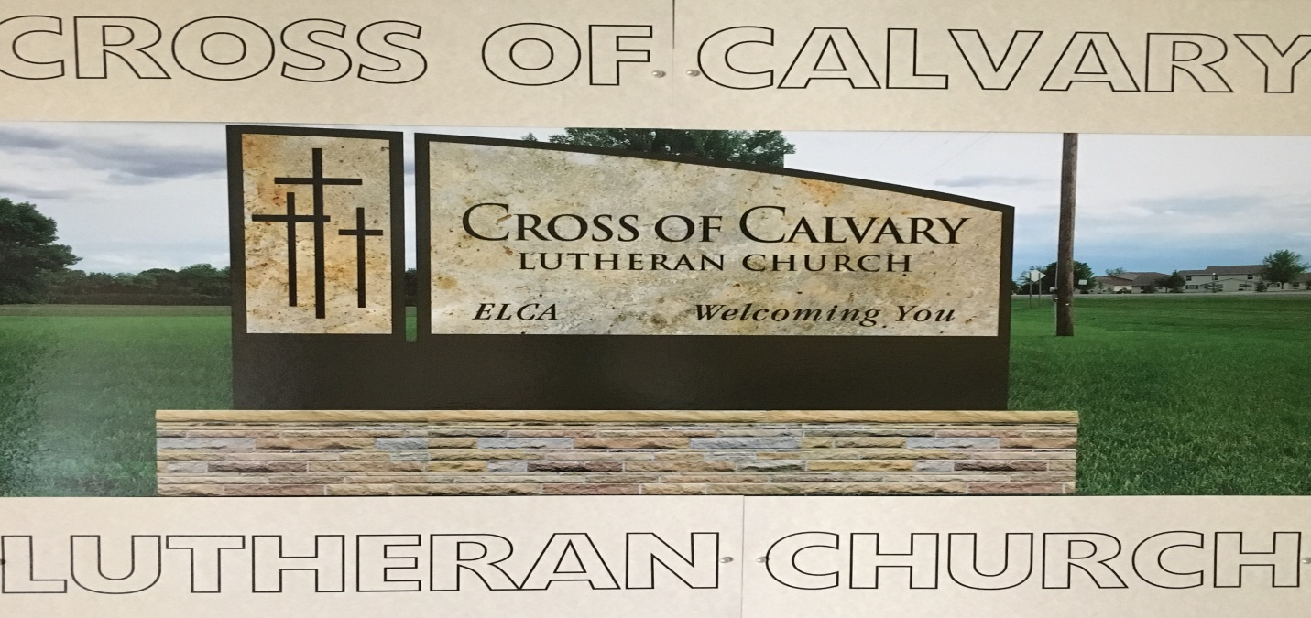

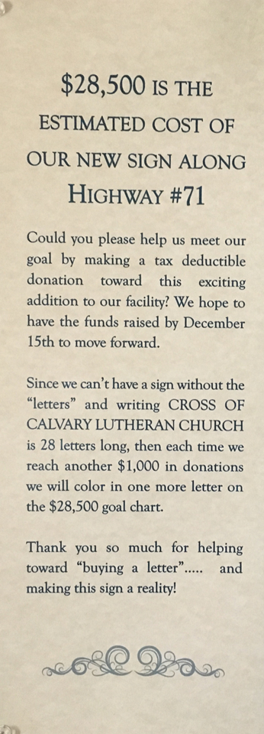
Cross of Calvary will start a fundraising campaign with the first $3,000 raised matched by Thrivent choice dollars.

There are envelopes placed by the sign for donation. Please either put the envelope in offering tray or the church office mailbox.

We look forward to seeing our new church sign along Highway #71 become a reality. The sign will certainly complement our church design. Your gift is greatly appreciated!
Thank You!

As of 10/23/2016 donation are $6,570.00
Cross of Calvary Lutheran Church Council Meeting
Minute for: Wednesday, October 12, 2016 @ 7:30pm

COUNCIL MEMBERS

(X)Aaron Thompson 2017* (X) Jon Hawkinson 2018 (X) Eric Skeie 2019*
(_)Keith Larson 2017* (X) Bobbi Kopel 2018 (X) Natasha Johnson 2019*
(X)Cindy Johnson 2017* (_) Paul Buhr 2019 (_) Michelle Jensen 2019*
(X) DeeAnne Newville 2017 (X) Gordon Blem 2019
(X)Steve Altmann 2018 Terms end at Annual Meeting (Jan.)
*Second term
STAFF
(X) Pastor Matt Hausken (X) Ashley Schmidt, Minister of Faith Formation (X) Sue Altmann, Council Recorder

AGENDA
- Meeting called to order- President Eric Skeie
- Devotions – DeeAnne Newville
- Approve minutes of the September meeting–Motion to approve the minutes by Gordy and seconded by Cindy. Motion passed.
- Financial Secretary and Treasurer Reports –September - Motion to approve the treasurer/secretary report by Gordy, seconded by Aaron, motion passed.
- The council asked to have a comparison of this year to date to last year to date from Curt Sather. It was asked that Curt Sather attend the next meeting.
- Pastors Report
- Confirmation is going very well.
- Book Club: starts in November with an in person sit down, covering 95 Thesis
- 1st Reformation event was held on Sunday, Oct. 9. 50-60 people attended the campfire and hayride. Next event will be November 6th, with potluck and swimming at BOLD school.
- Food Shelf: money is needed. Feb. & June will be the months that Lutheran Churches in the area will be collecting money. Nov. & March all area churches will be helping. The 1st & 3rd Tuesday the shelf is looking for help to unload trucks. We are hoping to have the Confirmation students help.
- Minister of Faith Formation’s report
- WOW: sang on October 16th.
- Jr. High Youth Gathering is November 18 & 19. Cross of Calvary has 28 students signed up, looking for chaperones.
- Ashley went to a Youth Workers Retreat, she learned about mental health and how to look for signs and how to help.

COMMITTEE REPORTS AND RECOMMENDATIONS
1. Youth Ministry- none
2. Equipping the Congregation - none
3. Outreach – none
4. Administration – none
5. AED Maintence – Steve checked.
OLD BUSINESS
- Website Information –Vanco for a website online giving/directory: progress?
- Vanco is all set up and ready. A presentation is needed to the congregation.
- It was recommended that Tom Osthus give the table talk. Also, a flier will be developed by Ashley and Sue.
- Sign for West side of building – fundraising events are beginning to take shape. Fliers, donation envelopes and donation cards have been placed about church.
- Carpet Cleaning is scheduled for November 7th. It was approved to have Sun-brite clean carpets.
- Cub Scouts will be contacted by Steve Altmann.
NEW BUSINESS
- Bennett (copy machine) lease up in February. It was recommended to get quotes from other companies. Sue will contact Marco for pricing.
- Century Link – Steve contacted both Century Link and Light Beam. Century Link gave the best deal. We will stay with them until further notice.
- LSS of MN was approved for continued donation. ($160.00 monthly)
- Green Lake Lutheran Ministries for the year – approved to continue donation
- 2017 Health Benefits: Approve Pastor Matt Hausken’s enrollment in the ELCA/Portico Gold Plus health benefit package for 2017. Gordy made a motion to approve, Steve seconded, motion passed.
Next Council meeting: Wednesday, November 16th at 7:30 pm
November Communion: 8:30 = Keith, 10:30 = Michelle
November Devotions – Keith
Adjourn / Close in prayer.

