January 1, 2017
Devotion: Use this resource at home to guide your household’s daily devotions. You can do this alone or with others; in the morning, during the day, or at night. Find a routine that works best for you.

Pray: Light a candle and open your devotion time with a prayer.
O Lord, sometimes we encounter you in unexpected places. May we meet you with joy and honor you in our speaking and acting. In your holy name we pray, Amen.
Reflect: Reflect on the key verses from Sunday’s reading.
Simeon took [Jesus] in his arms and praised God, saying, “Master, now you are dismissing your servant in peace, according to your word; for my eyes have seen your salvation, which you have prepared in the presence of all peoples, a light for revelation to the Gentiles and for glory to your people Israel.” And the child’s father and mother were amazed at what was being said about him. Luke 2:28-33
Study: Study the reading and consider the background.
Only eight days old, and Jesus is already making waves in the temple. Two long suffering servants, Simeon and Anna, are about to have the moment for which they have spent their lives waiting.

Consider: Consider this theme for the week’s text.
If we pay attention, we might recognize Jesus in unexpected places in the new year.

Read: Read the following daily readings to deepen your understanding of Sunday’s text. After the reading, ask the follow-up questions.
Sunday: Simeon and Anna, Luke 2:21-38
Monday: Purification of a Woman after Childbirth, Leviticus 12:1-8
Tuesday: The Law Concerning Dedication of Firstborns, Exodus 13:1-16
Wednesday: Levites Become Substitutes for Firstborns, Numbers 3:40-51
Thursday: God’s Servant, Isaiah 42:1-9
Friday: The Boy Jesus Is Found in the Temple, Luke 2:39-52
Saturday: Laws Concerning Festivals, Exodus 23:10-17
What kinds of rites and rituals are tied to infants in Jesus’ day?

Connect: Connect in conversation with others in your household. Discuss the following questions, or simply check in with “Highs” and “Lows.”
What was a high point of your day? What was a low point?
Where do you see Jesus in the world? Where would you like to see Jesus in the world?
What’s the meaning of your name? Do you have a title or an identity? How does your name, title, or identity shape how behave in the world? How does it shape how people treat you? How can you honor your family name? How can your name honor you?
Do: By acting on what we learn we make God’s word come alive. Do the following activity this week.
Volunteer to work in your church’s nursery. While you are there, pay attention to each child. Get to know their name and who their parents are. If they are infants, sing to them. If they are toddlers, play with them. If they are preschoolers, find out their favorite color, animal, and song. Praise God for the gift of children.

Bless: Close your devotion with a blessing.
May God bless you with wisdom to share with future generations. Amen.
Mission
Paraguay Missionaries – The Kevin & Rebekah Howell family
Bolivia Missionaries – Paul and Jay Mikaelson

Prayer Concerns
Prayer Matters! Please take your bulletin home and pray for those listed.
Prayer concerns are listed for one month.
Pray for: | Submitted by: | Pray for: | Submitted by:
Warren Mitchell | Cole Family | Diana Adkins | B Hennen
Vonna Ledeboer | A Ledeboer | Jill Revolinski | C Mallek
Family of  Red Fostvedt | Pastor Matt | Greg & Evelyn Rosenow | Teeny Kadelbach
Leslie Sagedahl | Daren Sagedahl | Caryn Jandl | Karen Barta
Joe Besledahl | Mattie family | Pat Aalderks | Pastor Matt
Family of Abbie McGregor | A & H Thompson | Family of LaVone Wurm | Pastor Matt
 |  | Family of Carol Johnson | Ryan Johnson
Emergency/Pastoral Care-Please have a family member or friend notify the church. You may also request hospital staff to call on your behalf. Call day or night at 523-1574. Never feel as though you are bothering Pastor or the staff. We are here to serve as a comfort and as a resource.

Ushers needed for the 2017 church year.
The week of Jan. 1 – Jan. 8
Today Worship 9:00 am
Mon Library reserved 6-8 pm
Tues Men’s Bible Study 6:15/7:00 am
Wed WOW 3:15
Confirmation 6:30 pm
Thur Breakfast Club
Fri MIA 6:00 pm
Sat Worship 5:30 pm
Sun Worship 8:30 am & 10:30 am

Dates needed: January late service (2), April late service(2), September early services (2), October early services (2) and 1 ushers for January early service, May early service, August service, November early service. Please contact either Daren Sagedahl or the church office. Thank you for volunteering!!

JANUARY VOLUNTEERS
Communion – 8:30 - Bobbi Kopel/10:30 – Jon Hawkinson
Altar Guild – Ronda Berg & Tami Stovern
Acolytes – Noah Boen & Ben Whited
Usher – 8:30 – Greg Mertens, Trey Mertens, Bill Kopel
10:30 – VOLUNTEERS NEEDED

COMMUNITY BOARD
CHECK THE EAST BULLETIN BOARD for more information /details

Confirmation Suppers. Would you consider working with a friend/family to prepare and serve a simple meal to our confirmation student on Wed nights? Approximately 25 kids roll in after school activities…hungry for supper and for time spent with Pastor and the small group leaders! The meal is served from 5:45 to 6:20. The confirmation parents are the first to volunteer, but there are more class dates than families. Sign-up sheet are on the BOARD.
Dates with openings: Jan. 4, 18, 25, Feb. 1, 8, 15 and 2

Reformation Events:
January: MIA Luther Exhibit on January 6th at 6:00 pm Cost of ticket is $12.00 per person. Tickets available from Pastor
Matt or sign up on The Board.
Check out the calendars on the table by youth board. A great way to get a wonderful calendar and help with the sign fundraising!!! (Thank you Dr. Buhr)

Quilters will start the 1st Thursday in January at 9:00 am

Come and go open house baby shower for Sara Benson to be held Saturday, January 21, 2017, from 9:30-11:30 a.m. at Cross of Calvary Lutheran Church in Olivia. Sara and Mike are expecting a Baby Boy in February and are registered at Target. Grandparents are Kenten & Joyce Damhof and Jeff & Sandy Benson

Cross of Calvary Lutheran Church
1103 W. Chestnut Ave. Olivia, MN 56277 320-523-1574

January 1, 2017
Weekly Announcements
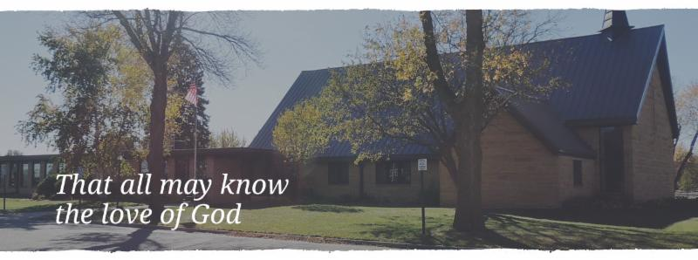

Cross of Calvary is the ELCA church in Olivia. We are an intergenerational (fancy word for young and old) community that follows Jesus out the building to where we live. We are all learners (disciples) here. This is a safe place to practice worship. And, believe us, it takes practice. Your questions, critical thinking, doubts and imperfect lives are welcome here.
Holy Communion
Holy Communion is open to all who are baptized and trust that Christ is present in the meal, regardless of your tradition or affiliation. Wine (red)/grape juice (white).
Participation
Bold type means all of us read or pray together. Out loud. * Please stand as you are able.
Children in Church
They belong here! They are hearing God’s Word, music and prayers. We don’t mind fidgeting and chatter! If you like, there are activity bags available in the entry.
Announcements
They are as printed or any new information please give to Pastor Matt prior to worship, please hand a note to Pastor with any announcements, including prayer requests.
Restrooms
They are located in the hallway to the left of the stairs. Changing table located in the Women’s bathroom.

Pastor Matt and Sarah (and boys) would like to thank everyone who gave a card or gift this holiday season. It is greatly appreciated.
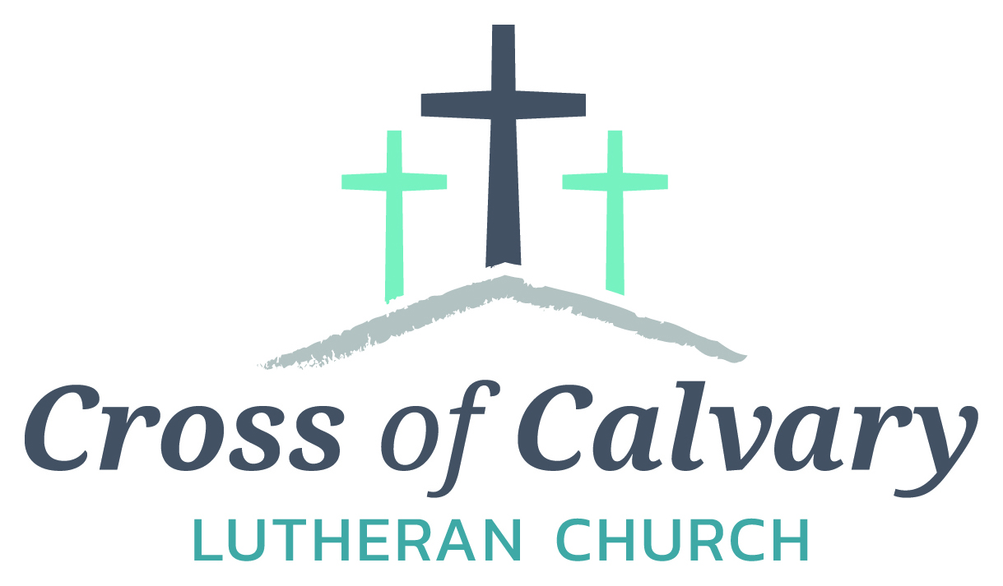
WorshipTimes
Saturdays: 5:30 pm
Sundays: 8:30 & 10:30
Coffee Hour
Sunday at 9:30 am
Sunday School
Sunday at 9:30 am
Building Hours
Mon-Thurs 8:30-7:00
Fri-Sun 8:30-2:00
Our Mission
That all may know the love of God

Matt Hausken
Pastor
hauskenmatt8@gmail.com
Ashley Schmidt
Minister of Faith Formation
cofcyouth@gmail.com
Sue Altmann
Office Administrator
crossofcalvary@gmail.com
________________
320-523-1574
Web:crossofcalvay.net
Online giving is now available. Go to website listed above.
Coming up January
WOW & Confirmation resume on Jan.4th
January 1 – Service at 9:00 am only
January 5 - Quilters begin at 9:00 am
January 8 – Sunday School Program at 10:30 am service
January 18 – Church Council Meeting at 7:30 am
January 22- Annual Meeting at 9:30 am

Annual Congregational Meeting
January 22, 2017 at 9:30 am
(Alternate date: 1/29/2017)
-please submit any reports for annual booklet by
January 13th!

Opportunity to Serve
Cross of Calvary is accepting applications for the position of Minister of Faith Formation (currently filled by Ashley Schmidt). Please submit applications and any additional office or drop box outside the office door. Any questions regarding the position or process may be directed to Eric Skeie, President of the congregation.

Please remember to check your mailbox!!
Thank you!!

GOOD GIFTS DONATIONS
Thank you! The money will go towards a farm for a family in need!!!
Given By: | In MEMORY of
David Torgelson | John Torgelson
Ron and Linda Fahse | Joni Erickson
Edith Vogt | Loved Ones
Keith and Stacey Larson | Paul and Mark Vogt; Mildred Larson
Mark & Sonia Grasmon | Delmer & Lydia Buerkle; Marv & Alvina Beckman: Marnold Ostby
Steve, Sue, Chloe & Lanie Altmann | Paige Altmann & Del Altmann
Barb Hausken | Terje Hausken

Given By: | In HONOR of
Doug and Kristi O’Neill | Barry O’Neill
Stacey & Keith Larson | Eva, Hanna and Cam Larson
Stan and Sue Malecek | Our grandchildren
Duane & Karen Flom | Tyler & Gavin Flom; Gabriel & Elijah Suess

Donation Given By:
Dennis & Karen Barta
Rosalie Sheggeby

Annual Report Committee & Financial Reports
I’m writing to make sure everyone is getting ready for the Annual Meeting which will be held on Sunday, January 22nd. Since this is my first “behind the scenes” take on this meeting, I’m not as prepared as soon as I’d like to be, but soon enough to complete on time.
I need the following reports from the following committees:
Committee Review Reports
Parish Life
Evangelism
Parish Education
Property
Technology
Youth and Family Ministry
Missions
Worship and Music

Financial Reports
Financial Secretary
Altar Guild
Bazaar
Endowment Fund
Lutheran Church Men
Passing on the Faith
Church Women (W.E.L.C.A.)
Youth Account

I truly appreciate your cooperation in getting these reports to me by January 13th so that I have time to prepare the full packets. I would also appreciate it if whomever will be the responsible person for these reports, please email/call me so that I may be aware. That way if things come up, I’ll know who to go too directly.
Thank you so very much and I anxiously wait to hear from you all. Remember, preferred deadline – January 13th.
Sue Altmann
Office Administrator

