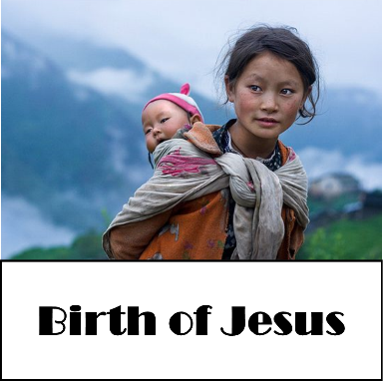
December 25, 2016
Devotion: Use this resource at home to guide your household’s daily devotions. You can do this alone or with others; in the morning, during the day, or at night. Find a routine that works best for you.

Pray: Light a candle and open your devotion time with a prayer.
This is the most holy of nights, O Lord. Gather us around our newborn savior, in awe and wonder at what you have done, and continue to do for us. For the sake of Jesus Christ, Amen.
Reflect: Reflect on the key verses from Sunday’s reading.
While they were there, the time came for her to deliver her child. And she gave birth to her firstborn son and wrapped him in bands of cloth, and laid him in a manger, because there was no place for them in the inn. Luke 2:6-7
Study: Study the reading and consider the background.
Away from home, and without proper lodging, a woman delivers a baby. Has this odd story of unconventional family, inconvenient birth, and unexpected rural visitors been so repeated that it loses some of its wonderful strangeness? Listen again—for the first time.
Consider: Consider this theme for the week’s text.
Jesus came for the whole human community.
Read: Read the following daily readings to deepen your understanding of Sunday’s text. After the reading, ask the follow-up questions.
Saturday, Birth of Jesus (Christmas Eve), Luke 2:1-14, [15-20]
Sunday: Shepherds Visit (Christmas Day), Luke 2:8-20
Monday: Isaiah Brings an Answer to Hezekiah’s Prayer, 2 Kings 19:20-34
Tuesday: The Sign of Immanuel, Isaiah 7:10-25
Wednesday: Compassion for the Repentant, Isaiah 57:14-21
Thursday: The Prayer for Renewal, Psalm 89:48
Friday: Exultant Response of the Captives, Isaiah 52:7-12
Saturday: Messiah’s Call and Commission, Isaiah 49:1-7
How is Jesus’ birth a fulfillment of Old Testament prophecies?
Connect: Connect in conversation with others in your household. Discuss the following questions, or simply check in with “Highs” and “Lows.”
What was a high point of your day? What was a low point?

What is it about babies that brings out the best in us? How do babies evoke faith, hope, and love?
What are you waiting for? What might you do while you wait to make the waiting less agonizing?
Do: By acting on what we learn we make God’s word come alive. Do the following activity this week. Before you open gifts in the morning, share with your friends or family the story of Jesus’ birth as you know it. Listen to the telling as others share it. What are the similarities? What are the differences? What does the telling of Jesus’ birth story say about the person sharing it?
Bless: Close your devotion with a blessing.
May God bless you with abundant gifts, both tangible and intangible. Amen.
Mission
Paraguay Missionaries – The Kevin & Rebekah Howell family
Bolivia Missionaries – Paul and Jay Mikaelson

Prayer Concerns
Prayer Matters! Please take your bulletin home and pray for those listed.
Prayer concerns are listed for one month.
Pray for: | Submitted by: | Pray for: | Submitted by:
Warren Mitchell | Cole Family | Diana Adkins | B Hennen
Vonna Ledeboer | A Ledeboer | Jill Revolinski | C Mallek
Family of  Red Fostvedt | Pastor Matt | Greg & Evelyn Rosenow | Teeny Kadelbach
Leslie Sagedahl | Daren Sagedahl | Caryn Jandl | Karen Barta
Joe Besledahl | Mattie family | Pat Aalderks | Pastor Matt
Abbie McGregor | A & H Thompson | Family of LaVone Wurm | Pastor Matt
Carol Horrmann | Cindy Johnson | Carol Johnson | Ryan Johnson
Emergency/Pastoral Care-Please have a family member or friend notify the church. You may also request hospital staff to call on your behalf. Call day or night at 523-1574. Never feel as though you are bothering Pastor or the staff. We are here to serve as a comfort and as a resource.

Ushers needed for the 2017 church year.
The week of Dec. 25 – Jan. 1
Today Worship 9:00 am
Mon Library reserved 6-8 pm
Tues Men’s Bible Study 6:15/7:00 am
Wed No WOW 3:15
No Confirmation 6:30 pm
Thur No Breakfast Club
Sat No Worship
Sun Worship 9:00 am

Dates needed: January late service (2), April late service(2), September early services (2), October early services (2) and 1 ushers for January early service, May early service, August service, November early service. Please contact either Daren Sagedahl or the church office. Thank you for volunteering!!

DECEMBER VOLUNTEERS
Communion - 8:30 Keith Larson/10:30 Cindy Johnson
Altar Guild – Sue Malecek, Jenny Evenson & Kathy Slagter
Acolytes – Andrew Holland & Leif Hausken
Usher -8:30 – Keith Larson, Nate Bahl, Dave Lindquist & Sue Lindquist
10:30- Steve & Sue Altmann
JANUARY VOLUNTEERS
Communion – 8:30 - Bobbi Kopel/10:30 – Jon Hawkinson
Altar Guild – Ronda Berg & Tami Stovern
Acolytes – Noah Boen & Ben Whited
Usher – 8:30 – Greg Mertens, Trey Mertens, Bill Kopel
10:30 – VOLUNTEERS NEEDED

COMMUNITY BOARD
CHECK THE EAST BULLETIN BOARD for more information /details

Fairview Place Independent Senior Housing Apartment Openings: Why worry about snow removal this winter: Fairview Place in Olivia currently has one and two bedroom apartments available, if you are interested or would like to set up a time to come and check us out please give Jenny a call at 320-523-1836.
Confirmation Suppers. Would you consider working with a friend/family to prepare and serve a simple meal to our confirmation student on Wed nights? Approximately 25 kids roll in after school activities…hungry for supper and for time spent with Pastor and the small group leaders! The meal is served from 5:45 to 6:20. The confirmation parents are the first to volunteer, but there are more class dates than families. Sign-up sheet are on the BOARD.
Dates with openings: Jan. 4, 18, 25, Feb. 1, 8, 15 and 22

Reformation Events:
January: MIA Luther Exhibit on January 6th at 6:00 pm Cost of ticket is $12.00 per person. Tickets available from Pastor Matt or sign up on The Board.
Check out the calendars on the table by youth board. A great way to get a wonderful calendar and help with the sign fundraising!!! (Thank you Dr. Buhr)

Quilters will start the 1st Thursday in January at 9:00 am

Come and go open house baby shower for Sara Benson to be held Saturday, January 21, 2017, from 9:30-11:30 a.m. at Cross of Calvary Lutheran Church in Olivia. Sara and Mike are expecting a Baby Boy in February and are registered at Target. Grandparents are Kenten & Joyce Damhof and Jeff & Sandy Benson
Cross of Calvary Lutheran Church
1103 W. Chestnut Ave. Olivia, MN 56277 320-523-1574

December 25, 2016
Weekly Announcements
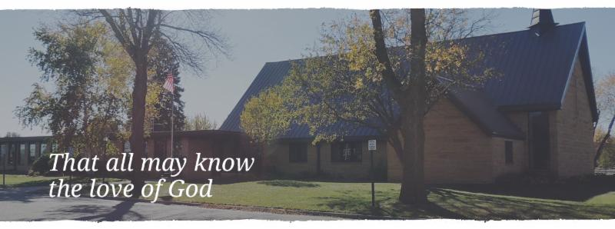

Cross of Calvary is the ELCA church in Olivia. We are an intergenerational (fancy word for young and old) community that follows Jesus out the building to where we live. We are all learners (disciples) here. This is a safe place to practice worship. And, believe us, it takes practice. Your questions, critical thinking, doubts and imperfect lives are welcome here.
Holy Communion
Holy Communion is open to all who are baptized and trust that Christ is present in the meal, regardless of your tradition or affiliation. Wine (red)/grape juice (white).
Participation
Bold type means all of us read or pray together. Out loud. * Please stand as you are able.
Children in Church
They belong here! They are hearing God’s Word, music and prayers. We don’t mind fidgeting and chatter! If you like, there are activity bags available in the entry.
Announcements
They are as printed or any new information please give to Pastor Matt prior to worship, please hand a note to Pastor with any announcements, including prayer requests.
Restrooms
They are located in the hallway to the left of the stairs. Changing table located in the Women’s bathroom.

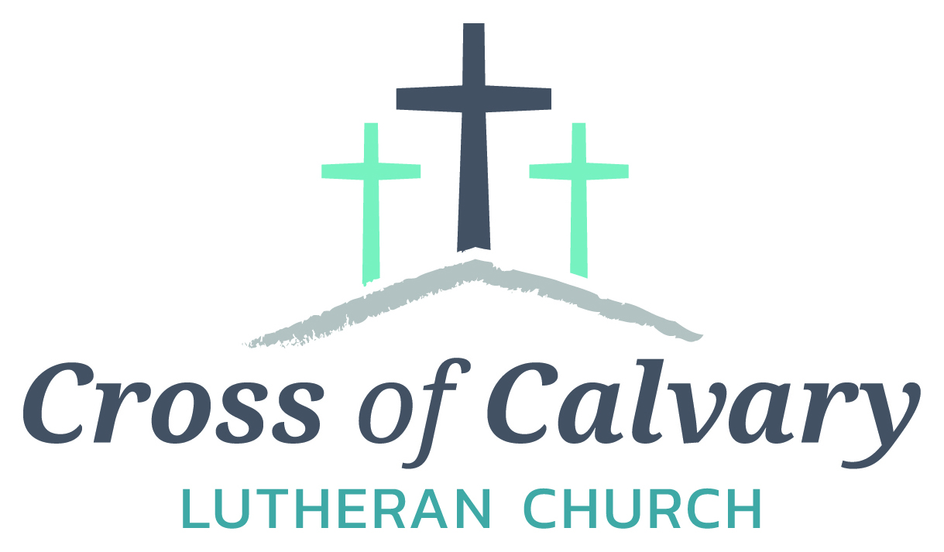
WorshipTimes
Saturdays: 5:30 pm
Sundays: 8:30 & 10:30
Coffee Hour
Sunday at 9:30 am
Sunday School
Sunday at 9:30 am
Building Hours
Mon-Thurs 8:30-7:00
Fri-Sun 8:30-2:00
Our Mission
That all may know the love of God

Matt Hausken
Pastor
hauskenmatt8@gmail.com
Ashley Schmidt
Minister of Faith Formation
cofcyouth@gmail.com
Sue Altmann
Office Administrator
crossofcalvary@gmail.com
________________
320-523-1574
Web:crossofcalvay.net
Online giving is now available. Go to website listed above.
Coming up in December
28 No Confirmation or WOW
29 No Breakfast Club
31 No Saturday service
WOW & Confirmation resume on Jan.4th
January 1 – Service at 9:00 am only
January 5 - Quilters begin at 9:00 am

Annual Congregational Meeting
January 22, 2017 at 9:30 am
(Alternate date: 1/29/2017)
-please submit any reports for annual booklet by
January 13th!

KOLV programming
As of January 1st KOLV will no longer be broadcasting Sunday service from Cross of Calvary church.

Opportunity to Serve
Cross of Calvary is accepting applications for the position of Minister of Faith Formation (currently filled by Ashley Schmidt). Please submit applications and any additional office or drop box outside the office door. Any questions regarding the position or process may be directed to Eric Skeie, President of the congregation.

2017 Envelopes are in the mailboxes, stop in the office if you have any question. Extra envelopes are on the shelf.
GOOD GIFTS DONATIONS
Thank you! The money will go towards a farm for a family in need!!!
Given By: | In MEMORY of
David Torgelson | John Torgelson
Ron and Linda Fahse | Joni Erickson
Edith Vogt | Loved Ones
Keith and Stacey Larson | Paul and Mark Vogt; Mildred Larson
Mark & Sonia Grasmon | Delmer & Lydia Buerkle; Marv & Alvina Beckman: Marnold Ostby
Steve, Sue, Chloe & Lanie Altmann | Paige Altmann & Del Altmann
Barb Hausken | Terje Hausken

Given By: | In HONOR of
Doug and Kristi O’Neill | Barry O’Neill
Stacey & Keith Larson | Eva, Hanna and Cam Larson
Stan and Sue Malecek | Our grandchildren
Duane & Karen Flom | Tyler & Gavin Flom; Gabriel & Elijah Suess

Donation Given By:
Dennis & Karen Barta
Rosalie Sheggeby

