The Follower
January 2017
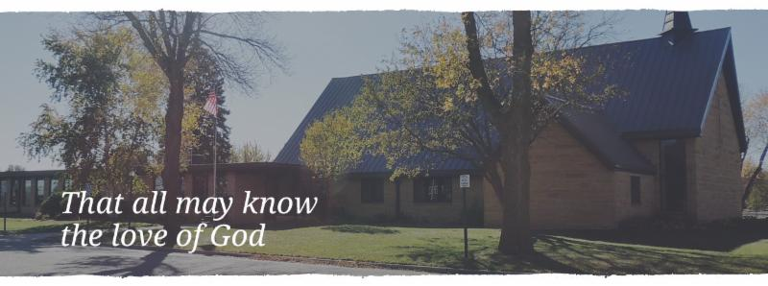

Annual Congregational Meeting
January 22, 2017 at 9:30 am
(Alternate date: 1/29/2017)
-please submit any reports for annual booklet by January 13th!

²²The steadfast love of the LORD never ceases, his mercies never come to an end: ²³ they are new every morning: great is your faithfulness. ²⁴ “The LORD is my portion, “says my soul, “Therefore I will hope in him.”
Lamentations 3: 22-24

PASTOR’S CORNER

Happy New Year!

We begin the new year with the joy of a new born savior! It is our hope the joy of what has been given to us will last throughout the year, through our highs and lows. We now enter into the season of Epiphany and what it tells us is essential to keeping the joy of Christmas in our hearts and minds all year long.

Epiphany begins on January 6th. It commemorates the arrival of the wise men to see the Christ Child. We remember that they were guided by the star to the place where Christ was. The word epiphany literally means “to reveal”, and we remember that the wise men had Christ revealed to them. It was a gift given to them. They would have had no other way to encounter Christ other than through this revelation that was given to them.

We to have Christ revealed to us as a gift. Whether it was through the voice of a parent or grandparent growing up or a friend inviting us to a bible study, the way we encounter Christ is a gift. Thanks be to God!

But, this revealing is not a one-time event. Christ is constantly making himself known to us every single day. The ability to see his presence is a gift from God! Thanks be to God! As we grow in faith we begin noticing Christ in everyday life. We need help from our brothers and sisters in Christ from time to time. But, whenever it happens it is a gift that strengthens our faith. There are the obvious ways we can encounter Christ—worship, bible study, the Lord ’s Supper. However, there are the not so obvious ways that once we name them we begin to see them—the rising of the sun, the comforting word spoken by a friend, the joyful gathering of friends and family, the birth of a child, and the list can go on.

So, this Epiphany, let us make a resolution to point out where we have experienced Christ with those around us and give thanks for these gifts of God continually revealing his Son to us!

Blessings for a grace filled 2017!!!!!

In Christ

Pastor Matt

PRAYERS OF HEALING AND STRENGTH

Prayer for: Submitted by:
Vonna Ledeboer A. Ledeboer
Diana Adkins B. Hennen
Jill Revolinski C. Mallak
Greg & Evelyn Rosenow T. Kadelbach
Lesley Sagedahl................................................................................................................Daren Sagedahl
Caryn Jandl...........................................................................................................................Karen Barta
Abbie McGregor ..........................................................................................Aaron & Heather Thompson
Pat Aalderks…..………………………………………………………………………………………………………..Pastor Matt
JANUARY VOLUNTEERS
COMMUNION 8:30 – Bobbi Kopel, 10:30 – Jon Hawkinson
USHERS 8:30 – Greg Mertens, Trey Mertens, Bill Kopel
10:30 – - VOLUNTEERS NEEDED
ACOLYTES: Noah Boen & Ben Whited
ALTAR GUILD: Ronda Berg & Tami Stovern

Renville County Food Shelf: The food shelf is low on dollars that are used for fresh produce. Area churches will be taking turns each month for collecting funds. Lutheran churches have the months of February and June. All churches have the months of November and March!
Any contributions will be greatly appreciated!!

Opportunity to Serve
***Minister of Faith Formation***
Cross of Calvary is accepting applications for the position of Minister of Faith Formation (currently filled by Ashley Schmidt). Please submit applications and any additional information in an envelope to the church office or drop box outside the office door. Any questions regarding the position or process may be directed to Eric Skeie, President of the congregation.

Confirmation Suppers. Would you consider working with a friend/family to prepare and serve a simple meal to our confirmation student on Wed nights? Approximately 25 kids roll in after school activities…hungry for supper and for time spent with Pastor and the small group leaders! The meal is served from 5:45 to 6:20. The confirmation parents are the first to volunteer, but there are more class dates than families. Sign-up sheet are on the BOARD. Dates with openings: Jan. 4, 18, 25, Feb. 1, 8, 15 and 22
Reformation Events:
January: MIA Luther Exhibit on January 6th at 6:00 pm Cost of ticket is $12.00 per person. Tickets available from Pastor Matt or sign up on The Board.

Quilters will start the 1st Thursday in January at 9:00 am
Breakfast Club
Thursday – 7:07am
Grades 9-12
Confirmation
Wednesday
Meal at 5:45pm
Class at 6:30-7:30pm
WOW
Wed. – 3:15-5:00pm
Grades 1-6
Sunday School
Sun. – 9:30-10:20am
3 year old – Grade 9

Youth Programs resume on January 4
January 8
Sunday School Christmas Program

January Birthdays
01/02 Allen Ledeboer 01/09 Hunter Evenson 01/20 Cade Morse
01/02 Alan Kircher 01/09 Haeden Honzay 01/20 Ella Jo Mages
01/02 Connor Weber 01/11 Breanna Balderston 01/21 Abby Steffel
01/03 Tom Revier 01/11 Jessica Altmann 01/21 Devin Nere
01/04 Shane Malvin 01/12 Stephanie Wallert 01/21 Martin Mittelstadt
01/04 McKenna Lilja 01/13 Bethel Fahse 01/22 Dennis Barta
01/04 Landon Robideau 01/14 Christel Enstad 01/22 Pamela Dettmann
01/04 Emma Dahl 01/16 Faye Johnson 01/23 Taylor Sagedahl
01/05 Matt Holland 01/16 Sandy Balderston 01/24 Nancy Mages
01/05 Henry Helin 01/17 Nancy Berry 01/24 Julie Slaughter
01/06 Michelle Jensen 01/17 Rebecca Thiesse 01/25 Kathie Zimmer
01/07 John Balgaard 01/17 John Morse 01/25 Brian Klinghagen
01/07 Sara Wussow 01/17 Avery Kopel 01/26 Bob Honzay
01/07 Krista Nelson 01/18 Doug Knudsen 01/27 Duane Senger
01/08 Myra Lindquist 01/18 Heidi Gross 01/27 Cameron Larson
01/08 Becky Nelson 01/18 Sara Benson 01/28 Jazlynn Cluka
01/08 Alex Gay 01/19 Cheryl Mallak 01/29 Elaine Livingood
01/08 Elsa Skeie 01/19 Jason Dobmeier 01/30 Hank Larson
01/19 Logan Triplett 01/31 Sandy Gay
01/31 Tim Kopel
01/31 Travis Honzay
GOOD GIFTS DONATIONS
Thank you! The money will go towards a farm for a family in need!!!
Given By: | In MEMORY of
David Torgelson | John Torgelson
Ron and Linda Fahse | Joni Erickson
Edith Vogt | Loved Ones
Keith and Stacey Larson | Paul and Mark Vogt; Mildred Larson
Mark & Sonia Grasmon | Delmer & Lydia Buerkle; Marv & Alvina Beckman: Marnold Ostby
Steve, Sue, Chloe & Lanie Altmann | Paige Altmann & Del Altmann
Barb Hausken | Terje Hausken

Given By: | In HONOR of
Doug and Kristi O’Neill | Barry O’Neill
Stacey & Keith Larson | Eva, Hanna and Cam Larson
Stan and Sue Malecek | Our grandchildren
Duane & Karen Flom | Tyler & Gavin Flom; Gabriel & Elijah Suess
Donation Given By:
Dennis & Karen Barta
Rosalie Sheggeby

Fundraising for the new sign at
Cross of Calvary on Highway #71
The goal is to fill all the letters on the picture below; each letter represents a $1,000.
Estimated cost: $28,500.00

WOW, only $7,000 left.
Thank you and keep it coming!!

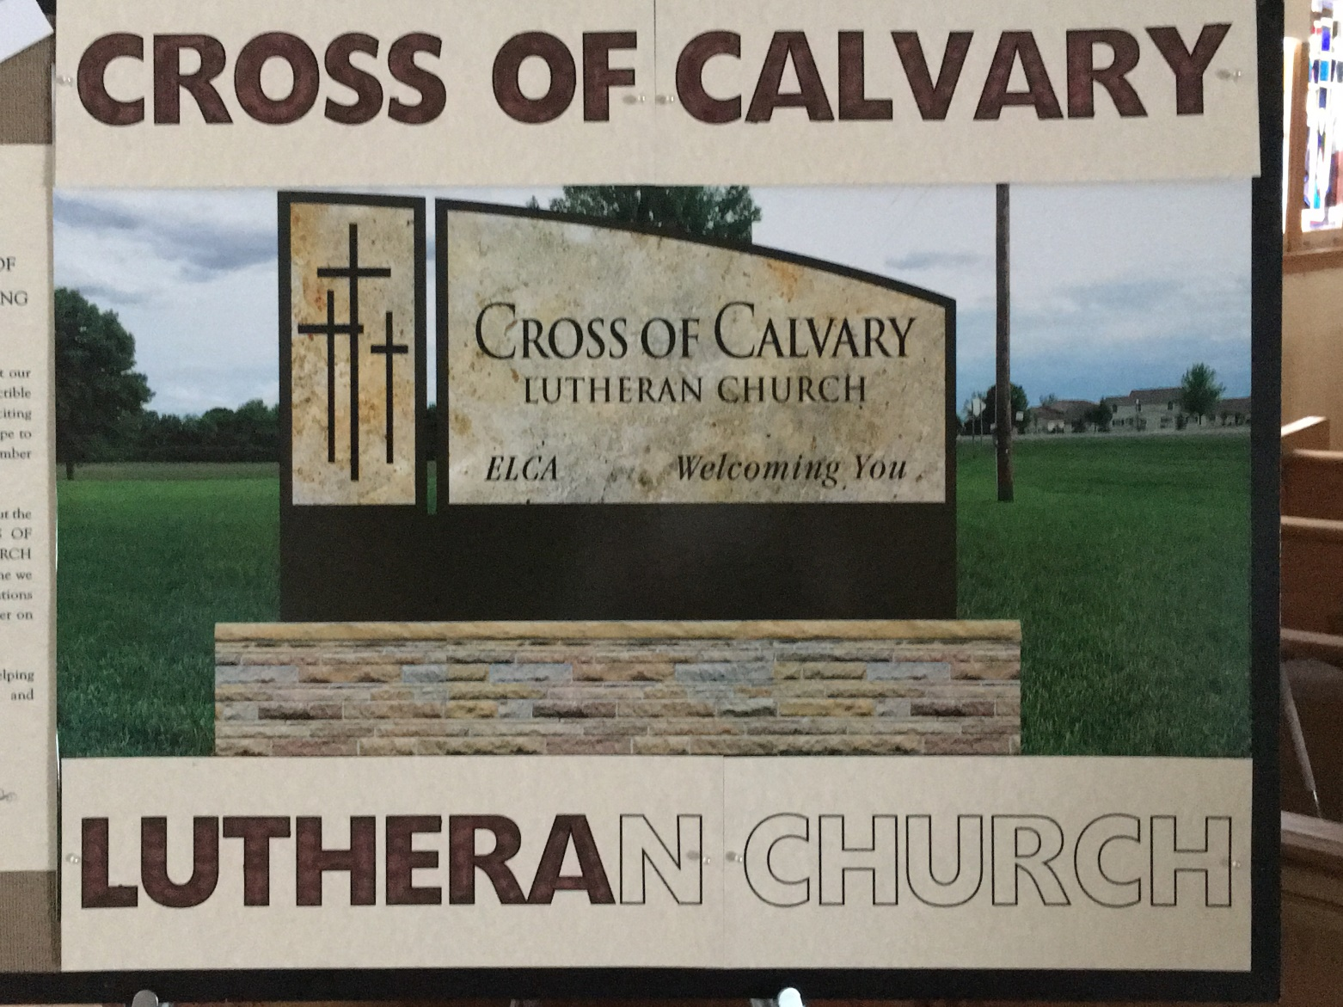
Cross of Calvary Lutheran Church COUNCIL MEETING
Minutes for: Wednesday, December 21, 2016 @ 7:30pm

COUNCIL MEMBERS

(X) Aaron Thompson 2017* (X) Jon Hawkinson 2018 (X) Eric Skeie 2019*
(X) Keith Larson 2017* (X) Bobbi Kopel 2018 (X) Natasha Johnson 2019*
(X) Cindy Johnson 2017* (_) Paul Buhr 2019 (X) Michelle Jensen 2019*
(X) DeeAnne Newville 2017 (X) Gordon Blem 2019
(X) Steve Altmann 2018 Terms end at Annual Meeting (Jan.) *Second term
STAFF
(X) Pastor Matt Hausken ( ) Minister of Faith Formation (X) Sue Altmann, Council Recorder

AGENDA
- Meeting called to order- President Eric Skeie
- Devotions – Jon Hawkinson
- Approve minutes of the November meeting – Motion to approve the minutes by Steve, seconded by Keith, motion passed.
- Financial Secretary and Treasurer Reports –November - Motion to approve the treasurer/secretary report by Gordy, seconded by Michelle, motion passed.
- Pastor’s report
- Committee has 3 resumes for the Minister of Faith Formation; they plan on conducting interviews soon.
- Confirmation is going along beautifully. Resume on January 4th.
- MIA is set for January 6th.
- January 8th there will be a Missionary speaking on Food for the Poor Inc., he is from Florida. The church will provide lodging and a meal. (Sheep Shedde Inn/Max’s Grill)
- Minister of Faith Formation’s report
- Everything is working out fine, many great volunteers helping with WOW, etc.

COMMITTEE REPORTS AND RECOMMENDATIONS
(requesting annual reports from all committees by the 1st week in January, by email)
1. Youth Ministry- none
2. Equipping the Congregation - none
3. Outreach – none
4. Administration – There was a leak in the roof of the church, lasted one day. The roofing company has been called and they will be coming
to take a look. Also, the parsonage needs new shingles. A line item will be put in the budget to cover this cost.
5. AED Maintence – Eric checked.
OLD BUSINESS
- Update on dollar amount for new sign - $14,330.00
(as of 12/20/16) a $7,000 donation was made by the Snowflake Bazaar, which now makes the total $21,330.00 – Council asked that a thank you be given the committee. The council is happy with the progress of the funds raised for the sign.
- Bennett: service agreement ends in February. Rate now: average about 8,500 pages monthly (current cost is $.0075 per page) Proposal: Under Bennett service rate schedule, at year four the rate would normally have increased, and once again at year six. What Bennett would do if we kept this current machine, is to put the rate where it would have normally been at year six, which is $.0125/page. Bennett would continue to cover toner, parts, labor, mileage and consumables as they have previously, with the exception of discontinued parts as before. Of course, CofC is likely to experience more downtime with an older machine as it ages out, as compared to the suggested new device. And if something happens and the needed parts are no longer available, then CofC is in the situation of having to make a hurried decision under pressure.
- There will be a line item in next year’s budget for a copy machine, it is there only if need. The church will not be buying a new machine at this time.
NEW BUSINESS
- January Reformation will be the MIA on Jan. 6th
- Master Gardeners would like to feature Prayer Garden on the tour in June 2017 (approval needed) Jon made a motion and Cindy seconded, motion passed.
- Update on Prayer Garden sign from DeeAnne Newville – Pastor Matt will be contacting the people with their name on the sign and get the okay to use their name on the sign.
- KOLV programming, no longer airing Sunday Services
- Approve the designation of $1500 of pastor’s 2017 as a furnishings allowance. Gordy made a motion for the $1500 to be designated for furnishings, Aaron seconded. Motion passed.
Next Council meeting: Wednesday, January 18 at 7:30 pm
January Communion: 8:30 - Bobbi, 10:30 - Jon
January Devotions – Bobbi

Adjourn / Close in prayer.

