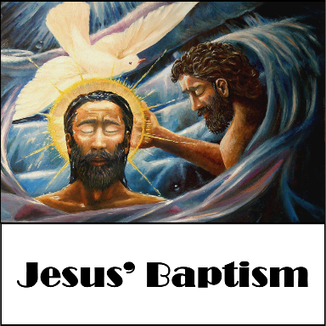
January 8, 2017
Devotion: Use this resource at home to guide your household’s daily devotions. You can do this alone or with others; in the morning, during the day, or at night. Find a routine that works best for you.

Pray: Light a candle and open your devotion time with a prayer.

Hear us, O Lord,
Your axe lies at the foot of the trees. May we bear good fruit and good news to all the people, in the name of Jesus Christ your Son, Amen.

Reflect: Reflect on the key verses from Sunday’s reading.

Now when all the people were baptized, and when Jesus also had been baptized and was praying, the heaven was opened, and the Holy Spirit descended upon him in bodily form like a dove. And a voice came from heaven, “You are my Son, the Beloved; with you I am well pleased.” Luke 3:21-22
Study: Study the reading and consider the background.
John the Baptizer has undeniable charisma. But be careful – if you ask him a question, you might not like the answer. John’s proclamation is the radical inbreaking of God’s kingdom on earth, and one that calls for a radical response.
Consider: Consider this theme for the week’s text.

There is no quick fix for this world; God’s kingdom is made well slowly, one right move at a time.

Read: Read the following daily readings to deepen your understanding of Sunday’s text. After the reading, ask the follow-up questions.
Sunday: Jesus’ Baptism (Baptism of Our Lord), Luke 3:1-22
Monday: Genealogy of Jesus, Luke 3:23-38
Tuesday: Jesus is Tempted in the Wilderness, Luke 4:1-13
Wednesday: Comfort, O Comfort My People, Isaiah 40:1-11
Thursday: God Will Restore Jerusalem, Isaiah 52:1-12
Friday: Elijah’s Flight, 1 Kings 19:1-9a
Saturday: Hear, O Israel, Deuteronomy 6:4-15
What promises from Israel’s history does Jesus come to fulfill?
Connect: Connect in conversation with others in your household. Discuss the following questions, or simply check in with “Highs” and “Lows.”

What was a high point of your day? What was a low point?
How has your lifestyle contributed to the institutionalization of oppression?
Does your baptism inform your actions and behaviors? If so, then how? If not, why not?
Do: By acting on what we learn we make God’s word come alive. Do the following activity this week.

Take the survey at http://slaveryfootprint.org to discover how many slaves your lifestyle employs. Make one change this week to lower your slavery footprint.

Bless: Close your devotion with a blessing.

You are God’s child, God’s beloved. With you God is well pleased. Amen.

Mission
Paraguay Missionaries
The Kevin & Rebekah Howell family

Bolivia Missionaries
Paul and Jay Mikaelson

Confirmation pictures are in, stop in the office.

Prayer Concerns
Prayer Matters! Please take your bulletin home and pray for those listed.
Prayer concerns are listed for one month.
Pray for: | Submitted by: | Pray for: | Submitted by:
 |  | Diana Adkins | B Hennen
Vonna Ledeboer | A Ledeboer | Jill Revolinski | C Mallek
Jenna Reynolds | Sue & Stan Malecek | Greg & Evelyn Rosenow | Teeny Kadelbach
Leslie Sagedahl | Daren Sagedahl | Caryn Jandl | Karen Barta
Emergency/Pastoral Care-Please have a family member or friend notify the church. You may also request hospital staff to call on your behalf. Call day or night at 523-1574. Never feel as though you are bothering Pastor or the staff. We are here to serve as a comfort and as a resource.

Ushers needed for the 2017 church year.
Dates needed: January late service (2), April late
service (2), September early services (2), October early services (2) and 1 ushers for January early service, May early service, August service, November early service. Please contact either Daren Sagedahl or the church office. Thank you for volunteering!!
The week of Jan. 8 – Jan. 15
Today Worship 8:30 & 10:30 am
Sunday School Program 10:30 am
Mon Library reserved 6-8 pm
FH reserved Boy Scouts 6-8 pm
Tues Men’s Bible Study 6:15/7:00 am
Wed WOW 3:15
Confirmation 6:30 pm
Thur Breakfast Club
Fri Annual Reports due by EOD
Sat Worship 5:30 pm
Sun Worship 8:30 am & 10:30 am

Office will be closed January 26 - January 30, 2017.

JANUARY VOLUNTEERS
Communion – 8:30 - Bobbi Kopel/10:30 – Jon Hawkinson
Altar Guild – Ronda Berg & Tami Stovern
Acolytes – Noah Boen & Ben Whited
Usher – 8:30 – Greg Mertens, Trey Mertens, Bill Kopel
10:30 – VOLUNTEERS NEEDED

COMMUNITY BOARD
CHECK THE EAST BULLETIN BOARD for more information /details

Confirmation Suppers. Would you consider working with a friend/family to prepare and serve a simple meal to our confirmation student on Wed nights? Approximately 25 kids roll in after school activities…hungry for supper and for time spent with Pastor and the small group leaders! The meal is served from 5:45 to 6:20. The confirmation parents are the first to volunteer, but there are more class dates than families. Sign-up sheet are on the BOARD.
Dates with openings: Jan. 18, 25, Feb. 1, 8, 15 and 2

Check out the calendars on the table by youth board. A great way to get a wonderful calendar and help with the sign fundraising!!! (Thank you Dr. Buhr)

Come and go open house baby shower for Sara Benson to be held Saturday, January 21, 2017, from 9:30-11:30 a.m. at Cross of Calvary Lutheran Church in Olivia. Sara and Mike are expecting a Baby Boy in February and are registered at Target. Grandparents are Kenten & Joyce Damhof and Jeff & Sandy Benson

Dana Boen is teaching a chair exercise class 2 times a week at Tula, located in downtown Olivia. If you have joint issues, or problems with balance, this would be a great way to get some exercise! Just contact Dana at 320-894-7885 for prices and times the class is offered, or if you just have any questions.

Super Bowl of Caring Sunday will be coming soon on February 5th. Remember to start saving your change (coins). The Youth will be collecting on Sunday, February 5th. Thank you!!!

February is Food Shelf month for ALL Lutherans. Cross of Calvary will be collecting food shelf items the month of February. Please bring any items you would like to donate (money is also an option, please place in a sealed envelope and mark Food Shelf) and place them in the shopping cart in the Narthex. Thank You!!!!

Cross of Calvary Lutheran Church
1103 W. Chestnut Ave. Olivia, MN 56277 320-523-1574

January 8, 2017
Weekly Announcements
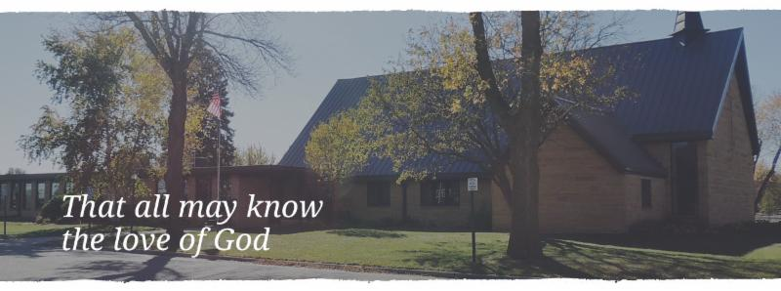

Cross of Calvary is the ELCA church in Olivia. We are an intergenerational (fancy word for young and old) community that follows Jesus out the building to where we live. We are all learners (disciples) here. This is a safe place to practice worship. And, believe us, it takes practice. Your questions, critical thinking, doubts and imperfect lives are welcome here.
Holy Communion
Holy Communion is open to all who are baptized and trust that Christ is present in the meal, regardless of your tradition or affiliation. Wine (red)/grape juice (white).
Participation
Bold type means all of us read or pray together. Out loud. * Please stand as you are able.
Children in Church
They belong here! They are hearing God’s Word, music and prayers. We don’t mind fidgeting and chatter! If you like, there are activity bags available in the entry.
Announcements
They are as printed or any new information please give to Pastor Matt prior to worship, please hand a note to Pastor with any announcements, including prayer requests.
Restrooms
They are located in the hallway to the left of the stairs. Changing table located in the Women’s bathroom.

Pastor Matt and Sarah (and boys) would like to thank everyone who gave a card or gift this holiday season. It is greatly appreciated.
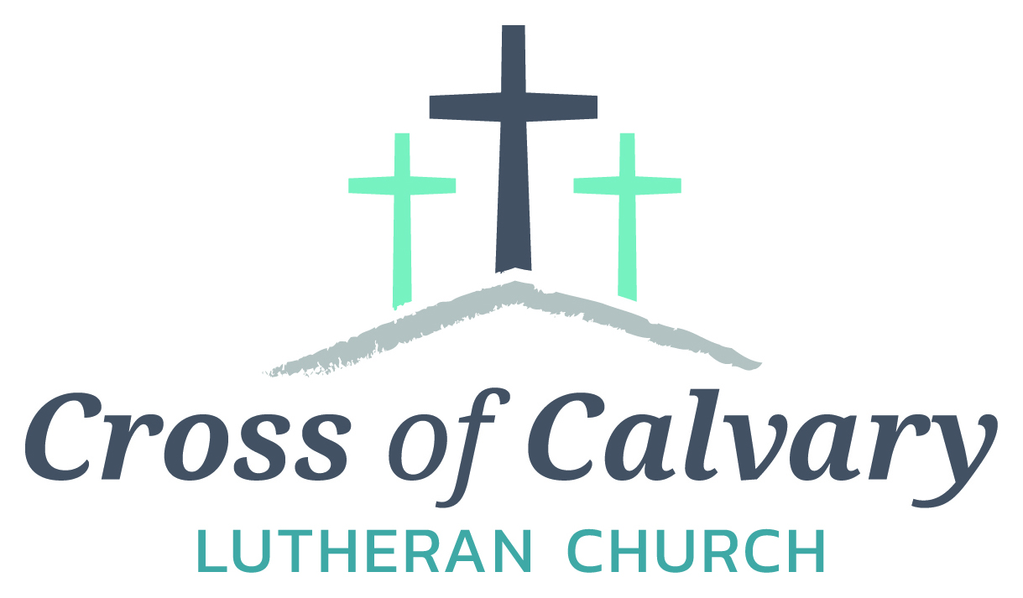
WorshipTimes
Saturdays: 5:30 pm
Sundays: 8:30 & 10:30
Coffee Hour
Sunday at 9:30 am
Sunday School
Sunday at 9:30 am
Building Hours
Mon-Thurs 8:30-7:00
Fri-Sun 8:30-2:00
Our Mission
That all may know the love of God

Matt Hausken
Pastor
hauskenmatt8@gmail.com
Ashley Schmidt
Minister of Faith Formation
cofcyouth@gmail.com
Sue Altmann
Office Administrator
crossofcalvary@gmail.com
________________
320-523-1574
Web:crossofcalvay.net
Online giving is now available. Go to website listed above.
Coming up in January
January 8 – Sunday School Program at 10:30 am service
January 13 – Annual Reports due to office
January 16 – Follower information deadline
January 18 – Church Council Meeting at 7:30 am
January 21 – Baby Shower for Sara Benson
January 22- Annual Meeting at 9:30 am

Annual Congregational Meeting
January 22, 2017 at 9:30 am
(Alternate date: 1/29/2017)
-please submit any reports for annual booklet by
January 13th!

Opportunity to Serve
Cross of Calvary is accepting applications for the position of Minister of Faith Formation (currently filled by Ashley Schmidt). Please submit applications and any additional office or drop box outside the office door. Any questions regarding the position or process may be directed to Eric Skeie, President of the congregation.
2016 Giving Statements will be distributed on January 9 and many of you will find them in a sealed enveloped in your mailbox just outside the church library. The remaining will be mailed. Please contact Sue if you have not received one by Sunday, January 24.
I’m writing to make sure everyone is getting ready for the Annual Meeting which will be held on Sunday, January 22nd. Since this is my first “behind the scenes” take on this meeting, I’m not as prepared as soon as I’d like to be, but soon enough to complete on time.

I need the following reports from the following committees:

Committee Review Reports
Parish Life
Evangelism
Parish Education
Property
Technology
Youth and Family Ministry
Missions
Worship and Music

Financial Reports
Financial Secretary
Altar Guild
Bazaar
Endowment Fund
Lutheran Church Men
Passing on the Faith
Church Women (W.E.L.C.A.)
Youth Account

I truly appreciate your cooperation in getting these reports to me by January 13th so that I have time to prepare the full packets. I would also appreciate it if whomever will be the responsible person for these reports, please email/call me so that I may be aware. That way if things come up, I’ll know who to go too directly.

Thank you so very much and I anxiously wait to hear from you all. Remember, preferred deadline – January 13th.

Thank you,

Sue Altmann
Office Administrator

Fundraising for the new sign at
Cross of Calvary on Highway #71
is marvelous!!!!!!
The goal is to fill all the letters on the picture below; each letter represents a $1,000.
Estimated cost: $28,500.00
WOW, only $7,000 left.
Thank you!!!!
