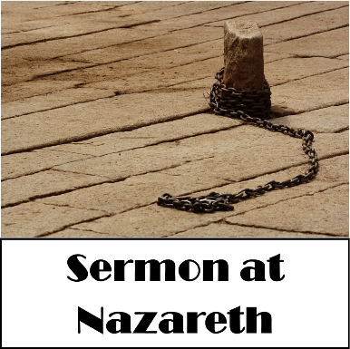
January 15, 2017
Devotion: Use this resource at home to guide your household’s daily devotions. You can do this alone or with others; in the morning, during the day, or at night. Find a routine that works best for you.

Pray: Light a candle and open your devotion time with a prayer.

Lord God,
You have fulfilled your word in the person of Jesus, your son. Gather us into your adopted family that his proclamation might be ours as well. In the name of Christ, Amen.

Reflect: Reflect on the key verses from Sunday’s reading.

And he said, “Truly I tell you, no prophet is accepted in the prophet’s hometown.”
Luke 4:24
Study: Study the reading and consider the background.
The boy from Nazareth has made good for himself, and now Jesus makes a rousing return to his childhood temple. But is his shocking brand of prophecy too much for the hometown crowd to handle? Joseph’s son is about to find out.
Consider: Consider this theme for the week’s text.

Prophetic words can be hard to hear.

Read: Read the following daily readings to deepen your understanding of Sunday’s text. After the reading, ask the follow-up questions.
Sunday: Sermon at Nazareth, Luke 4:14-30
Monday: Jesus Casts Out an Unclean Spirit, Luke 4:31-37
Tuesday: Jesus Heals Peter’s Mother-in-Law, Luke 4:38-39
Wednesday: Jesus Heals and Casts Out Demons, Luke 4:40-44
Thursday: The Spirit of the Lord, Isaiah 61:1-3
Friday: Elijah Helps a Widow, 1 Kings 17:8-16
Saturday: Elisha Heals Naaman, 2 Kings 5:1-14
How does Jesus’ ministry begin?

Connect: Connect in conversation with others in your household. Discuss the following questions, or simply check in with “Highs” and “Lows.”

What was a high point of your day? What was a low point?
Who are the outcasts in your community? How might you welcome and serve them?
When have you felt pressure to speak harsh or prophetic words to people you are close to? How were your words received? What, if anything, might you do differently the next time?
Do: By acting on what we learn we make God’s word come alive. Do the following activity this week.
View or read your regular news source throughout the week. Pay attention to the voices. Whose voice is speaking? Whose voice is being silenced?
Bless: Close your devotion with a blessing.
Speak your voice. Speak the voices of others. God hears you. Amen.
Mission
Paraguay Missionaries
The Kevin & Rebekah Howell family

Bolivia Missionaries
Paul and Jay Mikaelson

Confirmation pictures are in,
stop in the office and pick up your order.
Prayer Concerns
Prayer Matters! Please take your bulletin home and pray for those listed.
Prayer concerns are listed for one month.
Pray for: | Submitted by: | Pray for: | Submitted by:
Roger Schultes | Gordy & Lynette Blem | Diana Adkins | B Hennen
Vonna Ledeboer | A Ledeboer | Jill Revolinski | C Mallek
Jenna Reynolds | Sue & Stan Malecek | Greg & Evelyn Rosenow | Teeny Kadelbach
Leslie Sagedahl | Daren Sagedahl | Caryn Jandl | Karen Barta
Kent Kircher | Pastor Matt
Emergency/Pastoral Care-Please have a family member or friend notify the church. You may also request hospital staff to call on your behalf. Call day or night at 523-1574. Never feel as though you are bothering Pastor or the staff. We are here to serve as a comfort and as a resource.
Ushers needed for the 2017 church year.
Dates needed: January late service (2), April late service (2), September early services (2), October early services (2) and 1 ushers for January early service, May early service, August service, November early service. Please contact either Daren Sagedahl or the church office. Thank you for volunteering!!
The week of Jan. 15 – Jan.22
Today Worship 8:30 & 10:30 am
Mon Library reserved 6-8 pm
Tues Men’s Bible Study 6:15/7:00 am
Wed WOW 3:15
Confirmation 6:30 pm
Church Council Mtg. 7:30 pm
Thur Breakfast Club
Sat Baby Shower, Sara Benson
Worship 5:30 pm
Sun Worship 8:30 am & 10:30 am
Annual Congregational Meeting 9:30 am

JANUARY VOLUNTEERS
Communion – 8:30 - Bobbi Kopel/10:30 – Jon Hawkinson
Altar Guild – Ronda Berg & Tami Stovern
Acolytes – Noah Boen & Ben Whited
Usher – 8:30 – Greg Mertens, Trey Mertens, Bill Kopel
10:30 – VOLUNTEERS NEEDED

COMMUNITY BOARD
CHECK THE EAST BULLETIN BOARD for more information /details

Pancake Breakfast: Sunday, January 22 at St. John Church, Hector. They will be serving from 9:30 – 12:30. Menu: Pancakes, French Toast, Ham & Eggs, Applesauce and Beverage.
Adult Grief Support Group beginning February 6, 2017 at the Redwood Area Hospital
The Catholic Diocese of New Ulm is hosting a prayer service for the Week of Prayer for Christian Unity on Sunday January 15 at 2:00 p.m. at the Church St. Boniface in Stewart. Please come to join Bishop John LeVoir, and representatives from several other denominations in praying for Christian unity. The prayer service will be followed by a time of fellowship and refreshments. All are invited to attend.

Confirmation Suppers. Would you consider working with a friend/family to prepare and serve a simple meal to our confirmation student on Wed nights? Approximately 25 kids roll in after school activities…hungry for supper and for time spent with Pastor and the small group leaders! The meal is served from 5:45 to 6:20. The confirmation parents are the first to volunteer, but there are more class dates than families. Sign-up sheet are on the BOARD.
Dates with openings: Jan. 18, 25, Feb. 1, 8, 15 and 2

Come and go open house baby shower for Sara Benson to be held Saturday, January 21, 2017, from 9:30-11:30 a.m. at Cross of Calvary Lutheran Church in Olivia. Sara and Mike are expecting a Baby Boy in February and are registered at Target. Grandparents are Kenten & Joyce Damhof and Jeff & Sandy Benson

Dana Boen is teaching a chair exercise class 2 times a week at Tula, located in downtown Olivia. If you have joint issues, or problems with balance, this would be a great way to get some exercise! Just contact Dana at 320-894-7885 for prices and times the class is offered, or if you just have any questions.

Super Bowl of Caring Sunday will be coming soon on February 5th. Remember to start saving your change (coins). The Youth will be collecting on Sunday, February 5th. Thank you!!!
Cross of Calvary Lutheran Church
1103 W. Chestnut Ave. Olivia, MN 56277 320-523-1574

January 15, 2017
Weekly Announcements
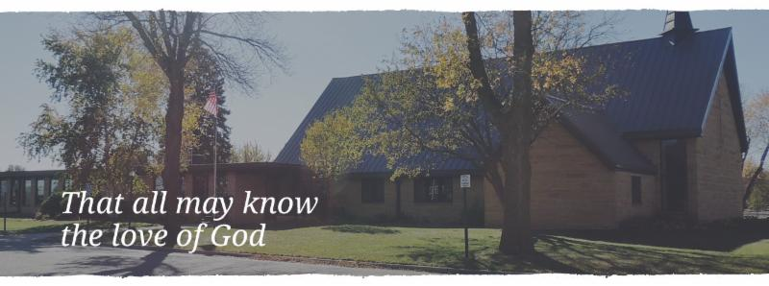

Cross of Calvary is the ELCA church in Olivia. We are an intergenerational (fancy word for young and old) community that follows Jesus out the building to where we live. We are all learners (disciples) here. This is a safe place to practice worship. And, believe us, it takes practice. Your questions, critical thinking, doubts and imperfect lives are welcome here.
Holy Communion
Holy Communion is open to all who are baptized and trust that Christ is present in the meal, regardless of your tradition or affiliation. Wine (red)/grape juice (white).
Participation
Bold type means all of us read or pray together. Out loud. * Please stand as you are able.
Children in Church
They belong here! They are hearing God’s Word, music and prayers. We don’t mind fidgeting and chatter! If you like, there are activity bags available in the entry.
Announcements
They are as printed or any new information please give to Pastor Matt prior to worship, please hand a note to Pastor with any announcements, including prayer requests.
Restrooms
They are located in the hallway to the left of the stairs. Changing table located in the Women’s bathroom.

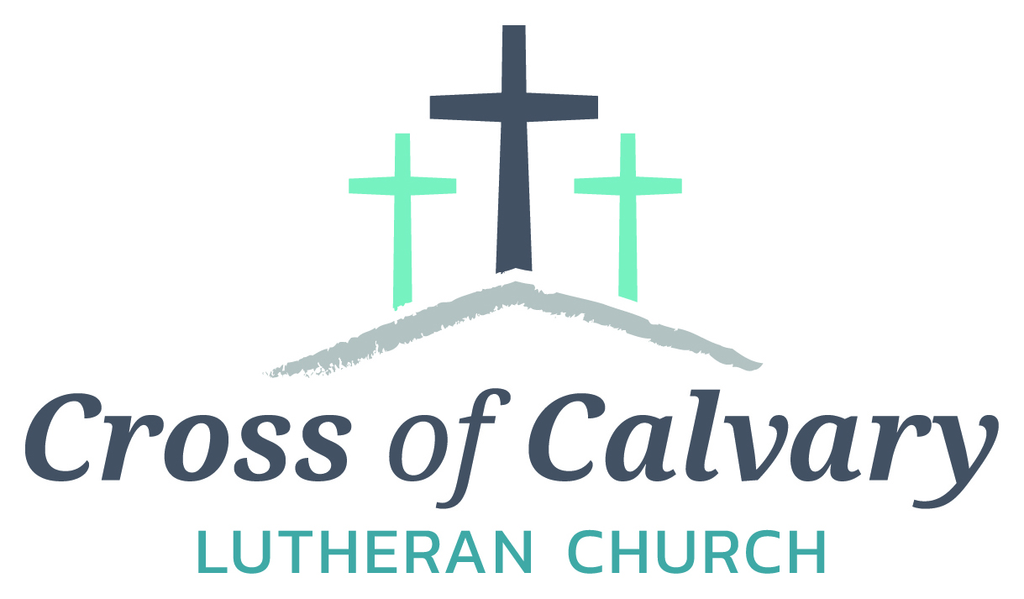
WorshipTimes
Saturdays: 5:30 pm
Sundays: 8:30 & 10:30
Coffee Hour
Sunday at 9:30 am
Sunday School
Sunday at 9:30 am
Building Hours
Mon-Thurs 8:30-7:00
Fri-Sun 8:30-2:00
Our Mission
That all may know the love of God

Matt Hausken
Pastor
hauskenmatt8@gmail.com
Ashley Schmidt
Minister of Faith Formation
cofcyouth@gmail.com
Sue Altmann
Office Administrator
crossofcalvary@gmail.com
________________
320-523-1574
Web:crossofcalvay.net
Online giving is now available. Go to website listed above.
Coming up in January
January 16 – Deadline for Follower notices
January 18 – Church Council Meeting at 7:30 am
January 21 – Baby Shower for Sara Benson
January 22- Annual Meeting at 9:30 am
January 23 – Ruth Bible Study at 1:30 at Parkview
January 26 – Dorcas Bible Study at 9:30 am
January 26-30 – Office Closed

Annual
Congregational
Meeting
January 22, 2017 at 9:30 am
(Alternate date: 1/29/2017)

Fundraising for the new sign at
Cross of Calvary on Highway #71
is going marvelously!!!!!!
The goal is to fill all the letters on the picture below; each letter represents a $1,000.
Estimated cost: $28,500.00
WOW: we are at $22,338.00 only $6,162.00 to go!!!
Just got the “N” filled in, hurray!!!
Thank you!!!!
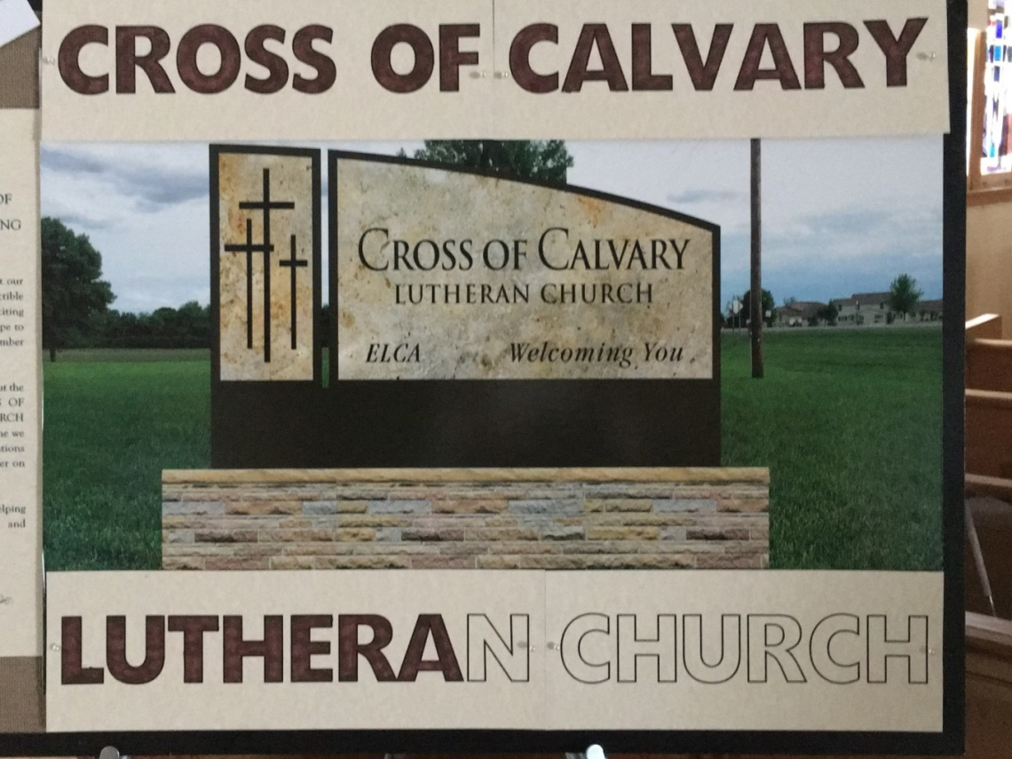
2016 Giving Statements have been distributed and many of you will find them in a sealed enveloped in your mailbox just outside the church library. The remaining will be mailed. Please contact Sue if you have not received one by Sunday, January 24, after the 24th all statements will be mailed.

Opportunity to Serve
Cross of Calvary is accepting applications for the position of Minister of Faith Formation (currently filled by Ashley Schmidt). Please submit applications and any additional office or drop box outside the office door. Any questions regarding the position or process may be directed to Eric Skeie, President of the congregation.

February is Food Shelf month for ALL Lutherans. Cross of Calvary will be collecting food shelf items the month of February. Please bring any items you would like to donate (money is also an option, please place in a sealed envelope and mark Food Shelf) and place them in the shopping cart in the Narthex. Thank You!!!!

