Super Bowl of Caring Sunday is TODAY!!!

The Youth will be collecting before and after the services.
Thank you!!!

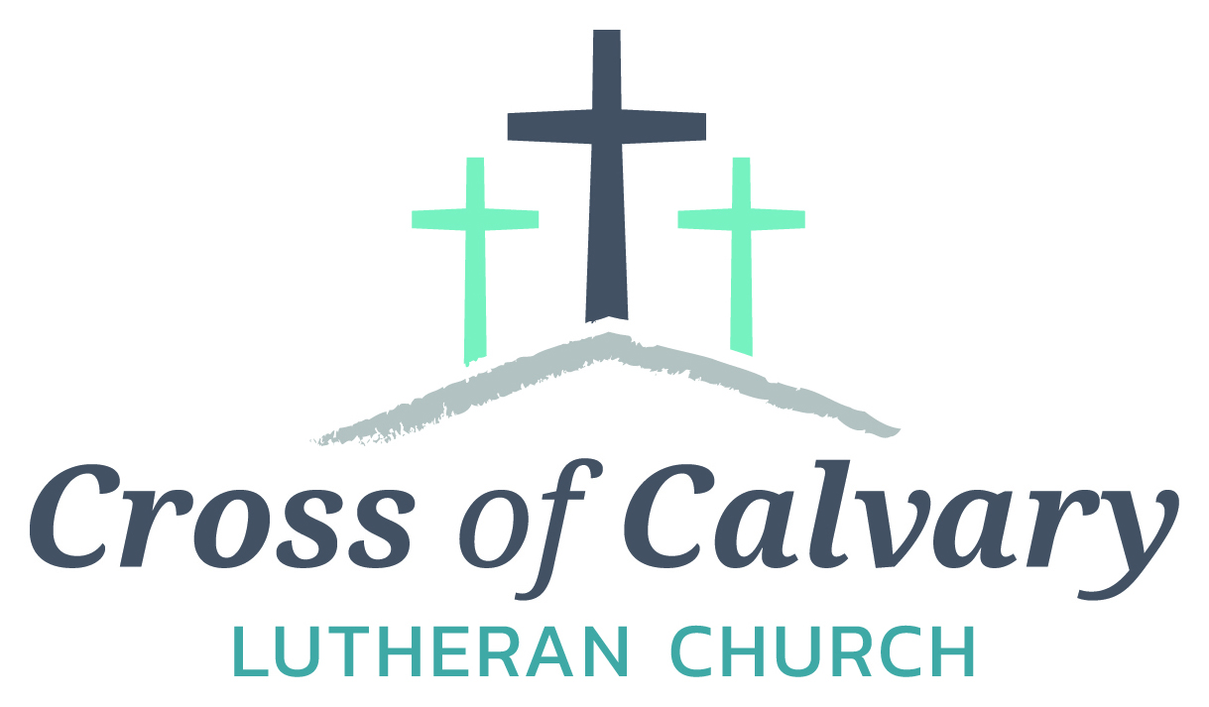
WorshipTimes
Saturdays: 5:30 pm
Sundays: 8:30 & 10:30
Coffee Hour
Sunday at 9:30 am
Sunday School
Sunday at 9:30 am
Building Hours
Mon-Thurs 8:30-7:00
Fri-Sun 8:30-2:00
Our Mission
That all may know the love of God

Matt Hausken
Pastor
hauskenmatt8@gmail.com

Minister of Faith Formation
cofcyouth@gmail.com
Sue Altmann
Office Administrator
crossofcalvary@gmail.com
________________
320-523-1574
Web:crossofcalvay.net
Online giving is now available. Go to website listed above.

Coming up in January/February
February 5 – Baptism
February 14 – Synod using Fellowship Hall & Kitchen for a meeting (9:00 – 10:30 am)
February 15 – Council Meeting at 7:30
February 23 – Dorcas Bible Study at 9:30
February 27 – Ruth Bible Study at 1:30

Prayer Concerns
Prayer Matters! Please take your bulletin home and pray for those listed.
Prayer concerns are listed for one month.
Pray for: | Submitted by: | Pray for: | Submitted by:
Roger Schultes | Gordy & Lynette Blem | Diana Adkins | B Hennen
Vonna Ledeboer | A Ledeboer | Jill Revolinski | C Mallek
Jenna Reynolds | Sue & Stan Malecek | Greg & Evelyn Rosenow | Teeny Kadelbach
Leslie Sagedahl | Daren Sagedahl | Caryn Jandl | Karen Barta
Kent Kircher | Pastor Matt | Warren Mitchell | Angela Cole
Emergency/Pastoral Care-Please have a family member or friend notify the church. You may also request hospital staff to call on your behalf. Call day or night at 523-1574. Never feel as though you are bothering Pastor or the staff. We are here to serve as a comfort and as a resource.

Ushers needed for the 2017 church year.
Dates needed: April late service (2), September early services (2), October early services (2) and 1 ushers for January early service, May early service, August service, November early service. Please contact either Daren Sagedahl or the church office. Thank you for volunteering!!
The week of Feb. 5 – Feb. 12
Today Worship 8:30 & 10:30 am
Baptism at 10:30 service
Mon Library reserved 6-8 pm
Tues Men’s Bible Study 6:15/7:00 am
Wed WOW 3:15
Confirmation 6:30 pm
Choir Practice
Thur Breakfast Club
Quilters
Fri
Sat Worship 5:30 pm
Sun Worship 8:30 am & 10:30 am

FEBRUARY VOLUNTEERS
Communion – 8:30 – Bobbi Kopel/10:30 – Eric Skeie
Altar Guild – Lynette Blem & Lowanda Frank
Acolytes – Ella Mages & Kya Young
Usher – 8:30 – Daren Sagedahl, Todd Gay, Brian Boen & Stan Malecek
10:30 – Corey Gluesing & Aaron Thompson
Thursday: Jesus Calms a Storm, Luke 8:22-25
Friday: Jesus Heals the Gerasene Demoniac, Luke 8:26-30
Saturday: Jesus Heals the Gerasene Demoniac, Luke 8:31-39
Why do you think Jesus taught and healed people?

Connect: Connect in conversation with others in your household. Discuss the following questions, or simply check in with “Highs” and “Lows.
What was a high point of your day? What was a low point?

Who in your community is in need to prayer and special care? What might you do to help?
What do you need from God? Can you pray for God’s help?

Do: By acting on what we learn we make God’s word come alive. Do the following activity this week.

Find out who in your community lives alone. Invite them for coffee.

Bless: Close your devotion with a blessing.

Receive God’s blessing when you are with people and when you are alone. Amen.
Mission
Paraguay Missionaries
The Kevin & Rebekah Howell family

Bolivia Missionaries
Paul and Jay Mikaelson

Confirmation pictures are in,
stop in the office and pick up your order.

February 5, 2017

Devotion: Use this resource at home to guide your household’s daily devotions. You can do this alone or with others; in the morning, during the day, or at night. Find a routine that works best for you.

Pray: Light a candle and open your devotion time with a prayer.
Holy Lord,
You hold the authority of heaven and earth in your hand. Look upon us kindly and grow our faith so that we would always know you as our loving teacher, provider, and example. In Jesus’ name, Amen.

Then he came forward and touched the bier, and the bearers stood still. And he said, “Young man, I say to you, rise!” The dead man sat up and began to speak, and Jesus gave him to his mother. Luke 7:14-15

Reflect: Reflect on the key verses from Sunday’s reading.

Study: Study the reading and consider the background.

Jesus is approaching superstar status. No longer are his fellow Jews the only ones putting their hopes on him, but now he is known throughout the region. And sometimes the faith of an outsider can surprise even Jesus.

Consider: Consider this theme for the week’s text.

Sometimes we might surprise Jesus with our faith.

Read: Read the following daily readings to deepen your understanding of Sunday’s text. After the reading, ask the follow-up questions.
Sunday: Raising the Widow’s Son, Luke 7:1-17
Monday: Jesus Speaks in Parables, Luke 8:4-10
Tuesday: Jesus Speaks in Parables, Luke 8:11-18
Wednesday: Jesus’ Mother and Brothers, Luke 8:19-21
COMMUNITY BOARD
CHECK THE EAST BULLETIN BOARD for more information /details

Adult Grief Support Group beginning February 6, 2017 at the Redwood Area Hospital

Confirmation Suppers. Would you consider working with a friend/family to prepare and serve a simple meal to our confirmation student on Wed nights? Approximately 25 kids roll in after school activities…hungry for supper and for time spent with Pastor and the small group leaders! The meal is served from 5:45 to 6:20. The confirmation parents are the first to volunteer, but there are more class dates than families.
Sign-up sheet are on the BOARD.
Dates with openings: Feb. 22

Dana Boen is teaching a chair exercise class 2 times a week at Tula, located in downtown Olivia. If you have joint issues, or problems with balance, this would be a great way to get some exercise! Just contact Dana at 320-894-7885 for prices and times the class is offered, or if you just have any questions.

February is Food Shelf month for ALL Lutherans. Cross of Calvary will be collecting food shelf items the month of February. Please bring any items you would like to donate (money is also an option, please place in a sealed envelope and mark Food Shelf) and place them in the shopping cart in the Narthex. Thank You!!!!

Cross of Calvary Lutheran Church
1103 W. Chestnut Ave. Olivia, MN 56277 320-523-1574

February 5, 2017
Weekly Announcements
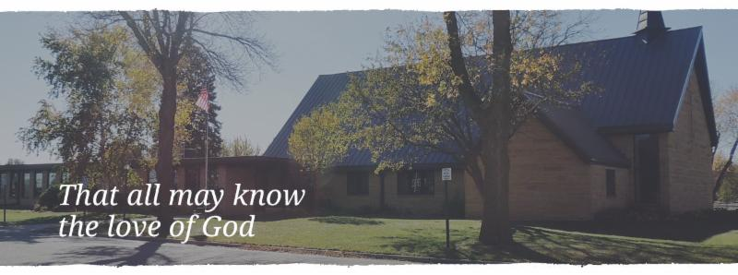

Cross of Calvary is the ELCA church in Olivia. We are an intergenerational (fancy word for young and old) community that follows Jesus out the building to where we live. We are all learners (disciples) here. This is a safe place to practice worship. And, believe us, it takes practice. Your questions, critical thinking, doubts and imperfect lives are welcome here.
Holy Communion
Holy Communion is open to all who are baptized and trust that Christ is present in the meal, regardless of your tradition or affiliation. Wine (red)/grape juice (white).
Participation
Bold type means all of us read or pray together. Out loud.
* Please stand as you are able.
Children in Church
They belong here! They are hearing God’s Word, music and prayers. We don’t mind fidgeting and chatter! If you like, there are activity bags available in the entry.
Announcements
They are as printed or any new information please give to Pastor Matt prior to worship, please hand a note to Pastor with any announcements, including prayer requests.
Restrooms
They are located in the hallway to the left of the stairs. Changing table located in the Women’s bathroom.

Fundraising for the new sign at
Cross of Calvary on
Highways #71 is going great!!!
The goal is to fill all the letters on the picture below; each letter represents a $1,000.
Estimated cost: $28,500.00

WOW: we are at $24,240.00 only $4,260.00 to go!!!
Thank you!!!!
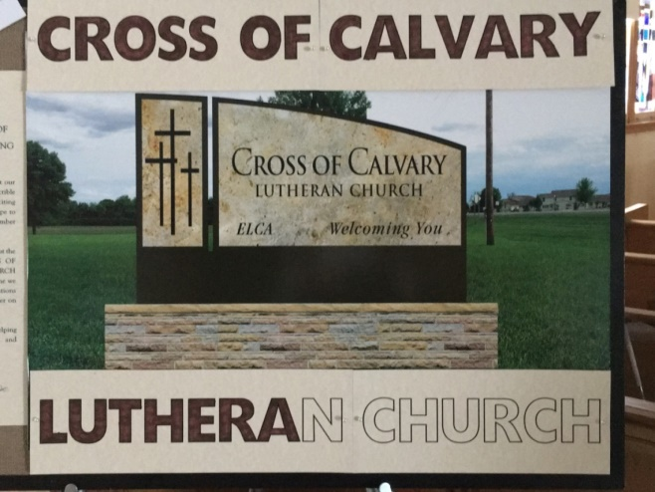

Spring 2017 Cross of Calvary Craft Retreat "Ordinary Joy"
will be held March 9-11. Registration forms will be available at church. The fee for the retreat will be $25. For your fee you will get a table to work on, four meals, and wonderful fellowship. Space is limited.

