**Cross of Calvary Lutheran Church**

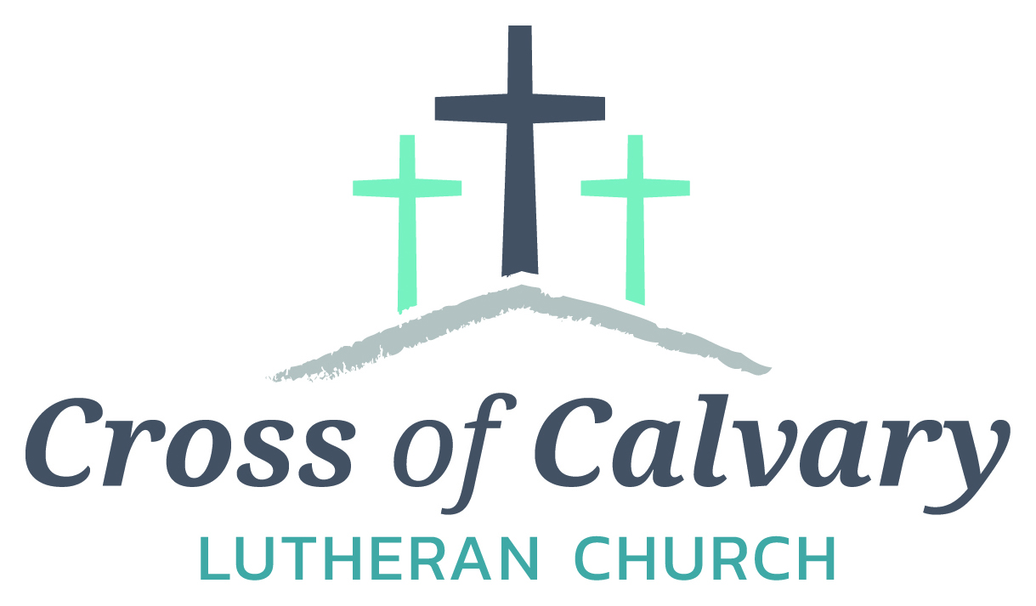

**WorshipTimes**

Saturdays: 5:30 pm

Sundays: 8:30 & 10:30

**Coffee Hour**

Sunday at 9:30 am

**Sunday School**

Sunday at 9:30 am

**Building Hours**

Mon-Thurs 8:30-7:00

Fri-Sun 8:30-2:00

**Office Hours**

Mon, Tues, Thurs.

8:30-3:00

Wednesday 8:30-4:00

Friday 8:30-2:00

**Our Mission**

*That all may know*

*the love of God*

Matt Hausken

Pastor

[hauskenmatt8@gmail.com](mailto:hauskenmatt8@gmail.com)

Minister of Faith Formation

[cofcyouth@gmail.com](mailto:cofcyouth@gmail.com)

Sue Altmann

Office Administrator

[crossofcalvary@gmail.com](mailto:crossofcalvary@gmail.com)

320-523-1574

Web:crossofcalvay.net

Online giving is now available. Go to website listed above.

**1103 W. Chestnut Ave. Olivia, MN 56277**

**320-523-1574**



**February 26, 2017**

**Weekly Announcements**

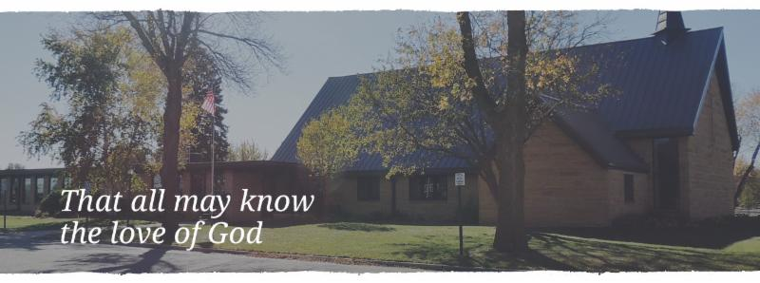

Cross of Calvary is the ELCA church in Olivia. We are an intergenerational (fancy word for young and old) community that follows Jesus out the building to where we live. We are all learners (disciples) here. This is a safe place to practice worship. And, believe us, it takes practice. Your questions, critical thinking, doubts and imperfect lives are welcome here.

**Holy Communion**

Holy Communion is open to all who are baptized and trust that Christ is present in the meal, regardless of your tradition or affiliation. Wine (red)/grape juice (white).

**Participation**

**Bold type means all of us read or pray together. Out loud.**

* Please stand as you are able.

**Children in Church**

They belong here! They are hearing God’s Word, music and prayers. We don’t mind fidgeting and chatter! If you like, there are activity bags available in the entry.

**Announcements**

They are as printed or any new information please give to Pastor Matt prior to worship, please hand a note to Pastor with any announcements, including prayer requests.

**Restrooms**

They are located in the hallway to the left of the stairs. Changing table located in the Women’s bathroom.

**Mission**

**Paraguay Missionaries**

The Kevin & Rebekah Howell family

**Bolivia Missionaries**

Paul and Jay Mikaelson

**New from the ELCA SW MN Synod!**

Thanks for your congregation’s mission support to our ELCA’s SW MN Synod! We received 100.5% of budgeted mission support in 2016. As a result you shared in the support of ministries in our synod and throughout the world. Our Synod shares mission support (51.5%) to our larger expression, ELCA Church wide. As a result **you were there** as people heard the Gospel, received food, and were supported in times of good and sadness. They were loved by Jesus through “God’s Work. OUR Hands” our ELCA’s calling.

Thanks be to God, **for you!**

**COMMUNITY and CHURCH BOARD**

CHECK THE BULLETIN BOARD for more information /details

Cross of Calvary Soup Supper Signup sheet has been posted on the “BOARD”.

Please sign up ASAP, to get the date your group prefers.

We are looking forward to yummy soups, sandwiches and desserts!

**Another chance for wonderful table talk!!!**

**Table talk: informal conversation carried on at meals**

**February is Food Shelf month for ALL Lutherans. Cross of Calvary will be collecting food shelf items the month of February. Please bring any items you would like to donate (money is also an option, please place in a sealed envelope and mark Food Shelf) and place them in the shopping cart in the Narthex. Thank You!!!!**

**A Day Set Apart for Women Retreat**

We hope you’ll join us for the 2017 Day Set Apart for Women – Break Every Chain Retreat, Friday and Saturday, March 17th and 18th at Grace Community Church in Olivia, MN.

**What is this retreat all about?** Chains, they’re an interesting thing, aren’t they? We all have them and they all look different….and yet the same. Often, I am blind to the chains I wear.  Looking at her chains, reminds me of the weight of my own. And by the Grace of Jesus, when I am finally free of one, I find another one underneath waiting to be broken. Isn’t that the way of life? But let me tell you there is more. There is an abundant life full of purpose waiting for you. We can continue to let fear, sadness, brokenness, and anger control our lives; keep us in bondage.  Or we can make the decision to truly live free in Christ and loose the chains that keep us from living the life He desires for us. Join us March 17thand 18th, 2017.  Let’s learn how to walk through this together.

Friday evening we will be joined by Grace Johnson from The Potter’s Heart ministry. Saturday our time together will include the testimony of two women. Women no different than you and I, who have removed their blinders, allowed the dark areas of their lives to be pierced with the truth, and watched as the Lord to breathed life into their brokenness.

Who is this for? We welcome women from all walks of life, denominations, and cultures. Young ladies age 15 and up are welcome to join us! For more detailed information visit our Facebook Page, A Day Set Apart for Women. Online registration is available

at: <https://docs.google.com/forms/d/1yQD5bK4Ege4CDZYnZnVQ6Vh7NDUvMkC6mmLJJBew_6Q> or contact: Leta Jacobs [(320) 579-1412](tel:(320)%20579-1412) -or-[leta.jacobs@yahoo.com](mailto:leta.jacobs@yahoo.com)

**Cost is $20** and includes all materials, refreshments, breakfast and lunch on Saturday.  FREE childcare will be provided at the Christian Community Outreach Center (CCOC) in Olivia. Food and beverage will be provided for the children as well. Scholarships are available for those in need.

Payments should be written out to Grace Community Church or GCC and can be mailed to:

Terri Tuma - 650 S. 9th Street, Bird Island, MN 55310

**The Woodbury Chorus and Orchestra** will be in Olivia presenting “American Impressions” on Sunday, March 19, 4:00pm at St. Aloysius Catholic Church to benefit the Renville County Food Shelf. This concert will include What Wondrous Love Is This, Wade in the Water, The Promise of Living, etc. The concert is free and no tickets are required. A free will offering will be taken, with 100% of the proceeds to benefit the Renville County Food Shelf.

**Renville County Hospice offers Annual Grief Support Opportunity:** “Walking Through Grief” is sponsored by Renville County Hospice. The sessions will be held on Thursday afternoons March 2, 9, 16, 23, 30, April 6, 13 and April 20 from 4:00 to 5:30 pm at the Renville County Hospital (Willette Room), 100 Healthy Way on Olivia. All are welcome and invited. Please call Dawn at 320-523-3451 to register.

**Redwood Area Hospital** is seeking Hospice Volunteers: for more information and who to contact see the board at the east entrance.

**FOTA Talent Show**: Friends of the Arts Talent Show!!! April 24th at 7:30 pm on the RCW stage! All ages! All talents! Fabulous prizes! Register now! Participants must be current residents/Staff/ students RCW, or graduates of RCW – registration closes on April 10th. Sign up form online at http://rcw.schoolwires.net/Page/54

**American Red Cross** is offering a one day Fast Track training for Disaster Action Team (DAT) . The location is Redwood Falls Library; date Saturday, March 4th from 10am-2:30pm. See the board for more details, if interested.

**Evangelical Free Church of Redwood Falls** is privileged to host a conference from Michael Card’s “BIBICAL Imagination” series. The conference dates are April 7-9, 2017. For more information see the bulletin board.

**Lutheran Men in Mission** will be having a 2017 Spring LMM Retreat on March 10 and March 11 at Green Lake Bible Camp, Spicer. Register Online at [www.swmnelca.org](http://www.swmnelca.org) – events page. Registration deadline: March 3rd. See bulletin board for brochure.

**The Tim Orth Memorial Foundation’s** annual fundraising event will be held on **Saturday, March 18th** at the BOLD School in Bird Island. Doors open at 4:00 p.m., Opening Ceremony at 5:45 p.m. Along with the boys and girls basketball games, this year entertainment will include Mascots Crunch and Bear, Alexandria Aces and the F-M Acro Team. A silent auction and raffle are also held.  Proceeds from the event will benefit children from the area battling a serious or life threatening illness.

**Prayer Concerns**

*Prayer Matters! Please take your bulletin home and pray for those listed.*

*Prayer concerns are listed for one month.*

Emergency/Pastoral Care-Please have a family member or friend notify the church. You may also request hospital staff to call on your behalf. Call day or night at 523-1574. Never feel as though you are bothering Pastor or the staff. We are here to serve as a comfort and as a resource.

**Our Sympathy is extended to:**

To the Rechkemmer Family, at the loss of George Rechkemmer

(father of Lyn Knoke)

*Diana Adkins *Greg & Evelyn Rosenow *Jill Revolinski

*Leslie Sagedahl *Emersyn Herdina

*Vonna Ledeboer *Warren Mitchel

*Jenna Reynolds *Donna Greenwell

**MARCH VOLUNTEERS**

Communion – 8:30 – Gordon Blem - 10:30 – Jon Hawkinson

Altar Guild – DeAnne Beckler, Marie Rauenhorst & Kristi O’Neil

Acolytes – Jordan Sagedahl & Drew Sagedahl

Usher – 8:30 – Kirk Elfering, Rich Elbert, Greg Helin & Richard Sigurdson

10:30 – Dave Altmann & Dan Beckler

**Coming up in March at Cross of Calvary**

**March 1 – Ash Wednesday worship: 12:00pm & 7:00 pm**

**First Soup Supper begins at 5:30-6:30**

**March 9-11 – Craft Retreat (Fellowship Hall)**

**March 15 – Church Council Mtg at 7:30**

**Dollar amount collected so far for the New sign: $25,902.00: almost there!!!!!!**

**SOUP SUPPERS 5:30-6:30**

A great way for your group to fundraise!

The sign-up sheet is on the BOARD.

**March 1 ____Altar Guild______________**

**March 8 ___________________________**

**March 15 __________________________**

**March 22___________________________**

**March 29___________________________**

**April 5 ____ Men’s Group_____________**



**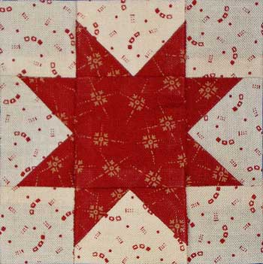*LOOKING FOR FABRIC!!***

The weekly “Quilters” are in need of additional fabric to construct and finish their quilts for the season. Flat sheets are ideal for backing and any and all additional fabric/remnants will be used for piecing the patterned quilt fronts. Please bring any fabric donations to the fellowship hall and specify on your bundle that it is for the “Quilters”. ***“Thank You!!”***



**VBS is June 25th-June 29th, 2017**

 (Meal starts at 5:30 and I believe VBS starts at 6 or 6:30 and runs to 8:30)

There is a VBS planning meeting for anyone interested in helping out with leadership role on February 28th at 7pm at Our Saviors.

March 14th and 28th: Work nights from 6-8pm at Our Saviors

March 25th: Work day from 10-4 at Our Saviors

April 6th and 20th: Work nights from 6-8pm at Our Saviors

May/June TBD if needed

Many hands make this work light and there are a variety of crafts & fairly simple building projects. Any National Honor Society students seeking volunteer hours would be awesome and I am guessing that PM would offer faith elements for Confirmation students to help out as well.

**Senior High Youth Gathering: March 10 & 11.**



Reminder: We are in need of families, groups, clubs, people to host coffee hour on Sundays. Please sign up on the board in the Narthex. Thank you in advance; it is a wonderful time for table talk!!!!



WOW is in need of snacks, for the months of March & April. Please sign up on the youth board. There are about 15 – 20 youth that participate each week. Please leave snacks in the kitchen, labeled WOW snack! Thanks!!!!

**February 26, 2017**

**Devotion:** Use this resource at home to guide your household’s daily devotions. You can do this alone or with others; in the morning, during the day, or at night. Find a routine that works best for you.

**Pray:** Light a candle and open your devotion time with a prayer.

**Transfigured Lord,   
You have transformed all things through the vision of an earth restored. Make us willing participants in your work to reconcile all things again to you, in Jesus’ holy name, Amen.**

**Reflect:** Reflect on the key verses from Sunday’s reading.

*Now about eight days after these sayings Jesus took with him Peter and John and James, and went up on the mountain to pray. And while he was praying, the appearance of his face changed, and his clothes became dazzling white.* Luke 9:28-29

**Study:** Study the reading and consider the background.

**Life with Jesus may be confusing at times, but never boring. Peter and friends have witnessed Jesus transfigured with ancient prophets, and triumphing over a malicious demon, all in the space of two days. But what are they to make of it all?**

**Consider:** Consider this theme for the week’s text.

**Jesus can reveal himself to us in ways we can’t yet understand, but maybe one day we will.**

**Read:** Read the following daily readings to deepen   
your understanding of Sunday’s text. After the reading,   
ask the follow-up questions.

Sunday: *Transfiguration*, Luke 9:28-45

Monday: *Who Is Greatest,* Luke 9:46-48   
Tuesday: *Whoever Is Not Against You Is For You,* Luke 9:49-50   
Wednesday: *The Challenge of Following (Ash Wednesday)*, Luke 9:51-62

Thursday: *Mission of the Seventy,* Luke 10:1-12   
Friday: *Woes to Unrepentant Cities,* Luke 10:13-16   
Saturday: *Seventy Return and Jesus Rejoices,* Luke 10:17-24

**How does Jesus describe greatness?**

**Connect:** Connect in conversation with others in your household. Discuss the following questions, or simply check in with “Highs” and “Lows.”

**What was a high point of your day? What was a low point?**

**Who are your community’s greatest leaders, past or present? How have they shaped your community? How might you become a leader in your community today?**

**How has God revealed truths about Jesus to you? (Scripture, people, worship, media?) How might you be intentional about giving time to those things that reveal Jesus to you this week?**

**Do:** By acting on what we learn we make God’s word come alive. Do the following activity this week.

**Add light to your home. Here are some ideas. Light candles that you have only used for decoration. Put “fairy lights” in a mason jar. Hang a string of outdoor lights across your living room. Fall asleep with a soft, flickering LED candle in your bedroom. Enjoy the light.**

**Bless:** Close your devotion with a blessing.

**Notice and be warmed by the light of Christ. Amen.**