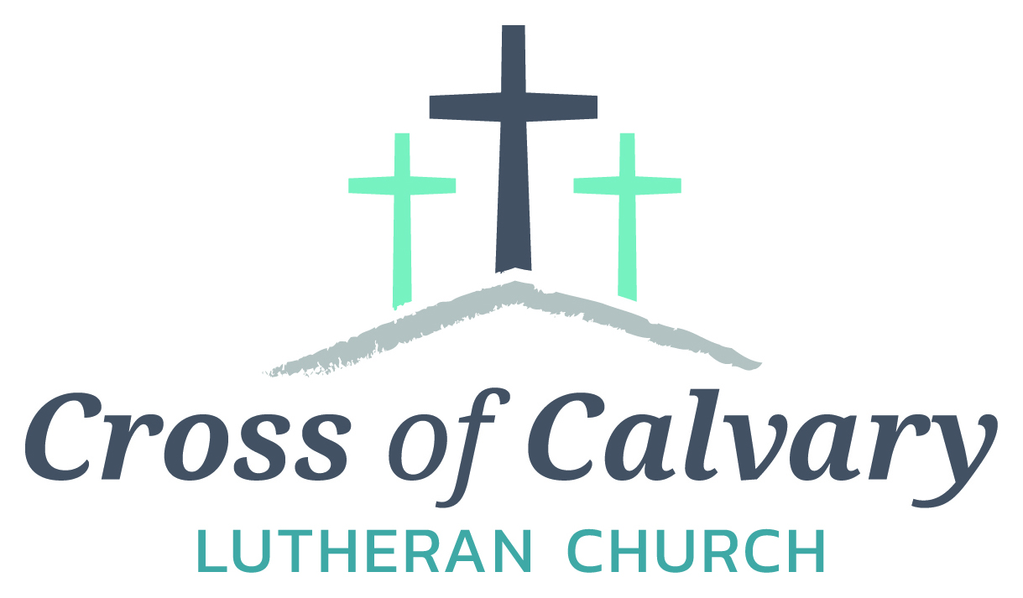
WorshipTimes
Saturdays: 5:30 pm
Sundays: 8:30 & 10:30
Coffee Hour
Sunday at 9:30 am
Sunday School
Sunday at 9:30 am
Building Hours
Mon-Thurs 8:30-7:00
Fri-Sun 8:30-2:00
Office Hours
Mon, Tues, Thurs.
8:30-3:00
Wednesday 8:30-4:00
Friday 8:30-2:00

Our Mission
That all may know
the love of God

Matt Hausken
Pastor
hauskenmatt8@gmail.com

Sue Altmann
Office Administrator
crossofcalvary@gmail.com
320-523-1574
Web:crossofcalvay.net
Online giving is now available. Go to website listed above.

Cross of Calvary Lutheran Church
1103 W. Chestnut Ave. Olivia, MN 56277
320-523-1574
April 16, 2017
Weekly Announcements
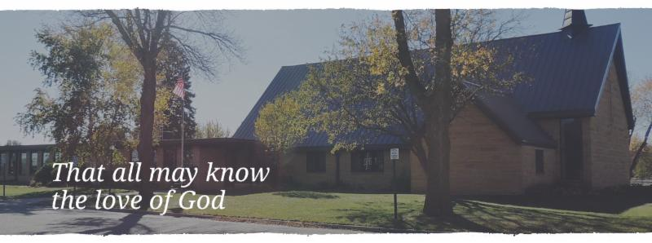
Cross of Calvary is the ELCA church in Olivia. We are an intergenerational (fancy word for young and old) community that follows Jesus out the building to where we live. We are all learners (disciples) here. This is a safe place to practice worship. And, believe us, it takes practice. Your questions, critical thinking, doubts and imperfect lives are welcome here.
Holy Communion
Holy Communion is open to all who are baptized and trust that Christ is present in the meal, regardless of your tradition or affiliation.
Wine (red)/grape juice (white).
Participation
Bold type means all of us read or pray together. Out loud.
* Please stand as you are able.
Children in Church
They belong here! They are hearing God’s Word, music and prayers. We don’t mind fidgeting and chatter! If you like, there are activity bags available in the entry.
Announcements
They are as printed or any new information please give to Pastor Matt prior to worship, please hand a note to Pastor with any announcements, including prayer requests.
Restrooms
They are located in the hallway to the left of the stairs. Changing table located in the Women’s bathroom.

COMMUNITY and CHURCH BOARD
CHECK THE BULLETIN BOARD or east bulletin board for more information /details
FOTA Talent Show: Friends of the Arts Talent Show!!! April 24th at 7:30 pm on the RCW stage! All ages! All talents! Fabulous prizes! Register now! Participants must be current residents/Staff/ students RCW, or graduates of RCW – registration closes on April 10th. Sign up form online at http://rcw.schoolwires.net/Page/54

Green Lake Lutheran Ministries will hold the 33rd Annual Quilt Auction July 22nd, 2017. Proceeds from this event go to our Annual Fund which allows us to provide fun, safe, quality camping and retreating opportunities for people of all ages who use any of our three camps.
Quilts: please delivery to camp by July 14th, viewing will be available online at www.gllm.org
Silent Auction: item must be brought to camp no later than 5:00 pm on July 20th.
Cash Donation:Checks may be sent to: GLLM, 9916 Lake Ave. S. Spicer, MN 56288.
More information is on the bulletin board on the east entrance.

Marriage Retreat
Cross of Calvary will be hosting a marriage retreat for both engaged to be married and married couples. (Engaged couples this is a requirement) The retreat will be Saturday, May 6th from 9:00 am -3:00 pm. The cost is $50.00 per couple, which includes the retreat inventory and a meal. Please sign up on the sheet on the board or contact Cross of Calvary to register. 320-523-1574

United Lutheran Church of Lake Lillian will be hosting their Annual Salad Luncheon, “Springtime Smarty Plants Luncheon”. The date of the luncheon is April 20th at 12:00 noon, featuring speaker Master Gardener Louise Anderson. Free will offering will be accepted. (Please bring a salad to share.)

Question: does anyone know who has the checkbook for the Community garden?
Car remote found – claim in office.
Please pick up your cake pans/etc. from the Ham Dinner – Thanks!!!
Prayer Concerns
Prayer Matters! Please take your bulletin home and pray for those listed.
Prayer concerns are listed for one month.
Emergency/Pastoral Care-Please have a family member or friend notify the church. You may also request hospital staff to call on your behalf. Call day or night at 523-1574. Never feel as though you are bothering Pastor or the staff. We are here to serve as a comfort and as a resource.
*Diana Adkins *Greg & Evelyn Rosenow *Jill Revolinski
*Leslie Sagedahl *Jenna Reynolds *Vonna Ledeboer
*Emily Reetz *Warren Mitchell
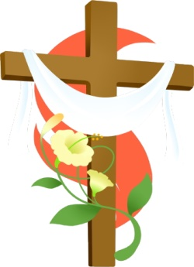
Flowers on organ: given in memory of Lost Loved Ones
Coming up in April at Cross of Calvary
April 16 – Easter: services at 6:30 am and 9:00 am
April 19 – WOW and Confirmation resume
Church Council Meeting at 7:30 pm
April 26 – End of year party for WOW and last Confirmation date

APRIL VOLUNTEERS
Communion – 8:30 –- Jill Hanson 10:30 – Jon Hawkinson
Altar Guild – Stacey Larson & Sarah Iverson
Acolytes – Jordan Amberg & Trent Paulson
Usher – 8:30 – Eric Skeie, Ron Fahse, Linda Fahse & Cheryl Mallak
10:30 – NEEDED: Ushers for the 10:30 services in April

VBS is June 25th-June 29th, 2017
(Meal starts at 5:30 and I believe VBS starts at 6 or 6:30 and runs to 8:30)
There is a VBS planning meeting for anyone interested in helping out with leadership role on February 28th at 7pm at Our Saviors.
March 14th and 28th: Work nights from 6-8pm at Our Saviors
March 25th: Work day from 10-4 at Our Saviors
April 6th and 20th: Work nights from 6-8pm at Our Saviors
May/June TBD if needed
Many hands make this work light and there are a variety of crafts & fairly simple building projects. Any National Honor Society students seeking volunteer hours would be awesome and I am guessing that PM would offer faith elements for Confirmation students to help out as well.

Last day of Sunday School: May 14th – students will be singing at 9:00 am service.
Dollar amount collected so far for the New sign: $27,542: almost there!!!!!!

GOOD GIFTS
for the Easter Season

Given By: | In MEMORY of
Larry and Susan Meyer | Ray Knudson
David Torgelson | John Torgelson
Sonja Fostvedt | Belmer (Red) Fostvedt
Rosalie Sheggeby | Gordon, Daniel & Rosalind Sheggeby
Steve, Sue, Chloe & Lanie Altmann | Paige Altmann
Edith Vogt | Loved Ones
Keith & Stacey Larson | Paul & Mark Vogt; Mildred Larson
Gary Beltz | His parents
Given By: | In HONOR of
Stan & Sue Malecek | Florence Malecek
Chet & Angie Boen | Grandchildren, Miranda, Noah, Zane & Rylee
Given By: | Donation
Mark & Sonia Grasmon
Angela Cole

Devotion: Use this resource at home to guide your household’s daily devotions. You can do this alone or with others; in the morning, during the day, or at night. Find a routine that works best for you.
Pray: Light a candle and open your devotion time with a prayer.
Risen Lord,
You have been true to your word, and you have shown that death could not defeat life. Pour the joy of your resurrection into our hearts, that our lips would also overflow with the joyous news. In the name of the risen Christ, Amen.
Reflect: Reflect on the key verse from Sunday’s reading.
The women were terrified and bowed their faces to the ground, but the men said to them, “Why do you look for the living among the dead? He is not here, but has risen.
Luke 24:5
Study: Study the reading and consider the background.
It’s been a grueling week for the followers of Jesus, but still they faithfully carry out the rituals due to the dead. How could these grieving women have known that their anointing oils would not be needed, for the best reason imaginable?
Consider: Consider this theme for the week’s text.
We live grounded in the mystery of the resurrection.

Read: Read the following daily readings to deepen
your understanding of Sunday’s text. After the reading,
ask the follow-up questions.
Sunday: Empty Tomb (Easter), Luke 24:1-12
Monday: Jesus Appears to His Disciples, Luke 24:36-53
Tuesday: Matthias Chosen to Replace Judas, Acts 1:12-26
Wednesday: The Holy Spirit, Acts 2:1-13
Thursday: Early Christians, Acts 2:14-47
Friday: Peter Heals a Crippled Beggar, Acts 3:1-10
Saturday: Peter Speaks in Solomon’s Portico, Acts 3:11-26
How did Jesus’ resurrection change the world?
Connect: Connect in conversation with others in your household. Discuss the following questions, or simply check in with “Highs” and “Lows.”
What was a high point of your day? What was a low point?
Easter marks the most significant event in a Christian’s life. Who could you share this news with?
How will you honor Christ today?
Do: By acting on what we learn we make God’s word come alive. Do the following activity this week.
Sing your favorite Easter hymn every morning when you wake up. If you don’t have a favorite Easter hymn, sing whatever favorite song reminds you that Jesus is alive!
Bless: Close your devotion with a blessing.
Christ is risen! He is risen indeed! Amen.

Mission
Paraguay Missionaries
The Kevin & Rebekah Howell family
Bolivia Missionaries
Paul and Jay Mikaelson

Reminder of the message:

