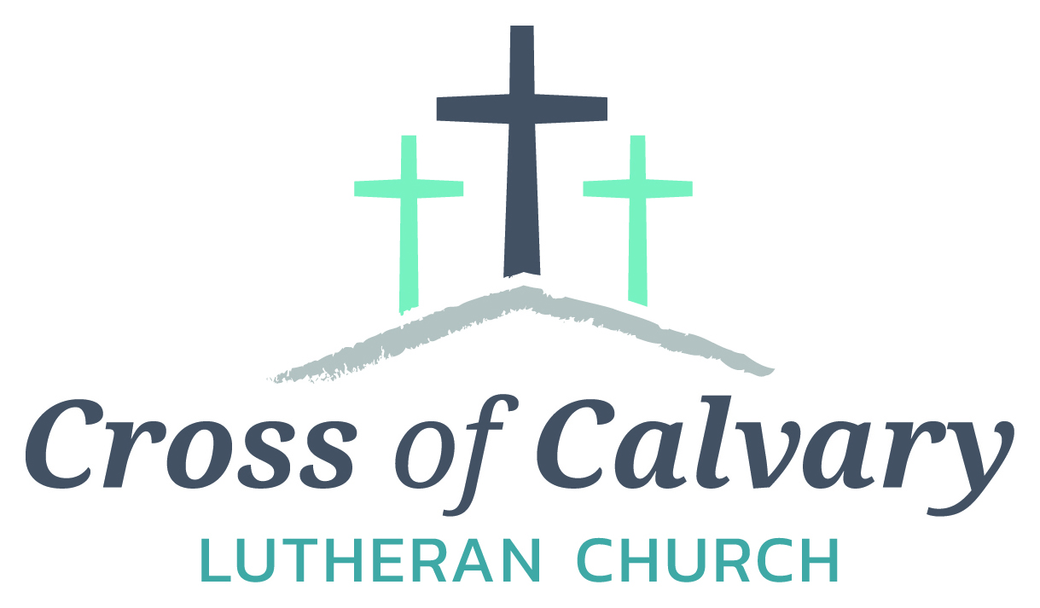
WorshipTimes
Saturdays: 5:30 pm
Sundays: 8:30 & 10:30
Coffee Hour
Sunday at 9:30 am
Sunday School
Sunday at 9:30 am
Building Hours
Mon-Thurs 8:30-7:00
Fri-Sun 8:30-2:00
Office Hours
Mon, Tues, Thurs.
8:30-3:00
Wednesday 8:30-4:00
Friday 8:30-2:00

Our Mission
That all may know
the love of God
Matt Hausken
Pastor
hauskenmatt8@gmail.com

Sue Altmann
Office Administrator
crossofcalvary@gmail.com
320-523-1574
Web:crossofcalvary.net
Online giving is now available. Go to the website listed above.

Cross of Calvary Lutheran Church
1103 W. Chestnut Ave. Olivia, MN 56277
320-523-1574
April 30, 2017
Weekly Announcements
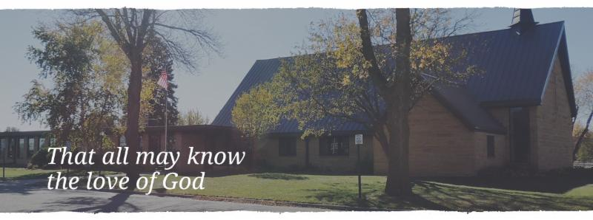
Cross of Calvary is the ELCA church in Olivia. We are an intergenerational (fancy word for young and old) community that follows Jesus out the building to where we live. We are all learners (disciples) here. This is a safe place to practice worship. And, believe us, it takes practice. Your questions, critical thinking, doubts and imperfect lives are welcome here.
Holy Communion
Holy Communion is open to all who are baptized and trust that Christ is present in the meal, regardless of your tradition or affiliation.
Wine (red)/grape juice (white).
Participation
Bold type means all of us read or pray together. Out loud.
* Please stand as you are able.
Children in Church
They belong here! They are hearing God’s Word, music and prayers. We don’t mind fidgeting and chatter! If you like, there are activity bags available in the entry.
Announcements
They are as printed or any new information please give to Pastor Matt prior to worship, please hand a note to Pastor with any announcements, including prayer requests.
Restrooms
They are located in the hallway to the left of the stairs. Changing table located in the Women’s bathroom.

COMMUNITY and CHURCH BOARD
CHECK THE BULLETIN BOARD or east bulletin board for more information /details
Green Lake Lutheran Ministries will hold the 33rd Annual Quilt Auction July 22nd, 2017. Proceeds from this event go to our Annual Fund which allows us to provide fun, safe, quality camping and retreating opportunities for people of all ages who use any of our three camps.
Quilts: please delivery to camp by July 14th, viewing will be available online at www.gllm.org
Silent Auction: item must be brought to camp no later than 5:00 pm on July 20th.
Cash Donation:Checks may be sent to: GLLM, 9916 Lake Ave. S. Spicer, MN 56288.
More information is on the bulletin board on the east entrance.

Marriage Retreat
Cross of Calvary will be hosting a marriage retreat for both engaged to be married and married couples. (Engaged couples this is a requirement) The retreat will be Saturday, May 6th from 9:00 am -3:00 pm. The cost is $50.00 per couple, which includes the retreat inventory and a meal. Please sign up on the sheet on the board or contact Cross of Calvary to register. 320-523-1574

Hospice Community Memorial Service on Monday, May 1, 2017 at 6:00 pm. Location: the Redwood Area Hospital Education Room in Redwood Falls, MN. This memorial service is open to anyone in the community who would like to remember loved ones.

Annual Pork Chop Dinner at United Lutheran Church in Lake Lillian on Friday, May 5th from 4:30 to 7:00.
Meal features: “Famous Don’s” grilled Pork chops, baked potatoes, Cole slaw, vegetable, bread/butter, beverages and a variety of homemade desserts. Cost: one chop dinner = $10 and two chop dinner - $13.
“Enjoy first grilling of the season!!!”

Spring Fling Ice Cream Social, Bake Sale and Bedding Plant Sale (vegetables & flowers): also a Quilt Display. St. John Cemetery Association of Osceola Township (formerly St. John Lutheran Church-42817 850th Ave, Hector) Date: Friday, May 12 from 4:00 pm to 7:00 pm, serving: hotdogs, BBQ’s, dessert & Ice Cream.

Please pick up your cake pans/etc. from the Ham Dinner – Thanks!!!

I want to thank my church family for the beautiful birthday cards. Also, I want to thank the
C of C Bible study group for the pretty flowers you gave me at the last meeting. Thank you!
Florence Malecek

Coming up in April/May at Cross of Calvary
April 30 – Camp Sunday!!!
May 3 – Altar Guild Meeting at 7:30 pm
May 7 – LYO Banquet (3:00-6:00 pm)
May 14 – Senior Recognition Sunday
Last day of Sunday school
Sunday services start at 9:00 am
May 17 – Church Council Meeting at 7:30 pm
May 18 – Thursday night services start at 6:00 pm

Prayer Concerns
Prayer Matters! Please take your bulletin home and pray for those listed.
Prayer concerns are listed for one month.
Emergency/Pastoral Care-Please have a family member or friend notify the church. You may also request hospital staff to call on your behalf. Call day or night at 523-1574. Never feel as though you are bothering Pastor or the staff. We are here to serve as a comfort and as a resource.
*Diana Adkins *Greg & Evelyn Rosenow *Jill Revolinski
*Leslie Sagedahl *Jenna Reynolds *Vonna Ledeboer
*Emily Reetz *Warren Mitchell *Barb Gomarko
*Bert Budd

APRIL VOLUNTEERS
Communion – 8:30 –- Jill Hanson 10:30 – Jon Hawkinson
Altar Guild – Stacey Larson & Sarah Iverson
Acolytes – Jordan Amberg & Trent Paulson
Usher – 8:30 – Eric Skeie, Ron Fahse, Linda Fahse & Cheryl Mallak
10:30 – NEEDED: Ushers for the 10:30 services in April

MAY VOLUNTEERS
Communion – 8:30 – Eric Skeie and 10:30 – Eric Skeie
Altar Guild – Karen van der Hagen & Angie Boen
Acolytes – Caeden Gluesing & London Prokosch
Usher – 8:30: Nathan Cole, Rod Osthus & Jon Hawkinson
10:30: Duane & Karen Flom & David Torkelson

VBS is June 25th-June 29th, 2017
(Meal starts at 5:30 and I believe VBS starts at 6 or 6:30 and runs to 8:30)
There is a VBS planning meeting for anyone interested in helping out with leadership role on February 28th at 7pm at Our Saviors.
March 14th and 28th: Work nights from 6-8pm at Our Saviors
March 25th: Work day from 10-4 at Our Saviors
April 6th and 20th: Work nights from 6-8pm at Our Saviors
May/June TBD if needed
Many hands make this work light and there are a variety of crafts & fairly simple building projects. Any National Honor Society students seeking volunteer hours would be awesome and I am guessing that PM would offer faith elements for Confirmation students to help out as well.

Last day of Sunday school: May 14th – students will be singing at 9:00 am service.

CAMP SUNDAY!!
- Sunday, April 30 at 9:30
- 4, $50, Scholarships will be drawn
- Find out more information about camp
- Deadline is May 8th for registration to camp

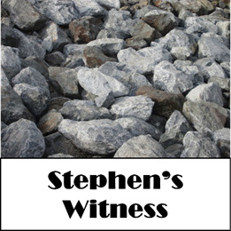

April 30, 2017
Devotion: Use this resource at home to guide your household’s daily devotions. You can do this alone or with others; in the morning, during the day, or at night. Find a routine that works best for you.
Pray: Light a candle and open your devotion time with a prayer.
Holy Lord,
Your servant Stephen was bold in the face of danger and death. Make us faithful in our witness, even under threat of opposition to your word, in the name of Jesus, Amen.
Reflect: Reflect on the key verses from Sunday’s reading.
Then they dragged him out of the city and began to stone him; and the witnesses laid their coats at the feet of a young man named Saul. While they were stoning Stephen, he prayed, “Lord Jesus, receive my spirit.” Then he knelt down and cried out in a loud voice, “Lord, do not hold this sin against them.” When he had said this, he died. Acts 7:58-60
Study: Study the reading and consider the background.
Introducing Stephen, a man of spirit and grace who seems to speak with the authority of God. The powerful are known for attracting attention, but it may not be the sort that Stephen would have wanted. How far are Jesus’ followers willing to go?
Consider: Consider this theme for the week’s text.
Sometimes the proclamation of truth is dangerous.

Read: Read the following daily readings to deepen
your understanding of Sunday’s text. After the reading,
ask the follow-up questions.
Sunday: Stephen’s Witness, Acts 6:1 – 7:2a, 44-60
Monday: Saul Persecutes the Church, Acts 8:1-25
Tuesday: The Conversion of Saul, Acts 9:1-19a
Wednesday: Saul Preaches in Damascus, Acts 9:19b-31
Thursday: Peter and Cornelius, Acts 10:1-33
Friday: Gentiles Receive the Holy Spirit, Acts 10:34-48
Saturday: Peter in Prison, Acts 12:1-19
What happened to apostles that preached Jesus?
Connect: Connect in conversation with others in your household. Discuss the following questions, or simply check in with “Highs” and “Lows.”
What was a high point of your day? What was a low point?
How have the duties in your faith community been distributed? How might you do things differently to best honor the gifts of those in your community?
What role do you play at home, at work, or at church? How are you best using your gifts to do God’s work in the world? Are you doing what God has created you to do, or is it time for a change?
Do: By acting on what we learn we make God’s word come alive. Do the following activity this week.
Keep a calendar this week of everything you do. Include trips to the grocery store and time spent on your phone or TV. At the end of the week, evaluate your calendar. How is your time reflecting your values? Make one change next week so your time honors your values.
Bless: Close your devotion with a blessing.
God has created you with unique gifts. Use them well. Amen.

Mission
Paraguay Missionaries
The Kevin & Rebekah Howell family
Bolivia Missionaries
Paul and Jay Mikaelson

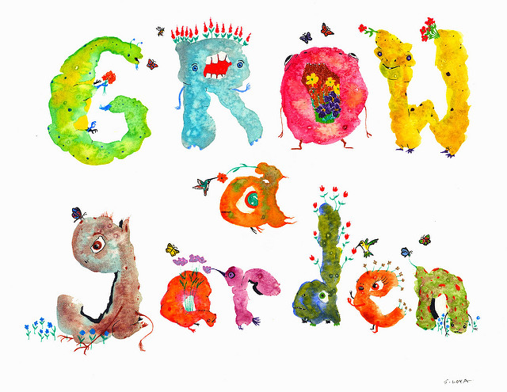
Community Garden
There are 3 spots available in the Community Garden, south of the parsonage. If interested, please let Sue know in the office.
(Available until all spots are taken)

SUMMER STRETCH
Wednesdays July 5, 12, 19 & 26 from 8:30 am-3:30pm & Thursday August 3rd(Valley Fair)
Cost is only $25.00 and for grades 6th, 7th and 8th. Includes a T-shirt and August 3rd trip to Valley Fair
Registration Deadline is May 8th, 2017 – Registration can be done online at https://goo.gl/forms/zbxLc2OCTQ3zwulX2 or paper forms can be turned in to one of the Ministries hosting Summer Stretch. Need more information? Contact Joan Honzay 523-2030 or stalreligiousedjh@gmail.com
Hosted by: CCOC, Our Savior’s Lutheran Church, Grace Community Church, Cross of Calvary Lutheran Church, United Lutheran and St. Aloysius Church

GIVING ONLINE at Cross of Calvary

Cross of Calvary is reminding you can now manage your giving online! Giving online is easy and allows you to set up automatic recurring contributions and view your complete online giving history from anywhere you have access to the Internet.

Simply follow these easy steps:

1) Visit the church website at crossofcalvary.net
2) Click on the GIVE button,
3) Click on HERE TO GIVE, then
4) Follow the onscreen instructions to create an online profile and to schedule your
recurring contributions.

Thank you for your contribution!!!

