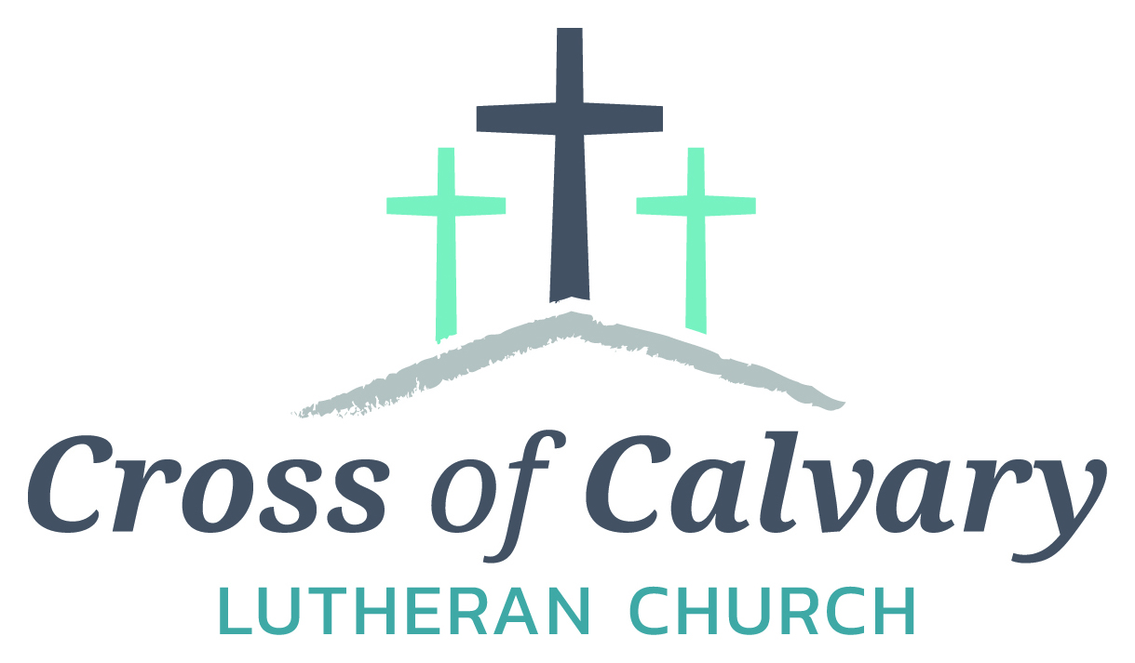
WorshipTimes
Thursday: 6:00
Sundays: 9:00
Coffee Hour
Resumes: 9/10/17
Sunday School
Resumes: 9/10/17
Building Hours
Mon-Thurs
8:30-7:00
Fri-Sun 8:30-2:00
Office Hours
Mon, Tues, and Thurs.; 8:30-3:00
Wednesday
8:30-4:00
Friday 8:30-2:00
Pastor
Matt Hausken
hauskenmatt8@gmail.com
Admin. Assist.
Sue Altmann
crossofcalvary@gmail.com

Cross of Calvary Lutheran Church
1103 W. Chestnut Ave. Olivia, MN 56277 320-523-1574
May 14, 2017
Weekly Announcements
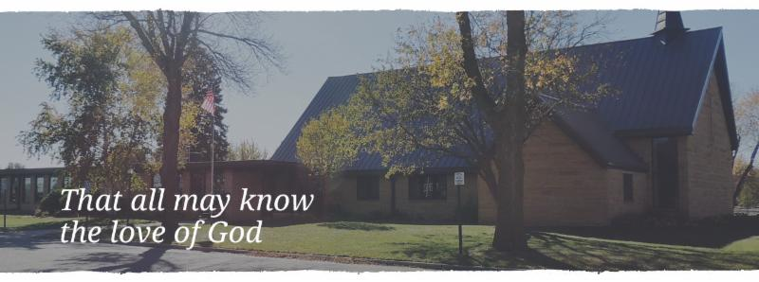
Cross of Calvary is the ELCA church in Olivia. We are an intergenerational (fancy word for young and old) community that follows Jesus out the building to where we live. We are all learners (disciples) here. This is a safe place to practice worship. And, believe us, it takes practice. Your questions, critical thinking, doubts and imperfect lives are welcome here.
Holy Communion
Holy Communion is open to all who are baptized and trust that Christ is present in the meal, regardless of your tradition or affiliation.
Wine (red)/grape juice (white).
Participation
Bold type means all of us read or pray together. Out loud.
* Please stand as you are able.
Children in Church
They belong here! They are hearing God’s Word, music and prayers. We don’t mind fidgeting and chatter! If you like, there are activity bags available in the entry.
Announcements
They are as printed or any new information please give to Pastor Matt prior to worship, please hand a note to Pastor with any announcements, including prayer requests.
Restrooms
They are located in the hallway to the left of the stairs. Changing table located in the Women’s bathroom.
COMMUNITY and CHURCH BOARD
CHECK THE BULLETIN BOARD or east bulletin board for more information /details
Green Lake Lutheran Ministries will hold the 33rd Annual Quilt Auction July 22nd, 2017. Proceeds from this event go to our Annual Fund which allows us to provide fun, safe, quality camping and retreating opportunities for people of all ages who use any of our three camps.
Quilts: please delivery to camp by July 14th, viewing will be available online at www.gllm.org
Silent Auction: item must be brought to camp no later than 5:00 pm on July 20th.
Cash Donation:Checks may be sent to: GLLM, 9916 Lake Ave. S. Spicer, MN 56288.
More information is on the bulletin board on the east entrance.

UPCOMING NURSING HOME EVENTS
IF YOU HAVE VOLUNTEERED AT THE NURING HOME IN THE LAST YEAR, PLEASE JOIN US FOR A SALAD LUNCHEON ON TUESDAY, MAY 16TH AT 1:15 AT THE OLIVIA REHABILITATION AND HEALTHCARE CENTER (FORMALLY GOLDEN LIVINGCENTER-OLIVIA).
HOPE TO SEE YOU HERE!!
COME JOIN US FOR AN EVENING OF FUN AND FOOD AT THE OLIVIA REHABILITATION AND HEALTHCARE CENTER (FORMALLY GOLDENLIVING CENTER, OLIVIA)
BOUNCY HOUSE, GAMES, HOTDOG COOKOUT AND ROOTBEER FLOATS
WEDNESDAY, MAY 17TH, 4:00~7:00

Renville County Volunteer Fair: Bring your friends and join us for a fun-filled time. Learn about opportunities to share your talents with others by giving back to your community through volunteering.
St. Aloysius will be hosting the event on Tuesday, May 23, 2017 from 9:00 am – 11:00 am. For more information, call 800-669-6714.

PGA Memorial Golf Tournament: Saturday, May 27: registration at 10:00 am, shotgun starts at 11:11am – A tournament to raise money for the Ronald McDonald House. All are welcome to play!!! Contact Steve & Sue Altmann if interested in playing or donating either money or a silent auction item. Thanks!!!!

Renville County Human Services is currently seeking individuals who are willing to be foster parents to children who are in need of a home. Foster parents can be blended families, one or two parent families, retired or single.
The most important aspects of fostering a child is your willingness to provide a loving, safe and stable environment. Foster parents are considered part of a team of individuals who are working to make a better life for a child. Foster parents help a child through a difficult time, share their gifts and talents and receive reimbursement for their dedication and service to children. Is it time to share your gifts and talents and become a foster parent?
Please call Bonnie Lund or Stacie Roxberg, Renville County Human Services at 320-523-2202 to find out more about fostering a child.

Prayer Concerns
Prayer Matters! Please take your bulletin home and pray for those listed.
Prayer concerns are listed for one month.
Emergency/Pastoral Care-Please have a family member or friend notify the church. You may also request hospital staff to call on your behalf. Call day or night at 523-1574. Never feel as though you are bothering Pastor or the staff. We are here to serve as a comfort and as a resource.
*Diana Adkins *Greg & Evelyn Rosenow *Jill Revolinski
*Leslie Sagedahl *Jenna Reynolds *Vonna Ledeboer
*Emily Reetz *Warren Mitchell *Barb Gomarko
*Bert Budd *Donna Greenwell

MAY VOLUNTEERS
Communion – 8:30 – Eric Skeie and 10:30 – Eric Skeie
Altar Guild – Karen van der Hagen & Angie Boen
Acolytes – Caeden Gluesing & London Prokosch
Usher – 8:30: Nathan Cole, Rod Osthus & Jon Hawkinson
10:30: Duane & Karen Flom & David Torkelson

VBS is June 25th-June 29th, 2017
(Meal starts at 5:30, VBS starts at 6 or 6:30 and runs to 8:30)
There is a VBS planning meeting for anyone interested in helping out with leadership role on February 28th at 7pm at Our Saviors.
March 14th and 28th: Work nights from 6-8pm at Our Saviors
March 25th: Work day from 10-4 at Our Saviors
April 6th and 20th: Work nights from 6-8pm at Our Saviors
May/June TBD if needed
Many hands make this work light and there are a variety of crafts & fairly simple building projects. Any National Honor Society students seeking volunteer hours would be awesome and I am guessing that PM would offer faith elements for Confirmation students to help out as well.

Coming up in May at Cross of Calvary
May 14 – Senior Recognition Sunday – cake and coffee after service please join the seniors
Last day of Sunday school
May 17 – Church Council Meeting at 7:30 pm
May 18 – Thursday night services start at 6:00 pm
May 21- Sunday service at 9:00 am only
May 22 – Ruth Bible Study at 1:30 (Parkview)
May 24 – Altar Guild Meeting at 7:30 pm
May 25 – Dorcas Bible Study at 10:00 am at Masters
Worship at 6:00 pm

GIVING ONLINE at Cross of Calvary

Cross of Calvary is reminding you can now manage your giving online! Giving online is easy and allows you to set up automatic recurring contributions and view your complete online giving history from anywhere you have access to the Internet.

Simply follow these easy steps:
1) Visit the church website at crossofcalvary.net
2) Click on the GIVE button,
3) Click on HERE TO GIVE, then
4) Follow the onscreen instructions to create an online profile and to schedule your recurring contributions.

Thank you for your contribution!!

May 14, 2017
Devotion: Use this resource at home to guide your household’s daily devotions. You can do this alone or with others; in the morning, during the day, or at night. Find a routine that works best for you.
Pray: Light a candle and open your devotion time with a prayer.
God of great mission,
You have set before us a great task, O God: keeping sight of the things which matter. Steer us away from our preoccupation with issues that do not bear on our eternal salvation, focusing instead on all who still long to hear your word of grace. In the name of Jesus, Amen.
Reflect: Reflect on the key verses from Sunday’s reading.
“Now therefore why are you putting God to the test by placing on the neck of the disciples a yoke that neither our ancestors nor we have been able to bear? On the contrary, we believe that we will be saved through the grace of the Lord Jesus, just as they will.”
Acts 15:10-11
Study: Study the reading and consider the background.
The early leaders of the faithful had an ever-growing task on their hands: to keep adding to the numbers of converted while trying to reconcile the old customs with the new message. Opinions are strong, and the young church faces one among many threats of division.
Consider: Consider this theme for the week’s text.
There are many things that can divide a church today, yet many more that can unite us.
Read: Read the following daily readings to deepen
your understanding of Sunday’s text. After the reading,
ask the follow-up questions.
Sunday: Council at Jerusalem, Acts 15:1-18
Monday: The Conversion of Lydia, Acts 16:11-15
Tuesday: Paul and Silas in Prison, Acts 16:16-40
Wednesday: Paul Sails for Rome, Acts 27:1-12
Thursday: The Storm at Sea, Acts 27:13-38
Friday: The Shipwreck, Acts 27:39-28:16
Saturday: Paul Preaches in Rome, Acts 28:23-31
How are these stories dramatic?
Connect: Connect in conversation with others in your household. Discuss the following questions, or simply check in with “Highs” and “Lows.”
What was a high point of your day? What was a low point?
Do you live as though you were saved by grace or by your good works? What difference does it make? How does your faith inform your behaviors?
What is your favorite dramatic or exciting biblical story? Why?
Do: By acting on what we learn we make God’s word come alive. Do the following activity this week.
Turn your favorite Bible story into a movie. Find a phone app to help you edit your movie. Or just write your story as a movie script. Be creative! Upload your movie to your social media. How do people respond?
Bless: Close your devotion with a blessing.
God unites us through Christ’s love. Amen.

Mission
Paraguay Missionaries
The Kevin & Rebekah Howell family
Bolivia Missionaries
Paul and Jay Mikaelson

Area Church Communities:

A free “Women’s Conservation Legacy” workshop will be held on Tuesday, May 16, 2017, at the Franklin Community Center in Franklin. This informal, women-focused workshop is designed for women who own or manage farmland who are interested in conservation practices and maintaining their land for future generations. Women conservationists from local and state agencies will be presenting this workshop to provide an opportunity for women landowners to learn more about conservation and other land management topics, improving soil and water quality on your land, and financial resources available.

Women are increasingly becoming sole landowners as they inherit farmland from family members or spouses. This workshop will provide a peer-to-peer, informal discussion format to allow women landowners the opportunity to talk about their individual land conservation goals, learn from other women landowners and conservationists, and gain knowledge, tools, and support for conservation planning.

Additional information regarding the event is provided on the flyer. There is no fee to attend the workshop, but an RSVP is requested to plan for food, seating, and supplies.

If you should have questions, please contact Heidi Rauenhorst with the Hawk Creek Watershed Project at (320) 523-3666 orheidi@hawkcreekwatershed.org, or myself at the contact information listed below.

Reminder
Please check the cart for a cake pan, dish or bowl that may have been left at church, are they yours?

Starting the week of May 15th, all announcements need to be to the office by Thursday morning. (Due to Thursday evening worship)

2017 Graduates – An Invitation to the Congregation
Leslie Adamski Matt and Cassandra Adamski
Open House: Saturday, June 10th from 1-4 pm
Danube Community Center
400 Main St. Danube, MN

Kristi Bratsch Darin and Stacy Bratsch
Open House: Friday, May 26 from 4-8 pm
28167 890th Ave., Danube, MN
RCW Graduation: Sunday, May 21 at 2:30 pm

Morgan Fennern Erick Fennern and Kris Kopel
Open House: Saturday, May 27 from 2-5 pm
Olivia American Legion

Taylor Lingl Joseph and Barb Lingl
83430-380th Street
Bird Island, MN

Elsa Skeie Eric and Jennifer Skeie
Open House: Sunday, June 4 from 4-8 pm
901 West Birch Ave.
Olivia, MN

Whitney Trongard Scott Trongard and Dave & Kathy Altmann
Open House: Friday, June 2nd from 5-8 pm
Olivia Golf Course

Camille Weber Todd and Tina Weber
312 S 9th St
Olivia, MN

