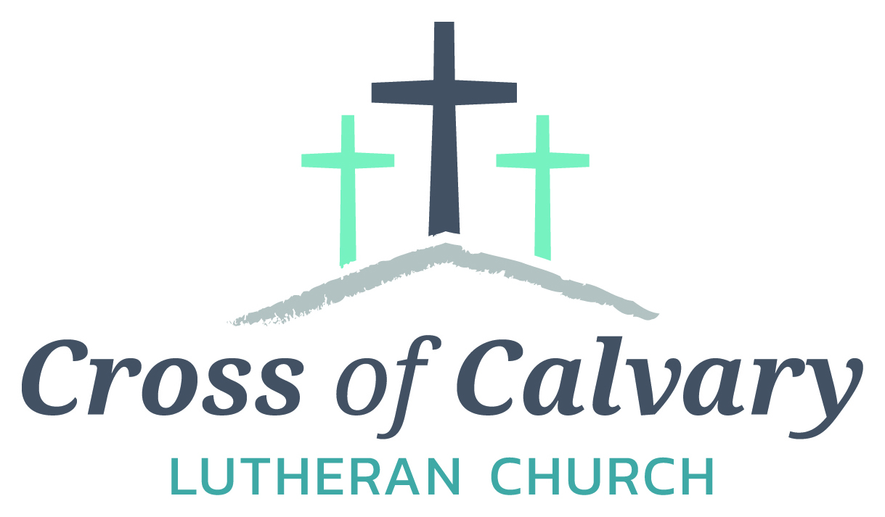
WorshipTimes
Thursday: 6:00
Sundays: 9:00
Coffee Hour
After service
Sunday School
Resumes: September
Building Hours
Mon-Thurs
8:30-7:00
Fri-Sun 8:30-2:00
Office Hours
Mon, Tues, and Thurs.; 8:30-3:00
Wednesday
8:30-4:00
Friday 8:30-2:00
Pastor
Matt Hausken
hauskenmatt8@gmail.com
Admin. Assist.
Sue Altmann
crossofcalvary@gmail.com

Cross of Calvary Lutheran Church
1103 W. Chestnut Ave. Olivia, MN 320-523-1574
May 21, 2017
Weekly Announcements
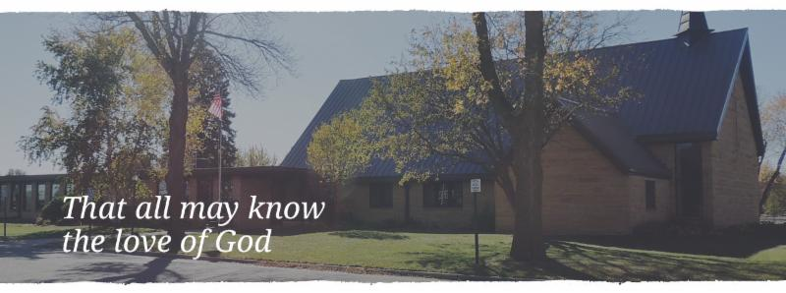
Cross of Calvary is the ELCA church in Olivia. We are an intergenerational (fancy word for young and old) community that follows Jesus out the building to where we live. We are all learners (disciples) here. This is a safe place to practice worship. And, believe us, it takes practice. Your questions, critical thinking, doubts and imperfect lives are welcome here.
Holy Communion
Holy Communion is open to all who are baptized and trust that Christ is present in the meal, regardless of your tradition or affiliation.
Wine (red)/grape juice (white).
Participation
Bold type means all of us read or pray together. Out loud.
* Please stand as you are able.
Children in Church
They belong here! They are hearing God’s Word, music and prayers. We don’t mind fidgeting and chatter! If you like, there are activity bags available in the entry.
Announcements
They are as printed or any new information please give to Pastor Matt prior to worship, please hand a note to Pastor with any announcements, including prayer requests.
Restrooms
They are located in the hallway to the left of the stairs. Changing table located in the Women’s bathroom.
COMMUNITY and CHURCH BOARD
CHECK THE BULLETIN BOARD or east bulletin board for more information /details
Green Lake Lutheran Ministries will hold the 33rd Annual Quilt Auction July 22nd, 2017. Proceeds from this event go to our Annual Fund which allows us to provide fun, safe, quality camping and retreating opportunities for people of all ages who use any of our three camps.
Quilts: please delivery to camp by July 14th, viewing will be available online at www.gllm.org
Silent Auction: item must be brought to camp no later than 5:00 pm on July 20th.
Cash Donation:Checks may be sent to: GLLM, 9916 Lake Ave. S. Spicer, MN 56288.
More information is on the bulletin board on the east entrance.

Renville County Volunteer Fair: Bring your friends and join us for a fun-filled time. Learn about opportunities to share your talents with others by giving back to your community through volunteering.
St. Aloysius will be hosting the event on Tuesday, May 23, 2017 from 9:00 am – 11:00 am. For more information, call 800-669-6714.

PGA Memorial Golf Tournament: Saturday, May 27: registration at 10:00 am, shotgun starts at 11:11am – A tournament to raise money for the Ronald McDonald House. All are welcome to play!!! Contact Steve & Sue Altmann if interested in playing or donating either money or a silent auction item. Thanks!!!!

Renville County Human Services is currently seeking individuals who are willing to be foster parents to children who are in need of a home. Foster parents can be blended families, one or two parent families, retired or single.
The most important aspects of fostering a child is your willingness to provide a loving, safe and stable environment. Foster parents are considered part of a team of individuals who are working to make a better life for a child. Foster parents help a child through a difficult time, share their gifts and talents and receive reimbursement for their dedication and service to children. Is it time to share your gifts and talents and become a foster parent?
Please call Bonnie Lund or Stacie Roxberg, Renville County Human Services at 320-523-2202 to find out more about fostering a child.

St. Cloud VAHCS and our Nation’s Veterans would like to thank the Cross of Calvary Quilters for their generous donation of quilts valued at over $1,500.00. The quilts will be distributed to Veterans receiving care throughout the facility.

A former member at Cross of Calvary: Marv Peterson died on May 16th at his home in Sun City, AZ. If you would like to send a sympathy card to his wife Marge, stop in the office for the address.

Mission
Paraguay Missionaries
The Kevin & Rebekah Howell family
Bolivia Missionaries
Paul and Jay Mikaelson

Prayer Concerns
Prayer Matters! Please take your bulletin home and pray for those listed.
Prayer concerns are listed for one month.
Emergency/Pastoral Care-Please have a family member or friend notify the church. You may also request hospital staff to call on your behalf. Call day or night at 523-1574. Never feel as though you are bothering Pastor or the staff. We are here to serve as a comfort and as a resource.
*Diana Adkins *Greg & Evelyn Rosenow *Jill Revolinski
*Leslie Sagedahl *Jenna Reynolds *Vonna Ledeboer
*Emily Reetz *Warren Mitchell *Barb Gomarko
*Bert Budd *Donna Greenwell

MAY VOLUNTEERS Coming up in May at Cross of Calvary
Communion – 8:30 – Eric Skeie and 10:30 – Eric Skeie May 21- Sunday service at 9:00 am only
Altar Guild – Karen van der Hagen & Angie Boen May 22 – Ruth Bible Study at 1:30 (Parkview)
Acolytes – Caeden Gluesing & London Prokosch May 24 – Altar Guild Meeting at 7:30 pm
Usher – 8:30: Nathan Cole, Rod Osthus & Jon Hawkinson May 25 – Dorcas Bible Study at 10:00 am at Masters
10:30: Duane & Karen Flom & David Torkelson Worship at 6:00 pm

VBS is June 25th-June 29th, 2017
(Meal starts at 5:30, VBS starts at 6 or 6:30 and runs to 8:30)
There is a VBS planning meeting for anyone interested in helping out with leadership role on February 28th at 7pm at Our Saviors.
March 14th and 28th: Work nights from 6-8pm at Our Saviors
March 25th: Work day from 10-4 at Our Saviors
April 6th and 20th: Work nights from 6-8pm at Our Saviors
May/June TBD if needed
Many hands make this work light and there are a variety of crafts & fairly simple building projects. Any National Honor Society students seeking volunteer hours would be awesome and I am guessing that PM would offer faith elements for Confirmation students to help out as well.
Devotion: Use this resource at home to guide your household’s daily devotions. You can do this alone or with others; in the morning, during the day, or at night. Find a routine that works best for you.
Pray: Light a candle and open your devotion time with a prayer.
God of life,
We all stand condemned, but for your grace, O God. Foster in us such love for your word that we cannot help but proclaim it freely and openly to all, in the name of your son Jesus. Amen.
Reflect: Reflect on the key verses from Sunday’s reading.
For through the law I died to the law, so that I might live to God. I have been crucified with Christ; and it is no longer I who live, but it is Christ who lives in me. And the life I now live in the flesh I live by faith in the Son of God, who loved me and gave himself for me. Galatians 2:19-20
Study: Study the reading and consider the background.
Paul’s gifts as an orator are beginning to blossom. With power and grace he calls out some of the leaders on their inconsistencies, and presents himself as the classic example of someone who could not have been justified but through the grace of Jesus.
Consider: Consider this theme for the week’s text.
There are no good guys and no bad guys. There are just people saved by the death and resurrection of Jesus Christ.
Read: Read the following daily readings to deepen
your understanding of Sunday’s text. After the reading,
ask the follow-up questions.
Sunday: Living by Faith, Galatians 1:13-17; 2:11-21
Monday: Welcome to the Galatians, Galatians 1:1-12
Tuesday: Paul Defends His Apostleship, Galatians 1:18-24
Wednesday: Paul and the Other Apostles, Galatians 2:1-10
Thursday: God’s Promise to Abraham, Galatians 3:10-18
Friday: The Purpose of the Law, Galatians 3:19-22
Saturday: Paul Reprimands the Galatians, Galatians 4:8-20
What is going on in Galatia?
Connect: Connect in conversation with others in your household. Discuss the following questions, or simply check in with “Highs” and “Lows.”
What was a high point of your day? What was a low point?
Christians historically have been notorious for expecting believers and non-believers to live by the law (as though saved by our good deeds and our refraining from sin). How might your story sound if you shared the good news that people are saved by the work of Jesus Christ apart from their good works? How might non-believers respond to such a message?
How do you feel about the news that your salvation doesn’t depend upon what you do or fail to do? Does this sound like good news or bad to you? What might prevent you from claiming this gift of justification and salvation? How can you begin to let go of your reservations?
Do: By acting on what we learn we make God’s word come alive. Do the following activity this week.
Watch an old movie about good guys and bad guys. Then watch a newer movie where the line between good and bad is blurred. Which feels more like your experience? Bless: Close your devotion with a blessing. You are good. Amen

