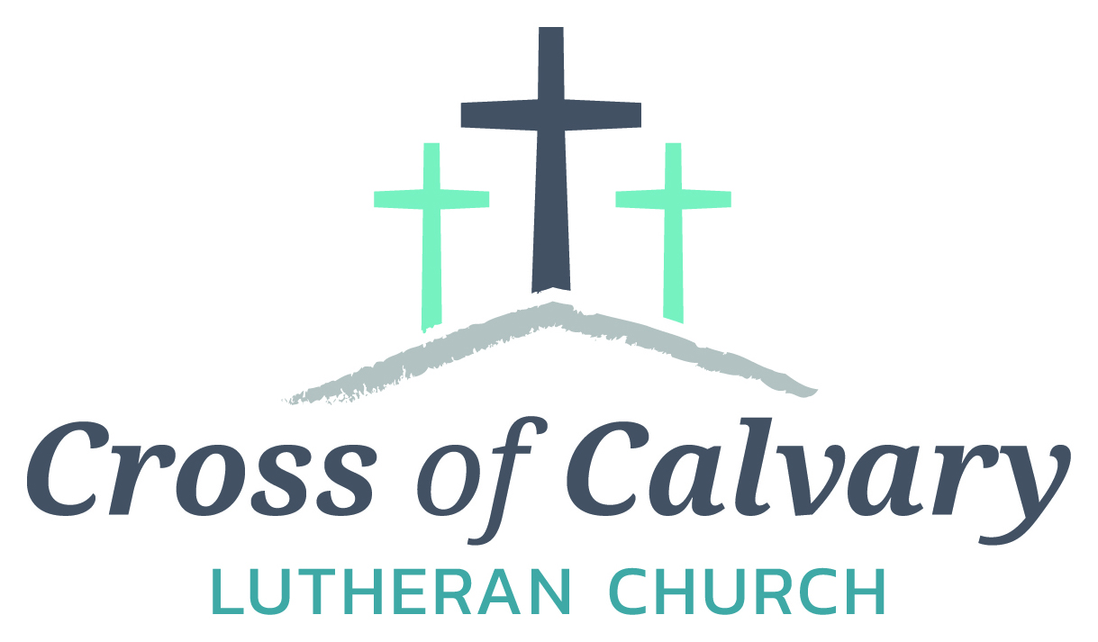
WorshipTimes
Thursday: 6:00
Sundays: 9:00
Coffee Hour
After service
Sunday School
Resumes: September
Building Hours
Mon-Thurs
8:30-7:00
Fri-Sun 8:30-2:00
Office Hours
Mon, Tues, and Thurs.; 8:30-3:00
Wednesday
8:30-4:00
Friday 8:30-2:00
Pastor
Matt Hausken
hauskenmatt8@gmail.com
Admin. Assist.
Sue Altmann
crossofcalvary@gmail.com

Cross of Calvary Lutheran Church
1103 W. Chestnut Ave. Olivia, MN 320-523-1574
May 28, 2017
Weekly Announcements
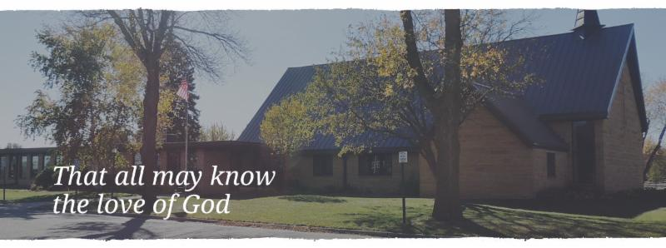
Cross of Calvary is the ELCA church in Olivia. We are an intergenerational (fancy word for young and old) community that follows Jesus out the building to where we live. We are all learners (disciples) here. This is a safe place to practice worship. And, believe us, it takes practice. Your questions, critical thinking, doubts and imperfect lives are welcome here.
Holy Communion
Holy Communion is open to all who are baptized and trust that Christ is present in the meal, regardless of your tradition or affiliation.
Wine (red)/grape juice (white).
Participation
Bold type means all of us read or pray together. Out loud.
* Please stand as you are able.
Children in Church
They belong here! They are hearing God’s Word, music and prayers. We don’t mind fidgeting and chatter! If you like, there are activity bags available in the entry.
Announcements
They are as printed or any new information please give to Pastor Matt prior to worship, please hand a note to Pastor with any announcements, including prayer requests.
Restrooms
They are located in the hallway to the left of the stairs. Changing table located in the Women’s bathroom.
COMMUNITY and CHURCH BOARD
CHECK THE BULLETIN BOARD or east bulletin board for more information /details
Green Lake Lutheran Ministries will hold the 33rd Annual Quilt Auction July 22nd, 2017. Proceeds from this event go to our Annual Fund which allows us to provide fun, safe, quality camping and retreating opportunities for people of all ages who use any of our three camps.
Quilts: please delivery to camp by July 14th, viewing will be available online at www.gllm.org
Silent Auction: item must be brought to camp no later than 5:00 pm on July 20th.
Cash Donation:Checks may be sent to: GLLM, 9916 Lake Ave. S. Spicer, MN 56288.
More information is on the bulletin board on the east entrance.

Renville County Human Services is currently seeking individuals who are willing to be foster parents to children who are in need of a home. Foster parents can be blended families, one or two parent families, retired or single.
The most important aspects of fostering a child is your willingness to provide a loving, safe and stable environment. Foster parents are considered part of a team of individuals who are working to make a better life for a child. Foster parents help a child through a difficult time, share their gifts and talents and receive reimbursement for their dedication and service to children. Is it time to share your gifts and talents and become a foster parent?
Please call Bonnie Lund or Stacie Roxberg, Renville County Human Services at 320-523-2202 to find out more about fostering a child.

The construction of the new sign is underway. The old block has been removed and placed on the west side of the church. If you are interested in any or all the block, please take what you want and leave a free will donation in the church office.

St. Cloud VAHCS and our Nation’s Veterans would like to thank the Cross of Calvary Quilters for their generous donation of quilts valued at over $1,500.00. The quilts will be distributed to Veterans receiving care throughout the facility.

A former member at Cross of Calvary: Marv Peterson died on May 16th at his home in Sun City, AZ. If you would like to send a sympathy card to his wife Marge, stop in the office for the address.

Mission
Paraguay Missionaries
The Kevin & Rebekah Howell family
Bolivia Missionaries
Paul and Jay Mikaelson

Prayer Concerns
Prayer Matters! Please take your bulletin home and pray for those listed.
Prayer concerns are listed for one month.
Emergency/Pastoral Care-Please have a family member or friend notify the church. You may also request hospital staff to call on your behalf. Call day or night at 523-1574. Never feel as though you are bothering Pastor or the staff. We are here to serve as a comfort and as a resource.
*Diana Adkins *Greg & Evelyn Rosenow *Jill Revolinski
*Leslie Sagedahl *Jenna Reynolds *Vonna Ledeboer
*Emily Reetz *Warren Mitchell *Barb Gomarko
*Bert Budd *Donna Greenwell

MAY VOLUNTEERS Coming up in May/June at Cross of Calvary
Communion – 9:00 : Eric Skeie May 29 – Office Closed
Altar Guild – Karen van der Hagen & Angie Boen June 1 – Worship @ 6:00 pm
Acolytes – Caeden Gluesing & London Prokosch June 3 – Flemming wedding (off site)
Usher – 8:30: Nathan Cole, Rod Osthus & Jon Hawkinson June 4 – BOLD Graduation
10:30: Duane & Karen Flom & David Torkelson June 9 & 10 – Synod Assembly @ Gustavus

VBS is June 25th-June 29th, 2017
(Meal starts at 5:30, VBS starts at 6 or 6:30 and runs to 8:30)
There is a VBS planning meeting for anyone interested in helping out with leadership role on February 28th at 7pm at Our Saviors.
March 14th and 28th: Work nights from 6-8pm at Our Saviors
March 25th: Work day from 10-4 at Our Saviors
April 6th and 20th: Work nights from 6-8pm at Our Saviors
May/June TBD if needed
Many hands make this work light and there are a variety of crafts & fairly simple building projects. Any National Honor Society students seeking volunteer hours would be awesome and I am guessing that PM would offer faith elements for Confirmation students to help out as well.
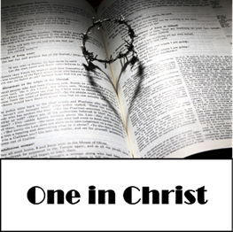

May 28, 2017
Devotion: Use this resource at home to guide your household’s daily devotions. You can do this alone or with others; in the morning, during the day, or at night. Find a routine that works best for you.
Pray: Light a candle and open your devotion time with a prayer.
God of unity and justice, You care less about our ancestry and more about the state of our hearts. Cover us with the garment of your salvation and prepare us for effective witness in your world. In Jesus’ name, Amen.
Reflect: Reflect on the key verses from Sunday’s reading.
As many of you as were baptized into Christ have clothed yourselves with Christ. There is no longer Jew or Greek, there is no longer slave or free, there is no longer male and female; for all of you are one in Christ Jesus. And if you belong to Christ, then you are Abraham’s offspring, heirs according to the promise. Galatians 3:27-29
Study: Study the reading and consider the background.
Paul wrote some of his most famous words to the church in Galatia, calling them out for improperly imposing Jewish customs on their Gentile members. If Paul had a time machine, what do you suppose he might say to us today?
Consider: Consider this theme for the week’s text.
We are one in Christ.
Read: Read the following daily readings to deepen your understanding of Sunday’s text. After the reading, ask the follow-up questions.
Sunday: One in Christ, Galatians 3:1-9, 23-29
Monday: Hagar and Sarah, Galatians 4:21-5:1
Tuesday: The Nature of Christian Freedom, Galatians 5:2-15
Wednesday: Works of the Flesh, Galatians 5:16-21
Thursday: The Fruit of the Spirit, Galatians 5:22-26
Friday: Bear One Another’s Burdens, Galatians 6:1-10
Saturday: Final Words and Blessing, Galatians 6:11-18
How does Paul describe the community of faith?
Connect: Connect in conversation with others in your household. Discuss the following questions, or simply check in with “Highs” and “Lows.”
What was a high point of your day? What was a low point?
What stories does your community have that shape who you are as a community? What stories do you want to have shape you? What stories are ready to be laid to rest? How can you write new stories to shape who you are moving forward?
Who do you want to get to know better? Why?
Do: By acting on what we learn we make God’s word come alive. Do the following activity this week.
Walk in someone’s shoes. Choose one person you love or even someone you want to know more about. Throughout the week, be aware of how the world treats that someone else based on their color, gender, size. How do you treat them?
Bless: Close your devotion with a blessing. We are one in Christ. Ame

