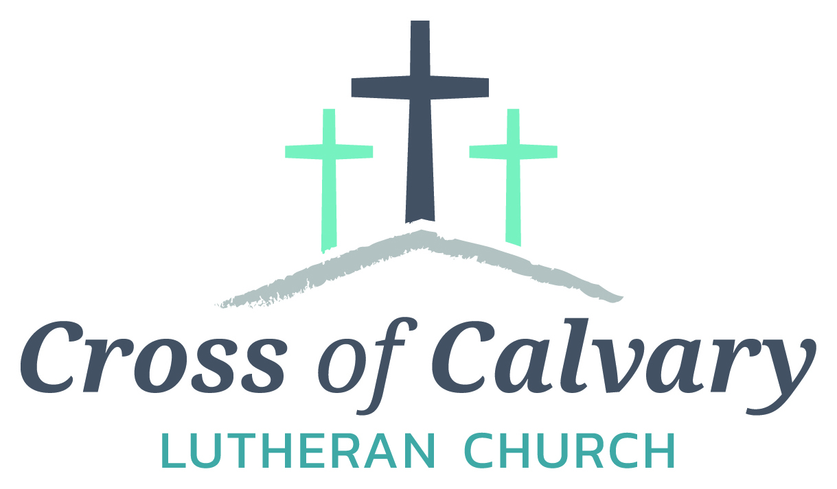

**WorshipTimes**

**Thursday: 6:00**

**Sundays: 9:00**

**Coffee Hour**

**After service**

**Sunday School**

**Resumes: September**

**Building Hours**

**Mon-Thurs**

**8:30-7:00**

**Fri-Sun 8:30-2:00**

**Office Hours**

**Mon, Tues, and Thurs.; 8:30-3:00**

**Wednesday**

**8:30-4:00**

**Friday 8:30-2:00**

**Pastor**

***Matt Hausken***

***hauskenmatt8@gmail.com***

**Admin. Assist.**

**Sue Altmann**

**crossofcalvary@gmail.com**

**Cross of Calvary Lutheran Church**

**1103 W. Chestnut Ave. Olivia, MN 320-523-1574**



**June 11, 2017**

**Weekly Announcements**

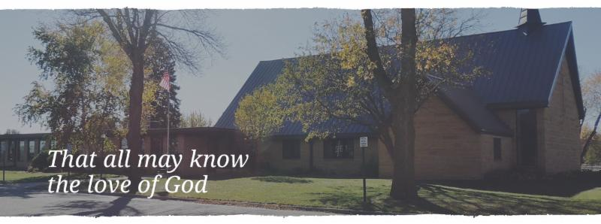

Cross of Calvary is the ELCA church in Olivia. We are an intergenerational (fancy word for young and old) community that follows Jesus out the building to where we live. We are all learners (disciples) here. This is a safe place to practice worship. And, believe us, it takes practice. Your questions, critical thinking, doubts and imperfect lives are welcome here.

**Holy Communion**

Holy Communion is open to all who are baptized and trust that Christ is present in the meal, regardless of your tradition or affiliation.

Wine (red)/grape juice (white).

**Participation**

**Bold type means all of us read or pray together. Out loud.**

* Please stand as you are able.

**Children in Church**

They belong here! They are hearing God’s Word, music and prayers. We don’t mind fidgeting and chatter! If you like, there are activity bags available in the entry.

**Announcements**

They are as printed or any new information please give to Pastor Matt prior to worship, please hand a note to Pastor with any announcements, including prayer requests.

**Restrooms**

They are located in the hallway to the left of the stairs. Changing table located in the Women’s bathroom.

**COMMUNITY and CHURCH BOARD**

**CHECK THE BULLETIN BOARD or east bulletin board for more information /details**

**Green Lake Lutheran Ministries will hold the 33rd Annual Quilt Auction July 22nd, 2017. Proceeds from this event go to our Annual Fund which allows us to provide fun, safe, quality camping and retreating opportunities for people of all ages who use any of our three camps.**

**Quilts**: please delivery to camp by July 14th, viewing will be available online at www.gllm.org

**Silent Auction**: item must be brought to camp no later than 5:00 pm on July 20th.

**Cash Donation:**Checks may be sent to: GLLM, 9916 Lake Ave. S. Spicer, MN 56288.

More information is on the bulletin board on the east entrance.

**Renville County Human Services** is currently seeking individuals who are willing to be foster parents to children who are in need of a home. Foster parents can be blended families, one or two parent families, retired or single.

The most important aspects of fostering a child is your willingness to provide a loving, safe and stable environment. Foster parents are considered part of a team of individuals who are working to make a better life for a child. Foster parents help a child through a difficult time, share their gifts and talents and receive reimbursement for their dedication and service to children. Is it time to share your gifts and talents and become a foster parent?

Please call Bonnie Lund or Stacie Roxberg, Renville County Human Services at 320-523-2202 to find out more about fostering a child.



Cross of Calvary Outreach Committee will be serving a lite dinner on Thursday evenings before service, starting at 5:00 pm. The dinner is a free will donation for missions. Dinner will be served every Thursday in June.

Join us for a Midsummer’s Festival at Swedlanda Lutheran Church on Wednesday, June 21. An Ice-Cream Social will be held from 4:30 – 7:30 pm, with pulled pork sandwiches, beans, potato salad, pie, and home-made ice cream. A program will begin at 7:00 pm and will feature Allen and Matt Carlson, a father and son team who will provide an evening of fun entertainment for the family. Invite your friends! Swedlanda Lutheran Church is 9 miles southwest of Hector, 73950 County. Rd. 16. Please call 320-848-2490 for further information.

The public is invited to an Ice Cream Social at Our Savior’s Lutheran Church Fellowship Hall, Bird Island, MN.

The Social will be on June 15 from 4:30 – 7:00 pm. Menu: BBQ’s, Turkey Sandwiches, Potato Salad, Homemade Baked Beans, Ice Cream, Pie, Cake, Lemonade and Coffee. Proceeds this year are going to: Emergency Funds for Our Savior’s Lutheran Church. Free will Offering. (Ecumenical worship service in the park at 7:00 pm)

**Mission**

**Paraguay Missionaries**

**The Kevin & Rebekah Howell family**

**Bolivia Missionaries**

**Paul and Jay Mikaelson**

**Renville County Food Shelf**



**The food shelf is in need of our help.**

**Cross of Calvary will be doing a 1st & 3rd Sunday of each month Food Shelf collection.**

**We ask that everyone coming to church on these Sunday’s to please bring even one can for the food shelf. Donations of any kind are wonderful.**

**Thank You!!!!**

**Community Garden is looking for volunteers to make a simple compost bin. If interested, contact Betsy Hennen for more information.**



**VBS is June 25th-June 29th, 2017**

**Time: 6:00-8:30 pm**

TIme

2017 VBS Registration online at HTTPS://GOO>GL/FORMS/FP1IMZETVO76CUAH2

Or paper forms are in the church office.

* For ages 3 years old – 6th Grade
* Cost is $15.00 per child (includes T-shirt)
* A light supper will be offered at 5:15pm for an additional $15 (for the week)

Please make checks payable to Our Savior’s Lutheran Church

Registration preferred by June 15th- - Walk in registrations welcome



**Prayer Concerns**

*Prayer Matters! Please take your bulletin home and pray for those listed.*

*Prayer concerns are listed for one month.*

Emergency/Pastoral Care-Please have a family member or friend notify the church. You may also request hospital staff to call on your behalf. Call day or night at 523-1574. Never feel as though you are bothering Pastor or the staff. We are here to serve as a comfort and as a resource.

*Diana Adkins *Greg & Evelyn Rosenow *Jill Revolinski

*Leslie Sagedahl *Jenna Reynolds *Vonna Ledeboer

*Emily Reetz *Warren Mitchell *Barb Gomarko

*Bert Budd *Donna Greenwell *Nancy Krumheuer

**JUNE VOLUNTEERS**

**COMMUNION 9:00 – Tashia Johnson**

**USHERS 9:00 – Shannon Visser, Bill Miller, John Johnston & Chris Hanson**

**ACOLYTES: Carson Kubesh & Ashley Frank**

**ALTAR GUILD: Katie Bahl, Sue Erickson & Jody Steffel**

**Things happen at Cross of Calvary in June**

**June 11 – Worship at 9:00 am**

**June 14 – Sue out of office (State Golf)**

**June 15 – Worship at 6:00 pm**

**June 18 – Worship at 9:00 am – Father’s Day**

**June 19 – Kitchen being used for Cooking Club at 5:00 pm**

**June 21 – Church Council Meeting at 7:00 pm**

**June 22 – Worship at 6:00 pm**

**June 25 – Worship at 9:00 am**

**June 25 – 29: VBS at Our Saviors in Bird Island**

**June 29 – Worship at 6:00 pm**

**June 30 – Pastor Matt Birthday!!!!**



**June 11, 2017**

***Use this resource at home to guide your household’s daily devotions.***

**Pray: Light a candle and open your devotion time with a**

**prayer.**

**God of all, you are ever worthy of our praise. Show us your**

**blessings anew and open our eyes to what has always been**

**before us. In the name of Jesus, Amen.**

**Read: Read the key verse from Sunday’s reading.**

***5For the Lord is good; his steadfast love endures forever, and***

***his faithfulness to all generations. (Psalm 100:5)***

**Reflect: Reflect on the scripture summary.**

**The whole creation erupts in praise for its Creator, and we are a**

**part of it. The time has come to rejoice in word, song, and**

**action.**

**Connect: Connect in conversation with others in your**

**household.**

**What was a high point of your day? What was a low point?**

**Where do you see God working in the world? What makes you praise God?**

**Wonder: What brings God joy? What is God’s favorite animal?**

**Geography? Weather? Food? What are some of God’s other**

**favorites? Why?**

**Bless: Close your devotion with a blessing.**

**May God bless you as you praise God! Amen.**

**Do: By acting on what we learn, we make God’s word come alive.**

**Do the following activity this week.**

**Take 5 minutes each day this week to praise God in a unique**

**way. Here are some ideas: Sing your favorite Christmas carol,**

**do your favorite yoga pose, or take a photo of something**

**beautiful.**



**Go Deeper: Go to clergystuff.com/daily-devotions for**

**devotions on the daily readings.**

**Sunday, Psalm 100**

**Monday, Psalm 103**

**Tuesday, Psalm 105**

**Wednesday, Psalm 111**

**Thursday, Psalm 135**

**Friday, Psalm 147**

**Saturday, Psalm 149**

Hello Everyone!

My name is Ben Davidson and I work for Special Olympics Minnesota. There is a Bocce Ball event taking place at Dirks Field in Olivia, MN on July 8th and we are looking for volunteers. We’ll be in the fields tossing Bocce and we need YOU to join in the fun!

I made it a point to reach out to Cross of Calvary because I know how much our athletes love to have an energetic crowd to cheer them on and volunteer throughout the day. No prior experience with Special Olympics is necessary and though we do have a few different rules, we would be happy to provide all of the necessary information and training to you ahead of time.

**In short…**

**WHAT:** Special Olympics MN Bocce Competition

**WHERE:** Dirks Field- Olivia, MN

**WHY:** Without volunteers, our events would not be possible! Did we mention you will receive a free volunteer shirt and lunch?

**WHEN**: Saturday, July 8, 7:00AM - 1:00PM (shift times vary)

**HOW**: E-mail [ben.davidson@somn.org](mailto:ben.davidson@somn.org) or register online at[http://specialolympicsminnesota.org/who-we-are/volunteers/.](http://specialolympicsminnesota.org/who-we-are/volunteers/)

By volunteering your time, you are directly making a positive impact on the lives of our Special Olympic athletes. Without people like you, we wouldn’t be able to put on a competition that our athletes look forward to competing in year after year.  If you are at all interested, please reply back to this email or head to our website to get registered!

**Volunteer Shifts:**

Set Up (5): 7:00AM-8:30AM

Scorekeeping at Pitches (20): 9;00AM-12:00PM

Awards Assistant (3): 11:00AM-12:30PM

If you have any questions about getting signed up or what the volunteer positions entail, please do not hesitate to contact me. Thank you!