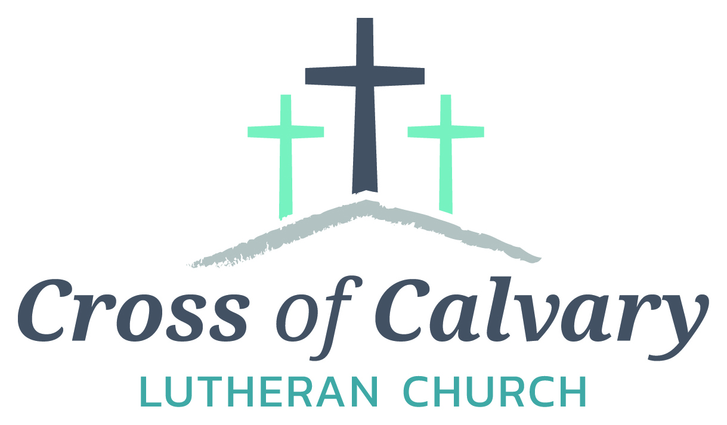

**WorshipTimes**

**Thursday: 6:00**

**Sundays: 9:00**

**Coffee Hour**

**After service**

**Sunday School**

**Resumes: September**

**Building Hours**

**Mon-Thurs**

**8:30-7:00**

**Fri-Sun 8:30-2:00**

**Office Hours**

**Mon, Tues, and Thurs.; 8:30-3:00**

**Wednesday**

**8:30-4:00**

**Friday 8:30-2:00**

**Pastor**

***Matt Hausken***

***hauskenmatt8@gmail.com***

**Admin. Assist.**

**Sue Altmann**

**crossofcalvary@gmail.com**

**Cross of Calvary Lutheran Church**

**1103 W. Chestnut Ave. Olivia, MN 320-523-1574**



**July 9, 2017**

**Weekly Announcements**

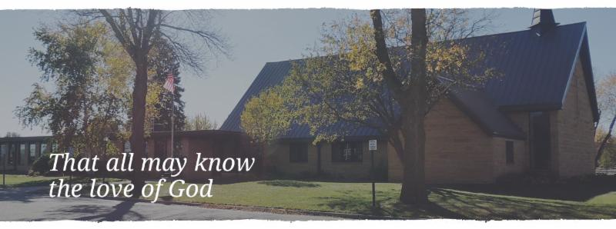

Cross of Calvary is the ELCA church in Olivia. We are an intergenerational (fancy word for young and old) community that follows Jesus out the building to where we live. We are all learners (disciples) here. This is a safe place to practice worship. And, believe us, it takes practice. Your questions, critical thinking, doubts and imperfect lives are welcome here.

**Holy Communion**

Holy Communion is open to all who are baptized and trust that Christ is present in the meal, regardless of your tradition or affiliation.

Wine (red)/grape juice (white).

**Participation**

**Bold type means all of us read or pray together. Out loud.**

* Please stand as you are able.

**Children in Church**

They belong here! They are hearing God’s Word, music and prayers. We don’t mind fidgeting and chatter! If you like, there are activity bags available in the entry.

**Announcements**

They are as printed or any new information please give to Pastor Matt prior to worship, please hand a note to Pastor with any announcements, including prayer requests.

**Restrooms**

They are located in the hallway to the left of the stairs. Changing table located in the Women’s bathroom.

**COMMUNITY and CHURCH Events**

**CHECK THE BULLETIN BOARD or east bulletin board for more information /details**

**Green Lake Lutheran Ministries will hold the 33rd Annual Quilt Auction July 22nd, 2017. Proceeds from this event go to our Annual Fund which allows us to provide fun, safe, quality camping and retreating opportunities for people of all ages who use any of our three camps.**

**Quilts**: please delivery to camp by July 14th, viewing will be available online at www.gllm.org

**Silent Auction**: item must be brought to camp no later than 5:00 pm on July 20th.

**Cash Donation:**Checks may be sent to: GLLM, 9916 Lake Ave. S. Spicer, MN 56288.

More information is on the bulletin board on the east entrance.

Fairview Place Pie & Ice Cream Social: Thursday, July 27th from 2:00-4:00 pm. They will be serving pie & ice cream, lemonade and coffee. They hope you will join them!!!!

(Fairview Place 603 E. Fairview Ave Olivia, MN

**United Lutheran Church of Lake Lillian** will be hosting an Ice Cream Social on Wednesday, July 12th from 5:00 – 7:00 pm Menu: BBQs, Hot dogs, Beans, Potato Chips, Pickles, Watermelon, Ice Cream Sundaes, Pies, and Beverage Free Will Offering

**JULY VOLUNTEERS**

COMMUNION 9:00 – Curt Sather

USHERS 9:00 – Mark Thiesse, Clayton Erickson, Randy Marguth, Curt Schroeder

ACOLYTES: Will Hanson & NEED Help!!!!!

ALTAR GUILD: Sandy Gay & Cheryl Mallak

**Things happening at Cross of Calvary in July**

July 15 – 21: TIM Convention (Pastor Matt)

(Teens in Mission)

July 25 – August 2 – Sue out of office (I will be in Ireland)

**Mission**

Paraguay Missionaries

The Kevin & Rebekah Howell family

Bolivia Missionaries

Paul and Jay Mikaelson

**Meals-on-Wheels (JULY)**

**Drivers are needed, sign-up on board in Narthex**

**(The week of July 30th is still open)**

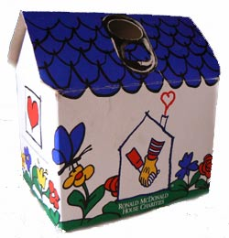Start saving those little aluminum tabs from your beverage containers and you could be a winner of one of three cash prizes. The **Sons of the American Legion** are sponsoring a contest for the purpose of collecting as many Aluminum tabs as possible. The tabs will be turned over to the Ronald McDonald Homes of Minnesota. These tabs generate funds to assist operating these homes which are made available to family members while children and adults are being treated at hospitals in MN. You can find these little tabs on beverage and soup cans. The tabs will weighed on Saturday, September 9th at the Legion in Olivia during the Fire Departments Annual Rib Fest. Cash prizes are as follows: first place $50, Second place $30 and third place $20.

**Prayer Concerns**

*Prayer Matters! Please take your bulletin home and pray for those listed.*

*Prayer concerns are listed for one month.*

Emergency/Pastoral Care-Please have a family member or friend notify the church. You may also request hospital staff to call on your behalf. Call day or night at 523-1574. Never feel as though you are bothering Pastor or the staff. We are here to serve as a comfort and as a resource.

*Diana Adkins *Greg & Evelyn Rosenow *Jill Revolinski

*Leslie Sagedahl *Jenna Reynolds *Vonna Ledeboer

*Emily Reetz *Warren Mitchell *Barb Gomarko

*Bert Budd *Donna Greenwell *Nancy Krumheuer

*Ron Balgaard

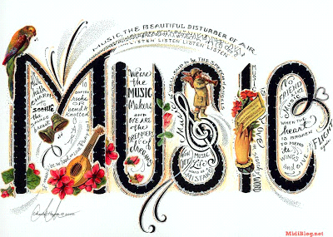

***Use this resource at home to guide your household’s daily devotions***



Pray: Light a candle and open your devotion time with a prayer.

** God in whom we praise, there is no place on earth or in heaven where our praise cannot reach you. Receive the offering of our hearts, and join our voice in one hymn of thanksgiving. In Jesus’ name, Amen.**

**Read:** Read the key verse from Sunday’s reading.

*6Let everything that breathes praise the Lord! Praise the Lord!*

*(Psalm 150:6)*

****Reflect:** Reflect on the scripture summary.

Imagine handing out instruments to a roomful of children, and what the sound would be like. The psalmist encourages us to praise God with every note, every breath, in every corner of creation.



**Connect:** Connect in conversation with others in yourhousehold.

**What was a high point of your day? What was a low point?**

**Tell of a time you were so happy, you danced.**

**Wonder: What makes God dance? What is God’s favorite musical instrument? Why?**



**Bless:** Close your devotion with a blessing.

**May God fill you with music. Amen.**



**Do:** By acting on what we learn, we make God’s word come alive.

Do the following activity this week.

**Make music. Dig out an old musical instrument, or make one. Put dry rice or beans in an empty paper towel roll and cover the ends with parchment paper to make a rain stick. Use wooden spoons and an upside-down pot to make a drum. Play along to**

**your favorite song or make up your own song of praise.**

**Go Deeper:** Go to clergystuff.com/daily-devotions for devotions on the daily readings.

**Sunday, Psalm 150-Monday, Psalm 2-Tuesday, Psalm 22-Wednesday, Psalm 25**

**Thursday, Psalm 50-Friday, Psalm 106-Saturday, Psalm 119**