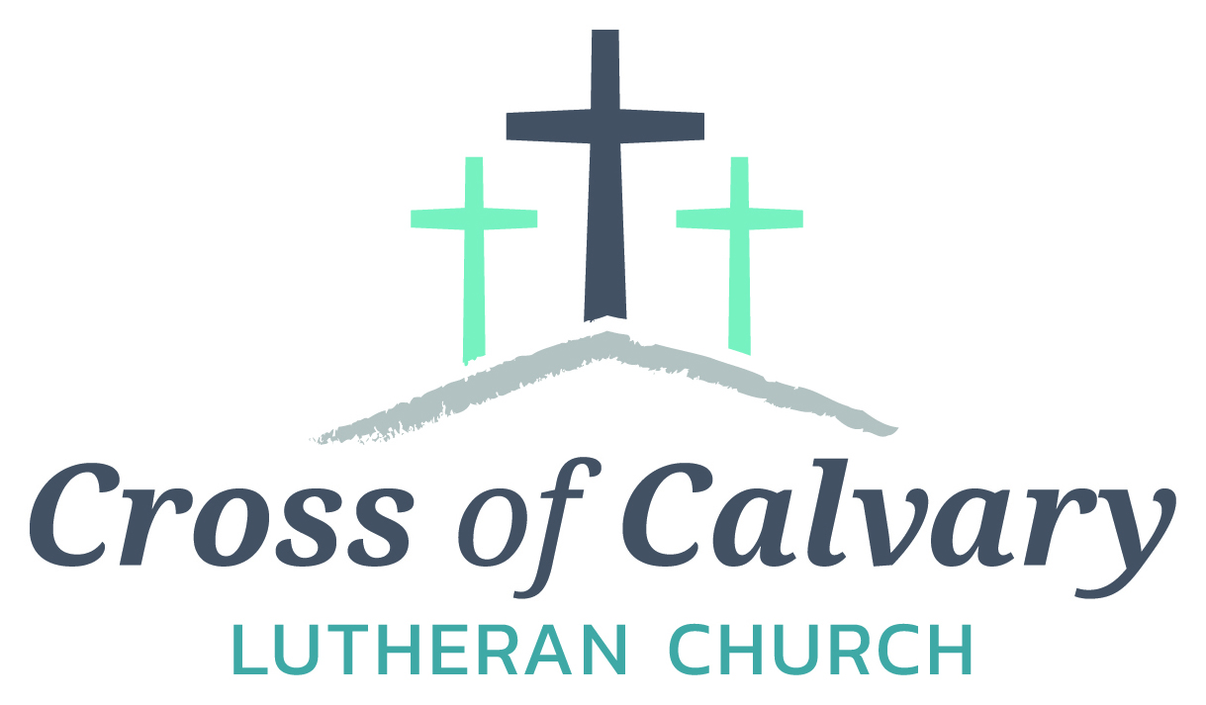

**WorshipTimes**

**Thursday: 6:00**

**Sundays: 9:00**

**Coffee Hour**

**After service**

**Sunday School**

**Resumes: September**

**Building Hours**

**Mon-Thurs**

**8:30-7:00**

**Fri-Sun 8:30-2:00**

**Office Hours**

**Mon, Tues, and Thurs.; 8:30-3:00**

**Wednesday 8:30-4:00**

**Friday 8:30-2:00**

**Pastor: Matt Hausken**

[***hauskenmatt8@gmail.com***](mailto:hauskenmatt8@gmail.com)

***Parish* Ministers*:* Sarah Hausken and Jeni Skeie**

[**crossofcalvaryouth@gmail.com**](mailto:crossofcalvaryouth@gmail.com)

**Admin: Sue Altmann**

**crossofcalvary@gmail.com**

**Cross of Calvary Lutheran Church**

**1103 W. Chestnut Ave. Olivia, MN 320-523-1574**



**September 3, 2017**

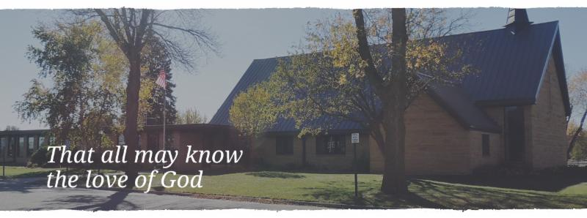

Cross of Calvary is the ELCA church in Olivia. We are an intergenerational (fancy word for young and old) community that follows Jesus out the building to where we live. We are all learners (disciples) here. This is a safe place to practice worship. And, believe us, it takes practice. Your questions, critical thinking, doubts and imperfect lives are welcome here.

**Holy Communion**

Holy Communion is open to all who are baptized and trust that Christ is present in the meal, regardless of your tradition or affiliation.

Wine (red)/grape juice (white).

**Participation**

**Bold type means all of us read or pray together. Out loud.** * Please stand as you are able.

**Children in Church**

They belong here! They are hearing God’s Word, music and prayers. We don’t mind fidgeting and chatter! If you like, there are activity bags available in the entry.

**Announcements**

They are as printed or any new information please give to Pastor Matt prior to worship, please hand a note to Pastor with any announcements, including prayer requests.

**Restrooms**

They are located in the hallway to the left of the stairs.

**COMMUNITY and CHURCH Events**

**CHECK THE BULLETIN BOARD or east bulletin board for more information /details**

**SEPTEMBER VOLUNTEERS**

**COMMUNION 8:30 – Bobbi Kopel - 10:30 – Dana Boen**

**USHERS 8:30 – Brian Kingery, Dan Gross, Dan Amberg & Jordan Amberg**

**10:30 – Doug Steffel & Duane Amberg**

**ACOLYTES:**

**ALTAR GUILD: Marlys Klinghagen & Barb Wertish**

**Things happening at Cross of Calvary in September**

9/6 – Confirmation Starts, Parent meeting at 6:00 pm

9/9 – Saturday night Service starts

9/10 – Rally Sunday, 8:30 & 10:30 service starts

9/10 – 3rd & 8th Grade receive their Bibles during service

**“God’s Work, Our Hands”**

**Sunday, September 10th**

**“God’s Work, Our Hands”**

 Sunday is an opportunity to celebrate who we are as the Evangelical Lutheran Church in America, freed in Christ to serve and love our neighbor.

11:45 am – Pot Luck Dinner

12:45 pm – Sending Devotion

1:00 – 3:00pm – Service Projects throughout our Community

Sign up on “The Door.”

**Olivia Cemetery Work Night**

The Olivia Cemetery has scheduled a Work Night on Monday, Sept 11th from 3:00 pm until dark. Do you have any friends or relatives buried there and ever wonder how the cemetery is even taken care of? In the desire to keep the grounds looking nice we welcome you to join us as we trim some trees, raise a few sunken markers and see what is needed to show honor for those buried in our cemetery. Questions can be directed to Gordy Blem at 523-1102. If you could give us an hour or so it would be much appreciated. Remember it is NOT a City owned cemetery and it's the volunteers who deserve the credit for keeping it nice!

Start saving those little aluminum tabs from your beverage containers and you could be a winner of one of three cash prizes. The **Sons of the American Legion** are sponsoring a contest for the purpose of collecting as many Aluminum tabs as possible. The tabs will be turned over to the Ronald McDonald Homes of Minnesota. These tabs generate funds to assist operating these homes which are made available to family members while children and adults are being treated at hospitals in MN. You can find these little tabs on beverage and soup cans. The tabs will weighed on Saturday, September 9th at the Legion in Olivia during the Fire Departments Annual Rib Fest. Cash prizes are as follows: first place $50, Second place $30 and third place $20.

**Prayer Concerns**

*Prayer Matters! Please take your bulletin home and pray for those listed.*

*Prayer concerns are listed for one month.*

Emergency/Pastoral Care-Please have a family member or friend notify the church. You may also request hospital staff to call on your behalf. Call day or night at 523-1574. Never feel as though you are bothering Pastor or the staff. We are here to serve as a comfort and as a resource.

*Diana Adkins *Greg & Evelyn Rosenow *Jill Revolinski

*Leslie Sagedahl *Jenna Reynolds *Vonna Ledeboer

*Emily Reetz *Warren Mitchell *Barb Gomarko

*Nancy Krumheuer *Todd Maresch *Jean Maresch * Charles W. Brown * Stan Matti *Bill & Barb Miller

*Joanne Balgaard *Russ Grisso *Mike & Brittney Harrell

Thanksgiving is worth celebrating any time of year! St. John’s Catholic Church in Hector is having their 19th annual Turkey Supper on Sept. 6, 2017. We will be serving in our parish hall from 4:00 to 7:000 pm. Take-outs will also be available at this time. The menu includes turkey, dressing, mashed potatoes and gravy, green beans, coleslaw, cranberries, bread, pickles, beverage and pumpkin bars. Cost is $10.00 for adults and $5.00 for children ages 4-10. All are invited!

United Lutheran Church in Lake Lillian is hosting its annual Fall Festival on Thursday, Oct. 5th from 5:00 – 7:00 pm. Swedish meatball supper, plus: produce, crafts & bake sale.

Adults: $10.00, 6-12 yrs: $3.00 & 5 years and under Free. Menu: Swedish meatball, potatoes, vegetables, beverage, coleslaw, rolls, desserts.

**September 3, 2017**

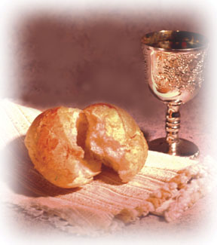

***Use this resource at home to guide your household’s daily devotions***

** Pray**: Light a candle and open your devotion time with a prayer.

Holy God, your law is good and exists for the sake of your

people. Uphold us in putting love above all other things, that

the world would know your goodness and mercy. In Jesus’

name, Amen.

**Read:** Read the key verse from Sunday’s reading.

*1At that time Jesus went through the grain fields on the sabbath; his disciples were hungry, and they began to pluck heads of grain and to eat. 2When the Pharisees saw it, they said to him, “Look, your disciples are doing what is not lawful to do on the sabbath.” (Matthew 12:1-2)*

**Reflect:** Reflect on the scripture summary.



*T*oday we cannot escape the image of God’s servants eating

holy grains against ritual practice, in order to sustain

themselves. And they might even get away with it—as long as God is the final judge.

**Connect:** Connect in conversation with others in yourhousehold.

** What was a high point of your day? What was a low point?**

**Today we cannot escape the image of God’s servants eating holy grains against ritual practice, in order to sustain themselves. And they might even get away with it—as long as God is the final judge.**

**Bless:** Close your devotion with a blessing.

**May God bless your changing expectations. Amen.**

**Do:** By acting on what we learn, we make God’s word come alive.

Do the following activity this week.

**Evaluate the rules and expectations in your household. Are there some rules that served a purpose at one time but no longer do? Change an expectation that is driving a wedge between you and others in your household.**

**Go Deeper:** Go to clergystuff.com/daily-devotions for devotions on the daily readings.

**Sunday, 1 Samuel 21:1-9, Matthew 12:1-8 or Mark 14:12-25, The Lord’s Supper**

**Monday, Psalm 43, Grace**

**Tuesday, Romans 3:23-24, Justified by Grace**

**Wednesday, Romans 8:8, Definition of Grace**

**Thursday, Ephesians 2:4-5, 8, By Grace We Are Saved**

**Friday, Lamentations 3:24-25, Hope in the Lord**

**Saturday, Psalm 33, Hope in God**

**GIVING ONLINE**

**at Cross of Calvary**

**Cross of Calvary is reminding you can now manage your giving online! Giving online is easy and allows you to set up automatic recurring contributions and view your complete online giving history from anywhere you have access to the Internet.**

**Simply follow these easy steps:**

**1) Visit the church website at crossofcalvary.net**

**2) Click on the GIVE button,**

**3) Click on HERE TO GIVE, then**

**4) Follow the onscreen instructions to create an online profile and to schedule your recurring contributions.**

**Thank you for your contribution!!!**



**Mission**

**Paraguay Missionaries**

**The Kevin & Rebekah Howell family**

**Bolivia Missionaries**

**Paul and Jay Mikaelson House**

**Cross of Calvary & Our Saviors**

**Annual Golf Tournament**



**What: Scramble Golf**

**When: September 17, 2017**

**Where: Olivia Golf Course**

**Who: EVERYONE!!!!**

**Cost: $50.00 per person, 4 person team**

**Things included in the day: golf, lunch & dinner**

**Extras: Games and more games**

**Sign on the bulletin board!!!!**



**Rally Sunday**

**September 10th**

**3rd & 8th Graders**

**Receive their Bibles**