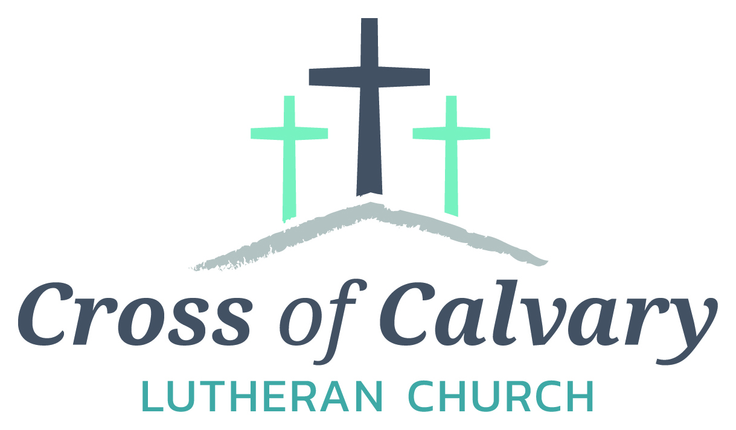

**WorshipTimes**

**Saturday: 5:30 PM**

**Sunday: 8:30 & 10:30**

**Coffee Hour**

**Sunday: 9:30 AM**

**Sunday School**

**Sunday: 9:30 AM**

**Building Hours**

**Mon-Thurs**

**8:30-7:00**

**Fri-Sun 8:30-2:00**

**Office Hours**

**Mon, Tues, and Thurs.; 8:30-3:00**

**Wednesday 8:30-4:00**

**Friday 8:30-2:00**

**Pastor: Matt Hausken**

[***hauskenmatt8@gmail.com***](mailto:hauskenmatt8@gmail.com)

***Parish* Ministers*:* Sarah Hausken and Jeni Skeie**

[**crossofcalvaryouth@gmail.com**](mailto:crossofcalvaryouth@gmail.com)

**Admin: Sue Altmann**

**crossofcalvary@gmail.com**

**Cross of Calvary Lutheran Church**

**1103 W. Chestnut Ave. Olivia, MN 320-523-1574**



**September 10, 2017**

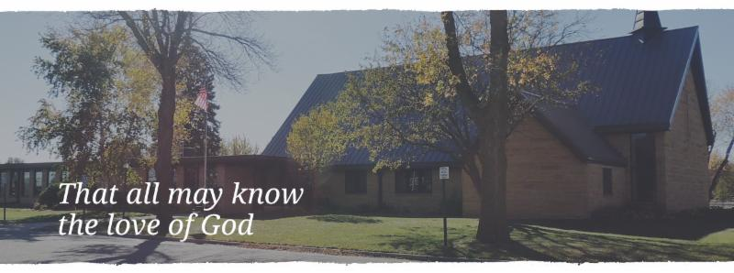

Cross of Calvary is the ELCA church in Olivia. We are an intergenerational (fancy word for young and old) community that follows Jesus out the building to where we live. We are all learners (disciples) here. This is a safe place to practice worship. And, believe us, it takes practice. Your questions, critical thinking, doubts and imperfect lives are welcome here.

**Holy Communion**

Holy Communion is open to all who are baptized and trust that Christ is present in the meal, regardless of your tradition or affiliation.

Wine (red)/grape juice (white).

**Participation**

**Bold type means all of us read or pray together. Out loud.** * Please stand as you are able.

**Children in Church**

They belong here! They are hearing God’s Word, music and prayers. We don’t mind fidgeting and chatter! If you like, there are activity bags available in the entry.

**Announcements**

They are as printed or any new information please give to Pastor Matt prior to worship, please hand a note to Pastor with any announcements, including prayer requests.

**Restrooms**

They are located in the hallway to the left of the stairs.

**COMMUNITY and CHURCH Events**

**CHECK THE BULLETIN BOARD or east bulletin board for more information /details**

**SEPTEMBER VOLUNTEERS**

**COMMUNION 8:30 – Bobbi Kopel - 10:30 – Dana Boen**

**USHERS 8:30 – Brian Kingery, Dan Gross, Dan Amberg & Jordan Amberg**

**10:30 – Doug Steffel & Duane Amberg**

**ACOLYTES: Leif Hausken & Cam Larson**

**ALTAR GUILD: Marlys Klinghagen & Barb Wertish**

**Things happening at Cross of Calvary in September**

9/10 – Rally Sunday, 8:30 & 10:30 service

9/10 – 3rd & 8th Grade receive their Bibles during service

9/11-9/17 – Jeni out of the office

9/17 – Baptism (Osthus)

9/19 – Staff at a workshop form 9:00 – 2:30 pm

**“God’s Work, Our Hands”**

**Sunday, September 10th**

**“God’s Work, Our Hands”**



Sunday is an opportunity to celebrate who we are as the Evangelical Lutheran Church in America, freed in Christ to serve and love our neighbor.

11:45 am – Pot Luck Dinner

12:45 pm – Sending Devotion

1:00 – 3:00pm – Service Projects throughout our Community

Sign up on “The Door.”

**Olivia Cemetery Work Night**

The Olivia Cemetery has scheduled a Work Night on Monday, Sept 11th from 3:00 pm until dark. Do you have any friends or relatives buried there and ever wonder how the cemetery is even taken care of? In the desire to keep the grounds looking nice we welcome you to join us as we trim some trees, raise a few sunken markers and see what is needed to show honor for those buried in our cemetery. Questions can be directed to Gordy Blem at 523-1102. If you could give us an hour or so it would be much appreciated. Remember it is NOT a City owned cemetery and it's the volunteers who deserve the credit for keeping it nice!

**United Lutheran Church in Lake Lillian** is hosting its annual Fall Festival on Thursday, Oct. 5th from 5:00 – 7:00 pm. Swedish meatball supper, plus: produce, crafts & bake sale. Adults: $10.00, 6-12 yrs.: $3.00 & 5 years and under Free. Menu: Swedish meatball, potatoes, vegetables, beverage, coleslaw, rolls, desserts.

**Prayer Concerns**

*Prayer Matters! Please take your bulletin home and pray for those listed.*

*Prayer concerns are listed for one month.*

Emergency/Pastoral Care-Please have a family member or friend notify the church. You may also request hospital staff to call on your behalf. Call day or night at 523-1574. Never feel as though you are bothering Pastor or the staff. We are here to serve as a comfort and as a resource.

*Diana Adkins *Greg & Evelyn Rosenow *Jill Revolinski

*Leslie Sagedahl *Jenna Reynolds *Vonna Ledeboer

*Emily Reetz *Warren Mitchell *Barb Gomarko

*Nancy Krumheuer *Todd Maresch *Jean Maresch * Charles W. Brown * Stan Matti *Barb Miller

*Mike & Brittney Harrell *Family of Bill Miller *Janice Gass

*Family of Mary Deano

**September 10, 2017**



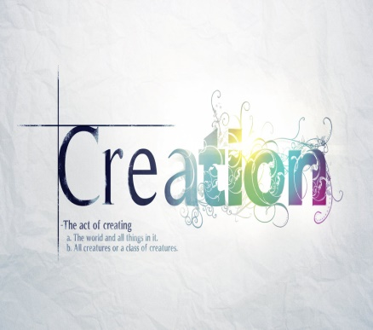

***Use this resource at home to guide your household’s daily devotions***

** Pray**: Light a candle and open your devotion time with a prayer.

**Beloved Creator, everything in heaven and earth bears your**

**signature. May we ever rejoice that you have made us, and that you have made us your own, through the loving-kindness of Jesus our Savior. Amen.**

**Read:** Read the key verse from Sunday’s reading.

*1 In the beginning when God created the heavens and the earth, 2 the earth was a formless void and darkness covered the face of the deep, while a wind from God swept over the face of the waters.*

*(Genesis 1:1-2)*

**Reflect:** Reflect on the scripture summary.

God is hard at work crafting each aspect of the universe,

sparing no detail. But even the Almighty Creator takes time to rest.******

**Connect:** Connect in conversation with others in yourhousehold.

**What was a high point of your day? What was a low point?**

**What does it mean that you are created in God’s image? What**

**about yourself reminds you of God?**

**Wonder: What is God’s favorite thing that God created?**



**Bless:** Close your devotion with a blessing.

**May God continue to create and re-create you each day. Amen**

**Do:** By acting on what we learn, we make God’s word come alive.

Do the following activity this week.

**Donate time or money to a local organization that protects the planet in some way. Journal about your experience.**

**Go Deeper:** Go to clergystuff.com/daily-devotions for devotions on the daily readings.

**Sunday, Genesis 1:1—2:4a, Creation by the Word**

**Monday, Genesis 2:4b-25, A Second Account of Creation**

**Tuesday, Genesis 3:1-13, The First Sin**

**Wednesday, Genesis 3:14-24, Punishment**

**Thursday, Genesis 4:1-16, Cain Murders Abel**

**Friday, Genesis 4:1-26, Beginnings of Civilization**

**Saturday, Genesis 18:1-15, A Son Promised to Abraham and Sarah**

**GIVING ONLINE**

**at Cross of Calvary**

**Cross of Calvary is reminding you can now manage your giving online! Giving online is easy and allows you to set up automatic recurring contributions and view your complete online giving history from anywhere you have access to the Internet.**

**Simply follow these easy steps:**

**1) Visit the church website at crossofcalvary.net**

**2) Click on the GIVE button,**

**3) Click on HERE TO GIVE, then**

**4) Follow the onscreen instructions to create an online profile and to schedule your recurring contributions.**

**Thank you for your contribution!!!**

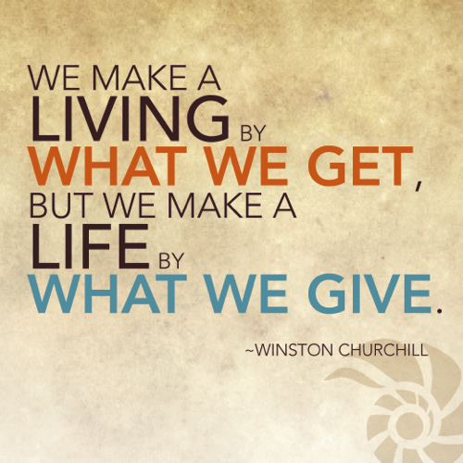

**Mission**

**Paraguay Missionaries**

**The Kevin & Rebekah Howell family**

**Bolivia Missionaries**

**Paul and Jay Mikaelson House**

**Cross of Calvary & Our Saviors**

**Annual Golf Tournament**



**What: Scramble Golf**

**When: September 17, 2017**

**Where: Olivia Golf Course**

**Who: EVERYONE!!!!**

**Cost: $50.00 per person, 4 person team**

**Things included in the day: golf, lunch & dinner**

**Extras: Games and more games**

**Sign on the bulletin board!!!!**



**9/13 – WOW starts at 3:15 pm**

**9/14 – Breakfast Club starts at 7:07 am**

**9/21 – 1st Communion Classes start at 3:30 pm (5th Grade)**