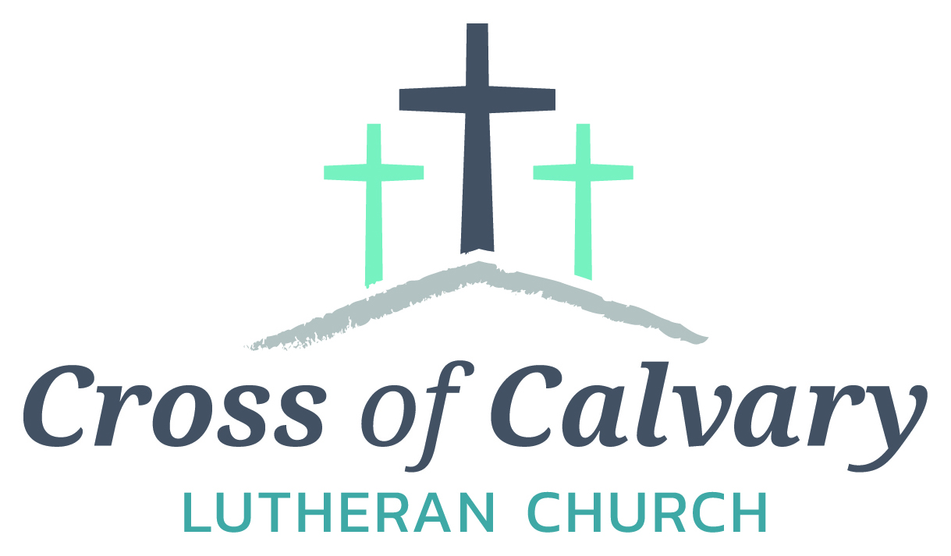

**WorshipTimes**

**Saturday: 5:30 PM**

**Sunday: 8:30 & 10:30**

**Coffee Hour**

**Sunday: 9:30 AM**

**Sunday School**

**Sunday: 9:30 AM**

**Building Hours**

**Mon-Thurs**

**8:30-7:00**

**Fri-Sun 8:30-2:00**

**Office Hours**

**Mon, Tues, and Thurs.; 8:30-3:00**

**Wednesday 8:30-4:00**

**Friday 8:30-2:00**

**Pastor: Matt Hausken**

[***hauskenmatt8@gmail.com***](mailto:hauskenmatt8@gmail.com)

***Parish* Ministers*:* Sarah Hausken and Jeni Skeie**

[**crossofcalvaryouth@gmail.com**](mailto:crossofcalvaryouth@gmail.com)

**Admin: Sue Altmann**

**crossofcalvary@gmail.com**

**Cross of Calvary Lutheran Church**

**1103 W. Chestnut Ave. Olivia, MN 320-523-1574**



**September 17, 2017**

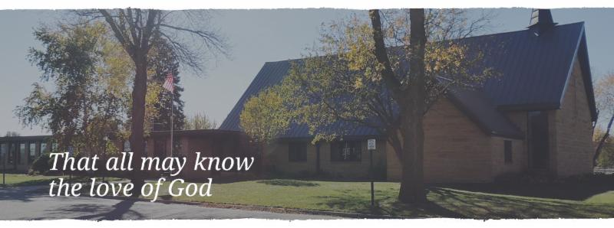

Cross of Calvary is the ELCA church in Olivia. We are an intergenerational (fancy word for young and old) community that follows Jesus out the building to where we live. We are all learners (disciples) here. This is a safe place to practice worship. And, believe us, it takes practice. Your questions, critical thinking, doubts and imperfect lives are welcome here.

**Holy Communion**

Holy Communion is open to all who are baptized and trust that Christ is present in the meal, regardless of your tradition or affiliation.

Wine (red)/grape juice (white).

**Participation**

**Bold type means all of us read or pray together. Out loud.** * Please stand as you are able.

**Children in Church**

They belong here! They are hearing God’s Word, music and prayers. We don’t mind fidgeting and chatter! If you like, there are activity bags available in the entry.

**Announcements**

They are as printed or any new information please give to Pastor Matt prior to worship, please hand a note to Pastor with any announcements, including prayer requests.

**Restrooms**

They are located in the hallway to the left of the stairs.

**COMMUNITY EVENTS**

**CHECK THE BULLETIN BOARD or east bulletin board for more information /details**

**United Lutheran Church in Lake Lillian** is hosting its annual Fall Festival on Thursday, Oct. 5th from 5:00 – 7:00 pm. Swedish meatball supper, plus: produce, crafts & bake sale. Adults: $10.00, 6-12 yrs.: $3.00 & 5 years and under Free. Menu: Swedish meatball, potatoes, vegetables, beverage, coleslaw, rolls, desserts.

**Adult Grief Support Group** will begin meeting on October 2, 2017. (Meetings will be every Monday until November 6th.)For more information on the support group or to register, please call Lacey Bruns at the Redwood Area Hospital at 507-637-4617. There is also a brochure on the east entrance board.

**Safe Avenues annual fundraiser “Make a Difference” Event** is on Friday, November 17th at 6:00 pm at Max’s Grill in Olivia! The fundraiser is held to raise awareness and support efforts to assist victims of domestic and sexual violence in our Renville Count Outreach Program.

**Renville County Services (Annmarie Suess)** is working with a group planning on bringing in a cooking class to Renville County geared towards adults that have young families. They are hoping to have childcare available to allow the parents to focus their energy on learning cooking basics. We are checking with local people and organizations to see if they would know anyone interested in volunteering some time. The class will meet on Thursdays from October 5-November 9 from 10-12 at the Olivia Government Center. There will be a meal provided at the end that the volunteers are welcome to eat with the families. A person could volunteer for all 6 classes or for a couple. If anyone from Cross of Calvary church would be interested in volunteering, either e-mail Annmarie or call directly. annmaries@renvillecountymn.com/320-523-3727

**Prayer Concerns**

*Prayer Matters! Please take your bulletin home and pray for those listed.*

*Prayer concerns are listed for one month.*

Emergency/Pastoral Care-Please have a family member or friend notify the church. You may also request hospital staff to call on your behalf. Call day or night at 523-1574. Never feel as though you are bothering Pastor or the staff. We are here to serve as a comfort and as a resource.

*Diana Adkins *Greg & Evelyn Rosenow *Jill Revolinski

*Leslie Sagedahl *Jenna Reynolds *Vonna Ledeboer

*Emily Reetz *Warren Mitchell *Barb Gomarko

*Nancy Krumheuer *Todd Maresch *Jean Maresch

* Charles W. Brown * Stan Matti *Barb Miller

*Mike & Brittney Harrell *Family of Bill Miller *Janice Gass

*Kent Kircher *Emily Schueler

**Mission**

**Paraguay Missionaries**

The Kevin & Rebekah Howell family

**Bolivia Missionaries**

Paul and Jay Mikaelson House

**SEPTEMBER VOLUNTEERS**

**COMMUNION 8:30 – Bobbi Kopel - 10:30 – Dana Boen**

**USHERS 8:30 – Brian Kingery, Dan Gross, Dan Amberg & Jordan Amberg**

**10:30 – Doug Steffel & Duane Amberg**

**ACOLYTES: Leif Hausken & Will Hanson**

**ALTAR GUILD: Marlys Klinghagen & Barb Wertish**

**VOLUNTEER: would you like to lead a Children’s message??? Please, sign up on “The Board” in the Narthex.**

**Things happening at Cross of Calvary in September**

**9/17 – Baptism (Osthus)**

**9/19 – Staff at a workshop from 9:00 – 2:30 pm**

**September 17, 2017**





***Use this resource at home to guide your household’s daily devotions***

** Pray**: Light a candle and open your devotion time with a prayer.

**Faithful God, you do not bestow gifts only to take them away again. Train our eyes and hearts upon your steadfastness, so that we also might be found faithful to your covenant. In Jesus’ name, Amen.**

**Read:** Read the key verse from Sunday’s reading.

***2 [God] said, “Take your son, your only son Isaac, whom you***

***love, and go to the land of Moriah, and offer him there as a***

***burnt offering on one of the mountains that I shall show you.”***

***(Genesis 22:2)***

**Reflect:** Reflect on the scripture summary.

Wood, fire, and knife. Father and son have all the elements

required for their sacrifice to God. All but an animal to be

offered, that is. Who could imagine the degree to which

Abraham’s faith is about to be tested?



**Connect:** Connect in conversation with others in yourhousehold.

**What was a high point of your day? What was a low point?**

**How does this story make you feel? What do you think is the**

**point of the story? When have you experienced life testing you beyond what you thought you could handle?**

**Wonder: Do you think God understood Abraham’s grief when**

**God lost Jesus to crucifixion?**

 **Bless:** Close your devotion with a blessing.

**May God bless you when life tests you. Amen**



**Do:** By acting on what we learn, we make God’s word come alive.

Do the following activity this week.

**Give something to God this week that is difficult to give. (Angry outbursts, disposable income, time, control)**

**Go Deeper:** Go to clergystuff.com/daily-devotions for devotions on the daily readings.

**Sunday, Genesis 21:1-3; 22:1-14, Binding of Isaac**

**Monday, Genesis 24:1-27, Choosing of Rebekah**

**Tuesday, Genesis 24:28-49, Choosing of Rebekah**

**Wednesday, Genesis 24:50-67, Marriage of Isaac and Rebekah**

**Thursday, Genesis 25:19-28, The Birth of Esau and Jacob**

**Friday, Genesis 25:29-34, Esau Sells His Birthright**

**Saturday, Genesis 26:1-33, Isaac and Abimelech**

**GIVING ONLINE**

**at Cross of Calvary**

**Cross of Calvary is reminding you can now manage your giving online! Giving online is easy and allows you to set up automatic recurring contributions and view your complete online giving history from anywhere you have access to the Internet.**

**Simply follow these easy steps:**

**1) Visit the church website at crossofcalvary.net**

**2) Click on the GIVE button,**

**3) Click on HERE TO GIVE, then**

**4) Follow the onscreen instructions to create an online profile and to schedule your recurring contributions.**

**Thank you for your contribution!!!**

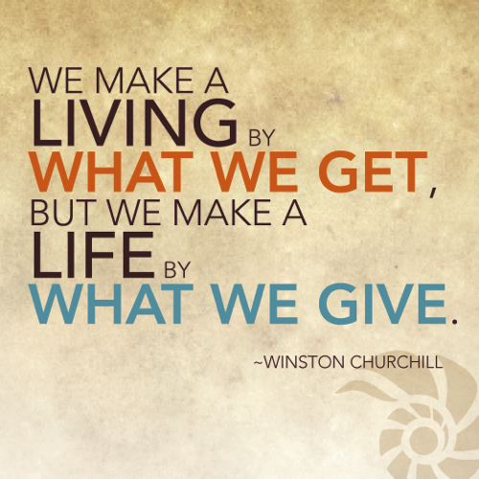



**9/17- No Senior Youth Gathering tonight –due to the Golf Tourney**

**9/20 – WOW (Wonders on Wednesdays) Grades 4-6**

**9/20 – 1st Communion Classes start at 3:30 pm (5th Grade)**

**9/20 – Confirmation 530 meal & 6:30 class**

**Snacks for Youth Events**

**-we would love your help in providing snacks for our WOW kids, Breakfast Club and Confirmation. If you are interested in providing a snack or meal, please sign up on “the door” in the Narthex.**

**Thank you for sharing your gifts!!**