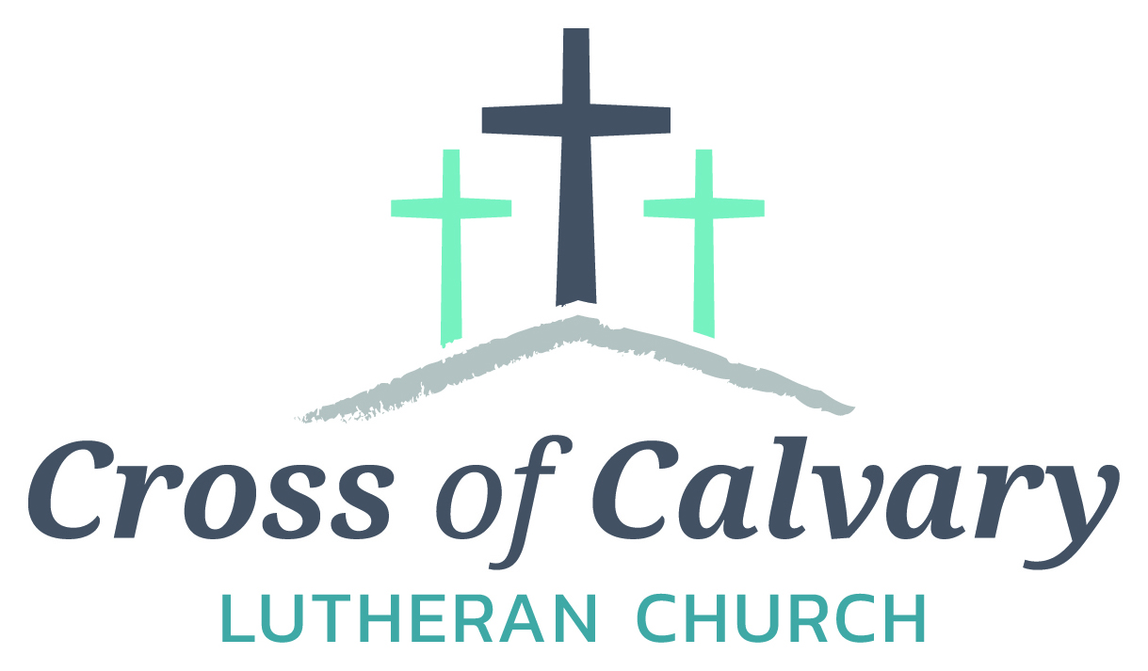

**WorshipTimes**

**Saturday: 5:30 PM**

**Sunday: 8:30 & 10:30**

**Coffee Hour**

**Sunday: 9:30 AM**

**Sunday School**

**Sunday: 9:30 AM**

**Building Hours**

**Mon-Thurs**

**8:30-7:00**

**Fri-Sun 8:30-2:00**

**Office Hours**

**Mon, Tues, and Thurs.; 8:30-3:00**

**Wednesday 8:30-4:00**

**Friday 8:30-2:00**

**Pastor: Matt Hausken**

[***hauskenmatt8@gmail.com***](mailto:hauskenmatt8@gmail.com)

***Parish* Ministers*:***

**Sarah Hausken**

**sarah.hausken@gmail.com**

**Jeni Skeie**

[**jeniskeie@gmail.com**](mailto:jeniskeie@gmail.com)

**Youth Email**

[**crossofcalvaryouth@gmail.com**](mailto:crossofcalvaryouth@gmail.com)

**Admin: Sue Altmann**

**crossofcalvary@gmail.com**

**Cross of Calvary Lutheran Church**

**1103 W. Chestnut Ave. Olivia, MN 320-523-1574**



**September 24, 2017**

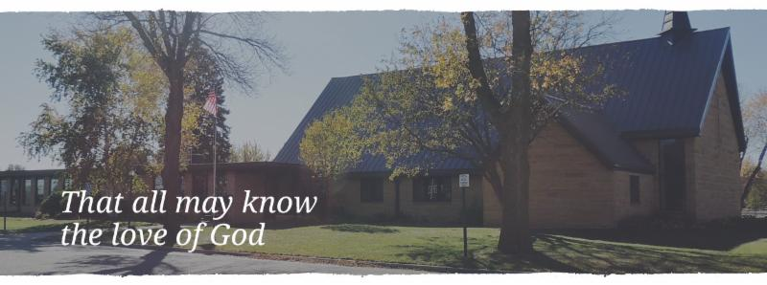

Cross of Calvary is the ELCA church in Olivia. We are an intergenerational (fancy word for young and old) community that follows Jesus out the building to where we live. We are all learners (disciples) here. This is a safe place to practice worship. And, believe us, it takes practice. Your questions, critical thinking, doubts and imperfect lives are welcome here.

**Holy Communion**

Holy Communion is open to all who are baptized and trust that Christ is present in the meal, regardless of your tradition or affiliation.

Wine (red)/grape juice (white).

**Participation**

**Bold type means all of us read or pray together. Out loud.** * Please stand as you are able.

**Children in Church**

They belong here! They are hearing God’s Word, music and prayers. We don’t mind fidgeting and chatter! If you like, there are activity bags available in the entry.

**Announcements**

They are as printed or any new information please give to Pastor Matt prior to worship, please hand a note to Pastor with any announcements, including prayer requests.

**Restrooms**

They are located in the hallway to the left of the stairs.

**COMMUNITY EVENTS**

**CHECK THE BULLETIN BOARD or east bulletin board for more information /details**

**United Lutheran Church in Lake Lillian** is hosting its annual Fall Festival on Thursday, Oct. 5th from 5:00 – 7:00 pm. Swedish meatball supper, plus: produce, crafts & bake sale. Adults: $10.00, 6-12 yrs.: $3.00 & 5 years and under Free. Menu: Swedish meatball, potatoes, vegetables, beverage, coleslaw, rolls, desserts.

**Adult Grief Support Group** will begin meeting on October 2, 2017. (Meetings will be every Monday until November 6th.)For more information on the support group or to register, please call Lacey Bruns at the Redwood Area Hospital at 507-637-4617. There is also a brochure on the east entrance board.

**Safe Avenues annual fundraiser “Make a Difference” Event** is on Friday, November 17th at 6:00 pm at Max’s Grill in Olivia! The fundraiser is held to raise awareness and support efforts to assist victims of domestic and sexual violence in our Renville Count Outreach Program.

**Renville County Services (Annmarie Suess)** is working with a group planning on bringing in a cooking class to Renville County geared towards adults that have young families. They are hoping to have childcare available to allow the parents to focus their energy on learning cooking basics. We are checking with local people and organizations to see if they would know anyone interested in volunteering some time. The class will meet on Thursdays from October 5-November 9 from 10-12 at the Olivia Government Center. There will be a meal provided at the end that the volunteers are welcome to eat with the families. A person could volunteer for all 6 classes or for a couple. If anyone from Cross of Calvary church would be interested in volunteering, either e-mail Annmarie or call directly. annmaries@renvillecountymn.com/320-523-3727

You are invited to attend our **“Scandinavian” Smorgasbord** at First Lutheran Church of Renville, 316 SW 3rd St on Sunday, October 8 from 11:15 am – 1:00 pm. Cost: $11 Adults, $5 – Ages 5-12, Under 5 FREE. Menu: Ham Meatballs, Mashed potatoes & Gravy, Corn, Squash, Pea Salad, Glorified Rice, Baked Rice, Deviled Eggs, Rommegrat, Lefse, Flat bread, Krumkaka, Kringla, Kringler, Spirtz cookies, Kransakaka, Fattigman, Rosettes, Sandbakkels, Cranberry relish, fruit soup and Cloverleaf Rolls.

**Faith United Methodist Church of Olivia** is hosting a Roast Beef Supper on Wednesday, Oct. 4, 2017. They will be serving from 4:30 – 7:00pm. Menu features: roast beef, real potatoes, homemade gravy, buttered corn, coleslaw, rolls, pumpkin dessert & beverage. Adults: $12.00, Ages 5-12: $6.00 and preschool – free (4 & under) Dine in and take available!!

**Prayer Concerns**

*Prayer Matters! Please take your bulletin home and pray for those listed.*

*Prayer concerns are listed for one month.*

Emergency/Pastoral Care-Please have a family member or friend notify the church. You may also request hospital staff to call on your behalf. Call day or night at 523-1574. Never feel as though you are bothering Pastor or the staff. We are here to serve as a comfort and as a resource.

*Diana Adkins *Jill Revolinski *Leslie Sagedahl

*Jenna Reynolds *Vonna Ledeboer *Emily Reetz

*Warren Mitchell *Barb Gomarko *Cleve Fults

*Charles W. Brown *Stan Matti *Barb Miller

*Mike & Brittney Harrell *Janice Gass *Kent Kircher

*Emily Schueler *Clayton Erickson *Bert Budd

*Florence Malecek *Cheryl Mallak

**Mission**

**Paraguay Missionaries**

The Kevin & Rebekah Howell family

**Bolivia Missionaries**

Paul and Jay Mikaelson House

**SEPTEMBER VOLUNTEERS**

**COMMUNION 8:30 – Bobbi Kopel - 10:30 – Dana Boen**

**USHERS 8:30 – Brian Kingery, Dan Gross, Dan Amberg & Jordan Amberg**

**10:30 – Doug Steffel & Duane Amberg**

**ACOLYTES: Leif Hausken & Will Hanson**

**ALTAR GUILD: Marlys Klinghagen & Barb Wertish**

**VOLUNTEER: Would you like to lead a Children’s message? Please, sign up on “The Board” in the Narthex.**

**Things happening at Cross of Calvary: September 24-Oct. 1**

**9/24 – Baptism (2)**

**9/24 – Altar Guild Meeting at 7:30**

**9/25 – Ruth Bible Study at Parkview – 1:320 pm**

**9/24-26 – Jeni, Sarah & Pastor Matt at conference**

**October 1 – Blue Jean Sunday**

**September 24, 2017**

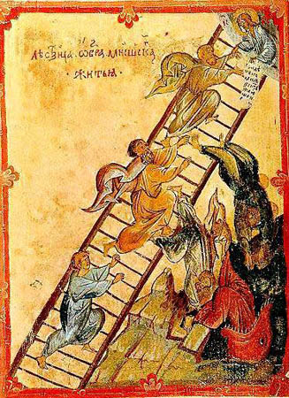

***Use this resource at home to guide your household’s daily devotions***

**Pray**: Light a candle and open your devotion time with a prayer.

**Great God, you have offered us the richness of your blessings.**

**Make us worthy to be the bearers of your life-giving word to the**

**world. In Jesus’ name, Amen**

**Read:** Read the key verse from Sunday’s reading.



*13And the Lord stood beside him and said, “I am the Lord, the*

*God of Abraham your father and the God of Isaac; the land on*

*which you lie I will give to you and to your offspring.*

*(Genesis 28:13)*

**Reflect:** Reflect on the scripture summary.

With a little help from Mom (and some hairy goats), Jacob

cheats his older brother out of his blessing. But is he prepared

for the overwhelming responsibility that comes with the gifts of God?

**Connect:** Connect in conversation with others in yourhousehold.

**What was a high point of your day? What was a low point?**

**Tell of a time you have tried to force God’s hand. What could**

**you do to give control over some aspect of your life to God?**

**Wonder: Why were angels climbing up and down the ladder?**

**What were angels doing on the earth?**

 **Bless:** Close your devotion with a blessing.

**May God give you God’s best blessing. Amen.**



**Do:** By acting on what we learn, we make God’s word come alive.

Do the following activity this week.

**Make a list of all the ways God has blessed you. Which of these**

**blessings come with responsibilities? Recommit yourself to**

**taking on those responsibilities with respect.**

**Go Deeper:** Go to clergystuff.com/daily-devotions for devotions on the daily readings.

**Sunday, Genesis 27:1-4, 15-23; 28:10-17, Jacob’s Dream**

**Monday, Genesis 27:30-40, Esau’s Lost Blessing**

**Tuesday, Genesis 27:41-28:5, Jacob Escapes**

**Wednesday, Genesis 28:6-9, Esau Marries Ishmael’s Daughter**

**Thursday, Genesis 29:1-14, Jacob Meets Rachel**

**Friday, Genesis 29:15-35, Jacob Marries Laban’s Daughters**

**Saturday, Genesis 30:1-24, Rachel’s Jealousy**

**“Your church offering information”**

Year-to-date receipts given $129,954

Year-to-date receipts needed for our budget $178,304

Year-to-date parish expenses $144,190

Year-to-date budgeted expenses $180,000

General Fund checking balance as of 1-1-17 $59,904

General Fund checking balance as of 8-31-17 $45,667

**We are grateful for the help to meet our weekly ministry needs.**

**Thank you for sharing your blessings in all the ways you do.”**

**GIVING ONLINE @ Cross of Calvary**

**Cross of Calvary provides online offering & donations! Giving online is easy. It allows you to set up automatic recurring contributions, make one-time gifts and review your giving history online.**

**Simply follow these easy steps:**

**1) Visit the church website at crossofcalvary.net**

**2) Click on the GIVE button**

**3) Click on HERE TO GIVE**

**4) Follow the instructions to create a profile and schedule your contributions.**

**Thank you for your offering!**



**9/27 – WOW (Wonders on Wednesdays) Grades 4-6 3:15 – 5:00 pm**

**9/27 – 1st Communion classes start at 3:30 pm (5th Grade)**

**9/27 – Confirmation 5:30 meal & 6:30 class**

**Snacks for Youth Events**

**We would love your help in providing snacks for our WOW kids, Breakfast Club and Confirmation. If you are interested in providing a snack or meal, please sign up on “the door” in the Narthex.**

**Thank you for sharing your gifts!**

**BLUE JEAN SUNDAY**



**It’s that time of year to do some fall cleaning!**

**Everyone is welcome to help clean the church and enjoy some fellowship while doing a good deed.**

**Most of the cleaning can be done between services and the rest can be finished after the second service.**

**There will be signs posted on what and where to clean, plus Angie and Craig Boen will be around to answer any questions.**