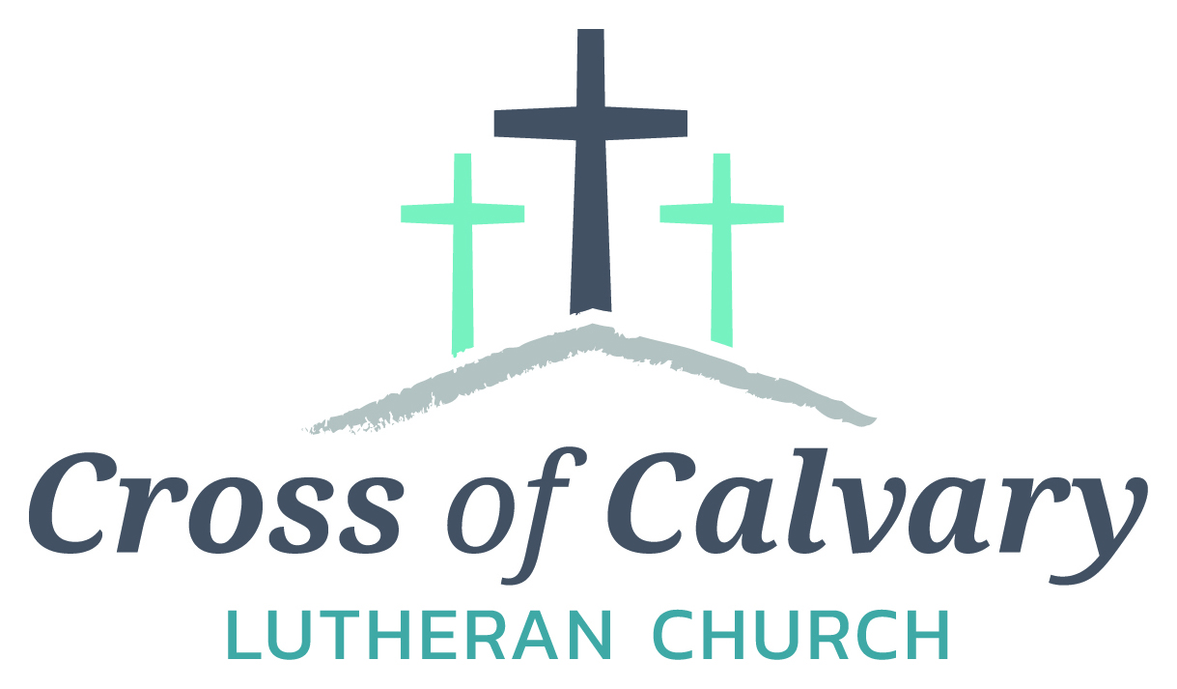

**WorshipTimes**

**Saturday: 5:30 PM**

**Sunday: 8:30 & 10:30**

**Coffee Hour**

**Sunday: 9:30 AM**

**Sunday School**

**Sunday: 9:30 AM**

**Building Hours**

**Mon-Thurs**

**8:30-7:00**

**Fri-Sun 8:30-2:00**

**Office Hours**

**Mon, Tues, and Thurs.; 8:30-3:00**

**Wednesday 8:30-4:00**

**Friday 8:30-2:00**

**Pastor: Matt Hausken**

[***hauskenmatt8@gmail.com***](mailto:hauskenmatt8@gmail.com)

***Parish* Ministers*:***

**Sarah Hausken**

[**sarah.hausken@gmail.com**](mailto:sarah.hausken@gmail.com)

**Jeni Skeie**

[**jeniskeie@gmail.com**](mailto:jeniskeie@gmail.com)

**Youth Email**

[**crossofcalvaryouth@gmail.com**](mailto:crossofcalvaryouth@gmail.com)

**Admin: Sue Altmann**

**crossofcalvary@gmail.com**

**Cross of Calvary Lutheran Church**

**1103 W. Chestnut Ave. Olivia, MN 320-523-1574**



**October 8, 2017**

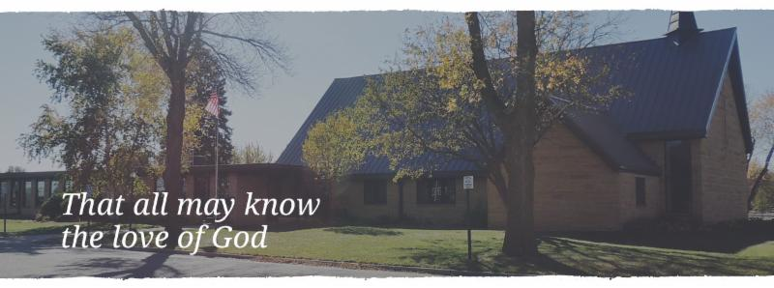

Cross of Calvary is the ELCA church in Olivia. We are an intergenerational (fancy word for young and old) community that follows Jesus out the building to where we live. We are all learners (disciples) here. This is a safe place to practice worship. And, believe us, it takes practice. Your questions, critical thinking, doubts and imperfect lives are welcome here.

**Holy Communion**

Holy Communion is open to all who are baptized and trust that Christ is present in the meal, regardless of your tradition or affiliation.

Wine (red)/grape juice (white).

**Participation**

**Bold type means all of us read or pray together. Out loud.** * Please stand as you are able.

**Children in Church**

They belong here! They are hearing God’s Word, music and prayers. We don’t mind fidgeting and chatter! If you like, there are activity bags available in the entry.

**Announcements**

They are as printed or any new information please give to Pastor Matt prior to worship, please hand a note to Pastor with any announcements, including prayer requests.

**Restrooms**

They are located in the hallway to the left of the stairs.

**OCTOBER WORSHIP VOLUNTEERS**

**COMMUNION 8:30 – Curt Sather**

**10:30 – DeeAnne Newville**

**USHERS 8:30 – Dick & Gladie Hagen**

**10:30 – Steve & Lynn Johnson**

**ACOLYTES: Kya Young & Maddi Jensen**

**ALTAR GUILD: Eleanor Ziesmer, Edith Vogt & Sheila Pietig**

**VOLUNTEER: Would you like to lead a Children’s message** **or read the Bible readings during worship? Please, sign up on “The Board” in the Narthex,**

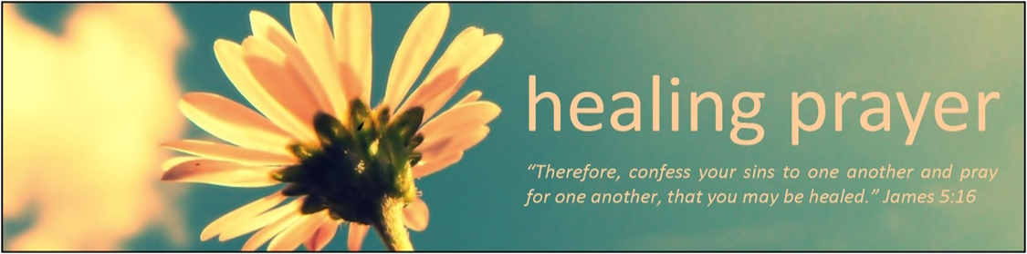

**Prayer Concerns**

Prayer Matters! Please take your bulletin home and pray for those listed.

Prayer concerns are listed for one month.

Emergency/Pastoral Care-Please have a family member or friend notify the church. You may also request hospital staff to call on your behalf. Call day or night at 523-1574. Never feel as though you are bothering Pastor or the staff. We are here to serve as a comfort and as a resource.

*Diana Adkins *Jill Revolinski *Leslie Sagedahl

*Jenna Reynolds *Vonna Ledeboer *Emily Reetz

*Warren Mitchell *Barb Gomarko *Cleve Fults

*McKenna Lilja *Stan Matti *Barb Miller

*Rosalie Sheggeby *Janice Gass *Kent Kircher

*Emily Schueler *Clayton Erickson *Bert Budd

*Florence Malecek *Pastor Maggie Cumings *Mike & Brittney Harrell and family

**Things happening at Cross of Calvary: October 1-8**

October 8 – New Member Sunday and Youth Band plays

October 8 – 3rd Grade Bible Class (during Sunday school hour)

October 10 – WeeWOW starting at 3:15

October 11 – Council Meeting at 7:30

October 14 – Bridal Shower from 10-2 (Flemming), Ashley Schmidt wedding off-site

*Welcome to Cross of Calvary*

*Grow in the* ***grace, and in the knowledge of our Lord and Savior Jesus Christ.***

2 Peter 3:18

Tim Abrahamson Shelby & Eric Gass Welchance Family

Samantha & Jesse Zeitz Dave Zupke

Miranda Braun Rachel Dahl

Samantha Erickson Troy Fuoss & Family

Dylan Gass Justin Gilberts Family

Ronald & Betty Hamborg Jeff Keltgen

Brittany Keltgen Tim Opdahl Family

Doug Steffel Weilage Family



10/08 – Sr. High Youth Group, Grades 9-12, 5:30-7:30 pm

10/10 – 1st-3rd Graders monthly after school program, 3:15 – 5:00 pm

10/11 – WOW (Wonders on Wednesdays) Grades 4-6, 3:15 – 5:00 pm

10/11 – 1st Communion classes start at 4:00 pm (5th Grade)

10/11 – Confirmation 5:30 meal & 6:30 class

10/12 – Breakfast Club, Grades 10-12, 7:07 am

**Opportunities to Serve**

We invite you to consider offering your time and talent in Jesus’ name through one of these opportunities to serve:

• Provide a snack for 20 WOW kids

• Provide breakfast for 10 Breakfast Club youth on a Thursday morning

• Provide supper for 25 Confirmation students on a Wednesday evening

• Help with the 1-3rd grade after school program the 2nd Tuesday of the month from 3-5 pm

**October 8, 2017**



***God Provides Manna***

***Use this resource at home to guide your household’s daily devotions***

**Pray**: Light a candle and open your devotion time with a prayer.



**Giving Lord, you have been generous beyond measure to your**

**children. Open our hearts in gratitude for all that we have**

**received, that we might give you the praise and honor befitting**

**your goodness. In Jesus’ name, Amen.**



**Read:** Read the key verse from Sunday’s reading.

*11The Lord spoke to Moses and said, 12 “I have heard the complaining of the Israelites; say to them, ‘At twilight you shall eat meat, and in the morning you shall have your fill of bread; then you shall know that I am the Lord your God.’” (Exodus 16:11-12)*

**Reflect:** Reflect on the scripture summary.

**God has looked after the Israelites as a loving parent would: first showing them the way out of slavery, then feeding and guiding them through the wilderness. And the people respond with all the gratitude of petulant children.**

**Connect:** Connect in conversation with others in yourhousehold.

**What was a high point of your day? What was a low point?**

**How, when, and with whom do you eat? Tell about your**

**favorite mealtime experiences, and how food brought you together.**

**Wonder: How many different ways could the Israelites have**

**prepared manna and quail? What else might they have eaten**

**during their time in the desert? What would you hope to eat if**

**you were starving?**

 **Bless:** Close your devotion with a blessing.

**May God provide for your every need. Amen.**



**Do:** By acting on what we learn, we make God’s word come alive.

Do the following activity this week.

**Host a dinner party. Prepare a meal with your own hands. Sit at**

**the table. Say grace. Have stimulating conversation. Enjoy the**

**entire experience.**

**Go Deeper:** Go to clergystuff.com/daily-devotions for devotions on the daily readings.

**Sunday, Exodus 16:1-18, God Provides Manna**

**Monday, Exodus 18:13-27, Jethro’s Advice**

**Tuesday, Exodus 20:1-21, The Ten Commandments**

**Wednesday, Exodus 25:10-22, The Ark of the Covenant**

**Thursday, Exodus 32:1-35, The Golden Calf**

**Friday, 1 Samuel 1:1-28, Samuel’s Birth and Dedication**

**Saturday, 1 Samuel 2:1-10, Hannah’s Prayer**

**“Your church offering information”**

Thru August 2017

Year-to-date receipts given $129,954

Year-to-date receipts needed for our budget $178,304

Year-to-date parish expenses $144,190

Year-to-date budgeted expenses $180,000

General Fund checking balance as of 1-1-17 $59,904

General Fund checking balance as of 8-31-17 $45,667

**We are grateful for the help to meet our weekly ministry needs.**

**Thank you for sharing your blessings in all the ways you do.**

**GIVING ONLINE @ Cross of Calvary**

**Cross of Calvary provides online offering & donations! Giving online is easy. It allows you to set up automatic recurring contributions, make one-time gifts and review your giving history online.**

**Simply follow these easy steps:**

**1) Visit the church website at crossofcalvary.net**

**2) Click on the GIVE button**

**3) Click on HERE TO GIVE**

**4) Follow the instructions to create a profile and schedule your contributions.**

**Thank you for your offering!**

**Please pray for our Missionaries**

Paraguay Missionaries

The Kevin & Rebekah Howell family

Bolivia Missionaries

Paul and Jay Mikaelson House

**COMMUNITY EVENTS**

**CHECK THE BULLETIN BOARD or east bulletin board for more information /details**

**Adult Grief Support Group** will begin meeting on October 2, 2017. (Meetings will be every Monday until November 6th.)For more information on the support group or to register, please call Lacey Bruns at the Redwood Area Hospital at 507-637-4617. There is also a brochure on the east entrance board.

**Safe Avenues** annual fundraiser “Make a Difference” Event is on Friday, November 17th at 6:00 pm at Max’s Grill in Olivia! The fundraiser is held to raise awareness and support efforts to assist victims of domestic and sexual violence in our Renville Count Outreach Program.

You are invited to attend our **“Scandinavian” Smorgasbord** at First Lutheran Church of Renville, 316 SW 3rd St on Sunday, October 8 from 11:15 am – 1:00 pm. Cost: $11 Adults, $5 – Ages 5-12, Under 5 FREE. Menu: Ham Meatballs, Mashed potatoes & Gravy, Corn, Squash, Pea Salad, Glorified Rice, Baked Rice, Deviled Eggs, Rommegrat, Lefse, Flat bread, Krumkaka, Kringla, Kringler, Spirtz cookies, Kransakaka, Fattigman, Rosettes, Sandbakkels, Cranberry relish, fruit soup and Cloverleaf Rolls.

**St. Aloysius Church** in Olivia invites you to join us on Sunday, October 15, 2017 for our annual **Fall Festival.** Our event begins with Mass at 10:00 am. Then continues your day with a home-made fried chicken dinner that includes mashed potatoes and gravy, candied carrots, cranberries, coleslaw, dinner roll, pumpkin dessert and beverage served from 11:00 am to 1:30 pm. The cost is $11.00 for adults or take-outs and $6.00 for children 10 & under. The day also includes a Pumpkin Patch, Farmers’ Market, Bakers’ Corner, Quilt Ladies Booth, Silent Auction, Cake Walk, Bingo and Church Raffle.

**Olivia Community Blood Drive** at St. Aloysius Catholic Church on Tuesday, October 17, 2017 from 1:00 – 7:00 PM, Please call 1-800-RED –CROSS or visit recrossblodd.org and enter OliviaMN to schedule an appointment. (Jubilee Center 302 S 10th St. Olivia, MN)

**RCW HOSTS “BREAKFAST WITH THE BAND AND CHOIR”**

On Saturday October 28, the Renville County West Music Department will be hosting their annual Breakfast with the Band and Choir fundraiser at the Renville Community Center. Breakfast will be served from 8:00 AM until 11:00 AM, and the Varsity Band and Choir will be providing entertainment while you eat. Freewill donations are accepted, proceeds to benefit the 2019 RCW Band and Choir Tour to New Orleans.

**CCOC Healthy snacks and volunteers**

Cross of Calvary is in charge of CCOC snacks for the month of November.

Snacks are needed Monday – Friday. Please bring snacks to the CCOC by 2:30 pm on the date that works best for you. There are around 35-40 kids.

The CCOC is also looking for volunteers to help. They are asking for you to help between 3:00-5:30, anytime or days would help. Come as often as you like and stay as long as you can.

Contact: Brian Anderson by email: [bryan@ccocmn.org](mailto:bryan@ccocmn.org)

**Bethlehem Lutheran Church in Atwater** will be holding their annual Uffda Day on Saturday, November 4, from 9 a.m. to noon. At our bazaar we will have handmade gifts and crafts, gently used puzzles, farmers market with fresh produce, Wayne's peanut brittle, baked goodies including Scandinavian treats and lefse, quilt raffle and more. Morning coffee will be served from 9 a.m. to 10 a.m. and a Scandinavian meal will be served from 10 a.m. to noon. The Scandinavian meal includes: open face sandwich (rullepølse, turkey or ham), chicken wild rice soup, fruit soup, rømmegrøt, lefse and specialty cookies. Please join us for a morning of fun and fellowship.

**Volunteer(s) needed**

Cross of Calvary is looking for an individual or couple to take over the food shelf cart. Please stop in the office if you are interested. Thank you!

Snowflake Bazaar!!

It’s time to start thinking of our annual Snowflake Bazaar! The date for this year’s event is Sunday, December 3rd. Each year, we appreciate your generous donations of raffle items and baked goods. **The deadline for raffle items is Sunday October 29th.** Any items received **after** this date will be given a price and placed in our craft room. Stay tuned for more announcements concerning Lefse night and cookie decorating!

Did you know that last year’s event allowed us to donate $7000 towards the new sign outside? One of the suggestions our committee has been approached with is to replace the old curtains in the balcony with new shades that are easier to open and close. If anyone has other suggestions as to areas that may need concern, we’d be happy to hear them!

Bazaar Committee: Dana Boen, Jen Kingery, Cathy Helin, Kathy Altmann, Jody Steffel, Sandy Gay