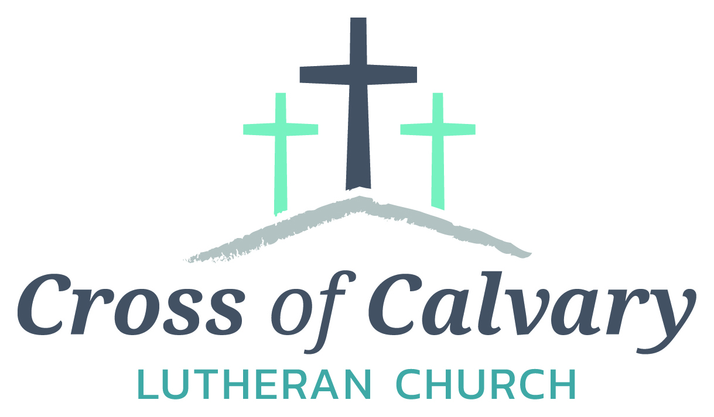

**WorshipTimes**

**Saturday: 5:30 PM**

**Sunday: 8:30 & 10:30**

**Coffee Hour**

**Sunday: 9:30 AM**

**Sunday School**

**Sunday: 9:30 AM**

**Building Hours**

**Mon-Thurs**

**8:30-7:00**

**Fri-Sun 8:30-2:00**

**Office Hours**

**Mon, Tues, and Thurs.; 8:30-3:00**

**Wednesday 8:30-4:00**

**Friday 8:30-2:00**

**Pastor: Matt Hausken**

[***hauskenmatt8@gmail.com***](mailto:hauskenmatt8@gmail.com)

***Parish* Ministers*:***

**Sarah Hausken**

[**sarah.hausken@gmail.com**](mailto:sarah.hausken@gmail.com)

**Jeni Skeie**

[**jeniskeie@gmail.com**](mailto:jeniskeie@gmail.com)

**Youth Email**

[**crossofcalvaryouth@gmail.com**](mailto:crossofcalvaryouth@gmail.com)

**Admin: Sue Altmann**

**crossofcalvary@gmail.com**

**Cross of Calvary Lutheran Church**

**1103 W. Chestnut Ave. Olivia, MN 320-523-1574**



**October 15, 2017**

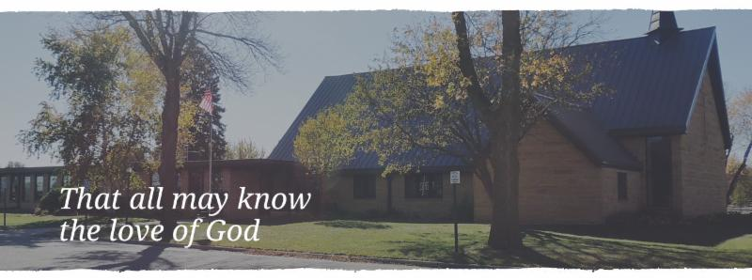

Cross of Calvary is the ELCA church in Olivia. We are an intergenerational (fancy word for young and old) community that follows Jesus out the building to where we live. We are all learners (disciples) here. This is a safe place to practice worship. And, believe us, it takes practice. Your questions, critical thinking, doubts and imperfect lives are welcome here.

**Holy Communion**

Holy Communion is open to all who are baptized and trust that Christ is present in the meal, regardless of your tradition or affiliation.

Wine (red)/grape juice (white).

**Participation**

**Bold type means all of us read or pray together. Out loud.** * Please stand as you are able.

**Children in Church**

They belong here! They are hearing God’s Word, music and prayers. We don’t mind fidgeting and chatter! If you like, there are activity bags available in the entry.

**Announcements**

They are as printed or any new information please give to Pastor Matt prior to worship, please hand a note to Pastor with any announcements, including prayer requests.

**Restrooms**

They are located in the hallway to the left of the stairs.

**OCTOBER WORSHIP VOLUNTEERS**

**COMMUNION 8:30 – Curt Sather**

**10:30 – DeeAnne Newville**

**USHERS 8:30 – Dick & Gladie Hagen**

**10:30 – Steve & Lynn Johnson**

**ACOLYTES: Kya Young & Maddi Jensen**

**ALTAR GUILD: Eleanor Ziesmer, Edith Vogt & Sheila Pietig**

**VOLUNTEER: Would you like to lead a Children’s message** **or read the Bible readings during worship? Please, sign up on “The Board” in the Narthex,**

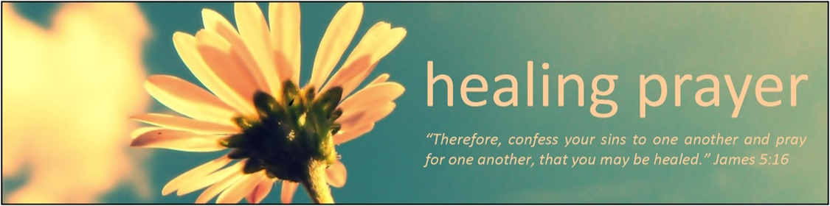

**Prayer Concerns**

Prayer Matters! Please take your bulletin home and pray for those listed.

Prayer concerns are listed for one month.

Emergency/Pastoral Care-Please have a family member or friend notify the church. You may also request hospital staff to call on your behalf. Call day or night at 523-1574. Never feel as though you are bothering Pastor or the staff. We are here to serve as a comfort and as a resource.

*Diana Adkins *Jill Revolinski *Leslie Sagedahl

*Jenna Reynolds *Vonna Ledeboer *Emily Reetz

*Warren Mitchell *Barb Gomarko *Cleve Fults

*McKenna Lilja *Barb Miller *Janice Gass

*Kent Kircher *Emily Schueler *Clayton Erickson

*June Lynn

**Things happening at Cross of Calvary: October 15-22**

October 15 – 3rd Grade Bible class (during Sunday school)

October 16 – Women’s Bible Study

October 18 – No confirmation or WOW

October 22 – Baby Boy Shower from 2-4, Levi Valentin

October 22 – NO Sunday School



10/15 – Sr. High Youth Group, Grades 9-12, 5:30-7:30 pm

10/15 – 3rd Grade Bible Study (during Sunday school)

10/11 – No, WOW (Wonders on Wednesdays) Grades 4-6, 3:15 – 5:00 pm

10/11 – No, 1st Communion classes start at 4:00 pm (5th Grade)

10/11 – No, Confirmation 5:30 meal & 6:30 class

10/12 – No, Breakfast Club, Grades 10-12, 7:07 am

MEA Weekend

**Opportunities to Serve**

We invite you to consider offering your time and talent in Jesus’ name through one of these opportunities to serve:

• Provide a snack for 20 WOW kids

• Provide breakfast for 10 Breakfast Club youth on a Thursday morning

• Provide supper for 25 Confirmation students on a Wednesday evening

• Help with the 1-3rd grade after school program the 2nd Tuesday of the month from 3-5 pm

**BOLD High School presents the musical “Oliver!”**

**Oct. 27th & 28th at 7:00 pm**

**Oct. 29th at 4:00 pm**

**Bird Island Campus Stage**

Cross of Calvary members in the cast:

Zane Boen as Oliver, Olivia Hanson, Will Hanson, Leif Hausken, Gage Amberg, Tucker Amberg, Brody Plass, Madison Zupke, Cam Larson, (Noah Boen and Caeden Gluesing –lights/props)

Come watch and support the many talents of our students!!

**October 15, 2017**



***God Calls Samuel***

***Use this resource at home to guide your household’s daily devotions***

**Pray**: Light a candle and open your devotion time with a prayer.

**God who call us, your call comes often when we do not expect**

**it. Incline our ears to hear what you are saying, and grant us**

**courage to do what you ask. In Jesus’ name, Amen.**



**Read:** Read the key verse from Sunday’s reading.

*10Now the Lord came and stood there, calling as before,*

*“Samuel! Samuel!” And Samuel said, “Speak, for your servant is*

*listening.” (1 Samuel 3:10)*

**Reflect:** Reflect on the scripture summary.

It takes several tries before young Samuel realizes that the One

calling him in the night is God, rather than his master Eli. But delivering the message will prove even trickier.

**Connect:** Connect in conversation with others in yourhousehold.

**What was a high point of your day? What was a low point?**

**Tell of a time God called you to do something you were**

**reluctant to do. (When was it hard to do the right thing?) How**

**did you find the courage to do it?**

**Wonder: How would your 11-year-old self-have responded to a**

**call by God?**

 **Bless:** Close your devotion with a blessing.

**May God grant you courage to come when called. Amen.**



**Do:** By acting on what we learn, we make God’s word come alive.

Do the following activity this week.

**Compare a current news story in a variety of news outlets.**

**Check the newspaper, TV networks, and social media. How is**

**the story different depending on whose voice is speaking? Who**

**do you believe? Why?**

**Go Deeper:** Go to clergystuff.com/daily-devotions for devotions on the daily readings.

**Sunday, 1 Samuel 3:1-21, God Calls Samuel**

**Monday, 1 Samuel 4:1-11, The Ark of God Captured**

**Tuesday, 1 Samuel 5:1-12, Philistines and the Ark**

**Wednesday, 1 Samuel 6:1-16, The Ark Returned**

**Thursday, 1 Samuel 8:1-18, Israel Demands a King**

**Friday, 1 Samuel 9:27-10:8, Samuel Anoints Saul as King**

**Saturday, 1 Samuel 15:10-34, Saul Rejected as King**

**“Your church offering information”**

Thru August 2017

Year-to-date receipts given $129,954

Year-to-date receipts needed for our budget $178,304

Year-to-date parish expenses $144,190

Year-to-date budgeted expenses $180,000

General Fund checking balance as of 1-1-17 $59,904

General Fund checking balance as of 8-31-17 $45,667

**We are grateful for the help to meet our weekly ministry needs.**

**Thank you for sharing your blessings in all the ways you do.**

**GIVING ONLINE @ Cross of Calvary**

**Cross of Calvary provides online offering & donations! Giving online is easy. It allows you to set up automatic recurring contributions, make one-time gifts and review your giving history online.**

**Simply follow these easy steps:**

**1) Visit the church website at crossofcalvary.net**

**2) Click on the GIVE button**

**3) Click on HERE TO GIVE**

**4) Follow the instructions to create a profile and schedule your contributions.**

**Thank you for your offering!**

**Please pray for our Missionaries**

Paraguay Missionaries

The Kevin & Rebekah Howell family

Bolivia Missionaries

Paul and Jay Mikaelson House

**CHURCH and COMMUNITY EVENTS**

**CHECK THE BULLETIN BOARD or east bulletin board for more information /details**

**Safe Avenues** annual fundraiser “Make a Difference” Event is on Friday, November 17th at 6:00 pm at Max’s Grill in Olivia! The fundraiser is held to raise awareness and support efforts to assist victims of domestic and sexual violence in our Renville Count Outreach Program.

**St. Aloysius Church** in Olivia invites you to join us on Sunday, October 15, 2017 for our annual **Fall Festival.** Our event begins with Mass at 10:00 am. Then continues your day with a home-made fried chicken dinner that includes mashed potatoes and gravy, candied carrots, cranberries, coleslaw, dinner roll, pumpkin dessert and beverage served from 11:00 am to 1:30 pm. The cost is $11.00 for adults or take-outs and $6.00 for children 10 & under. The day also includes a Pumpkin Patch, Farmers’ Market, Bakers’ Corner, Quilt Ladies Booth, Silent Auction, Cake Walk, Bingo and Church Raffle.

**Olivia Community Blood Drive** at St. Aloysius Catholic Church on Tuesday, October 17, 2017 from 1:00 – 7:00 PM, Please call 1-800-RED –CROSS or visit recrossblodd.org and enter OliviaMN to schedule an appointment. (Jubilee Center 302 S 10th St. Olivia, MN)

**RCW HOSTS “BREAKFAST WITH THE BAND AND CHOIR”**

On Saturday October 28, the Renville County West Music Department will be hosting their annual Breakfast with the Band and Choir fundraiser at the Renville Community Center. Breakfast will be served from 8:00 AM until 11:00 AM, and the Varsity Band and Choir will be providing entertainment while you eat. Freewill donations are accepted, proceeds to benefit the 2019 RCW Band and Choir Tour to New Orleans.

**Bethlehem Lutheran Church in Atwater** will be holding their annual Uffda Day on Saturday, November 4, from 9 a.m. to noon. At our bazaar we will have handmade gifts and crafts, gently used puzzles, farmers market with fresh produce, Wayne's peanut brittle, baked goodies including Scandinavian treats and lefse, quilt raffle and more. Morning coffee will be served from 9 a.m. to 10 a.m. and a Scandinavian meal will be served from 10 a.m. to noon. The Scandinavian meal includes: open face sandwich (rullepølse, turkey or ham), chicken wild rice soup, fruit soup, rømmegrøt, lefse and specialty cookies. Please join us for a morning of fun and fellowship.

**Zion Lutheran Church at 228 NW 5th Street, Buffalo Lake is hosting a Lutefisk/Swedish Meatball Supper:** Sunday, November 19th, serving 4:30 - 6:30 pm. Menu: Lutefisk, Swedish Meatballs with mushroom gravy, corn, boiled potatoes, coleslaw, cream sauce and melted butter, lefse and dessert. Adults: $15.00, Ages 5-12 $8.00 and 4 years and under: Free. Family style dining plus take outs available.

***November* CCOC Healthy snacks and volunteers**

**It’s Cross of Calvary’s month!!!**

Cross of Calvary is in charge of CCOC snacks for the month of November.

Snacks are needed Monday – Friday. Please bring snacks to the CCOC by 2:30 pm on the date that works best for you. There are around 35-40 kids.

The CCOC is also looking for volunteers to help. They are asking for you to help between 3:00-5:30, anytime or days would help. Come as often as you like and stay as long as you can.

Contact: Brian Anderson by email: [bryan@ccocmn.org](mailto:bryan@ccocmn.org)

**Share the Spirit of Santa’s Closet**: Join us at the CCOC in Olivia on Wednesday, November 1, from 9am – 3 pm for Hot Chocolate & Special “K” Bars. Free Will Donation for “Blankets for Kids, donate a blanket or money for a blanket or help with fleece blanket tying. Donations can also be mailed to Santa’s Closet, PO Box 115, Olivia, MN 56277. Sponsored by a Thrivent Action Team & Master’s Coffee Shop

**Volunteer(s) needed**

Cross of Calvary is looking for an individual or couple to take over the food shelf cart. Please stop in the office if you are interested. Thank you!

Snowflake Bazaar!!

It’s time to start thinking of our annual Snowflake Bazaar! The date for this year’s event is Sunday, December 3rd. Each year, we appreciate your generous donations of raffle items and baked goods. **The deadline for raffle items is Sunday October 29th.** Any items received **after** this date will be given a price and placed in our craft room. Stay tuned for more announcements concerning Lefse night and cookie decorating!

Did you know that last year’s event allowed us to donate $7000 towards the new sign outside? One of the suggestions our committee has been approached with is to replace the old curtains in the balcony with new shades that are easier to open and close. If anyone has other suggestions as to areas that may need concern, we’d be happy to hear them!

Bazaar Committee: Dana Boen, Jen Kingery, Cathy Helin, Kathy Altmann, Jody Steffel, Sandy Gay







**Inviting all to experience the life-changing love of Jesus through vibrant settings in community and creation.**

We had a wonderful summer of ministry at GLLM, and are looking forward to the summer of 2018 already! Keep your eyes open for our 2018 summer theme— “Get Lost!” which is focused on Matthew 10:39—”Those who find their life will lose it, and those who lose their life for my sake will find it.” We are so excited to explore ways that we can get lost in God’s love next summer. In the meantime, we have lots of great opportunities for you to enjoy this fall and winter!

**October 28** at 9:00 a.m. we will be hosting a **Volunteer Work Day** at Shores of St. Andrew. Come out to help us get our facilities ready for winter! There will be opportunities to clean up the wood pile, rake leaves, and do some indoor cleaning as well. Wear work boots and bring gloves! We will provide a lunch. RSVP to KP by calling (320)796-2181 or e-mailing [retreat@gllm.org](mailto:retreat@gllm.org)

**November 17-19** is the **Creative Souls Craft Retreat at Green Lake** **Bible Camp**. If you have a crafty hobby but need some time away to work on it, this is just for you! Get those projects done before Christmas! Experience a weekend full of fellowship, fun, and faith. Register online at

www.gllm.org or call (320)796-2181.

**2017 GLLM Dinner Theater: Star**

Join us at Green Lake Bible Camp for an evening of delightful entertainment and a delicious four-course meal! This year’s performance, titled “Star” is a musical and is sure to be a great addition to your holiday plans. Make it an outing with your Bible Study group, small group, or come with your family!

Tickets are $40.00.

**December 1, 2, 8 & 9 at 5:30 p.m. | December 10 at 4:00 p.m.**

Call (320)796-2181 to reserve tickets or e-mail [kpeterson@gllm.org](mailto:kpeterson@gllm.org).

**More information is available at** [**www.gllm.org**](http://www.gllm.org)

