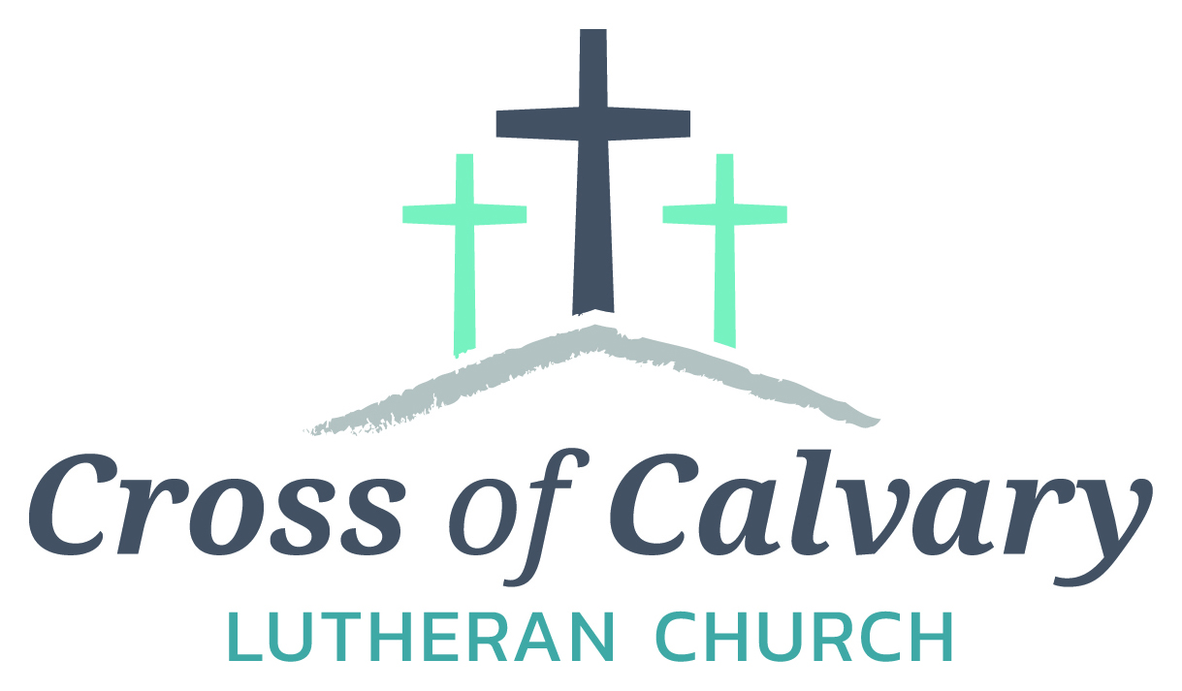

**WorshipTimes**

**Saturday: 5:30 PM**

**Sunday: 8:30 & 10:30**

**Coffee Hour**

**Sunday: 9:30 AM**

**Sunday School**

**Sunday: 9:30 AM**

**Building Hours**

**Mon-Thurs**

**8:30-7:00**

**Fri-Sun 8:30-2:00**

**Office Hours**

**Mon, Tues, and Thurs.; 8:30-3:00**

**Wednesday 8:30-4:00**

**Friday 8:30-2:00**

**Pastor: Matt Hausken**

[***hauskenmatt8@gmail.com***](mailto:hauskenmatt8@gmail.com)

***Parish* Ministers*:***

**Sarah Hausken**

[**sarah.hausken@gmail.com**](mailto:sarah.hausken@gmail.com)

**Jeni Skeie**

[**jeniskeie@gmail.com**](mailto:jeniskeie@gmail.com)

**Youth Email**

[**crossofcalvaryouth@gmail.com**](mailto:crossofcalvaryouth@gmail.com)

**Admin: Sue Altmann**

**crossofcalvary@gmail.com**

**Cross of Calvary Lutheran Church**

**1103 W. Chestnut Ave. Olivia, MN 320-523-1574**



**October 29, 2017**

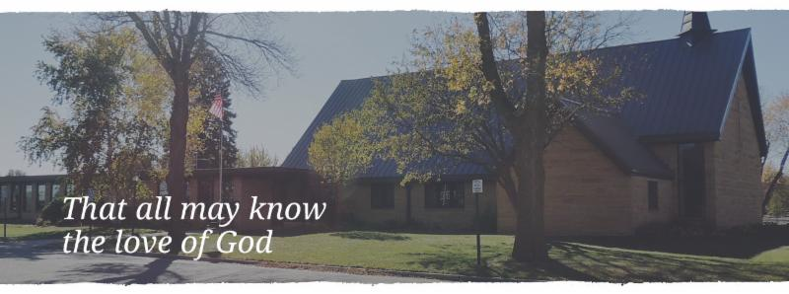

Cross of Calvary is the ELCA church in Olivia. We are an intergenerational (fancy word for young and old) community that follows Jesus out the building to where we live. We are all learners (disciples) here. This is a safe place to practice worship. And, believe us, it takes practice. Your questions, critical thinking, doubts and imperfect lives are welcome here.

**Holy Communion**

Holy Communion is open to all who are baptized and trust that Christ is present in the meal, regardless of your tradition or affiliation.

Wine (red)/grape juice (white).

**Participation**

**Bold type means all of us read or pray together. Out loud.** * Please stand as you are able.

**Children in Church**

They belong here! They are hearing God’s Word, music and prayers. We don’t mind fidgeting and chatter! If you like, there are activity bags available in the entry.

**Announcements**

They are as printed or any new information please give to Pastor Matt prior to worship, please hand a note to Pastor with any announcements, including prayer requests.

**Restrooms**

They are located in the hallway to the left of the stairs.

**OCTOBER WORSHIP VOLUNTEERS**

**COMMUNION 8:30 – Curt Sather**

**10:30 – DeeAnne Newville**

**USHERS 8:30 – Dick & Gladie Hagen**

**10:30 – Steve & Lynn Johnson**

**ACOLYTES: Kya Young & Maddi Jensen**

**ALTAR GUILD: Eleanor Ziesmer, Edith Vogt & Sheila Pietig**

**VOLUNTEER: Would you like to lead a Children’s message** **or read the Bible readings during worship? Please, sign up on “The Board” in the Narthex,**

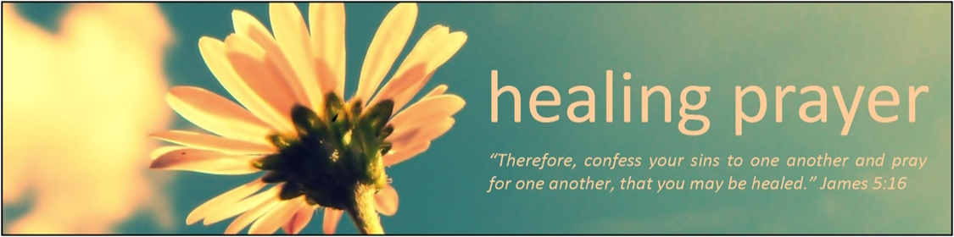

**Prayer Concerns**

Prayer Matters! Please take your bulletin home and pray for those listed.

Prayer concerns are listed for one month.

Emergency/Pastoral Care-Please have a family member or friend notify the church. You may also request hospital staff to call on your behalf. Call day or night at 523-1574. Never feel as though you are bothering Pastor or the staff. We are here to serve as a comfort and as a resource.

*Diana Adkins *Jill Revolinski *Leslie Sagedahl

*Jenna Reynolds *Vonna Ledeboer *Emily Reetz

*Warren Mitchell *Barb Gomarko *Cleve Fults

*Jane Johnson *Barb Miller *Janice Gass

*Kent Kircher *Emily Schueler *Clayton Erickson

*June Lynn *Clayton Erickson

**Things happening at Cross of Calvary: October 29-November 5**

**October 29 – Confirmation Sunday**

**November 5 – 1st Communion Sunday (both services) Grade 5**

**Baptism (Hernandez) at 10:30 service**

**Women’s Bible Study:** Days to meet are Sunday at 9:30 am, Tuesdays at 7:30 pm and Thursdays at 8:15 am. Note in time change: October 31st the meeting time is 8:30 pm.

Also, there will be **no** Bible Study the week of November 19 – 25.



10/29 – Confirmation Sunday at 10:30 service

Sr. High Youth Group, Grades 9-12, 6:30 – 8:30 pm

10/30 – Concordia College will be at BOLD High School at 12:30, if you would like to visit with them about attending college stop in the Counselors office at school.

11/1 – WOW & Confirmation

11/5 – 1st Communion at both services – Families: please be at the service of your choice 15 minutes early and meet in the library for instructions with Pastor Matt

**Opportunities to Serve**

We invite you to consider offering your time and talent in Jesus’ name through one of these opportunities to serve:

• Provide a snack for 20 WOW kids on Wednesday after school

• Provide breakfast for 10 Breakfast Club youth on a Thursday morning

• Provide supper for 25 Confirmation students on a Wednesday evening

• Help with the 1-3rd grade after school program the 2nd Tuesday of the month from 3-5 pm

**BOLD High School presents the musical “Oliver!”**

**Oct. 29th at 4:00 pm**

**Bird Island Campus Stage**

Cross of Calvary members in the cast:

Zane Boen as Oliver, Olivia Hanson, Will Hanson, Leif Hausken, Gage Amberg, Tucker Amberg, Brody Plass, Madison Zupke, Cam Larson, (Noah Boen and Caeden Gluesing –lights/props)

Come watch and support the many talents of our students!!

**October 29, 2017 **

***Use this resource at home to guide your household’s daily devotions***



**Pray**: Light a candle and open your devotion time with a prayer.

**Loving Lord, we are your living house. Make of us a holy and sure dwelling**

**place for your presence, to the honor of your glory and steadfast love. In Jesus’ name, Amen**





**Read:** Read the key verse from Sunday’s reading.

***5“So I intend to build a house for the name of the Lord my God, as the Lord said to my father David, ‘Your son, whom I will set on your throne in your place, shall build the house for my name.’” (1 Kings 1:5)***

**Reflect:** Reflect on the scripture summary.

**Solomon now has the chance to do what his father never could: make a permanent temple for the Lord. And though it may be grand, this tribute in stone is really a symbol of the dwelling place that has been and is the people of God: indestructible and for all time.**

**Connect:** Connect in conversation with others in yourhousehold.

**What was a high point of your day? What was a low point?**

**In your place of worship, what makes worship meaningful? What hinders meaningful worship? What stands in the way of putting God first?**

**Wonder: What did it feel like to stand in Solomon’s temple – in the presence of God?**



**Bless:** Close your devotion with a blessing.

**May God bless your home. Amen.**



**Do:** By acting on what we learn, we make God’s word come alive.

Do the following activity this week.

**Volunteer your time around the church this week. Clean the pews, organize the Sunday School closet, or host a funeral luncheon. Be creative!**



**Go Deeper:** Go to clergystuff.com/daily-devotions for devotions on the daily readings.

Sunday, 1 Kings 5:1-5; 8:1-13, Solomon’s Temple

Monday, 1 Kings 17:1-7, Elijah Predicts a Drought

Tuesday, 1 Kings 17:8-16, The Widow Zarephath

Wednesday, 1 Kings 17:17-24, Elijah Revives the Widow’s Son

Thursday, 1 Kings 18:1-19, Elijah’s Message to Ahab

Friday, 1 Kings 18:20-40, Elijah’s Triumph over the Priests of Baal

Saturday, 1 Kings 18:41-46, The Drought Ends

***We welcome the 2017 Confirmation Class into***

***adult membership at Cross of Calvary***

Jordan Daniel Amberg

Parents: Dan & Robin Amberg

Tucker Dean Amberg

Parents: Pete & Tara Amberg

Olivia Johnston Hanson

Parents: Chris & Jill Hanson

Hanna Grace Larson

Parents: Keith & Stacey Larson

Trent Allen Paulsen

Parents: Michelle Ryan & Randy Paulsen

London Katrina Prokosch

Tracey & Dale Prokosch

Brady Roger Ridler

Parents: Roger & Tonia Ridler

Jordan John Sagedahl

Parents: Daren & Melissa Sagedahl

Ashley Sophia Rae Trongard

Parents: Dave & Kathy Altmann, Scott Trongard

Brenna Lea Weis

Parents: Curt & Jody Weis

**CHURCH and COMMUNITY EVENTS**

**CHECK THE BULLETIN BOARD or east bulletin board for more information /details**

**Safe Avenues** annual fundraiser “Make a Difference” Event is on Friday, November 17th at 6:00 pm at Max’s Grill in Olivia! The fundraiser is held to raise awareness and support efforts to assist victims of domestic and sexual violence in our Renville Count Outreach Program.

**Bethlehem Lutheran Church in Atwater** will be holding their annual Uffda Day on Saturday, November 4, from 9 a.m. to noon. At our bazaar we will have handmade gifts and crafts, gently used puzzles, farmers market with fresh produce, Wayne's peanut brittle, baked goodies including Scandinavian treats and lefse, quilt raffle and more. Morning coffee will be served from 9 a.m. to 10 a.m. and a Scandinavian meal will be served from 10 a.m. to noon. The Scandinavian meal includes: open face sandwich (rullepølse, turkey or ham), chicken wild rice soup, fruit soup, rømmegrøt, lefse and specialty cookies. Please join us for a morning of fun and fellowship.

**Zion Lutheran Church at 228 NW 5th Street, Buffalo Lake is hosting a Lutefisk/Swedish Meatball Supper:** Sunday, November 19th, serving 4:30 - 6:30 pm. Menu: Lutefisk, Swedish Meatballs with mushroom gravy, corn, boiled potatoes, coleslaw, cream sauce and melted butter, lefse and dessert. Adults: $15.00, Ages 5-12 $8.00 and 4 years and under: Free. Family style dining plus take outs available.

**22nd Annual Lutheran Men in Mission Lutefisk & Meatball Supper.** Thursday, November 16th from 4:30 – 6:30 pm. At Gloria Dei Lutheran Church in Redwood Falls. Menu: Lutefisk, Meatballs, Lefse and all the trimmings! Cost: Adults - $13, under 12 - $5 and preschoolers free.

**Olivia Lions Harvest Brunch: Sunday** October 29 from 9:00 – 1:00 at the American Legion. Menu: Pancakes, Eggs, and Danube Locker Links. Suggested donation $10 - $5 under12 years – Donation are to support BOLD Seniors. Also, drop off used shoes for Soles2Souls

**The women of St. John’s Catholic Church in Hector** are holding their Annual Craft and Bake Sate on Saturday, November 11, from 8:00 to 1:00 pm at the Buffalo Lake High School, Hector Campus, small gym. Cinnamon rolls, caramel rolls, coffee and juice will be served from 8:00 to 11:00 and BBQ lunch will be served from 11:00 -1:00 pm. Both seasonal and general, hand-made craft items will be sold, as well as a variety of home-baked goodies. New this year we will be holding a silent auction with the final bid closing at 12:30 on November 11.

Wanted: Piano player for sing-along **Where: Olivia Healthcare and Rehabilitation Center** When: Once or Twice a month

Contact: Sheila Pietig @ SPietig@OliviaRHCC.com or 523-1652. Any questions, please contact me.

Please join us for the annual *Harvest Fest at Blomkest Baptist Church* on Sunday, November 12 at 7 pm. The evening will include a musical presentation by **Crow River Junction** (band). A pie and coffee fellowship will follow the program. A fee-will offering will be given to the United Campus Ministry at Ridgewater College.

***November* CCOC Healthy snacks and volunteers**

**It’s Cross of Calvary’s month!!!**

Cross of Calvary is in charge of CCOC snacks for the month of November.

Snacks are needed Monday – Friday. Please bring snacks to the CCOC by 2:30 pm on the date that works best for you. There are around 35-40 kids. Sign-up sheet is on “The BOARD”

The CCOC is also looking for volunteers to help. They are asking for you to help between 3:00-5:30, anytime or days would help. Come as often as you like and stay as long as you can.

Contact: Brian Anderson by email: [bryan@ccocmn.org](mailto:bryan@ccocmn.org)

**Share the Spirit of Santa’s Closet**: Join us at the CCOC in Olivia on Wednesday, November 1, from 9am – 3 pm for Hot Chocolate & Special “K” Bars. Free Will Donation for “Blankets for Kids, donate a blanket or money for a blanket or help with fleece blanket tying. Donations can also be mailed to Santa’s Closet, PO Box 115, Olivia, MN 56277. Sponsored by a Thrivent Action Team & Master’s Coffee Shop

Snowflake Bazaar!!

It’s time to start thinking of our annual Snowflake Bazaar! The date for this year’s event is Sunday, December 3rd. Each year, we appreciate your generous donations of raffle items and baked goods. **The deadline for raffle items is Sunday October 29th.** Any items received **after** this date will be given a price and placed in our craft room. Stay tuned for more announcements concerning Lefse night and cookie decorating!

Did you know that last year’s event allowed us to donate $7000 towards the new sign outside? One of the suggestions our committee has been approached with is to replace the old curtains in the balcony with new shades that are easier to open and close. If anyone has other suggestions as to areas that may need concern, we’d be happy to hear them!

Bazaar Committee: Dana Boen, Jen Kingery, Cathy Helin, Kathy Altmann, Jody Steffel, Sandy Gay

**Please pray for our Missionaries**

Paraguay Missionaries

The Kevin & Rebekah Howell family

Bolivia Missionaries

Paul and Jay Mikaelson House







**Inviting all to experience the life-changing love of Jesus through vibrant settings in community and creation.**

We had a wonderful summer of ministry at GLLM, and are looking forward to the summer of 2018 already! Keep your eyes open for our 2018 summer theme— “Get Lost!” which is focused on Matthew 10:39—”Those who find their life will lose it, and those who lose their life for my sake will find it.” We are so excited to explore ways that we can get lost in God’s love next summer. In the meantime, we have lots of great opportunities for you to enjoy this fall and winter!

**November 17-19** is the **Creative Souls Craft Retreat at Green Lake** **Bible Camp**. If you have a crafty hobby but need some time away to work on it, this is just for you! Get those projects done before Christmas! Experience a weekend full of fellowship, fun, and faith. Register online at

www.gllm.org or call (320)796-2181.

**2017 GLLM Dinner Theater: Star**

Join us at Green Lake Bible Camp for an evening of delightful entertainment and a delicious four-course meal! This year’s performance, titled “Star” is a musical and is sure to be a great addition to your holiday plans. Make it an outing with your Bible Study group, small group, or come with your family!

Tickets are $40.00.

**December 1, 2, 8 & 9 at 5:30 p.m. | December 10 at 4:00 p.m.**

Call (320)796-2181 to reserve tickets or e-mail [kpeterson@gllm.org](mailto:kpeterson@gllm.org).

**More information is available at** [**www.gllm.org**](http://www.gllm.org)

