***The Follower***



**June 2018**



It is hard to believe that we are once again at the threshold of summer. It was a longer winter than I think we were expecting but once summer came back it didn’t waste any time warming up. We know it is coming but there are some winters that really stop and make you wonder if summer will come! But, it always does and we live through winter in that hope.

I think that makes it a little easier for us here in the Midwest to grasp the Gospel of Jesus Christ. There are times in our life when things seem bleak, but we know that the bleakness does not have the last word. The last word is a word of life spoken by our God. We live in light of that hope. Each day in prayer, devotion, and scripture we are reminded and renewed by that hope. Each week we gather with our brothers and sisters in Christ to celebrate the victory over sin and death that was won by Christ to give us this hope.

We need to keep this hope always alive. So, as we enter these summer months may we keep reminding ourselves of this hope through regular prayer, bible reading, and worship. May we be strengthened by it and may we live in its brilliant light!

God’s blessings for a wonderful month of June!

In Christ,

Pastor Matt

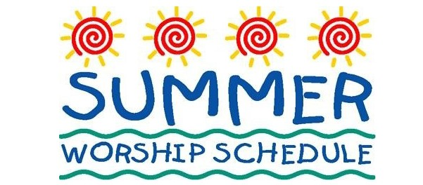

**Sunday – 9:00 am**

**Thursday – 7:00 pm**

**Prayer Request**

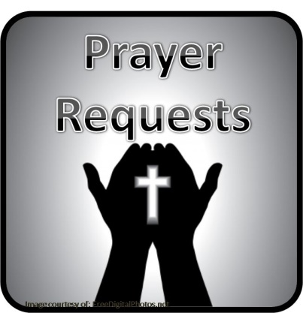**Prayer Matters!**

Please take your bulletin home and pray for those listed.

Emergency/Pastoral Care-Please have a family member or friend notify the church. You may also request hospital staff to call on your behalf. Call day or night at 523-1574. Never feel as though you are bothering Pastor or the staff. We are here to serve as a comfort and as a resource.

*Diana Adkins *Jill Revolinski *Leslie Sagedahl *Alexa Fischer

*Jenna Reynolds *Sonia Grasmon *Laura Wacek *Mike Abrahamson

*Caryn Behr *Corinne Skogen *Clayton Erickson *Pastor Hackmann

*Jen Beckler *Betsy Hennen *Barb Gomarko

*Dave Pedersen



.

**Cross of Calvary Day Camp**

**(Our version of VBS)**  Day camp for youth who have finished grades K-6 will be Sunday July 8-Thursday, July 12. Cost is $30 per student or $75 per family.

Sunday = 3pm-8pm (with a Campfire worship at 7:15)

Monday = 1pm-6pm

Tuesday = 1p-6pm (Tie Dye day)

Wednesday = 1pm-6pm (Program at 5:30)

Thursday = 1pm - 6pm

Evening meals provided each day

*Please bring a pillowcase or t-shirt labeled with your name on Sunday or Monday for the tie dye project on Tuesday.

*We will be feeding the campers every night before 6, so we will be asking for food donations.

Below is the link for registration. **Registration closes July 6.**

<https://goo.gl/forms/OZnpGxBmdh4aNEHD3>



**Summer Bible Camp**

Camp information is on table beneath Youth Board.

Register at www.gllm.org and fill out our info sheet.

Cross of Calvary youth get $100 in scholarships right off the bat.

Contact: Sarah or Jeni

**Church Events/News**

**Stephen Ministry**

One-to-one caring ministry planting a seed of hope and healing

If interested in more information, please

talk to Jeni Skeie, Carole Buhr, or Pastor Matt

**Faith Club** Hello to all. Our women's study has taken a break for the month of May. But I am anxious to get back together. Our book for the summer is not so much of a Bible study, but a study of faiths. It is a conversation between a Muslim, a Christian, and a Jew, three women searching for understanding. This book was recommended by a member who has read it 3 times and was willing to read it again. It is called The Faith Club by Ranya Idliby, Suzanne Oliver, and Priscila Warner.

We will have two formats. One group will meet on Thursday mornings at 8:15 am beginning June 7, (with no meeting on July 5). Thursday group please read pages 300 to the end and the first 2 chapters before we meet.

The other group will meet at my house 3 times over the summer on a Tuesday night at 6pm, June 26, July 24, and August 28. Tuesday group will read pages 300 to the end and thru chapter 7 by June 26.

If these times don’t work, please still feel free to join in reading the book. Enjoy!!!! Spread the word. All are welcome.

Peace to you,

Jeni Skeie

**"Better Together Redwood Falls"** will provide 120,000 meals for local food shelves, backpack programs and disabled/homeless veterans, as we build community by working side by side. We will be “better together!” There are opportunities to volunteer from 7 am to 5 pm, but please join other Cross of Calvary members in packing meals from 9 am - 11 am on Friday, June 8. Make sure to sign up here as space is limited to 150 volunteers per shift. http://www.signupgenius.com/go/20f0548a8a82ea6f94-better

**JUNE VOLUNTEERS**

COMMUNION 9:00 – Jill Hanson

USHERS 9:00 – Shannon Visser, John Johnston & Chris Hanson

ACOLYTES: Ben Whited & Andy Bahl

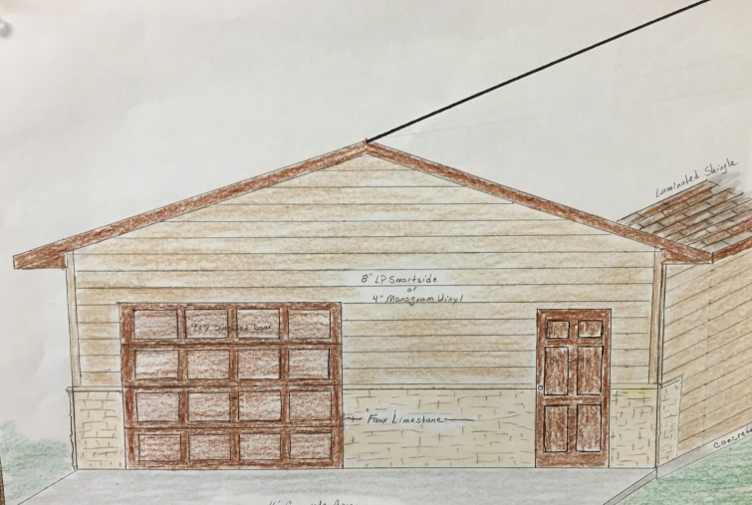ALTAR GUILD: Katie Bahl, Sue Erickson & Jody Steffel

**Men’s Group Project**

New Storage shed

See board in the Narthex,

for more information on how to give!

| ◄ | **June 2018** | | | | | ► |
| --- | --- | --- | --- | --- | --- | --- |
| **Sun** | **Mon** | **Tue** | **Wed** | **Thu** | **Fri** | **Sat** |
|  | Office Closed | Men’s Bible Study  6:15 am and 7:00 am |  | Worship 7:00 pm | 1 | 2 |
| 3  **Worship 9:00 am**  **Communion**  **Larson Graduation**  **4-7**  (church used 12-9) | 4  Library Reserved  6:00-8:00 pm | 5  Men’s Bible Study  6:15 am and 7:00 am | 6 | 7  Worship 7:00 pm  Faith Club 8:15 am | 8  **Office Closed**  Better Together 9-11  Synod Assembly | 9 Wedding offsite  (Hagen/Bratsch)  Synod Assembly |
| 10  **Worship 9:00 am** | 11  Library Reserved  6:00-8:00 pm | 12  Men’s Bible Study  6:15 am and 7:00 am | 13 | 14  Worship 7:00 pm  Faith Club 8:15 am | 15 | 16 Wedding  (Honzay/Braun) |
| 17  **Worship 9:00 am**  **Communion**  **Baptism - Baumgartner**  Family Camp - Hausken | 18  Library Reserved  6:00-8:00 pm  Family Camp - Hausken | 19  Men’s Bible Study  6:15 am and 7:00 am  Family Camp - Hausken | 20  Council Meeting 7:30  Committee Mtg. – set time by each committee  Family Camp - Hausken | 21  Worship 7:00 pm  Faith Club 8:15 am  Family Camp - Hausken | 22  **Office Closed**  Family Camp - Hausken | 23 |
| 24  **Worship 9:00 am** | 25  Library Reserved  6:00-8:00 pm  ELCA National  Youth Gathering – leave 5:30 am | 26  Men’s Bible Study  6:15 am and 7:00 am  Faith Club 6:00 pm  ELCA National Youth Gathering | 27  ELCA National Youth Gathering | **28**  Worship 7:00 pm  Faith Club 8:15 am  ELCA National Youth Gathering | 29  ELCA National Youth Gathering | 30  ELCA National Youth Gathering |

**Community Events/News**

**Vacation Bible School**

Location: Our Saviors Lutheran Church 510 Dogwood Ave, Bird Island

Dates: June 25-29

Time: 6-8:30 pm

Ages 3 years old – 6th Grade

All Denomination Welcome

Call the church for more information 320-365-3996

Cost: $20 and additional $10 if you would like to have a meal before class begins

Registration forma on the Youth table

**SAL (SAL: Sons of the American Legion) Pop-Tab Contest: Cash Prizes,** start saving those little aluminum tabs from you beverage containers and you could be winner of one of three cash prizes. The SAL is sponsoring a contest for the purpose of colleting as many Aluminum tabs as possible. The tabs will be turned over the Ronald McDonald home of MN. These tabs generate funds to assist operating these homes which are made available to family members while children and adults are being treated at hospitals in MN. You can find these little tabs on beverage and soup cans. The tabs will be weighed on Saturday, September 8th at the Legion in Olivia during the Fire Departments Annual Rib Fest. Cash prizes are as follows: 1st prize: $50.00, 2nd prize: $30.00 and 3rd prize: $20.00

On Sunday, June 10th from 4:00 – 7:00 pm Calvary Lutheran Church of Willmar will be having their Annual 50’a Drive In. This is a fundraiser for our youth activities and trips which includes: good food, classic cars and sock hop music!

**Renville County Human Services** is currently seeking individuals who are willing to be foster parents to children who are in need of a home. Foster parents can be blended families, one or two parent families, retired or single.

The most important aspects of fostering a child is your willingness to provide a loving, save and stable environment. Foster parents are considered part of a team of individuals who are working to make a better life for a child. Foster parents help a child through a difficult time, share their gifts and talents and receive reimbursement for their dedication and service to children. Is it time to share your gifts and talents and become a foster parent?

Please call Bonnie Lund or Stacie Roxberg, Renville County Human Services at 320-523-2202 to find out more about how to become a foster parent for Renville County.

June birthday

**Midsummer Festival:** Friday – June 15, 2018, Chicken Dinner at United Lutheran Church in Lake Lillian. Menu: Don Boll’s Fried Chicken, Potatoes, Green Beans, Coleslaw, Ostkaka, Bread, Beverage and Dessert. Time: 5-7 pm Cost; Adults: $11 and 12 yrs. and under: $5.00

**Olivia American Legion Breakfast:** Sunday, June 10, Serving from 9:00 – 1:00; Pancakes, eggs, sausage, ham, biscuits & gravy. Adults: $10, kids under 12: $6 and Little guys & gals: FREE



**Happy Birthday**

06/01 Patricia Aalderks 06/10 Susan Meyer 06/21 Karen Revier

06/01 Gary Beltz 06/10 Danielle Larson 06/21 Amanda Steffel

06/01 Sandy Schlomann 06/10 Ethan Sullivan 06/21 Michael Kingstrom

06/01 Mathew Crow 06/10 Samuel Welchance 06/21 Hunter Baumgartner

06/01 Amber Enestvedt 06/11 Michael Steinbeisser 06/24 Kevin Schwer

06/01 Kyle Frank 06/12 Sue Wagemaker 06/25 Lynette Blem

06/02 Charlene Norris 06/12 Leslie Adamski 06/25 Ronda Berg

06/02 Zachary Kopel 06/13 Sharon Malecek 06/26 Cole Schwer

06/03 Jennifer Mertz 06/13 Todd Weber 06/26 Mark Neubauer

06/04 Anthony Boen 06/13 Christopher Johnson 06/26 Finley Bruns

06/04 Sydney Slagter 06/13 Thor Bergren 06/27 Kathy Brown

06/04 Jack Gross 06/13 Paisley Gilberts 06/27 Tracey Johnson

06/04 Oliver Plumley 06/13 Maren Osthus

06/05 Craig Mages 06/16 Sheldon Hatch 06/27 Kristi Vesterby

06/05 Amanda Zupke

06/05 Spencer Helmer 06/16 Katie Osthus-Tuthill 06/27 Jaime Morse

06/06 Randy Mertz 06/16 Whitney Trongard 06/27 Cole Mertens

06/06 Laila Ridler 06/18 Vonnie Wertish 06/28 Bonnie Triplett

06/06 Leo Adamski 06/18 Erick Fennern 06/28 Steve Altmann

06/07 Lane Wacek 06/18 Karrie Jansen 06/28 Alex Neubauer

06/07 Deb Person 06/18 Lisa Meints 06/28 Hanna Larson

06/07 Greg Mertens 06/18 Andy Bahl 06/29 Willian Nere

06/07 Maddison Jensen 06/19 Chris Revier 06/29 Maegen Honzay

06/08 Lucy Malvin

06/09 Ben Mitchell 06/19 Joseph Mikosch 06/30 Margaret Flemming

06/09 Bennett Trochlil 06/20 Summer Hennen 06/30 Matthew Hausken

06/09 Miranda Boen 06/30 Samantha Newland

**Cross of Calvary Lutheran Church COUNCIL MEETING**

**Minutes for: Wednesday, May 16, 2018 @ 7:30pm**

**COUNCIL MEMBERS**

Dana Boen 2020 Jon Hawkinson 2021* Eric Skeie 2019*

Curt Sather 2020 Laurence Stratton 2021 Tashia Johnson 2019*

Jill Hanson 2020 Paul Buhr 2019 Alex Gay 2021

DeeAnne Newville 2020* Gordon Blem 2019

Steve Altmann 2021* Terms end at Annual Meeting (Jan.)

*Second term

**STAFF**

Pastor Matt Hausken Jeni Skeie, Parish Minister Sarah Hausken, Parish Minister Sue Altmann, Council Recorder

**AGENDA**

1. Meeting called to order- Gordy Blem
2. Devotions – *Tashia Johnson*
3. Approve minutes of the ***April meeting*** – Motion to approve the minutes by Steve Altmann, seconded by Curt Sather, motion
4. passed.
5. Financial Secretary and Treasurer Reports *–* ***April-*** Motion to approve the treasurer/secretary report by Steve Altmann, seconded by Tashia Johnson, motion passed.
6. Pastor’s report

* Everything is going smoothly at church.
* Stephen Ministry – will start May 23rd, training has gone wonderfully, and there are 8 people that will take training.
* Golf Tournament will be May 20th – everything is ready.
* Two weddings in June.

1. Parish Ministers report - notes separate

**COMMITTEE REPORTS AND RECOMMENDATIONS (2018)**

1. Administration – Gordy Blem, Curt Sather & Steve Altmann –

* Insurance has been updated with the help of Curt Sather and Gordy Blem.
* Renter Insurance – Hausken’s have
* Outside of building – SW needs to be tended to – a date has been set for May 29th

2. Children, Youth and Family- Laurence Stratton & Natasha Johnson

* Discussed funds for Youth Gathering with Dawn Mertens (Youth treasurer)
* Working with Jill Hanson on Sunday School for next year.

3. Equipping – Eric Skeie

* No report

4. Missions – Paul Buhr & Alex Gay

* $1000.00 to Back the Pack
* Paul Buhr gave a talk about a mission/Global Health Ministry. He gave ideas to donate to the mission.

5. Worship and Music – Paul Buhr & Jill Hanson

* No report

6. Care Team – DeeAnne Newville

* Working on gathering members for their committee
* Looking to support Stephen Ministry

7. Parish Life – Dana Boen

* No report

8. Outreach – Jon Hawkinson & Jill Hanson

* New members are being looked to join, they will be collecting data on what is

9. Technology – Steve Altmann

* Privacy Policy has been set and is good.

10. AED Maintence – Steve Altmann

**OLD BUSINESS**

* Update on new storage shed, thank you men’s group!
* Promotional board has been made to show the progress of donation from members.
* Envelopes have been made to help with donations.
* Funds are coming in nicely.
* Plot is set, permits in the work.
* Update on building insurance carrier – taken care by Administration committee.
* Date for spring clean-up? – talk to Betsy Hennen” May 29th set to clean up SW side of church
* Remember to sign up to play or work at the Golf tournament, which is May 20th
* Summer Worship times: starting Thursday, May 24th at 7:00 pm and Sunday, May 20th at 9:00 am
* Better Together: June 8th from 9:00 -11:00am

**NEW BUSINESS**

* National Youth Gathering: June 25-July 2, 21 students from Cross of Calvary attending!

Next Council meeting: Wednesday, June 20th at 7:30 pm

June Communion: 9:00 – Jill Hanson

July Communions: 9:00 – Curt Sather

June Devotion – Jill Hanson

July – No council meeting

**Adjourn / Close in prayer.**

