The Follower
[September] 2016
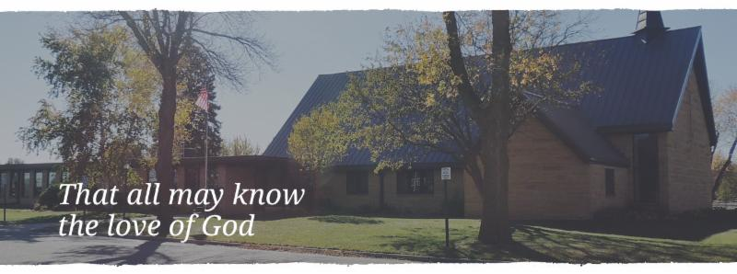
He said to them, “When you pray, say: Father, hallowed be your name. Your kingdom come. Give us each day our daily bread. And forgive us our sins, for we ourselves forgive everyone indebted to us. And do not bring us to the time of trial.”
Luke 11: 2-4
PASTOR’S CORNER

We are kicking off what will be a 15 month celebration here at Cross of Calvary and with Lutherans from around the world! Next year, 2017, will mark the 500th anniversary of the beginning of the Reformation! So, we will have many events, worship services, etc. that will center around this historic event. We hope that these celebrations will center us even more strongly in the message Luther and the other reformers dedicated their lives work towards—the Gospel of Jesus Christ at the center of all we do.

As a part of these events, we will be starting a book of the month study. We will begin in September with a biography of Martin Luther called When Lightening Struck. In October, we will look at the writing that started everything, The 95 Theses. We will follow each month with a short book that will allow us to dig deeper into what it means to be Lutheran.

As we go through the books, we will meet on facebook and if people wish in person. We will come up with questions to guide you through these wonderful books. Don’t let the nature of the book intimidate you. All of the translations are brand new and have many good study notes. This makes these writings more accessible and fun to read.

This club will also be come and go. This means if there is a book that really doesn’t interest you or you know you won’t have time to read it you can skip that month and feel free to jump back into the study the next month.

If you have any questions, please feel free to ask me about the club. This is just one of many things we will be hosting to remember the 500th anniversary. May God bless this journey and our celebration!

God’s blessings for a wonderful month of September!
In Christ,

Pastor Matt

PRAYERS OF HEALING AND STRENGTH

Prayer for: Submitted by:
Vonna Ledeboer A. Ledeboer
Diana Adkins B. Hennen
Jill Revolinski C. Mallak
Greg & Evelyn Rosenow T. Kadelbach
Ann Orth D. Orth
Family of Edward Winslow McNeal…………………………………………………….…Dawn Matti & Stan Matti

September VOLUNTEERS
________________________________________

COMMUNION Eric Skeie
USHERS 8:30 – Dan Gross, Brian Kingery, Tom Osthus
10:30 – Doug Steffel, Duane Senger
ACOLYTES TBD
ALTAR GUILD Marlys Klinghagen, Barb Wertish
USHERS: 8:30 – Dan Gross, Brian Kingery, Tom Osthus, 10:30 – Doug Steffel, Duane Senger

YOUTH NEWS

Program

The time is here! Cross of Calvary youth programs will be starting very soon! Check the information below!

Sunday School
Sunday - 9:30-10:20am
Beginning September 11

This year we are using the Living the Word: Teaching Kids God’s Story curriculum published by Spirit and Truth. This curriculum will match the scriptures and themes that are used in worship which will help our kids make connections between Sunday school, worship, and their daily lives.

Confirmation Class & Meal
Wednesday – 6:30-7:30pm
Meal served at 5:45pm
Beginning September 7

WOW
(Wonders on Wednesdays)
Wednesday – 3:15-5:00pm
Beginning September 7

This after school program is for kids in grades 1-6 to come to church and have fun with friends, games, activities, Bible lessons, singing and more!
Breakfast Club
Thursday – 7:07am
Beginning September 8

Breakfast is served for grades 9-12 at Cross of Calvary!

Youth Calendar Events

September 7
- WOW begins
- 5th Grade Communion class begins during WOW
- Confirmation begins
- Sunday School Teacher Meeting – 7:30pm
September 8
- Breakfast Club begins
September 11
- Rally Sunday – Sunday School begins
- 3rd graders & 8th graders receive their Bibles during the 10:30 service

Coffee Hour Schedule

September 18
Newville
Gluesing
Jensen
Malvin

September 25
Whited
Larson
Adamski
Mages

Youth Feature

Cave Quest VBS 2016 was a blast! To see more photos visit the “Our Savior’s & Cross of Calvary VBS” page on Facebook!

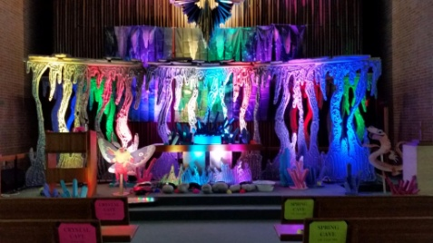
Welcome to the cave!

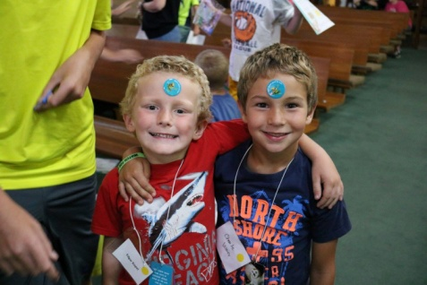
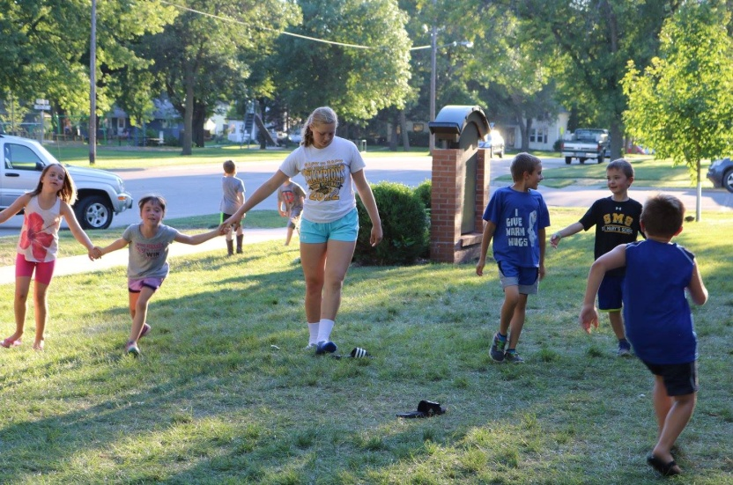
Lots of friends!

Fun games to play

CHURCH ANNOUNCEMENTS

SPECIAL CONGREGATIONAL MEETING
When: Sunday, September 18th, 2016 Will be held after the first service so approximately 9:40 a.m.
Reason: Presentation and voting to ordering and install a new sign near Highway #71 to replace the existing one.
The sign committee members worked on ideas these past several months and at the August Church Council meeting presented their proposed sign and estimated costs. The Council passed the motion to have a Congregational meeting to vote on its approval and to organize the fund raising for this special project.
We hope you can be part of this discussion as we continue to be good stewards of our church property.

NEW WEBSITE!
The Cross of Calvary website has been updated to have a more modern look. There are some new aspects to the site while keeping the same structure and navigation. If you have any trouble finding something on the new website, please contact the church office and we will gladly help you!

CELBRATE “REFORMATION” 500 YEARS!
Rally Sunday (September 11) will be the kickoff event for the Reformation Celebration. In 2017 it will be the 500th anniversary of the Lutheran Reformation, and we are celebrating for a full year leading up to it! Each month we will have a planned event to celebrate.

WOW will begin on Wednesday, September 7th at 3:15.

CONFIRMATION
Confirmation starts on Wednesday, September 7th: meal at 5:45 to 6:20pm with a student and parent meeting starting from 6:30-7:30 pm. The meeting will consist of scheduled dates, meal schedule, Acolyte schedule and robe sizes.

Thank you: Once again we are amazed by our family and friends. What an awesome surprise! So very special in every way to celebrate our 50th Anniversary early. Thank You! Thank You! A real blessing to have family, friends and our church family share 50 years of cherished memories with us. – With Thankful hearts,
Bruce & Sharon Metteer

Library News
The library will be cleaning out ALL materials in the library. We are looking for homes and people to ‘shop’ starting on Rally Sunday. If when shopping you want make a free will offering, drop money in the box by the office door. (Please note that it is for books) We plan on having it all cleaned out by the end of September.

9/1 Gladys Hagen 9/9 Madelyn Cole 9/21 Ella Dietrich
9/1 Katherine Gatsche 9/9 Kye Elfering 9/22 Parker Ridler
9/2 Madison Van Vleet 9/10 Don Revier 9/23 Ione Plowman
9/2 Cahleah Harrell 9/10 Dale Frank 9/23 Carole Buhr
9/3 Scott Sunvold 9/10 Megan Ridler 9/23 Steve Helmer
9/4 Veva Mittelstadt 9/10 Katelyn Torkelson 9/24 Gloria Franzen
9/4 Daren Sagedahl 9/11 Mamie Folkerts 9/24 June Mertz
9/4 Braxton Helmer 9/12 Barry Slagter 9/24 Cal Wick
9/5 Rocky Pietig 9/12 Siri Youngkrantz 9/24 Elin Elfering
9/5 Brenna Weis 9/13 Karen Revier 9/25 Ethan Whited
9/6 Elaine Maurice 9/13 Darnell Bratsch 9/25 Kya Young
9/6 Tom Balderston 9/14 Justin Fahse 9/25 Hollie Bratsch
9/6 Chris Hanson 9/14 Joseph Lingl 9/25 Jennifer Bratsch
9/6 Devin Gluesing 9/14 Jordan Skeie 9/25 Kaylee Fennern
9/6 Bjorn Hausken 9/14 Kylee Berg 9/26 Willem Deklerk
9/7 Nancy Shafer 9/14 Matt Fischer 9/26 Craig Lothert
9/7 Sharon Metteer 9/15 Isiah Boehme 9/26 Kelli Meyer
9/7 Loren Rausch 9/16 Bill Miller 9/26 Ashley Trongard
9/7 Dick Steinbeisser 9/16 Debbie Knudson 9/27 Shad Evenson
9/7 Charlie Visser 9/16 Andy Lang 9/28 Jordan Amberg
9/8 Kathy Reese 9/18 Dawn Mertens 9/29 Larry Larson
9/8 Ruth Linde 9/18 Christopher McDowell 9/29 Dave Triplett
9/8 Lynn Johnson 9/19 Stan Malecek 9/29 Erik Wogen
9/8 Kaden Bahl 9/19 Alicia Osthus 9/29 Casey Meyer
9/9 Marlys Klinghagen 9/20 Caitlyn Bellig 9/29 Liam Tretsven
9/9 Rich Elbert 9/20 Baylie Kubesh 9/30 Ryan Erickson
9/9 Brian Mittelstadt 9/20 Jacob Lingl 9/30 Kelsey Fischer
9/9 Angela Cole 9/21 Bob Fliflet 9/30 Katherine Wick

Cross of Calvary Lutheran Church COUNCIL MEETING
Minutes for: Wednesday August 17, 2016 @ 7:30pm

COUNCIL MEMBERS
(_)Aaron Thompson 2017* (X) Jon Hawkinson 2018 (X) Eric Skeie 2019*
(X)Keith Larson 2017* (X) Bobbi Kopel 2018 (X) Natasha Johnson 2019*
(X)Cindy Johnson 2017* ( ) Paul Buhr 2019 (X) Michelle Jensen 2019*
(X)DeeAnne Newville 2017 (X) Gordon Blem 2019
(X)Steve Altmann 2018
Terms end at Annual Meeting (Jan.) *Second term
STAFF
(x) Pastor Matt Hausken ( ) Ashley Schmidt, Minister of Faith Formation (x) Sue Altmann, Council Recorder

AGENDA

1. Meeting called to order- President Eric Skeie
2. Devotions – Michelle
3. Approve minutes of the June (no July meeting) meeting – Motion to approve the minutes by Steve, seconded by Jon H., motion passed.
4. Financial Secretary and Treasurer Reports (June & July) - Motion to approve the treasurer/secretary report by Gordy, seconded by DeeAnne, motion passed.
5. Pastor’s report – Pastor was busy with premarital sessions and weddings this summer. Church is getting ready for the Reformation Celebration. We will be starting a book club: topic will be Martin Luther. The book club will have its own FaceBook page for people to follow and comment. Rally Sunday will have the books available for ½ price. Confirmation leaders and Sunday School teachers are all in place, meetings will be happening in the next few weeks. Thanks to the Blem’s for hosting the Confirmation Retreat again this year.
6. Minister of Faith Formation’s report – 1. 30 Cross of Calvary kids registered for VBS. The congregation was very generous in supplying scholarships to those who needed them. 2. Ashley participated in 3 camps during July. All went well. Photos are on the website. 3. Summer Stretch went through July, ending with a trip to Valley Fair. The kids were able to participate in many service projects during the month that were appreciated by many people in the community. (40 total) 4. WOW starting on Sept. 7 – looking for volunteers. 5. Breakfast Club starting on Sept. 8th.

COMMITTEE REPORTS AND RECOMMENDATIONS

1. Youth Ministry-none
2. Equipping the Congregation - none
3. Outreach – none
4. Administration – Parsonage: dishwasher needs fixing and shingles need to be replaced on a section of the roof, either this fall or spring.
5. AED Maintence – Steve checked.

OLD BUSINESS
• Website Information – Voted to start the process for online giving/directory. The company will be Vanco. Steve made a motion to move forward and Gordy seconded, motion passed.
• Sign for West side of building – Gordy reported from the committee. The final details are being worked out; we are close to raising money for the project. Thank you to the committee for your time. The sign will be in the same spot as old sign. Congregational meeting on Sept. 18 at 9:40 am
NEW BUSINESS
• Reminder needed in September for storing Wogen benches. (September 18th)
• Church Clean-up Day: Gordy suggested that we have a church clean-up day. This has been done in the past. The date was set for Oct. 2. More information to follow, the agenda will be set up for cleaning.
Next Council meeting: Wednesday, September 21st at 7:30 pm
Communion: 9:00 – Steve (July)
Communion: 9:00 - Steve (August)
Communion: 8:30 – Eric/10:30 – Natashia (September)
Devotions – Natashia

Adjourn /Close in prayer

