Prayer Concerns
Prayer Matters! Please take your bulletin home and pray for those listed. Prayer concerns are listed for one month.
Please write another prayer request and drop it in the offering plate or in the office mailbox to ensure your request gets extend on the prayer concerns list.
Pray for: | Submitted by: | Pray for: | Submitted by:
Roxie Fliflet | Sandy Whited | Diana Adkins | B Hennen
Vonna Ledeboer | A Ledeboer | Jill Revolinski | C Mallek
Abbie McGregor | A & H Thompson | Greg & Evelyn Rosenow | Teeny Kadelbach
Roger Schultes | Lynnette Blem | Family of Ann Orth | Family of Ann Orth
Ian Nelson | Becky Nelson | Carol Senkyr | Pastor Matt
Amy Senger | Duane Senger | Caryn Jandl | Karen Barta
Lesley Sagedahl  Joan Novak | Daren Sagedahl  Jan Rauenhorst | Red Fostvedt | Sonja Fostvedt
Emergency/Pastoral Care-Please have a family member or friend notify the church. You may also request hospital staff to call on your behalf. Call day or night at 523-1574. Never feel as though you are bothering Pastor or the staff. We are here to serve as a comfort and as a resource.
OCTOBER WORSHIP VOLUNTEERS
The week of Oct. 16 – Oct. 23
Sun Worship 8:30 & 10:30 am
Mon Library reserved 6-8 pm
Tues Men’s Bible Study 6:15/7:00 am
Wed No WOW 3:15 pm
No Confirmation Meal 5:30-6:20 pm
No Confirmation 6:30-7:30 pm
Sat Worship 5:30 pm
Sun Worship 8:30 & 10:30 am
No Sunday school
Communion - 8:30 Jon Hawkinson
10:30 DeeAnne Newville
Altar Guild – Eleanor Ziesmer, Edith Vogt,
Sheila Pietig
Acolytes - Hannah Larson, Olivia Hanson
Ushers -8:30 – Dick & Gladie Hagen
10:30- Steve Johnson, Lynn Johnson

The Snowflake Bazaar Committee is once again asking for your help with this year's event. It will be held on SUNDAY, December 4th, from 9:30 am to 12:30 pm. Once again, we are making a change to the menu as it's always nice to see what would work the best and be easiest on our service workers. We will be having a scrambled egg/sausage brunch and will need food donations. We also ask that you think of us when doing your holiday baking as the bake sale is an important part of the morning.
The Raffle this year has a deadline of NOVEMBER 9th. This is important so that we may start selling tickets on Nov. 13th. Last year, a few items came in just days prior to the event and it just made more work for the committee, so we thank you in advance for your promptness in this! We also would appreciate any craft donations for our craft room. On Nov. 13th, after the 9:30 service, anyone that would like to help us paint a few items is welcome to join us in the fellowship hall during coffee... we promise it is VERY easy and a lot of fun! Thanks for all your help - we plan on making a sizable donation to the new sign fund and the success of our bazaar is because of our great congregation.
Dana Boen, Cathy Helin, Jen Kingery, Sandy Gay and Jody Steffel

COMMUNITY BOARD
CHECK THE EAST BULLETIN BOARD
***Some fliers are posted at the East entrance***
Adult Grief Support: The group will meet on Monday, Oct. 3-Nov. 7, 2016 from 2-4 pm in the Redwood Area Hospital education room. There is no cost to participate.
Lutheran Marriage Encounter Weekend: October 21-23, for more information see Community Board.
Scandinavian Smorgasbord: You are invited to attend out smorgasbord at First Lutheran Church of Renville, 316 SW 3rd Street. Sunday, October 16th from 11:15 to 1:00 pm. Yummy Scandinavian meal!!
Renville County Food Shelf: The food shelf is low on items; any donation would be greatly appreciated!! Also, area churches will be taking turns each month for collecting funds. Lutheran churches have the months of February and June. All churches have November and March!
Peace Officer Appreciation Day! Everyone is invited to have dinner with the Renville County Peace Officers and their families, October 22nd at the American Legion in Olivia from 4pm-7pm. Free will donation.
Festival of Hymns Soli Deo Gloria “To God and God Alone the Glory”: Sunday, October 16th at 4 pm at the Vinje Lutheran Church West Central Singers. Join the West Central Singers in a celebration of congregational song. Tickets are $10 at the door. (Children and students are free)
Hospital Ambassador: Hospital Seeks Outgoing Personalities: Friendly, active volunteers sought to help as a Hospital Ambassador. Assist visitors and patients in finding their way through our many hallways by escorting, giving directions, and providing wheelchair assistance. Age 16 and older with many shifts available. Please contact Jennifer Grund at 320.523.3493 or email grundj@rchospital.com
"The Celebration Ringers bell choir of Our Savior's in Bird Island is looking for new bell ringer. The bells available are low C and D. They are the largest of the bells and the music is the easiest to play. We practice Mondays at 5:00 for about 1 to 1 1/2 hours. We perform basically once a month during a church service. Our practice starts the first Monday after Labor Day in September through our last performance in May. We also take off generally 2 weeks at Christmas/New Year's. We will sometimes also play at 1 or 2 Lenten services if we are unable to play 1 or 2 Sundays during Lent. We are also in need of subs. You do not need to be a member of Our Savior's to play in the choir...both men and women are welcome to join us. It is helpful if you can read music. If you are interested, please call Brenda Erickson (director) at 320-365-4836. We are hoping that you will prayerfully consider joining the bell choir."
BOLD ECI meeting: This is a reminder of the upcoming BOLD ECI monthly meeting that will be held next week on Tuesday October 18th at 5:30 pm at The Learning Funhouse in Bird Island.
Our meetings are held the third Tuesday of each month and will now be held at The Learning Funhouse childcare center. Please join us.
Bethany Christian Services will be hosting a Discover Adoption/Foster Care event on Thursday, October 27 at 6:00pm at our office in Willmar, MN. The attached flyer contains all the details. If you would be so kind and post this flyer at your church we would appreciate it. If there is room in your weekly bulletin it would also be appreciated if you would post the details there as well.
80th Birthday Party for Mary Ann Bentley; The party will be held at the Ren Villa Nursing Home at 205 S. East Elm St., Renville, MN 56284. Date and time of the party are Saturday, Oct. 22nd from 1:30-3:30.
Devotion: Use this resource at home to guide your household’s daily devotions. You can do this alone or with others; in the morning, during the day, or at night. Find a routine that works best for you.
Pray: Light a candle and open your devotion time with a prayer.
You are a Lord of mercy who heeds the prayers of your people. Grant us those requests which will glorify you and bring us into more perfect devotion of our Lord and Savior Jesus Christ. Amen.
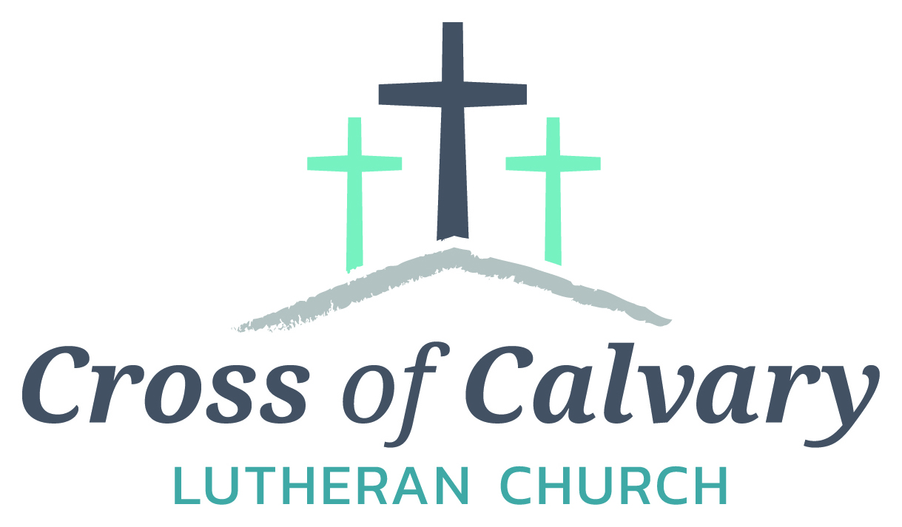
WorshipTimes
Saturdays: 5:30 pm
Sundays: 8:30 & 10:30
Coffee Hour
Sunday at 9:30 am
Sunday School
Sunday at 9:30 am
Building Hours
Mon-Thurs 8:30-7:00
Fri-Sun 8:30-2:00
Our Mission
That all may know the love of God

Matt Hausken
Pastor
hauskenmatt8@gmail.com
Ashley Schmidt
Minister of Faith Formation
cofcyouth@gmail.com
Sue Altmann
Office Administrator
crossofcalvary@gmail.com
__________________
320-523-1574
Web:crossofcalvay.net

Reflect: Reflect on the key verses from Sunday’s reading.
They rose early in the morning and worshiped before the Lord; then they went back to their house at Ramah. Elkanah knew his wife Hannah, and the Lord remembered her. In due time Hannah conceived and bore a son. She named him Samuel, for she said, “I have asked him of the Lord.” 1 Samuel 1:19-20
Study: Study the reading and consider the background.
Hannah knows what she wants, and is bold enough to ask for it. However, the intensity of her prayer is equaled by her promise to dedicate her son to the Lord. How could God resist such a request?
Consider: Consider this theme for the week’s text.
God answers prayer.
Read: Read the following daily readings to deepen your understanding of Sunday’s text. After the reading, ask the follow-up questions.
Sunday: God Answers Hannah, 1 Samuel 1:9-11, 19-20; 2:1-10 Thursday: Saul Rejected and David Anointed, 1 Samuel 16:1-13
Monday: God Calls Samuel, 1 Samuel 3:1-18 Friday: David Defeats Goliath, 1 Samuel 17:1-54
Tuesday: The Ark of God Captured, 1 Samuel 4:2-11, 6:2, 11-13 Saturday: David Brings the Ark to Jerusalem, 2 Samuel 6:1-23
Wednesday: Samuel Anoints Saul as King, 1 Samuel 9:27-10:8, 10:17-27
What are the benefits and drawbacks for Israel to shift from a tribal nation to a kingdom? How might our political system serve God?
Connect: Connect in conversation with others in your household. Discuss the following questions, or simply check in with “Highs” and “Lows.”
What was a high point of your day? What was a low point?
How do you think prayer works? How did Hannah’s prayer affect her life? How did affect the future of Israel?

What have you asked God for that still awaits an answer? What did you bargain in return for a favorable answer? Does God require something in exchange for answered prayer? Where do you see God working while you wait for the answer?
Do: By acting on what we learn we make God’s word come alive. Do the following activity this week.
Set aside 10 minutes every day to pray in a way you’re not used to. Here are some possibilities: a quiet, still posture of prayer; yoga; meditation; mindfulness; prayer while walking or running, be creative with your prayer life. How did the habit of prayer affect your mood?
Bless: Close your devotion with a blessing
May God love you with passion and forgiveness. Amen.
Welcome to Cross of Calvary Lutheran Church
1103 W. Chestnut Ave. Olivia, MN 56277 October 16, 2016

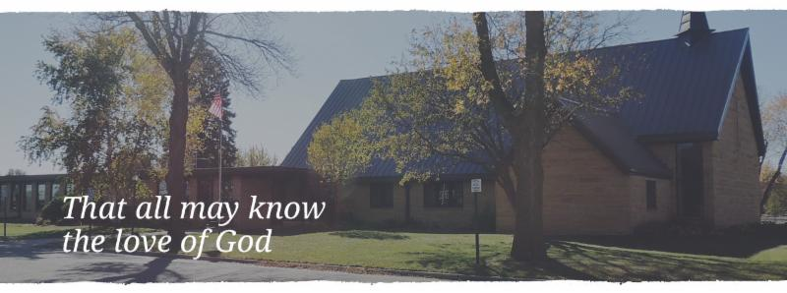
Cross of Calvary is the ELCA church in Olivia. We are an intergenerational (fancy word for young and old) community that follows Jesus out the building to where we live. We are all learners (disciples) here. This is a safe place to practice worship. And, believe us, it takes practice. Your questions, critical thinking, doubts and imperfect lives are welcome here.
Holy Communion
Holy Communion is open to all who are baptized and trust that Christ is present in the meal, regardless of your tradition or affiliation. Wine (red)/grape juice (white).
Participation
Bold type means all of us read or pray together. Out loud.
* Please stand as you are able.
Children in Church
They belong here! They are hearing God’s Word, music and prayers. We don’t mind fidgeting and chatter, really! If you like, there are activity bags available in the entry.
Announcements
They are as printed or any new information please give to Pastor Matt prior to worship, please hand a note to Pastor with any announcements, including prayer requests.
Restrooms
They are located in the hallway to the left of the stairs. Changing table located in the Women’s bathroom.
Mission
Paraguay Missionaries-The Kevin and Rebekah Howell family
Bolivia Missionaries – Paul and Jay Mikaelson

