Prayer Concerns
Prayer Matters! Please take your bulletin home and pray for those listed. Prayer concerns are listed for one month.
Please write another prayer request and drop it in the offering plate or in the office mailbox to ensure your request gets extend on the prayer concerns list.
Pray for: | Submitted by: | Pray for: | Submitted by:
Sonja Fostvedt | Pastor Matt | Diana Adkins | B Hennen
Vonna Ledeboer | A Ledeboer | Jill Revolinski | C Mallek
Abbie McGregor | A & H Thompson | Greg & Evelyn Rosenow | Teeny Kadelbach
Joan Novak | Jan Rauenhorst | Sara Selander | Sharon Alton
Ian Nelson | Becky Nelson | Carol Senkyr | Pastor Matt
Amy Senger | Duane Senger | Caryn Jandl | Karen Barta
Lesley Sagedahl | Daren Sagedahl | Red Fostvedt | Pastor Matt
Emergency/Pastoral Care-Please have a family member or friend notify the church. You may also request hospital staff to call on your behalf. Call day or night at 523-1574. Never feel as though you are bothering Pastor or the staff. We are here to serve as a comfort and as a resource.
The week of Oct. 30-Nov. 6
Sun Worship 8:30 & 10:30 am
Confirmation Sunday 10:30 am
Mon Library reserved 6-8 pm
Tues Men’s Bible Study 6:15/7:00 am
Wed WOW 3:15
Confirmation 6:30 pm
3rd Grade Bible Class 3:15
Thur Craft Retreat Start at 5:00 pm
Fri Craft Retreat 8 am – 10 pm
Sat Worship 5:30 pm
Craft Retreat 8 am – 6 pm
Sun Worship (1st Communion) 8:30 & 10:30 am
Reformation Event: Potluck after 10:30 service
Swimming at BOLD from 1-2

November WORSHIP VOLUNTEERS
Communion - 8:30 Keith Larson
10:30 Michelle Jensen
Altar Guild – Jill Hanson, Dawn Gluesing
Acolytes – Brady Ridler, Maddie Jensen
Ushers -8:30 – Ron Nelson, Margaret Flemming,
Craig Flemming
10:30- Tom & DeeAnne Newville

FYI: Carpet Cleaning: November 7th

The Snowflake Bazaar Committee is once again asking for your help with this year's event. It will be held on SUNDAY, December 4th, from 9:30 am to 12:30 pm. Once again, we are making a change to the menu as it's always nice to see what would work the best and be easiest on our service workers. We will be having a scrambled egg/sausage brunch and will need food donations. We also ask that you think of us when doing your holiday baking as the bake sale is an important part of the morning.
The Raffle this year has a deadline of NOVEMBER 9th. This is important so that we may start selling tickets on Nov. 13th. Last year, a few items came in just days prior to the event and it just made more work for the committee, so we thank you in advance for your promptness in this! We also would appreciate any craft donations for our craft room. On Nov. 13th, after the 9:30 service, anyone that would like to help us paint a few items is welcome to join us in the fellowship hall during coffee... we promise it is VERY easy and a lot of fun! Thanks for all your help - we plan on making a sizable donation to the new sign fund and the success of our bazaar is because of our great congregation.
Dana Boen, Cathy Helin, Jen Kingery, Sandy Gay and Jody Steffel

COMMUNITY BOARD
CHECK THE EAST BULLETIN BOARD for more information /details
Adult Grief Support: The group will meet on Monday, Oct. 3-Nov. 7, 2016 from 2-4 pm in the Redwood Area Hospital education room. There is no cost to participate.
Hospital Ambassador: Hospital Seeks Outgoing Personalities: Friendly, active volunteers sought to help as a Hospital Ambassador. Assist visitors and patients in finding their way through our many hallways by escorting, giving directions, and providing wheelchair assistance. Age 16 and older with many shifts available. Please contact Jennifer Grund at 320.523.3493 or email grundj@rchospital.com
Annual Grief Support Opportunity: “Good Grief” is sponsored by Renville County Hospice. The sessions will be held on Monday evenings November 7, 14, 21 and December 5, 2016 from 5:30 to 7:30 pm at Renville County Hospital (Willette Room), 100 Healthy Way in Olivia. All are welcome and invited. Please call Dawn at 320-523-34512 to register.
Harvest Fest at Blomkest Baptist: Please join us for the annual Harvest Fest on Sunday, November 13 at 7 pm. The evening will include a musical presentation be Norma Watson and auto-harp. A free-will offering will go to the Ridgewater Campus Ministry as directed by our interim pastor, Jeffrey Schmitz, and for supplies of the Legacy House for those in need. There is no charge for the pie social following the program.
Turkey Supper: Our Savior’s Lutheran Church in Bird Island will be hosting their annual supper, Nov. 16th starting at 5:00 pm Details are on the Community Board.
Miracles from Scrap/Craft/Quilt Fall Retreat: November 3rd -5th at Cross of Calvary Church.
Volunteer needed to shop every 2 weeks for residents of the Golden Living Center. It would only take about an hour and would be local, either B & D or Dollar General. If interested, please contact Sheila Pietig at 320-523-1652 or sheila.pietig@goldenliving.com
Harvest Brunch: Sunday November 6th from 8 am – 12. Sponsored by Olivia Lions, place: American Legion. Free will offering, proceeds to Olivia Cub Scouts, Boy scouts and BOLD FFA. Menu: pancakes, sausages, scrambled eggs.
The women of St. John’s Catholic Church in Hector are holding their annual Craft and Bake Sale on Saturday, Nov. 12 from, 8-1 at the Buffalo Lake High School, Hector campus small gym. See board for more details.
21st Annual Lutheran Men in Mission Lutefisk & Meatball Supper: Thursday, Nov. 17 from 4:30-6:30 at Gloria Dei Lutheran Church in Redwood Falls. See board for more details.
Westcourt Apartments are now accepting application for 1 bedroom apartments for rent. See board
Beef Commercial Dinner: Olivia Kiwanis/Santa’s Closet of Renville County invites you to BE A WINNER!!!!
When: Election Day, Tuesday, November 8th from 4-7 pm at the CCOC in Olivia.
Question? There is a set of Halloween Dishes at the church. Does anyone know who they belong too?? Contact the office with any information. Thank You
RCW Area Friends of the Arts presents “The Cemetery Club” Come & enjoy some great entertainment on November 11/12 at 7:30 pm; November 13 matinee at 2:00 pm (directed by Bev Raske). It will be held at the RCW small gym/stage – wheelchair accessible. Tickets sold at the door: $15 (adults); $10 (students).

Devotion: Use this resource at home to guide your household’s daily devotions. You can do this alone or with others; in the morning, during the day, or at night. Find a routine that works best for you.
Pray: Light a candle and open your devotion time with a prayer.
Lord, our vision is often too small to see the vastness of your abundance. Open our clenched hands, that in so doing we might find them already full of your blessings. In Jesus’ name Amen.
Reflect: Reflect on the key verses from Sunday’s reading.
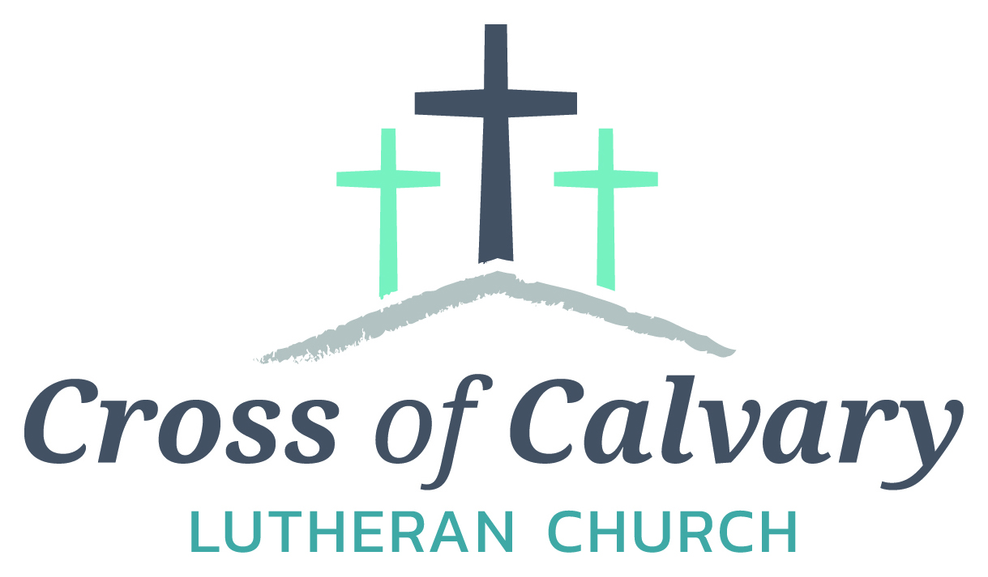
WorshipTimes
Saturdays: 5:30 pm
Sundays: 8:30 & 10:30
Coffee Hour
Sunday at 9:30 am
Sunday School
Sunday at 9:30 am
Building Hours
Mon-Thurs 8:30-7:00
Fri-Sun 8:30-2:00
Our Mission
That all may know the love of God

Matt Hausken
Pastor
hauskenmatt8@gmail.com
Ashley Schmidt
Minister of Faith Formation
cofcyouth@gmail.com
Sue Altmann
Office Administrator
crossofcalvary@gmail.com
__________________
320-523-1574
Web:crossofcalvay.net

Elijah said to her, “Do not be afraid; go and do as you have said; but first make me a little cake of it and bring it to me, and afterwards make something for yourself and your son. For thus says the Lord the God of Israel: The jar of meal will not be emptied and the jug of oil will not fail until the day that the Lord sends rain on the earth.” 1 Kings 17:13-14
Study: Study the reading and consider the background.
When resources are scarce, we are tempted to cling to what little we have. If the widow of Zarephath had done the same, she would never have known the unpredictable joys of welcoming Elijah the prophet.
Consider: Consider this theme for the week’s text.
When we care for our planet, our planet cares for us.
Read: Read the following daily readings to deepen your understanding of Sunday’s text. After the reading, ask the follow-up questions.
Sunday: God’s Care for the Widow, 1 Kings 17:1-16 [17-24]
Monday: Elijah Meets God, 1 Kings 19:11-18, 2 Kings 9:30-37
Tuesday: Elijah Ascends to Heaven and Elisha Succeeds Elijah, 2 Kings 2:1-18
Wednesday: Elisha Heals Naaman, 2 Kings 5:1-19
Thursday: Amos Prophesies Against Israel, Amos 5:18-24
Friday: Hosea Prophesies Against Israel, Hosea 2:1-13
Saturday: Micah Prophesies to Both Kingdoms, Micah 6:1-8
What is going on in the world at the time of Elijah? How is Elijah’s world like ours? How is it different?
Connect: Connect in conversation with others in your household. Discuss the following questions, or simply check in with “Highs” and “Lows.”
What was a high point of your day? What was a low point?
When have you accepted or offered help to someone whose skin is a different color, or who speaks a different language? What can you do to provide food or water to someone who is in need?
What have you been refraining from doing because it’s hard to trust God? What can you do to demonstrate trust in God this week?
Do: By acting on what we learn we make God’s word come alive. Do the following activity this week.
Plant some bulbs that will grow in the spring. Over the winter, pray for the healing of our planet. In the spring, as your bulbs sprout and blossom, celebrate the planet’s resilience.
Bless: Close your devotion with a blessing.
May God bless all who care for the planet and its people. Amen.
Welcome to Cross of Calvary Lutheran Church
1103 W. Chestnut Ave. Olivia, MN 56277 October 30, 2016 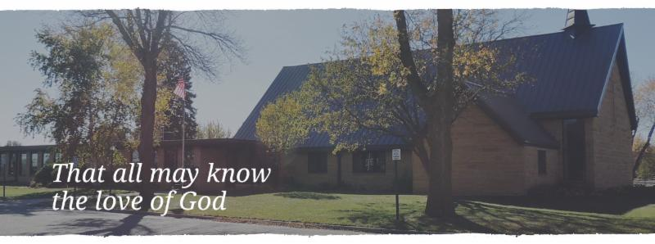Cross of Calvary is the ELCA church in Olivia. We are an intergenerational (fancy word for young and old) community that follows Jesus out the building to where we live. We are all learners (disciples) here. This is a safe place to practice worship. And, believe us, it takes practice. Your questions, critical thinking, doubts and imperfect lives are welcome here.
Holy Communion
Holy Communion is open to all who are baptized and trust that Christ is present in the meal, regardless of your tradition or affiliation. Wine (red)/grape juice (white).
Participation
Bold type means all of us read or pray together. Out loud.
* Please stand as you are able.
Children in Church
They belong here! They are hearing God’s Word, music and prayers. We don’t mind fidgeting and chatter, really! If you like, there are activity bags available in the entry.
Announcements
They are as printed or any new information please give to Pastor Matt prior to worship, please hand a note to Pastor with any announcements, including prayer requests.
Restrooms
They are located in the hallway to the left of the stairs. Changing table located in the Women’s bathroom.
Mission
Paraguay Missionaries-The Kevin and Rebekah Howell family
Bolivia Missionaries – Paul and Jay Mikaelson

