**Prayer Concerns**

*Prayer Matters! Please take your bulletin home and pray for those listed.*

*Prayer concerns are listed for one month.*

|  |  |  |  |
| --- | --- | --- | --- |
| Pray for: | *Submitted by:* | Pray for: | *Submitted by:* |
| Sonja Fostvedt | *Pastor Matt* | **Diana Adkins** | *B Hennen* |
| Vonna Ledeboer | *A Ledeboer* | **Jill Revolinski** | *C Mallek* |
| Abbie McGregor | *A & H Thompson* | **Greg & Evelyn Rosenow** | *Teeny Kadelbach* |
| Roger Schultes | *Lynette Blem* | **Family of Sara Selander** | *Sharon Alton* |
| Joe Besledahl | *Mattie family* | **Carol Senkyr** | *Pastor Matt* |
| Amy Senger | *Duane Senger* | **Caryn Jandl** | *Karen Barta* |
| Lesley Sagedahl | *Daren Sagedahl* | **Red Fostvedt** | *Pastor Matt* |
| Luella Norberg | *Lynette Blem* | **Warren Mitchell** | *Cole Family* |

Emergency/Pastoral Care-Please have a family member or friend notify the church. You may also request hospital staff to call on your behalf. Call day or night at 523-1574. Never feel as though you are bothering Pastor or the staff. We are here to serve as a comfort and as a resource.

**The week of Nov. 27 – Dec . 4**

Today Worship 9:00 am

Baptism

Good Gifts

Fellowship Hall used after service

Mon Library reserved 6-8 pm

Ruth Bible Study 1:30

Tues Men’s Bible Study 6:15/7:00 am

Wed WOW 3:15

Confirmation 6:30 pm

Church Decorating 4:00 pm

Advent Service 7:00 pm

Sat. Worship 5:30 pm

Baptism

Sun Worship 8:30 & 10:30 am



**DECEMBER VOLUNTEERS**

**Communion** - 8:30 Keith Larson10:30 Cindy Johnson

**Altar Guild** – Sue Malecek, Jenny Evenson & Kathy Slagter

**Acolytes** – Andrew Holland & Leif Hausken

**Usher** -8:30 – Keith Larson, Nate Bahl, Dave Lindquist & Sue Lindquist

10:30- Steve & Sue Altmann

**COMMUNITY BOARD**

CHECK THE EAST BULLETIN BOARD for more information /details

**Annual Grief Support Opportunity:** “Good Grief” is sponsored by Renville County Hospice. The sessions will be held on Monday evenings November 7, 14, 21 and December 5, 2016 from 5:30 to 7:30 pm at Renville County Hospital (Willette Room), 100 Healthy Way in Olivia. All are welcome and invited. Please call Dawn at 320-523-34512 to register.

**A Noel Celebration:** presented by the Olivia Kiwanis on Thursday, December 1st at 7:00 pm at St. Aloysius Catholic Church in Olivia.



**Cross of Calvary Lutheran Church**

**1103 W. Chestnut Ave. Olivia, MN 56277 320-523-1574**

**November 27, 2016 Weekly Announcements**

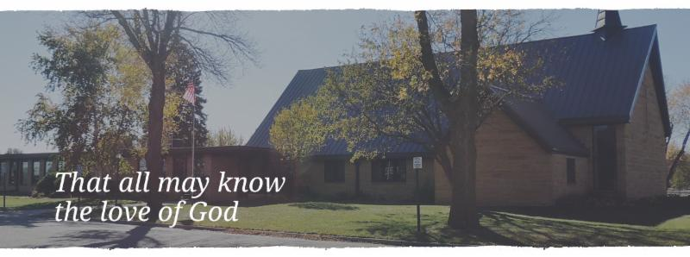

Cross of Calvary is the ELCA church in Olivia. We are an intergenerational (fancy word for young and old) community that follows Jesus out the building to where we live. We are all learners (disciples) here. This is a safe place to practice worship. And, believe us, it takes practice. Your questions, critical thinking, doubts and imperfect lives are welcome here.

**Holy Communion**

Holy Communion is open to all who are baptized and trust that Christ is present in the meal, regardless of your tradition or affiliation. Wine (red)/grape juice (white).

**Participation**

**Bold type means all of us read or pray together. Out loud.** * Please stand as you are able.

**Children in Church**

They belong here! They are hearing God’s Word, music and prayers. We don’t mind fidgeting and chatter! If you like, there are activity bags available in the entry.

**Announcements**

They are as printed or any new information please give to Pastor Matt prior to worship, please hand a note to Pastor with any announcements, including prayer requests.

**Restrooms**

They are located in the hallway to the left of the stairs. Changing table located in the Women’s bathroom.

**Mission**

Paraguay Missionaries-The Kevin and Rebekah Howell family

Bolivia Missionaries – Paul and Jay Mikaelson



**Coming up in November**

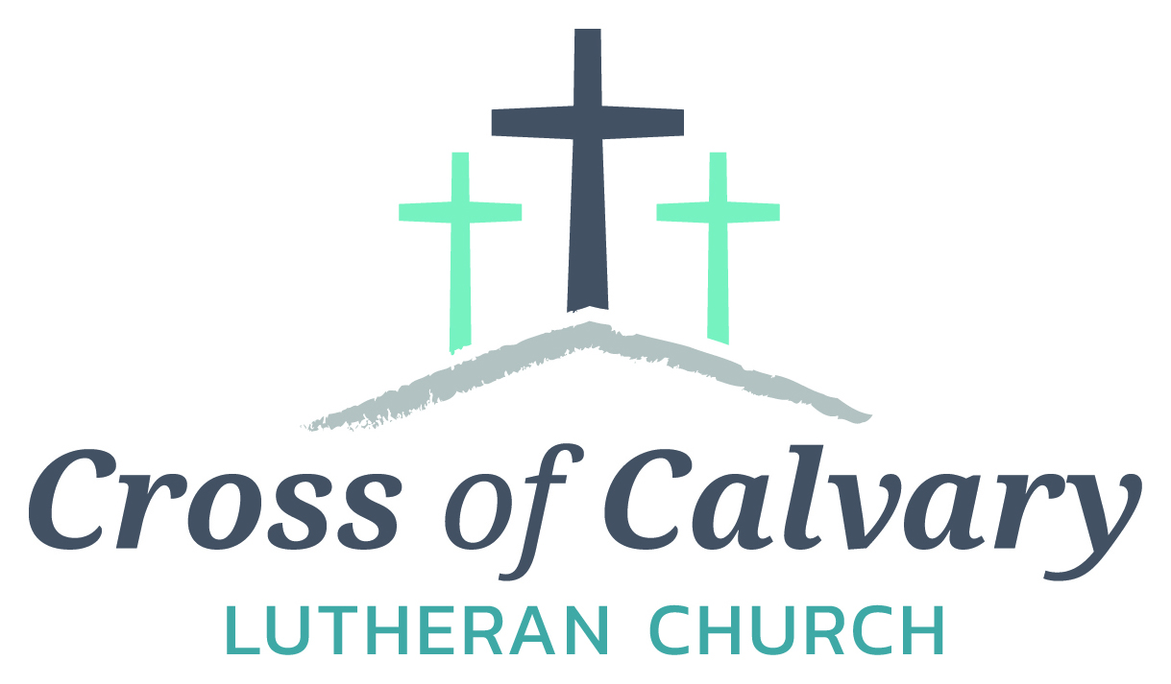

**WorshipTimes**

Saturdays: 5:30 pm

Sundays: 8:30 & 10:30

**Coffee Hour**

Sunday at 9:30 am

**Sunday School**

Sunday at 9:30 am

**Building Hours**

Mon-Thurs 8:30-7:00

Fri-Sun 8:30-2:00

**Our Mission**

That all may know the love of God

Matt Hausken

Pastor

[hauskenmatt8@gmail.com](mailto:hauskenmatt8@gmail.com)

Ashley Schmidt

Minister of Faith Formation

[cofcyouth@gmail.com](mailto:cofcyouth@gmail.com)

Sue Altmann

Office Administrator

[crossofcalvary@gmail.com](mailto:crossofcalvary@gmail.com)

________________

320-523-1574

Web:crossofcalvay.net

**27 Worship 9:00 am only**

**28 Ruth Bible Study**

**Assemble Follower**

**29 Girl Scouts**

**30 Advent Service 7:00 pm**

**Decorate Church**

**Coming up in December**

**3 Lefse making at Hausken’s**

**4 Snowflake Bazaar**

**7 Deadline for application “Youth Minister”**

**Advent Service**

**14 Advent Service**

**15 Dorcas Bible Study at Master’s at 10:00 am**

**18 Sunday School Program (2nd Service**

**19 Deadline for “Good Gifts”**

**21 Advent Service**

**Church Council at 7:30 pm**

**January 22nd-Annual Meeting**

**Midweek Advent Worship**

**7pm each Wed. evening beginning Nov. 30, continuing with Dec. 7, 14 and 21. Join us in a brief half-hour time of sharing the quiet hope, waiting and preparing of the Advent season.**

**Devotion:** Use this resource at home to guide your household’s daily devotions. You can do this alone or with others; in the morning, during the day, or at night. Find a routine that works best for you.

**Pray:** Light a candle and open your devotion time with a prayer.

**Lord, you know the dangers that we face. Give us the wisdom to call on you always, and deliver us in our hour of need. For Jesus’ sake, Amen.**

**Reflect:** Reflect on the key verses from Sunday’s reading.

***Daniel then said to the king, “O king, live forever! My God sent his angel and shut the lions’ mouths so that they would not hurt me, because I was found blameless before him; and also before you, O king, I have done no wrong.” Daniel 6:21-22***

**Study:** Study the reading and consider the background.

**King Darius is in a pickle. His friend Daniel has violated an unbreakable law, and must now face a den of lions. The powerless king spends an anxious night fasting, hoping for a miracle. What will the morning bring?**

**Consider:** Consider this theme for the week’s text.

**Faith can be something worth giving up one’s life for. How that faith is manifested may be quite different for different people.**

**Read:** Read the following daily readings to deepen your understanding of Sunday’s text. After the reading, ask the follow-up questions.

**Sunday: Daniel’s Hope in God, Daniel 6:6-27**

**Monday: Nebuchadnezzar’s Dream, Daniel 2:1-49**

**Tuesday: The Fiery Furnace, Daniel 3:1-30**

**Wednesday: Belshazzar’s Feast, Daniel 5:1-30**

**Thursday: Visions of Four Beasts, Daniel 7:1-28**

**Friday: Seventy Weeks, Daniel 9:20-27**

**Saturday: The Resurrection of the Dead, Daniel 12:1-13**

**What do the images and stories from the book of Daniel tell you about God?**

**Connect:** Connect in conversation with others in your household. Discuss the following questions, or simply check in with “Highs” and “Lows.”

**What was a high point of your day? What was a low point?**

**Are there ordinances or laws that you do not find just? What can you do to live faithfully according to God’s word?**

**When has God rescued you from certain demise? Did you put your faith in God before your rescue? After? How do you demonstrate faith?**

**Do:** By acting on what we learn we make God’s word come alive. Do the following activity this week.

Download a mindfulness app to your smartphone. (Lotus Bud Mindfulness Bell is a good one.) Every time the mindfulness bell goes off, stop what you are doing and pray.

**Bless:** Close your devotion with a blessing.

**May God strengthen you in your prayer and faith life. Amen.**

**Advent – Friends and Family**

Pastor would like to include families and/or groups of friends with the lighting of the Advent candles at each Sat & Sun service. What a joy to see children and families, friends and neighbors taking an active role during worship as we prepare for Christmas!

Please contact Pastor or Sue for more information and to choose a date and service time. (Advent services start November 30th)

**Opportunity to Serve**

**\*\*\*Minister of Faith Formation\*\*\***

Cross of Calvary is acceptingapplications for the position of Minister of Faith Formation (currently filled by Ashley Schmidt) with a close date of December 7th, end of business day. Please submit applications and any additional information in an envelope to the church office or drop box outside the office door. Any questions regarding the position or process may be directed to Eric Skeie, President of the congregation.

**C:\Users\Office\AppData\Local\Microsoft\Windows\Temporary Internet Files\Content.IE5\VTLSJFWR\MC900331471[1].wmfSharing Special Music at Christmas**

If you are considering providing special music at the Sunday

School Service on Dec. 18, or at the Christmas Eve service(s) on Dec. 24, please help the organist, pianist, tech people, office and Pastor with preparations. Simply fill out the form found below, or in the Follower, then submit it to office by the due date noted. Thanks!!

NAME ______________Cell /Home phone__________________

|  |  |
| --- | --- |
| **Sunday School Program**  (Preschool – grade 12) | **Christmas Eve**  (HS and adults) |
| **Dec 18 10:30** | **Dec 24** please circle 4:30 or 9:00 |
| The following must be  COMPLETED by – Dec 4 | The following must be  COMPLETED by – Dec 11 |
| Your piece is selected, and you have the music in hand. YES or NO  Title:  It is a LEGAL copy? YES or NO  Do you need the church to help you obtain a legal copy? YES or NO | Your piece is selected, and you have the music in hand. YES or NO  Title:  It is a LEGAL copy? YES or NO  Do you need the church to help you obtain a legal copy? YES or NO |
| Are others performing with you, and it is confirmed. YES or NO  Names: | Are others performing with you, and it is confirmed. YES or NO  Names: |
| You have contacted an accompanist, and it is confirmed. YES NO NA  Name: | You have contacted an accompanist, and it is confirmed. YES NO NA  Name: |
| Do you need microphones?  YES or NO How many? ____ | Do you need microphones?  YES or NO How many? ____ |
| Do you need music or video run though the tech system?  YES or NO | Do you need music or video run though the tech system?  YES or NO |
| You have arranged for a rehearsal time with the accompanist and the office. YES or NO | You have arranged for a rehearsal time with the accompanist and the office. YES or NO |



**DECORATING the SANTUARY**

****Sure could use some extra help on Wednesday, Nov. 30th starting around 4:00 or after work. Our Sanctuary always looks beautiful for Christmas, but many hands are needed. Pizza & beverage will be provided

**Santa’s Closet.** It’s never too early to be thinking of

donating to Santa’s Closet. While you are out and

about, keep this ministry in mind. Look for the open

Christmas box under the news board in the narthex.

* Santa’s Closet of Renville County is about to begin for another year. Our mission and vision is to provide a store-like atmosphere for people to shop with dignity and respect. With the help of volunteers and donations Santa’s Closet will work very hard to serve the people of Renville County.
* Join Santa’s Closet at the CCOC in Olivia for Hot Chocolate & Special “K” bars on Tuesday, November 29th from 9am-3pm. “Blankets for Kids’ – either donate a blanket or money for a blanket. Donations can also be mailed to: Santa’s Closet, PO Box 115, Olivia, MN 56277

**Confirmation Suppers.** Would you consider working with a friend/family to prepare and serve a simple meal to our confirmation student on Wed nights? Approximately 25 kids roll in after school activities…hungry for supper and for time spent with Pastor and the small group leaders! The meal is served from 5:45 to 6:20. The confirmation parents are the first to volunteer, but there are more class dates than families. Sign-up sheet are on the BOARD.

**Upcoming Reformation Events:**

**December:** Christmas Caroling and Hot Cocoa Bar – FOR ALL AGES!

December 18th at 3:30pm (Meet at the church then we will carpool together to the locations) We will sing at the Golden Living Center, Fairview Place and Parkview then go back to Cross of Calvary Church to enjoy some hot cocoa with family and friends!

**January:** MIA Luther Exhibit on January 6th at 6:00 pm

pm. Cost of ticket is $12.00 per person. More information to follow, tickets available from Pastor Matt.