

**Devotion:** Use this resource at home to guide your household’s daily devotions. You can do this alone or with others; in the morning, during the day, or at night. Find a routine that works best for you.

**Pray:** Light a candle and open your devotion time with a prayer.

**Nothing is impossible with you, O Lord. Gladden our hearts with your promises, and do not let us keep silent about all you have done for us. In Jesus’ holy name, Amen.**

**Reflect:** Reflect on the key verses from Sunday’s reading.

***And Mary said, “My soul magnifies the Lord, and my spirit rejoices in God my Savior,8for he has looked with favor on the lowliness of his servant. Surely, from now on all generations will call me blessed; for the Mighty One has done great things for me, and holy is his name.”* Luke 1:46-49**

**Study:** Study the reading and consider the background.

**It’s all spinning out of control. Here is Mary, unmarried, now pregnant, but with the Son of God? There’s nothing else to do but take refuge at her cousin’s, where two women share a common bond and a mutual experience of God’s miracles on earth.**

**Consider:** Consider this theme for the week’s text.

**Mary spoke on behalf of a nation united in its anticipation of something better.**

**Read:** Read the following daily readings to deepen your understanding of Sunday’s text. After the reading, ask the follow-up questions.

Sunday: *Jesus’ Birth Announced,* Luke 1:26-45 [46-56]

Monday: *Introduction to Luke*, Luke 1:1-4

Tuesday: *An Angel Tells Zechariah of John’s Birth,* Luke 1:5-25

Wednesday: *Mary’s Song,* Luke 1:46-56

Thursday: *Birth of John the Baptist,* Luke 1:57-66

Friday: *Prophecy of Zechariah,* Luke 1:67-80

Saturday, *Birth of Jesus (Christmas Eve),* Luke 2:1-14, [15-20]

**How will Jesus’ arrival change the course of human history?**

**Connect:** Connect in conversation with others in your household. Discuss the following questions, or simply check in with “Highs” and “Lows.”

**What was a high point of your day? What was a low point?**

**What can you do to help mothers-to-be prepare for the arrival of their babies? How can your community of faith support them as they raise their children?**

**When have you had to wait for someone or something that had the potential to change your life? What did you do to prepare for its arrival?**

**Do:** By acting on what we learn we make God’s word come alive. Do the following activity this week.

**Put together a new baby care kit for expectant parents or those waiting on adoption in your community. Be creative about what you include in the kit. How will your kit support the new parents? How will it support the baby? How will it lift up God’s love for the family?**

**Bless:** Close your devotion with a blessing.

May God bless whatever you are anticipating in your life. Amen.

**Mission**

Paraguay Missionaries – The Kevin & Rebekah Howell family

Bolivia Missionaries – Paul and Jay Mikaelson



**Prayer Concerns**

*Prayer Matters! Please take your bulletin home and pray for those listed.*

*Prayer concerns are listed for one month.*

|  |  |  |  |
| --- | --- | --- | --- |
| Pray for: | *Submitted by:* | Pray for: | *Submitted by:* |
| Warren Mitchell | *Cole Family* | **Diana Adkins** | *B Hennen* |
| Vonna Ledeboer | *A Ledeboer* | **Jill Revolinski** | *C Mallek* |
| Family of  Red Fostvedt | *Pastor Matt* | **Greg & Evelyn Rosenow** | *Teeny Kadelbach* |
| Leslie Sagedahl | *Daren Sagedahl* | **Caryn Jandl** | *Karen Barta* |
| Joe Besledahl | *Mattie family* | **Pat Aalderks** | *Pastor Matt* |
| Abbie McGregor | *A & H Thompson* |  |  |

Emergency/Pastoral Care-Please have a family member or friend notify the church. You may also request hospital staff to call on your behalf. Call day or night at 523-1574. Never feel as though you are bothering Pastor or the staff. We are here to serve as a comfort and as a resource.

**The week of Dec. 18 – Dec . 25**

Today Worship 8:30 & 10:30 am

**Sunday School Program 10:30 am**

Mon Library reserved 6-8 pm

Ruth Bible Study (potluck) noon

Follower notes need by end of day

Tues Men’s Bible Study 6:15/7:00 am

Wed WOW 3:15

Confirmation 6:30 pm

Advent Service 7:00 pm

Church Council 7:30 pm

Sat Worship 4:30 & 9:00 pm

Sun Worship 9:00 am

**DECEMBER VOLUNTEERS**

**Communion** - 8:30 Keith Larson10:30 Cindy Johnson

**Altar Guild** – Sue Malecek, Jenny Evenson & Kathy Slagter

**Acolytes** – Andrew Holland & Leif Hausken

**Usher** -8:30 – Keith Larson, Nate Bahl, Dave Lindquist & Sue Lindquist

10:30- Steve & Sue Altmann

**Ushers needed for the 2017 church year.**

Dates needed: January late service (2), April late service(2), September early services (2), October early services (2) and 1 ushers for January early service, May early service, August service, November early service. Please contact either Daren Sagedahl or the church office. Thank you for volunteering!!

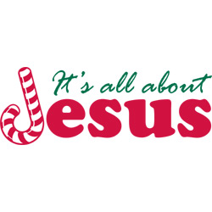



**COMMUNITY BOARD**

CHECK THE EAST BULLETIN BOARD for more information /details

**Fairview Place Independent Senior Housing Apartment Openings:** Why worry about snow removal this winter: Fairview Place in Olivia currently has one and two bedroom apartments available, if you are interested or would like to set up a time to come and check us out please give Jenny a call at 320-523-1836.

**Santa’s Closet.** It’s never too early to be thinking of

donating to Santa’s Closet. While you are out and

about, keep this ministry in mind. Look for the open

Christmas box under the news board in the narthex.

Santa’s Closet of Renville County mission and vision is to provide a store-like atmosphere for people to shop with dignity and respect. With the help of volunteers and donations Santa’s Closet will work very hard to serve the people of Renville County.

**Confirmation Suppers.** Would you consider working with a friend/family to prepare and serve a simple meal to our confirmation student on Wed nights? Approximately 25 kids roll in after school activities…hungry for supper and for time spent with Pastor and the small group leaders! The meal is served from 5:45 to 6:20. The confirmation parents are the first to volunteer, but there are more class dates than families. Sign-up sheet are on the BOARD. **Dates with openings: Dec. 21 and Jan. 4**

**Upcoming Reformation Events:**

**December:** Christmas Caroling and Hot Cocoa Bar – FOR ALL AGES!

December 18th at 3:30pm (Meet at the church then we will carpool together to the locations) We will sing at the Golden Living Center, Fairview Place and Parkview then go back to Cross of Calvary Church to enjoy some hotcocoa with family and friends!

**January:** MIA Luther Exhibit on January 6th at 6:00 pm Cost of ticket is $12.00 per person. Tickets available from Pastor Matt or sign up on The Board.

**Check out the calendars on the table by youth board. A great way to get a wonderful calendar and help with the sign fundraising!!! (Thank you Dr. Buhr)**

**Cross of Calvary Lutheran Church**

**1103 W. Chestnut Ave. Olivia, MN 56277 320-523-1574**

**December 18, 2016 Weekly Announcements**

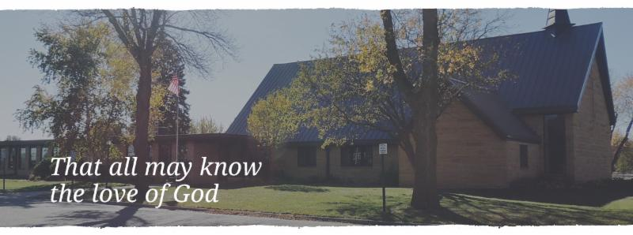

Cross of Calvary is the ELCA church in Olivia. We are an intergenerational (fancy word for young and old) community that follows Jesus out the building to where we live. We are all learners (disciples) here. This is a safe place to practice worship. And, believe us, it takes practice. Your questions, critical thinking, doubts and imperfect lives are welcome here.

**Holy Communion**

Holy Communion is open to all who are baptized and trust that Christ is present in the meal, regardless of your tradition or affiliation. Wine (red)/grape juice (white).

**Participation**

**Bold type means all of us read or pray together. Out loud.** * Please stand as you are able.

**Children in Church**

They belong here! They are hearing God’s Word, music and prayers. We don’t mind fidgeting and chatter! If you like, there are activity bags available in the entry.

**Announcements**

They are as printed or any new information please give to Pastor Matt prior to worship, please hand a note to Pastor with any announcements, including prayer requests.

**Restrooms**

They are located in the hallway to the left of the stairs. Changing table located in the Women’s bathroom.





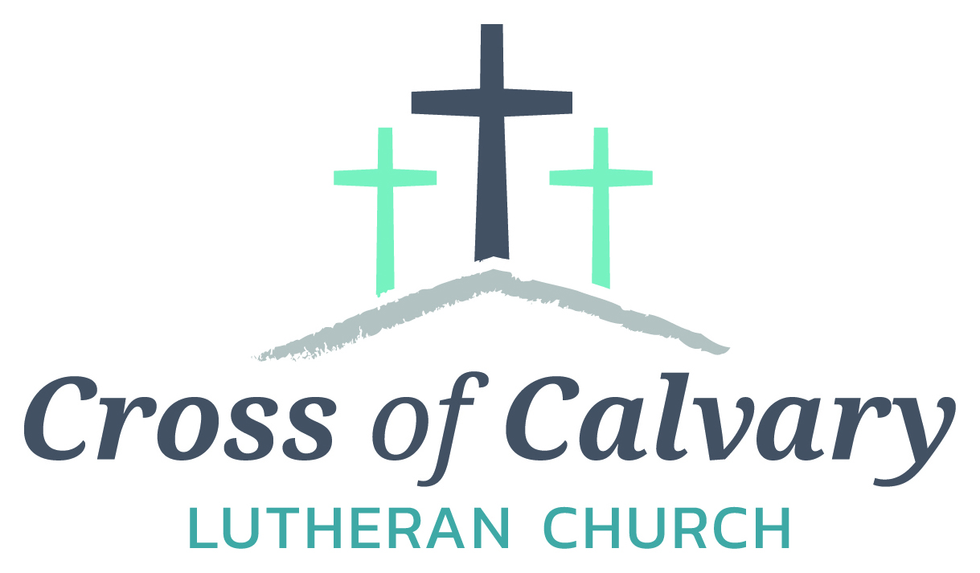

**WorshipTimes**

Saturdays: 5:30 pm

Sundays: 8:30 & 10:30

**Coffee Hour**

Sunday at 9:30 am

**Sunday School**

Sunday at 9:30 am

**Building Hours**

Mon-Thurs 8:30-7:00

Fri-Sun 8:30-2:00

**Our Mission**

That all may know the love of God

Matt Hausken

Pastor

[hauskenmatt8@gmail.com](mailto:hauskenmatt8@gmail.com)

Ashley Schmidt

Minister of Faith Formation

[cofcyouth@gmail.com](mailto:cofcyouth@gmail.com)

Sue Altmann

Office Administrator

[crossofcalvary@gmail.com](mailto:crossofcalvary@gmail.com)

________________

320-523-1574

Web:crossofcalvay.net

Online giving is now available. Go to website listed above.

**Coming up in December**

**18 Sunday School Program (2nd Service**

**19 Ruth Bible Study at noon (potluck)**

**21 Advent Service**

**Church Council at 7:30 pm**

**28 No Confirmation or WOW**

**29 No Breakfast Club**

**31 No Saturday service**

**January 1 – Service at 9:00 am only**

**Annual Congregational Meeting**

**January 22, 2017 at 9:30 am**

**(Alternate date: 1/29/2017)**

**Midweek Advent Worship**

7pm each Wed. evening beginning Nov. 30, continuing thru Dec. 21. Join us in a brief half-hour time of sharing the quiet hope, waiting and preparing of the Advent season.

**KOLV programming**

As of January 1st KOLV will no longer be broadcasting Sunday service from Cross of Calvary church.

**Opportunity to Serve**

Cross of Calvary is accepting applications for the position of Minister of Faith Formation (currently filled by Ashley Schmidt). Please submit applications and any additional office or drop box outside the office door. Any questions regarding the position or process may be directed to Eric Skeie, President of the congregation.

Deadline is today – Thank you to all that gave!!!!



