**Cross of Calvary Lutheran Church**

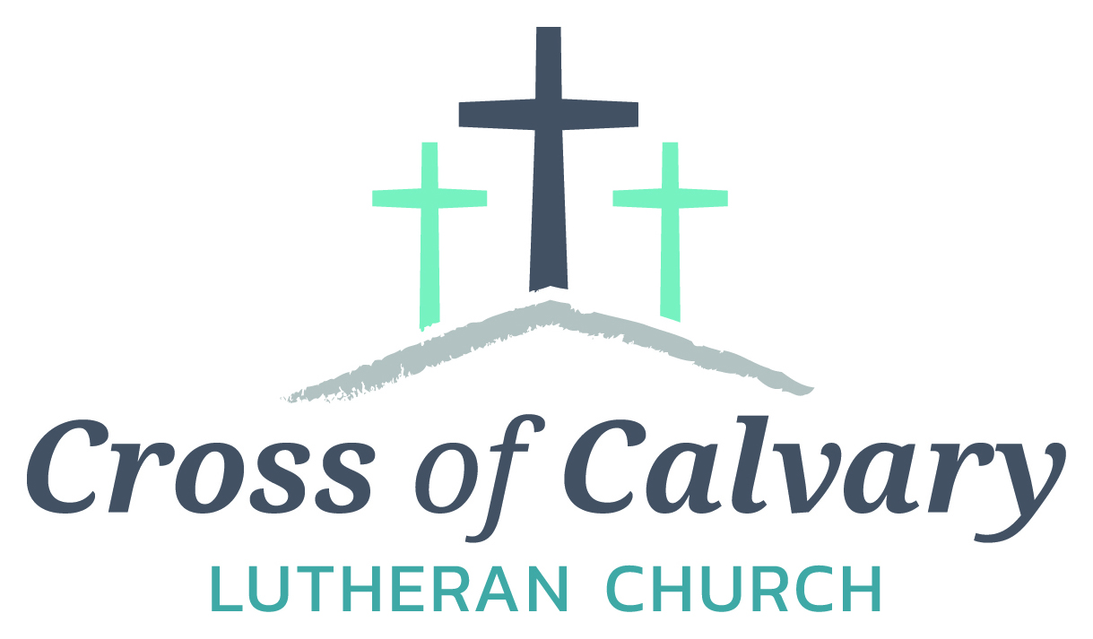

**WorshipTimes**

Saturdays: 5:30 pm

Sundays: 8:30 & 10:30

**Coffee Hour**

Sunday at 9:30 am

**Sunday School**

Sunday at 9:30 am

**Building Hours**

Mon-Thurs 8:30-7:00

Fri-Sun 8:30-2:00

**Office Hours**

Mon, Tues, Thurs.

8:30-3:00

Wednesday 8:30-4:00

Friday 8:30-2:00

**Our Mission**

*That all may know*

*the love of God*

Matt Hausken

Pastor

[hauskenmatt8@gmail.com](mailto:hauskenmatt8@gmail.com)

Minister of Faith Formation

[cofcyouth@gmail.com](mailto:cofcyouth@gmail.com)

Sue Altmann

Office Administrator

[crossofcalvary@gmail.com](mailto:crossofcalvary@gmail.com)

________________

320-523-1574

Web:crossofcalvay.net

Online giving is now available. Go to website listed above.

**1103 W. Chestnut Ave. Olivia, MN 56277**

**320-523-1574**



**February 12, 2017**

**Weekly Announcements**

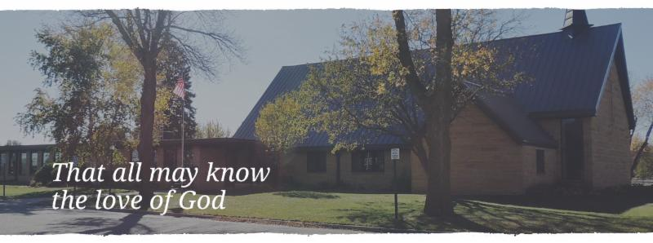

Cross of Calvary is the ELCA church in Olivia. We are an intergenerational (fancy word for young and old) community that follows Jesus out the building to where we live. We are all learners (disciples) here. This is a safe place to practice worship. And, believe us, it takes practice. Your questions, critical thinking, doubts and imperfect lives are welcome here.

**Holy Communion**

Holy Communion is open to all who are baptized and trust that Christ is present in the meal, regardless of your tradition or affiliation. Wine (red)/grape juice (white).

**Participation**

**Bold type means all of us read or pray together. Out loud.**

* Please stand as you are able.

**Children in Church**

They belong here! They are hearing God’s Word, music and prayers. We don’t mind fidgeting and chatter! If you like, there are activity bags available in the entry.

**Announcements**

They are as printed or any new information please give to Pastor Matt prior to worship, please hand a note to Pastor with any announcements, including prayer requests.

**Restrooms**

They are located in the hallway to the left of the stairs. Changing table located in the Women’s bathroom.

** Mission**

**Paraguay Missionaries**

The Kevin & Rebekah Howell family

**Bolivia Missionaries**

Paul and Jay Mikaelson

**New from the ELCA SW MN Synod!**

Thanks for your congregation’s mission support to our ELCA’s SW MN Synod! We received 100.5% of budgeted mission support in 2016. As a result you shared in the support of ministries in our synod and throughout the world. Our Synod shares mission support (51.5%) to our larger expression, ELCA Church wide. As a result **you were there** as people heard the Gospel, received food, and were supported in times of good and sadness. They were loved by Jesus through “God’s Work. OUR Hands” our ELCA’s calling.

Thanks be to God, **for you!**

**COMMUNITY and CHURCH BOARD**

CHECK THE BULLETIN BOARD for more information /details



Cross of Calvary Soup Supper Signup sheet has been posted on the “BOARD”.

Please sign up ASAP, to get the date your group prefers.

We are looking forward to yummy soups, sandwiches and desserts!

**Another chance for wonderful table talk!!!**

**Table talk: informal conversation carried on at meals**



**Spring 2017 Cross of Calvary Craft Retreat "Ordinary Joy"** will be held March 9-11. Registration forms will be available at church. The fee for the retreat will be $25. For your fee you will get a table to work on, four meals, and wonderful fellowship. Space is limited.

**February is Food Shelf month for ALL Lutherans. Cross of Calvary will be collecting food shelf items the month of February. Please bring any items you would like to donate (money is also an option, please place in a sealed envelope and mark Food Shelf) and place them in the shopping cart in the Narthex. Thank You!!!!**



**Dana Boen is teaching a chair exercise class 2 times a week at Tula, located in downtown Olivia.  If you have joint issues, or problems with balance, this would be a great way to get some exercise!  Just contact Dana at**[**320-894-7885**](tel:(320)%20894-7885)**for prices and times the class is offered, or if you just have any questions.**

The **Olivia VFW Post # 4097** is sponsoring a fundraiser for Jonathan Ceplecha on Sunday, February 19th from 8AM to 1PM. Mr. Ceplecha is a single father and is a resident of Redwood Falls and he lost his home to a fire. Menu: Scrambled eggs, Doug’s Sausage, pancakes, caramel rolls, hash browns, biscuits & gravy – plus coffee, juice and milk. Cost: adults $12 and under 10 $5.

**A Day Set Apart for Women Retreat**

We hope you’ll join us for the 2017 Day Set Apart for Women – Break Every Chain Retreat, Friday and Saturday, March 17th and 18th at Grace Community Church in Olivia, MN.

**What is this retreat all about?** Chains, they’re an interesting thing, aren’t they? We all have them and they all look different….and yet the same. Often, I am blind to the chains I wear.  Looking at her chains, reminds me of the weight of my own. And by the Grace of Jesus, when I am finally free of one, I find another one underneath waiting to be broken. Isn’t that the way of life? But let me tell you there is more. There is an abundant life full of purpose waiting for you. We can continue to let fear, sadness, brokenness, and anger control our lives; keep us in bondage.  Or we can make the decision to truly live free in Christ and loose the chains that keep us from living the life He desires for us. Join us March 17thand 18th, 2017.  Let’s learn how to walk through this together.

Friday evening we will be joined by Grace Johnson from The Potter’s Heart ministry. Saturday our time together will include the testimony of two women. Women no different than you and I, who have removed their blinders, allowed the dark areas of their lives to be pierced with the truth, and watched as the Lord to breathed life into their brokenness.

Who is this for? We welcome women from all walks of life, denominations, and cultures. Young ladies age 15 and up are welcome to join us! For more detailed information visit our Facebook Page, A Day Set Apart for Women. Online registration is available

at: <https://docs.google.com/forms/d/1yQD5bK4Ege4CDZYnZnVQ6Vh7NDUvMkC6mmLJJBew_6Q> or contact: Leta Jacobs [(320) 579-1412](tel:(320)%20579-1412) -or-[leta.jacobs@yahoo.com](mailto:leta.jacobs@yahoo.com)

**Cost is $20** and includes all materials, refreshments, breakfast and lunch on Saturday.  FREE childcare will be provided at the Christian Community Outreach Center (CCOC) in Olivia. Food and beverage will be provided for the children as well. Scholarships are available for those in need.

Payments should be written out to Grace Community Church or GCC and can be mailed to:

Terri Tuma - 650 S. 9th Street, Bird Island, MN 55310

**Annual Family Style Turkey Supper**: Zion United Methodist Church in Buffalo Lake, MN is hosting an eat in & take-out meal supper from 4:30 to 7:30 on Wednesday, February 22nd. Advanced tickets are on sale for $9.00 or $10.00 at the door.

**Senior High Youth Gathering: March 10 & 11. Talk to Sarah or Jeni Skeie for more information.**

**Prayer Concerns**

*Prayer Matters! Please take your bulletin home and pray for those listed.*

*Prayer concerns are listed for one month.*

Emergency/Pastoral Care-Please have a family member or friend notify the church. You may also request hospital staff to call on your behalf. Call day or night at 523-1574. Never feel as though you are bothering Pastor or the staff. We are here to serve as a comfort and as a resource.

**Our Sympathy is extended to:**

To the Meyer Family, at the loss of Darcy Meyer

To the Peterson Family, at the loss of Marie Peterson

|  |  |  |  |
| --- | --- | --- | --- |
| Pray for: | *Submitted by:* | Pray for: | *Submitted by:* |
| Roger Schultes | *Gordy & Lynette Blem* | **Diana Adkins** | *B Hennen* |
| Vonna Ledeboer | *A Ledeboer* | **Jill Revolinski** | *C Mallek* |
| Jenna Reynolds | *Sue & Stan Malecek* | **Greg & Evelyn Rosenow** | *Teeny Kadelbach* |
| Leslie Sagedahl | *Daren Sagedahl* | **Caryn Jandl** | *Karen Barta* |
| Kent Kircher | *Pastor Matt* | **Warren Mitchell** | *Angela Cole* |

**FEBRUARY VOLUNTEERS**

Communion – 8:30 – Bobbi Kopel - 10:30 – Eric Skeie

Altar Guild – Lynette Blem & Lowanda Frank

Acolytes – Ella Mages & Kya Young

Usher – 8:30 – Daren Sagedahl, Todd Gay, Brian Boen & Stan Malecek

10:30 – Corey Gluesing & Aaron Thompson

**Coming up in February at Cross of Calvary**

**February 13 – Deadline for March follower information**

**February 14 – Synod using Fellowship Hall & Kitchen for a meeting (9:00 – 10:30 am)**

**February 15 – Council Meeting at 7:30**

**Outreach Meeting**

**February 19 – VFW Breakfast**

**February 23 – Dorcas Bible Study at 9:30**

**February 26 – Baptism at 10:30 service**

**February 27 – Ruth Bible Study at 1:30**

**Dollar amount collected so far for the New sign: $24,642.00: almost there!!!!!!**

**VBS is June 25th-June 29th, 2017**

 (Meal starts at 5:30 and I believe VBS starts at 6 or 6:30 and runs to 8:30)

There is a VBS planning meeting for anyone interested in helping out with leadership role on February 28th at 7pm at Our Saviors.

March 14th and 28th: Work nights from 6-8pm at Our Saviors

March 25th: Work day from 10-4 at Our Saviors

April 6th and 20th: Work nights from 6-8pm at Our Saviors

May/June TBD if needed

Many hands make this work light and there are a variety of crafts & fairly simple building projects. Any National Honor Society students seeking volunteer hours would be awesome and I am guessing that PM would offer faith elements for Confirmation students to help out as well.



Reminder: We are in need of families, groups, clubs, people to host coffee hour on Sundays. Please sign up on the board in the Narthex. Thank you in advance; it is a wonderful time for table talk!!!!

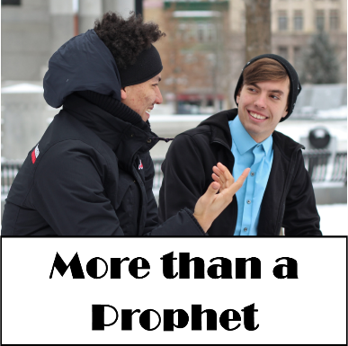**February 12, 2017 Devotion:** Use this resource at home to guide your household’s daily devotions. You can do this alone or with others; in the morning, during the day, or at night. Find a routine that works best for you.

**Pray:** Light a candle and open your devotion time with a prayer.

**Holy Voice,   
You have shown us your wisdom, O God, in your messengers. Make their proclamation our own: a world where all is restored and justice prevails. By the holy name of Christ, Amen.**

**Reflect:** Reflect on the key verses from Sunday’s reading.

*”What then did you go out to see? A prophet? Yes, I tell you, and more than a prophet. This is the one about whom it is written, ‘See, I am sending my messenger ahead of you, who will prepare your way before you.’”* Luke 7:26-27

**Study:** Study the reading and consider the background.

**Jesus and John were two cousins with a common purpose: not only in proclaiming, but also in acting to bring about the kingdom of God. They may suffer insults and opposition from the authorities, but that’s not enough to stop these two persistent prophets.**

**Consider:** Consider this theme for the week’s text.

**John encouraged a lifestyle of humility, service, and repentance. We can continue to work toward justice and peace as John did.**

**Read:** Read the following daily readings to deepen your understanding of Sunday’s text. After the reading, ask the follow-up questions.  
Sunday: *More than a Prophet*, Luke 7:18-35

Monday: *Jairus’ Plea,* Luke 8:40-42

Tuesday: *A Woman Restored*, Luke 43-44

Wednesday: *A Woman Restored*, Luke 45-48

Thursday: *Jairus’ Daughter Healed*, Luke 49-56

Friday: *Jesus Sends Out Disciples,* Luke 9:1-6

Saturday: *Herod Hears of Jesus’ Healings,* Luke 9:7-9

**Describe Jesus’ and John’s relationship with each other.**

**Connect:** Connect in conversation with others in your household. Discuss the following questions, or simply check in with “Highs” and “Lows.

**What was a high point of your day? What was a low point?**

**If someone who didn’t know Jesus asked you about him, how would you describe him?**

**Describe a favorite relationship you have with someone you love. Describe a relationship you have with someone that is challenging for you to love. What similarities and differences do you notice between the two?**

**Do:** By acting on what we learn we make God’s word come alive. Do the following activity this week.

**If someone who didn’t know Jesus asked you about him, how would you describe him?**

**Describe a favorite relationship you have with someone you love. Describe a relationship you have with someone that is challenging for you to love. What similarities and differences do you notice between the two?**

**Bless:** Close your devotion with a blessing.

**God bless you as you live your best life. Amen.**