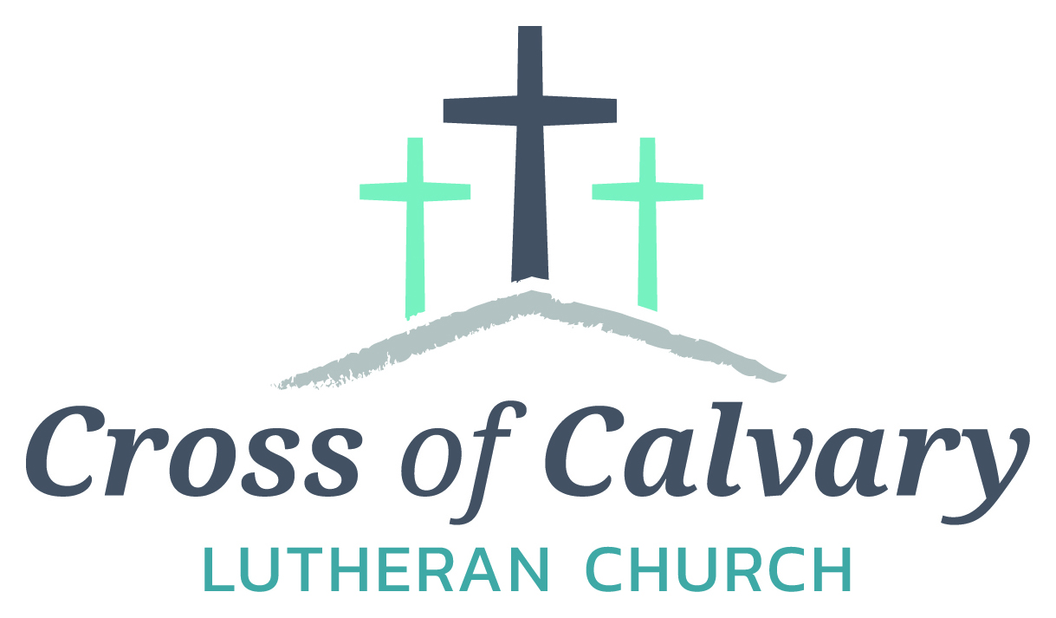

**WorshipTimes**

Saturdays: 5:30 pm

Sundays: 8:30 & 10:30

**Coffee Hour**

Sunday at 9:30 am

**Sunday School**

Sunday at 9:30 am

**Building Hours**

Mon-Thurs 8:30-7:00

Fri-Sun 8:30-2:00

**Office Hours**

Mon, Tues, Thurs.

8:30-3:00

Wednesday 8:30-4:00

Friday 8:30-2:00

**Our Mission**

*That all may know*

*the love of God*

Matt Hausken

Pastor

[hauskenmatt8@gmail.com](mailto:hauskenmatt8@gmail.com)

Sue Altmann

Office Administrator

[crossofcalvary@gmail.com](mailto:crossofcalvary@gmail.com)

320-523-1574

Web:crossofcalvay.net

Online giving is now available. Go to website listed above.

**Cross of Calvary Lutheran Church**

**1103 W. Chestnut Ave. Olivia, MN 56277**

**320-523-1574**



**April 2, 2017**

**Weekly Announcements**

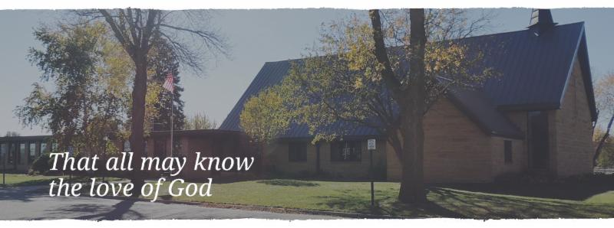

Cross of Calvary is the ELCA church in Olivia. We are an intergenerational (fancy word for young and old) community that follows Jesus out the building to where we live. We are all learners (disciples) here. This is a safe place to practice worship. And, believe us, it takes practice. Your questions, critical thinking, doubts and imperfect lives are welcome here.

**Holy Communion**

Holy Communion is open to all who are baptized and trust that Christ is present in the meal, regardless of your tradition or affiliation.

Wine (red)/grape juice (white).

**Participation**

**Bold type means all of us read or pray together. Out loud.**

* Please stand as you are able.

**Children in Church**

They belong here! They are hearing God’s Word, music and prayers. We don’t mind fidgeting and chatter! If you like, there are activity bags available in the entry.

**Announcements**

They are as printed or any new information please give to Pastor Matt prior to worship, please hand a note to Pastor with any announcements, including prayer requests.

**Restrooms**

They are located in the hallway to the left of the stairs. Changing table located in the Women’s bathroom.

**COMMUNITY and CHURCH BOARD**

**CHECK THE BULLETIN BOARD or east bulletin board for more information /details**



**Cross of Calvary Soup Supper (final supper: April 5th)**

**Wednesday nights from 5:30-6:30 pm**

**BAKED HAM DINNER**

**Sunday, April 2, 2017 11:00 am – 1:00pm**

**Cross of Calvary**

**FOTA Talent Show: Friends of the Arts Talent Show!!! April 24th at 7:30 pm on the RCW stage! All ages! All talents! Fabulous prizes! Register now! Participants must be current residents/Staff/ students RCW, or graduates of RCW – registration closes on April 10th. Sign up form online at http://rcw.schoolwires.net/Page/54**

**Evangelical Free Church of Redwood Falls is privileged to host a conference from Michael Card’s “BIBICAL Imagination” series. The conference dates are April 7-9, 2017. For more information see the bulletin board.**

**Green Lake Lutheran Ministries will hold the 33rd Annual Quilt Auction July 22nd, 2017. Proceeds from this event go to our Annual Fund which allows us to provide fun, safe, quality camping and retreating opportunities for poeople of all ages who use any of our three camps.**

**Quilts**: please delivery to camp by July 14th, viewing will be available online at wwww.gllm.org

**Silent Auction**: item must be brought to camp no later than 5:00 pm on July 20th.

**Cash Donation:**Checks may be sent to: GLLM, 9916 Lake Ave. S. Spicer, MN 56288.

More information is on the bulletin board on the east enterance.

**Marriage Retreat**

Cross of Calvary will be hosting a marriage retreat for both engaged to be married and married couples. (Engaged couples this is a requirement) The retreat will be Saturday, May 6th from 9:00 am -3:00 pm. The cost is $50.00 per couple, which includes the retreat inventory and a meal. Please sign up on the sheet on the board or contact Cross of Calvary to register. 320-523-1574

**Mission**

**Paraguay Missionaries**

The Kevin & Rebekah Howell family

**Bolivia Missionaries**

Paul and Jay Mikaelson

**Prayer Concerns**

*Prayer Matters! Please take your bulletin home and pray for those listed.*

*Prayer concerns are listed for one month.*

Emergency/Pastoral Care-Please have a family member or friend notify the church. You may also request hospital staff to call on your behalf. Call day or night at 523-1574. Never feel as though you are bothering Pastor or the staff. We are here to serve as a comfort and as a resource.

*Diana Adkins *Greg & Evelyn Rosenow *Jill Revolinski

*Leslie Sagedahl *Jenna Reynolds *Vonna Ledeboer

**Coming up in March at Cross of Calvary**

**April 2 – Ham Dinner**

**April 4 – Fellowship Hall used from 5:30-8:30 pm**

**April 9-16: Easter (Holy) week**

**Lenten Service, Wednesday at 7:00 pm, April 5th**



**MARCH VOLUNTEERS**

Communion – 8:30 – Gordon Blem - 10:30 – Jon Hawkinson

Altar Guild – Deanne Beckler, Marie Rauenhorst & Kristi O’Neil

Acolytes – Jordan Sagedahl & Drew Sagedahl

Usher – 8:30 – Kirk Elfering, Rich Elbert, Greg Helin & Richard Sigurdson

10:30 – Dave Altmann & Dan Beckler

**NEEDED: Ushers for the 10:30 services in April**

**Cross of Calvary Quilting Season** is coming to an end. They appreciate your donation of fabric. It has been fun to work with nice fabrics! The quilts go to the Lutheran World Relief, Santa’s Closet, Veteran’s Hospital, and others.

Thank you for helping with our mission!!!!

**ELCA GOOD GIFTS**

**Deadline: April 10**

**The Easter season is upon us. It is a wonderful time to give to those in need. Your gift will help our church family purchase a much needed item for other church families. Thank you and God Bless you!!!!**

**Envelopes have been placed by the basket under the “DOOR”. Please drop the envelopes in the offering basket or in the box by the office door.**







**VBS is June 25th-June 29th, 2017**

 (Meal starts at 5:30 and I believe VBS starts at 6 or 6:30 and runs to 8:30)

There is a VBS planning meeting for anyone interested in helping out with leadership role on February 28th at 7pm at Our Saviors.

March 14th and 28th: Work nights from 6-8pm at Our Saviors

March 25th: Work day from 10-4 at Our Saviors

April 6th and 20th: Work nights from 6-8pm at Our Saviors

May/June TBD if needed

Many hands make this work light and there are a variety of crafts & fairly simple building projects. Any National Honor Society students seeking volunteer hours would be awesome and I am guessing that PM would offer faith elements for Confirmation students to help out as well.

**Dollar amount collected so far for the New sign: $27,542: almost there!!!!!!**

**2017 Spring Fling Flower Sales**



**It is that time of year again when the youth of Cross of Calvary have the opportunity to sell flowers!!!**

**Sales will run Sunday, March 26th – Friday, April 14th**

**Flower Pickup will be Friday, May 12th**

***(Please note there will NOT be pick up on Saturday as in the past)***

**All proceeds from their individual sales will go into your family youth account. This is a wonderful opportunity to raise money for things like bible camp or youth gatherings!!**

**Never done this before? Here is how it works:**

* **As orders are taken fill out one INDIVIDUAL ORDER FORM for buyer.**
* **Once you have completed your selling please total all orders together on the MASTER ORDER FORM with your overall family total sold.**
* **You must collect money with order*. Checks can be made out to “Cross of Calvary Youth”***
* **Turn in all forms and money on or before FRIDAY, APRIL 14th.**
* **All forms and money can be turned in to Sue Altmann in the church office (please do not leave them in the mailbox) or to one of the committee members.**
* **Customers can pick up their orders on Friday, May 12th from 4:30 – 7:30pm at the church.**
  + ***Please use the south door (by the Sunday school rooms). If they are unable to pick up at this time it is the seller’s responsibility to pick up and deliver them. If you need to make arrangements for another pick up time please contact one of the committee members.***

***NO ORDERS OR ADDITIONS WILL BE TAKEN AFTER APRIL 14TH***

**Cost:**

**Hanging Baskets $22.00 Ivy Geranium, Pansies, Impatiens and Begonias**

**8” Pot $16.00 Geraniums**

**12” Pot $26.00 Geraniums**

**Committee Members Contact Information:**

**Amanda Malvin (320) 579-1515** [**bamalvin@msn.com**](mailto:bamalvin@msn.com)

**Bobbie Kopel (320) 522-0731** [**bobbieloowho@hotmail.com**](mailto:bobbieloowho@hotmail.com)

**Tara Amberg (320) 444-0129** [**tamberg@rccbi.com**](mailto:tamberg@rccbi.com)

***\*\*Plants come from Dundee Nursery (Carr Flowers) of Hutchinson***

|  |  |  |  |  |  |  |  |  |  |  |
| --- | --- | --- | --- | --- | --- | --- | --- | --- | --- | --- |
|  |  | | | | |  | | |  | |
| **Individual Order** |  |  |  | |
| Buyer **Name __________________** | **Phone ______________** |
| ***Youth* Seller ___________________** | **Phone ______________** |
|  |  |  | |  | |
|  | Qty | Price **Each** | | Total | |
| Hanging Baskets for Sunny ***Spots*** |  |  | |  | |
| Ivy Geranium - Red |  | $ 22.00 | |  | |
| Ivy Geranium - Pink |  | $ 22.00 | |  | |
| Ivy Geranium - Lavender |  | $ 22.00 | |  | |
| Wave Petunia - Light Pink |  | $ 22.00 | |  | |
| ***Wave Petunia -*** Dark Pink |  | $ 22.00 | |  | |
| Wave Petunia - Dark Purple |  | $ 22.00 | |  | |
| Pansies - Mix |  | $ 22.00 | |  | |
| Hanging Baskets for ***Shady Spots*** |  |  | |  | |
| Impatiens - Red |  | $ 22.00 | |  | |
| Impatients - Rose |  | $ 22.00 | |  | |
| Impatients - Violet |  | $ 22.00 | |  | |
| Begonia - Pink |  | $ 22.00 | |  | |
| Begonia - Orange |  | $ 22.00 | |  | |
| ***Begonia -*** Yellow |  | $ 22.00 | |  | |
| Begonia - Red |  | $ 22.00 | |  | |
| Fuschia - Bi-color |  | $ 22.00 | |  | |
| Potted Plants |  |  | |  | |
| 8" Geranium Pot - Red |  | $ 16.00 | |  | |
| 8" Geranium Pot - Pink |  | $ 16.00 | |  | |
| 8" Geranium Pot - Lavender |  | $ 16.00 | |  | |
| **12" Patio Pot -** Red |  | $ 26.00 | |  | |
| 12**" Patio Pot -** Pink |  | $ 26.00 | |  | |
| **12" Patio Pot -** Lavender | |  | | $ 26.00 | |  | |
| **Total Plants and Sales** |  | XXXXXX | |  | | |
|  | |  | |  | |  | | | |
| Plants **can be picked up on Friday, May 12** |  |  | |
| from **4:30 - 7:30 pm ONLY** |  |  | |  | | |
|  |  |  | |
|  |  |  | |  | | |
|  |  |

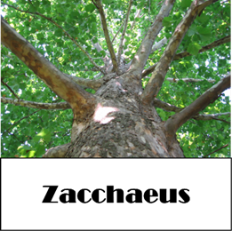

**Devotion:** Use this resource at home to guide your household’s daily devotions. You can do this alone or with others; in the morning, during the day, or at night. Find a routine that works best for you.

**Pray:** Light a candle and open your devotion time with a prayer.

**God of mercy and compassion,   
You never neglect your children in need. So bless us with your healing presence that we might remain by your side on this road of sorrows. In Jesus’ holy name, Amen.**

**Reflect:** Reflect on the key verses from Sunday’s reading.

*Zacchaeus stood there and said to the Lord, “Look, half of my possessions, Lord, I will give to the poor; and if I have defrauded anyone of anything, I will pay back four times as much.” Then Jesus said to him, “Today salvation has come to this house, because he too is a son of Abraham. For the Son of Man came to seek out and to save the lost.”*Luke 19:8-10

**Study:** Study the reading and consider the background.

**No sight? No height? No problem. Jesus has a way of finding those who truly seek his attention. And as we should have learned by now, even a brief encounter with the Son of God has the power to transform a life forever.**

**Consider:** Consider this theme for the week’s text.

**Jesus can heal bodies and spirits, and often does both at the same time.**

**Read:** Read the following daily readings to deepen   
your understanding of Sunday’s text. After the reading,   
ask the follow-up questions.

Sunday: *Zacchaeus*, Luke 18:31 – 19:10

Monday: *Parable of the Ten Pounds,* Luke 19:11-28  
Tuesday: *Jesus Cleanses the Temple,* Luke 19:45- 20:8  
Wednesday: *Parable of Wicked Tenants,* Luke 20:9-19  
Thursday:  *Jesus is Questioned,* Luke 20:20-47  
Friday: *The Widow’s Offering,* Luke 21:1-19  
Saturday: *Destruction of Jerusalem Foretold,* Luke 21:20-38

**Why do you think Jesus is drawn to the underdogs?**

**Connect:** Connect in conversation with others in your household. Discuss the following questions, or simply check in with “Highs” and “Lows.”

**What was a high point of your day? What was a low point?**

**Who in your community has fallen from grace? How might they be restored? What part can you play in lifting up those who have fallen?**

**How focused are you on fairness? Could you give more than is fair? How might such generosity change you? How might it change the ones to whom you give?**

**Do:** By acting on what we learn we make God’s word come alive. Do the following activity this week.

**Make physical and spiritual fitness a priority this week. Add more exercise, healthy foods, and sleep to your routine. Add more meditation, prayer, and stillness to your routine. How does your contribution to your wellness help Jesus heal your body and spirit?**

**Bless:** Close your devotion with a blessing.

**Jesus heals bodies and spirits. May Jesus heal yours. Amen.**

