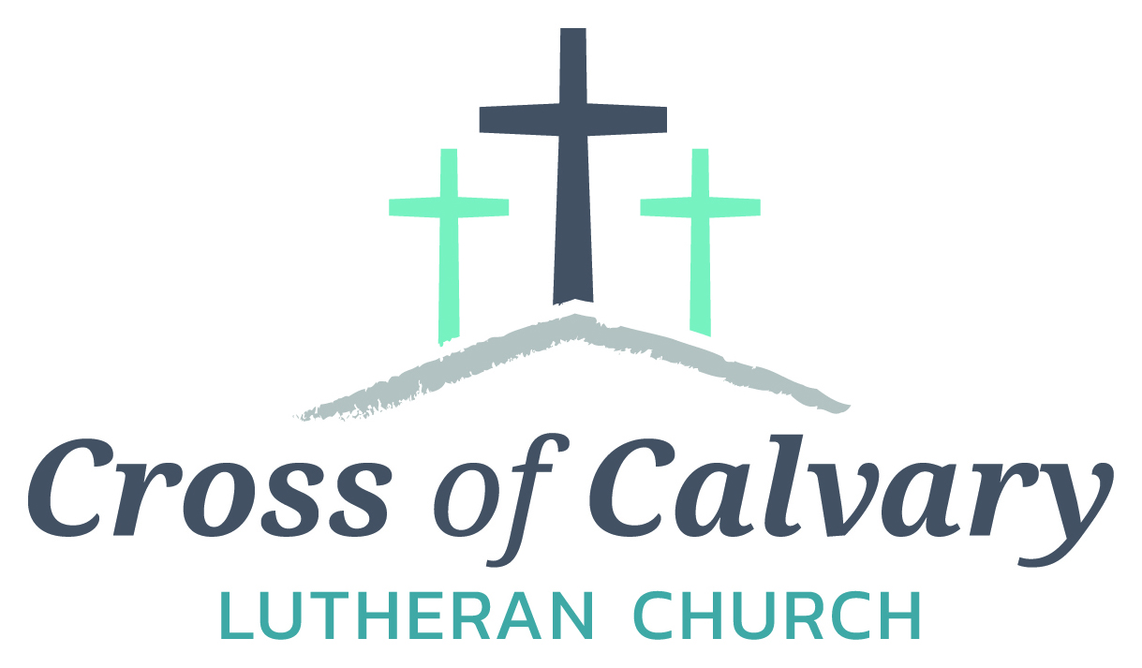
WorshipTimes
Saturdays: 5:30
Sundays: 8:30 & 10:30
Coffee Hour
Sunday at 9:30

Sunday School
Sunday at 9:30

Building Hours
Mon-Thurs
8:30-7:00
Fri-Sun 8:30-2:00
Office Hours
Mon, Tues, and Thurs.; 8:30-3:00
Wednesday
8:30-4:00
Friday
8:30-2:00

Cross of Calvary Lutheran Church
1103 W. Chestnut Ave. Olivia, MN 56277
320-523-1574
May 7, 2017
Weekly Announcements
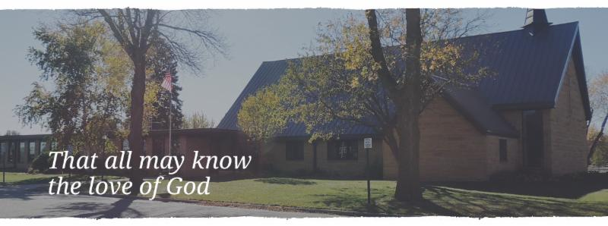
Cross of Calvary is the ELCA church in Olivia. We are an intergenerational (fancy word for young and old) community that follows Jesus out the building to where we live. We are all learners (disciples) here. This is a safe place to practice worship. And, believe us, it takes practice. Your questions, critical thinking, doubts and imperfect lives are welcome here.
Holy Communion
Holy Communion is open to all who are baptized and trust that Christ is present in the meal, regardless of your tradition or affiliation.
Wine (red)/grape juice (white).
Participation
Bold type means all of us read or pray together. Out loud.
* Please stand as you are able.
Children in Church
They belong here! They are hearing God’s Word, music and prayers. We don’t mind fidgeting and chatter! If you like, there are activity bags available in the entry.
Announcements
They are as printed or any new information please give to Pastor Matt prior to worship, please hand a note to Pastor with any announcements, including prayer requests.
Restrooms
They are located in the hallway to the left of the stairs. Changing table located in the Women’s bathroom.

COMMUNITY and CHURCH BOARD
CHECK THE BULLETIN BOARD or east bulletin board for more information /details
Green Lake Lutheran Ministries will hold the 33rd Annual Quilt Auction July 22nd, 2017. Proceeds from this event go to our Annual Fund which allows us to provide fun, safe, quality camping and retreating opportunities for people of all ages who use any of our three camps.
Quilts: please delivery to camp by July 14th, viewing will be available online at www.gllm.org
Silent Auction: item must be brought to camp no later than 5:00 pm on July 20th.
Cash Donation:Checks may be sent to: GLLM, 9916 Lake Ave. S. Spicer, MN 56288.
More information is on the bulletin board on the east entrance.

Spring Fling Ice Cream Social, Bake Sale and Bedding Plant Sale (vegetables & flowers): also a Quilt Display. St. John Cemetery Association of Osceola Township (formerly St. John Lutheran Church-42817 850th Ave, Hector) Date: Friday, May 12 from 4:00 pm to 7:00 pm, serving: hotdogs, BBQ’s, dessert & Ice Cream.

American Legion Post #186 will be having a Sunday Brunch fundraiser for the BOLD/AMERICAN Legion baseball. Sunday, May 7th: serving from 8:00 – 1:00 pm, including pancakes, eggs & sausage. – Free will offering!

UPCOMING NURSING HOME EVENTS
IF YOU HAVE VOLUNTEERED AT THE NURING HOME IN THE LAST YEAR, PLEASE JOIN US FOR A SALAD LUNCHEON ON TUESDAY, MAY 16TH AT 1:15 AT THE OLIVIA REHABILITATION AND HEALTHCARE CENTER (FORMALLY GOLDEN LIVINGCENTER-OLIVIA).
HOPE TO SEE YOU HERE!!
COME JOIN US FOR AN EVENING OF FUN AND FOOD AT THE OLIVIA REHABILITATION AND HEALTHCARE CENTER (FORMALLY GOLDENLIVING CENTER, OLIVIA)
BOUNCY HOUSE, GAMES, HOTDOG COOKOUT AND ROOTBEER FLOATS
WEDNESDAY, MAY 17TH, 4:00~7:00

The flowers on the altar are in memory of Joni Erickson by the Grasmon, Fahse, and Barta families.
Joni passed away May 5, 1997

Coming up in May at Cross of Calvary
May 7 – Baptism (Fellowship Hall used after service)
LYO Banquet (3:00-6:00 pm)
May 13 – Flemming Shower: 12:00-4:00 pm (Fellowship Hall)
May 14 – Senior Recognition Sunday – cake and coffee after service please join the seniors
Last day of Sunday school (only singing at service)
Sunday services start at 9:00 am
May 17 – Church Council Meeting at 7:30 pm
May 18 – Thursday night services start at 6:00 pm
May 21- Sunday service at 9:00 am only
May 22 – Ruth Bible Study at 1:30 (Parkview)
May 24 – Altar Guild Meeting at 7:30 pm
May 25 – Dorcas Bible Study at 10:00 am at Masters
Worship at 6:00 pm

Prayer Concerns
Prayer Matters! Please take your bulletin home and pray for those listed.
Prayer concerns are listed for one month.
Emergency/Pastoral Care-Please have a family member or friend notify the church. You may also request hospital staff to call on your behalf. Call day or night at 523-1574. Never feel as though you are bothering Pastor or the staff. We are here to serve as a comfort and as a resource.
*Diana Adkins *Greg & Evelyn Rosenow *Jill Revolinski
*Leslie Sagedahl *Jenna Reynolds *Vonna Ledeboer
*Emily Reetz *Warren Mitchell *Barb Gomarko
*Bert Budd *Donna Greenwell

MAY VOLUNTEERS
Communion – 8:30 – Eric Skeie and 10:30 – Eric Skeie
Altar Guild – Karen van der Hagen & Angie Boen
Acolytes – Caeden Gluesing & London Prokosch
Usher – 8:30: Nathan Cole, Rod Osthus & Jon Hawkinson
10:30: Duane & Karen Flom & David Torkelson

Please pick up your cake pans/etc. from the Ham Dinner – Thanks!!!

VBS is June 25th-June 29th, 2017
(Meal starts at 5:30, VBS starts at 6 or 6:30 and runs to 8:30)
There is a VBS planning meeting for anyone interested in helping out with leadership role on February 28th at 7pm at Our Saviors.
March 14th and 28th: Work nights from 6-8pm at Our Saviors
March 25th: Work day from 10-4 at Our Saviors
April 6th and 20th: Work nights from 6-8pm at Our Saviors
May/June TBD if needed
Many hands make this work light and there are a variety of crafts & fairly simple building projects. Any National Honor Society students seeking volunteer hours would be awesome and I am guessing that PM would offer faith elements for Confirmation students to help out as well.

SUMMER STRETCH
Wednesdays July 5, 12, 19 & 26 from 8:30 am-3:30pm & Thursday August 3rd (Valley Fair)
Cost is only $25.00 and for grades 6th, 7th and 8th. Includes a T-shirt and August 3rd trip to Valley Fair
Registration Deadline is May 8th, 2017 – Registration can be done online at https://goo.gl/forms/zbxLc2OCTQ3zwulX2 or paper forms can be turned in to one of the Ministries hosting Summer Stretch. Need more information? Contact Joan Honzay
523-2030 or stalreligiousedjh@gmail.com
Hosted by: CCOC, Our Savior’s Lutheran Church, Grace Community Church, Cross of Calvary Lutheran Church, United Lutheran and St. Aloysius Church

May 7, 2017
Devotion: Use this resource at home to guide your household’s daily devotions. You can do this alone or with others; in the morning, during the day, or at night. Find a routine that works best for you.
Pray: Light a candle and open your devotion time with a prayer.
God of encounters,
Your good news stops us in our tracks with amazement, O God. Renew our wonder at the word and all the promises contained within it, gifts especially for us, your children. In Jesus’ name, Amen.
Reflect: Reflect on the key verses from Sunday’s reading.
As they were going along the road, they came to some water; and the eunuch said, “Look, here is water! What is to prevent me from being baptized?” He commanded the chariot to stop, and both of them, Philip and the eunuch, went down into the water, and Philip baptized him. Acts 8:36-38
Study: Study the reading and consider the background.
The disciples’ mission is now springing up everywhere, this time in the middle of the desert, with a high-ranking foreign official. What will this Ethiopian say when Philip reveals to him the astounding truth of the scriptures?
Consider: Consider this theme for the week’s text.
There is a God-shaped hole in each of us that can only be filled by God.

Read: Read the following daily readings to deepen
your understanding of Sunday’s text. After the reading,
ask the follow-up questions.
Sunday: Ethiopian Comes to Believe, Acts 8:26-39
Monday: The Death of Herod, Acts 12:20-25
Tuesday: Barnabas and Paul Commissioned, Acts 13:1-3
Wednesday: The Apostles Preach in Cyprus, Acts 13:4-12
Thursday: Paul and Barnabas in Iconium, Acts 14:1-7
Friday: Paul and Barnabas in Lystra and Derbe, Acts 14:8-20
Saturday: Return to Antioch in Syria, Acts 14:21-28
How is the apostles’ preaching beginning to spread throughout the world?
Connect: Connect in conversation with others in your household. Discuss the following questions, or simply check in with “Highs” and “Lows.”
What was a high point of your day? What was a low point?
How does your community of faith engage in the exchange of ideas concerning the things of faith? How are you personally engaged in a community to help you grow in faith? What might your community of faith do to engage more of the community inside and outside your church?
If you have had a conversion experience, who have you told? If you have been a person of faith your whole life, who have you told? Who might be hungry for the Word and the story of how you experience God?
Do: By acting on what we learn we make God’s word come alive. Do the following activity this week.
Use water more intentionally this week. Here are some ideas. Take shorter showers. Steam some vegetables. Give your pet a bath. Donate to an organization that helps developing communities gain access to clean water.
Bless: Close your devotion with a blessing.
God delights in the joy you experience hearing God’s word. Amen.
Mission
Paraguay Missionaries
The Kevin & Rebekah Howell family
Bolivia Missionaries
Paul and Jay Mikaelson

GIVING ONLINE at Cross of Calvary

Cross of Calvary is reminding you can now manage your giving online! Giving online is easy and allows you to set up automatic recurring contributions and view your complete online giving history from anywhere you have access to the Internet.

Simply follow these easy steps:
1) Visit the church website at crossofcalvary.net
2) Click on the GIVE button,
3) Click on HERE TO GIVE, then
4) Follow the onscreen instructions to create an online profile and to schedule your recurring contributions.

Thank you for your contribution!!!

Area Church Communities:

A free “Women’s Conservation Legacy” workshop will be held on Tuesday, May 16, 2017, at the Franklin Community Center in Franklin. This informal, women-focused workshop is designed for women who own or manage farmland who are interested in conservation practices and maintaining their land for future generations. Women conservationists from local and state agencies will be presenting this workshop to provide an opportunity for women landowners to learn more about conservation and other land management topics, improving soil and water quality on your land, and financial resources available.

Women are increasingly becoming sole landowners as they inherit farmland from family members or spouses. This workshop will provide a peer-to-peer, informal discussion format to allow women landowners the opportunity to talk about their individual land conservation goals, learn from other women landowners and conservationists, and gain knowledge, tools, and support for conservation planning.

Additional information regarding the event is provided on the flyer. There is no fee to attend the workshop, but an RSVP is requested to plan for food, seating, and supplies.

If you should have questions, please contact Heidi Rauenhorst with the Hawk Creek Watershed Project at (320) 523-3666 orheidi@hawkcreekwatershed.org, or myself at the contact information listed below.

