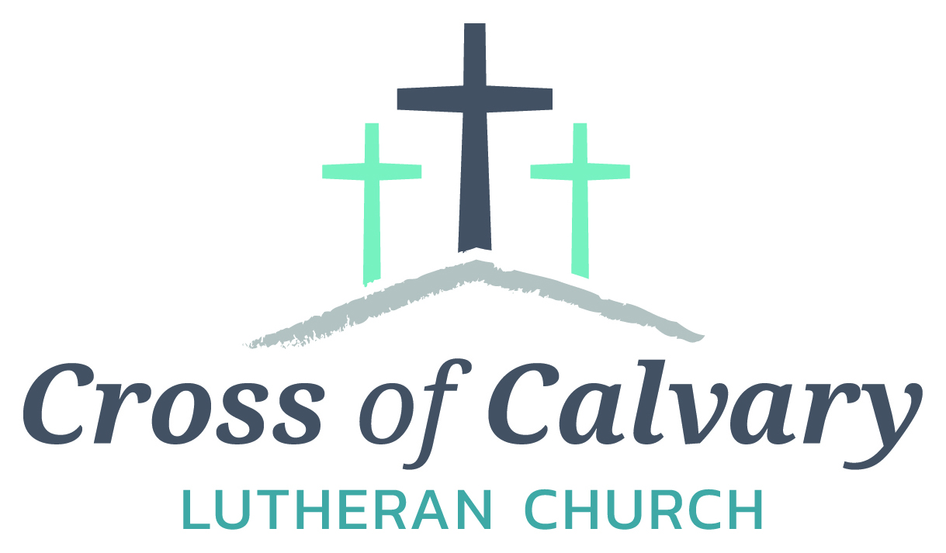
WorshipTimes
Thursday: 6:00
Sundays: 9:00
Coffee Hour
After service
Sunday School
Resumes: September
Building Hours
Mon-Thurs
8:30-7:00
Fri-Sun 8:30-2:00
Office Hours
Mon, Tues, and Thurs.; 8:30-3:00
Wednesday
8:30-4:00
Friday 8:30-2:00
Pastor
Matt Hausken
hauskenmatt8@gmail.com
Admin. Assist.
Sue Altmann
crossofcalvary@gmail.com

Cross of Calvary Lutheran Church
1103 W. Chestnut Ave. Olivia, MN 320-523-1574
June 4, 2017
Weekly Announcements
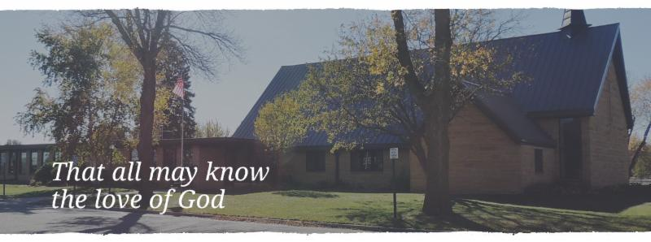
Cross of Calvary is the ELCA church in Olivia. We are an intergenerational (fancy word for young and old) community that follows Jesus out the building to where we live. We are all learners (disciples) here. This is a safe place to practice worship. And, believe us, it takes practice. Your questions, critical thinking, doubts and imperfect lives are welcome here.
Holy Communion
Holy Communion is open to all who are baptized and trust that Christ is present in the meal, regardless of your tradition or affiliation.
Wine (red)/grape juice (white).
Participation
Bold type means all of us read or pray together. Out loud.
* Please stand as you are able.
Children in Church
They belong here! They are hearing God’s Word, music and prayers. We don’t mind fidgeting and chatter! If you like, there are activity bags available in the entry.
Announcements
They are as printed or any new information please give to Pastor Matt prior to worship, please hand a note to Pastor with any announcements, including prayer requests.
Restrooms
They are located in the hallway to the left of the stairs. Changing table located in the Women’s bathroom.
COMMUNITY and CHURCH BOARD
CHECK THE BULLETIN BOARD or east bulletin board for more information /details
Green Lake Lutheran Ministries will hold the 33rd Annual Quilt Auction July 22nd, 2017. Proceeds from this event go to our Annual Fund which allows us to provide fun, safe, quality camping and retreating opportunities for people of all ages who use any of our three camps.
Quilts: please delivery to camp by July 14th, viewing will be available online at www.gllm.org
Silent Auction: item must be brought to camp no later than 5:00 pm on July 20th.
Cash Donation:Checks may be sent to: GLLM, 9916 Lake Ave. S. Spicer, MN 56288.
More information is on the bulletin board on the east entrance.

Renville County Human Services is currently seeking individuals who are willing to be foster parents to children who are in need of a home. Foster parents can be blended families, one or two parent families, retired or single.
The most important aspects of fostering a child is your willingness to provide a loving, safe and stable environment. Foster parents are considered part of a team of individuals who are working to make a better life for a child. Foster parents help a child through a difficult time, share their gifts and talents and receive reimbursement for their dedication and service to children. Is it time to share your gifts and talents and become a foster parent?
Please call Bonnie Lund or Stacie Roxberg, Renville County Human Services at 320-523-2202 to find out more about fostering a child.
Cross of Calvary Outreach Committee will be serving a lite dinner on Thursday evenings before service, starting at 5:00 pm. The dinner is a free will donation for missions. Dinner will be served every Thursday in June. (Starting on June 1st)

Graduation Open House
for Elsa Skeie
901 West Birch Ave, Olivia
Sunday, June 4th from 4:00 – 8:00 pm
All are welcome!!!

Mission
Paraguay Missionaries
The Kevin & Rebekah Howell family
Bolivia Missionaries
Paul and Jay Mikaelson

Prayer Concerns
Prayer Matters! Please take your bulletin home and pray for those listed.
Prayer concerns are listed for one month.
Emergency/Pastoral Care-Please have a family member or friend notify the church. You may also request hospital staff to call on your behalf. Call day or night at 523-1574. Never feel as though you are bothering Pastor or the staff. We are here to serve as a comfort and as a resource.
*Diana Adkins *Greg & Evelyn Rosenow *Jill Revolinski
*Leslie Sagedahl *Jenna Reynolds *Vonna Ledeboer
*Emily Reetz *Warren Mitchell *Barb Gomarko
*Bert Budd *Donna Greenwell *Nancy Krumheuer

JUNE VOLUNTEERS
COMMUNION 9:00 – Tashia Johnson
USHERS 9:00 – Shannon Visser, Bill Miller, John Johnston & Chris Hanson
ACOLYTES: Carson Kubesh & Ashley Frank
ALTAR GUILD: Katie Bahl, Sue Erickson & Jody Steffel

VBS is June 25th-June 29th, 2017
Time: 6:00-8:30 pm
TIme
2017 VBS Registration online at HTTPS://GOO>GL/FORMS/FP1IMZETVO76CUAH2
Or paper forms are in the church office.
- For ages 3 years old – 6th Grade
- Cost is $15.00 per child (includes T-shirt)
- A light supper will be offered at 5:15pm for an additional $15 (for the week)
Please make checks payable to Our Savior’s Lutheran Church
Registration preferred by June 15th- - Walk in registrations welcome
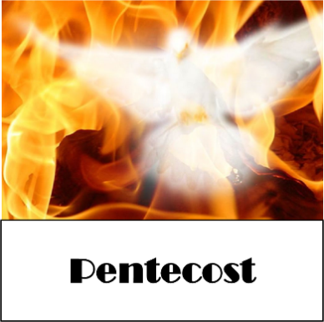
Devotion: Use this resource at home to guide your household’s daily devotions. You can do this alone or with others; in the morning, during the day, or at night. Find a routine that works best for you.
Pray: Light a candle and open your devotion time with a prayer.
God of fire,
Your Spirit rushes in and sweeps us up in its wake. Send us forth in the fire of your inspiration, to light up the world with the witness to your unquenchable love, in the name of the Risen One, Amen.
Reflect: Reflect on the key verses from Sunday’s reading.
When the day of Pentecost had come, they were all together in one place. And suddenly from heaven there came a sound like the rush of a violent wind, and it filled the entire house where they were sitting. Divided tongues, as of fire, appeared among them, and a tongue rested on each of them. All of them were filled with the Holy Spirit and began to speak in other languages, as the Spirit gave them ability. Acts 2:1-4
Study: Study the reading and consider the background.
How can the Word spread to the ends of the earth if its hearers can’t even understand the language? The Holy Spirit is about to take care of that.
Consider: Consider this theme for the week’s text.
The Holy Spirit’s first gift was understanding through shared language.
Read: Read the following daily readings to deepen your understanding of Sunday’s text. After the reading, ask the follow-up questions.
Sunday: Pentecost, Acts 2:1-4; Galatians 4:1-7
Monday: Paul Greets the Ephesians, Ephesians 1
Tuesday: One in Christ, Ephesians 2
Wednesday: Paul’s Ministry to the Gentiles, Ephesians 3
Thursday: New Life in Christ, Ephesians 4
Friday: On Being Christian, Ephesians 5
Saturday: Put on the Armor of God, Ephesians 6
How does the Holy Spirit’s light explode in the new world?
Connect: Connect in conversation with others in your household.
Discuss the following questions, or simply check in with “Highs” and “Lows.”
What was a high point of your day? What was a low point?
How is your life shaped by the gift of the Holy Spirit? How does it shape your behaviors, and relationships with God and others?
What have you seen recently that has gone viral? Does it deserve its following? What have you done that you would like to go viral?
Do: By acting on what we learn we make God’s word come alive. Do the following activity this week.
Go online and view the top posts in your social media. Make a note of what goes viral. What do you think attracts people to the post? What does that say about what is needed in this world? Post something uplifting and see what reactions you get.
Bless: Close your devotion with a blessing.
The Holy Spirit lights your life. Amen.

