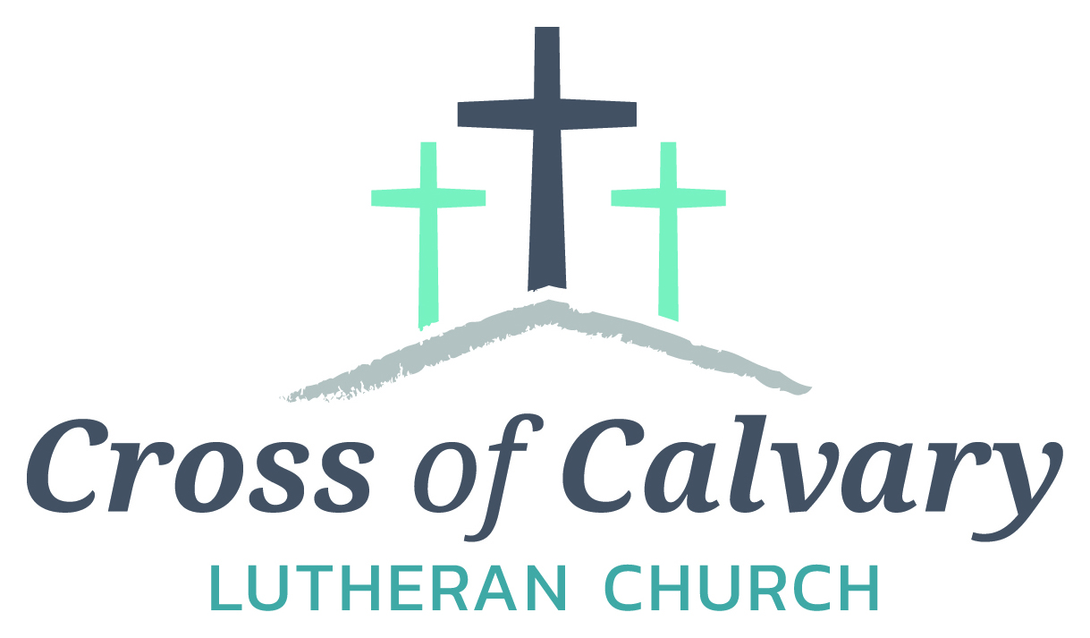

**WorshipTimes**

**Thursday: 6:00**

**Sundays: 9:00**

**Coffee Hour**

**After service**

**Sunday School**

**Resumes: September**

**Building Hours**

**Mon-Thurs**

**8:30-7:00**

**Fri-Sun 8:30-2:00**

**Office Hours**

**Mon, Tues, and Thurs.; 8:30-3:00**

**Wednesday**

**8:30-4:00**

**Friday 8:30-2:00**

**Pastor**

***Matt Hausken***

***hauskenmatt8@gmail.com***

**Admin. Assist.**

**Sue Altmann**

**crossofcalvary@gmail.com**

**Cross of Calvary Lutheran Church**

**1103 W. Chestnut Ave. Olivia, MN 320-523-1574**



**July 2, 2017**

**Weekly Announcements**

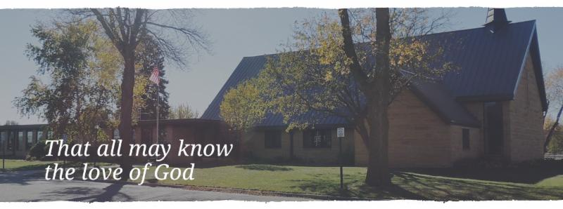

Cross of Calvary is the ELCA church in Olivia. We are an intergenerational (fancy word for young and old) community that follows Jesus out the building to where we live. We are all learners (disciples) here. This is a safe place to practice worship. And, believe us, it takes practice. Your questions, critical thinking, doubts and imperfect lives are welcome here.

**Holy Communion**

Holy Communion is open to all who are baptized and trust that Christ is present in the meal, regardless of your tradition or affiliation.

Wine (red)/grape juice (white).

**Participation**

**Bold type means all of us read or pray together. Out loud.**

* Please stand as you are able.

**Children in Church**

They belong here! They are hearing God’s Word, music and prayers. We don’t mind fidgeting and chatter! If you like, there are activity bags available in the entry.

**Announcements**

They are as printed or any new information please give to Pastor Matt prior to worship, please hand a note to Pastor with any announcements, including prayer requests.

**Restrooms**

They are located in the hallway to the left of the stairs. Changing table located in the Women’s bathroom.

**COMMUNITY and CHURCH Events**

**CHECK THE BULLETIN BOARD or east bulletin board for more information /details**

**Green Lake Lutheran Ministries will hold the 33rd Annual Quilt Auction July 22nd, 2017. Proceeds from this event go to our Annual Fund which allows us to provide fun, safe, quality camping and retreating opportunities for people of all ages who use any of our three camps.**

**Quilts**: please delivery to camp by July 14th, viewing will be available online at www.gllm.org

**Silent Auction**: item must be brought to camp no later than 5:00 pm on July 20th.

**Cash Donation:**Checks may be sent to: GLLM, 9916 Lake Ave. S. Spicer, MN 56288.

More information is on the bulletin board on the east entrance.

**Renville County Human Services** is currently seeking individuals who are willing to be foster parents to children who are in need of a home. Foster parents can be blended families, one or two parent families, retired or single.

The most important aspects of fostering a child is your willingness to provide a loving, safe and stable environment. Foster parents are considered part of a team of individuals who are working to make a better life for a child. Foster parents help a child through a difficult time, share their gifts and talents and receive reimbursement for their dedication and service to children. Is it time to share your gifts and talents and become a foster parent?

Please call Bonnie Lund or Stacie Roxberg, Renville County Human Services at 320-523-2202 to find out more about fostering a child.

Community Garden is looking for volunteers to make a simple compost bin. If interested, contact Betsy Hennen for more information.

Come and Check us out: Safe, comfortable, & affordable Senior Living in Olivia, Fairview Place currently has one bedroom apartments available. For more information please give Jenny a call at 320-523-1836.

**Zion United Methodist Church** – Danube is hosting a Homemade Ice Cream Social on Wednesday, July 5th. Serving begins at 5:00 pm. This is free will donation with proceeds going to support mission projects.

Menu: BBQ’s, Hot Dogs, Coney Dogs, Pie, Brownies, Sundaes, Coffee & Punch – Take Outs will be available.

**Fundraiser for a Family Coping with Cancer:** Time to get your pillows cleaned –puffed-deodorized and new ticking. Wednesday, July 5th from 4-8 pm or Thursday, July 6th from 7 am – 3 pm. Location: two blacks south of the signal lights in Olivia, watch for signs.

**United Lutheran Church of Lake Lillian** will be hosting an Ice Cream Social on Wednesday, July 12th from 5:00 – 7:00 pm Menu: BBQs, Hot dogs, Beans, Potato Chips, Pickles, Watermelon, Ice Cream Sundaes, Pies, and Beverage Free Will Offering

**No Men’s Bible Study on Tuesday, July 4th**

**Renville County Food Shelf**

**The food shelf is in need of our help.**

**Cross of Calvary will be doing a 1st & 3rd Sunday of each month Food Shelf collection.**

**We ask that everyone coming to church on these Sunday’s to please bring even one can for the food shelf. Donations of any kind are wonderful. Thank You!!!!**



**Meals-on-Wheels (JULY)**

**Drivers are needed, sign-up on board in Narthex**

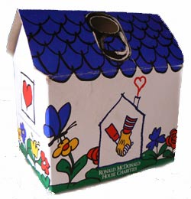Start saving those little aluminum tabs from your beverage containers and you could be a winner of one of three cash prizes. The **Sons of the American Legion** are sponsoring a contest for the purpose of collecting as many Aluminum tabs as possible. The tabs will be turned over to the Ronald McDonald Homes of Minnesota. These tabs generate funds to assist operating these homes which are made available to family members while children and adults are being treated at hospitals in MN. You can find these little tabs on beverage and soup cans. The tabs will weighed on Saturday, September 9th at the Legion in Olivia during the Fire Departments Annual Rib Fest. Cash prizes are as follows: first place $50, Second place $30 and third place $20.



**Vacation Bible School**

**Thank you to all who helped with VBS**

**this year!**

**It was a great success!**

**Prayer Concerns**

*Prayer Matters! Please take your bulletin home and pray for those listed.*

*Prayer concerns are listed for one month.*

Emergency/Pastoral Care-Please have a family member or friend notify the church. You may also request hospital staff to call on your behalf. Call day or night at 523-1574. Never feel as though you are bothering Pastor or the staff. We are here to serve as a comfort and as a resource.

*Diana Adkins *Greg & Evelyn Rosenow *Jill Revolinski

*Leslie Sagedahl *Jenna Reynolds *Vonna Ledeboer

*Emily Reetz *Warren Mitchell *Barb Gomarko

*Bert Budd *Donna Greenwell *Nancy Krumheuer

**JULY VOLUNTEERS**

**COMMUNION 9:00 – Curt Sather**

**USHERS 9:00 – Mark Thiesse, Clayton Erickson, Randy Marguth, Curt Schroeder**

**ACOLYTES: Will Hanson & NEED Help!!!!!**

**ALTAR GUILD: Sandy Gay & Cheryl Mallak**

**Things happening at Cross of Calvary in July**

**July 3 & 4 – Sue out of office**

**July 15 – 21: TIM Convention (Pastor Matt)**

**(Teens in Mission)**

**July 25 – August 2 – Sue out of office (I will be in Ireland)**

***.***

**July 2, 2017**

***Use this resource at home to guide your household’s daily devotions***

Pray: Light a candle and open your devotion time with a prayer.

**God of life, you have the power to bring us up even from the**

**depths of death. Dry our tears and lift our heads to the light of**

**your healing love, through Jesus Christ our Lord, Amen.**



**Read:** Read the key verse from Sunday’s reading.

*2O Lord my God, I cried to you for help, and you have healed me.*

*3O Lord, you brought up my soul from Sheol, restored me to life*

*from among those gone down to the Pit. (Psalm 30:2-3)*

 Reflect:** Reflect on the scripture summary.

**The praise of a soul lifted up from despair cannot be silenced.**

**The psalmist knows deep grief; thanksgiving for deliverance**

**from that grief is deeper still.**

**Connect:** Connect in conversation with others in your ****household.

**What was a high point of your day? What was a low point?**

**Tell of a time you felt God restored you from grief or illness.**

**How did it feel when you were grieved or sick? How did it feel**

**to be restored?**

**Wonder: If sadness was a place, what would it look like?**

**Bless:** Close your devotion with a blessing.

**May God restore you to wholeness. Amen.**



**Do:** By acting on what we learn, we make God’s word come alive.

Do the following activity this week.

**Reach out to someone who has recently experienced a loss.**

**Bring a meal or offer a listening ear.**



**Go Deeper:** Go to clergystuff.com/daily-devotions for

devotions on the daily readings.

**Sunday, Psalm 30**

**Monday, Psalm 34**

**Tuesday, Psalm 40**

**Wednesday, Psalm 57**

**Thursday, Psalm 66**

**Friday, Psalm 116**

**Saturday, Psalm 138**

**Mission**

**Paraguay Missionaries**

**The Kevin & Rebekah Howell family**

**Bolivia Missionaries**

**Paul and Jay Mikaelson**

Hello Everyone!



My name is Ben Davidson and I work for Special Olympics Minnesota. There is a Bocce Ball event taking place at Dirks Field in Olivia, MN on July 8th and we are looking for volunteers. We’ll be in the fields tossing Bocce and we need YOU to join in the fun!

I made it a point to reach out to Cross of Calvary because I know how much our athletes love to have an energetic crowd to cheer them on and volunteer throughout the day. No prior experience with Special Olympics is necessary and though we do have a few different rules, we would be happy to provide all of the necessary information and training to you ahead of time.

**In short…**

**WHAT:** Special Olympics MN Bocce Competition

**WHERE:** Dirks Field- Olivia, MN

**WHY:** Without volunteers, our events would not be possible! Did we mention you will receive a free volunteer shirt and lunch?

**WHEN**: Saturday, July 8, 7:00AM - 1:00PM (shift times vary)

**HOW**: E-mail [ben.davidson@somn.org](mailto:ben.davidson@somn.org) or register online at[http://specialolympicsminnesota.org/who-we-are/volunteers/.](http://specialolympicsminnesota.org/who-we-are/volunteers/)

By volunteering your time, you are directly making a positive impact on the lives of our Special Olympic athletes. Without people like you, we wouldn’t be able to put on a competition that our athletes look forward to competing in year after year.  If you are at all interested, please reply back to this email or head to our website to get registered!

**Volunteer Shifts:**

Set Up (5): 7:00AM-8:30AM

Scorekeeping at Pitches (20): 9:00AM-12:00PM

Awards Assistant (3): 11:00AM-12:30PM

If you have any questions about getting signed up or what the volunteer positions entail, please do not hesitate to contact me. Thank you!

**GIVING ONLINE at Cross of Calvary**

Cross of Calvary is reminding you can now manage your giving online! Giving online is easy and allows you to set up automatic recurring contributions and view your complete online giving history from anywhere you have access to the Internet.

Simply follow these easy steps:

1) Visit the church website at crossofcalvary.net

2) Click on the GIVE button,

3) Click on HERE TO GIVE, then

4) Follow the onscreen instructions to create an online profile and to schedule your recurring contributions.

Thank you for your contribution!!!