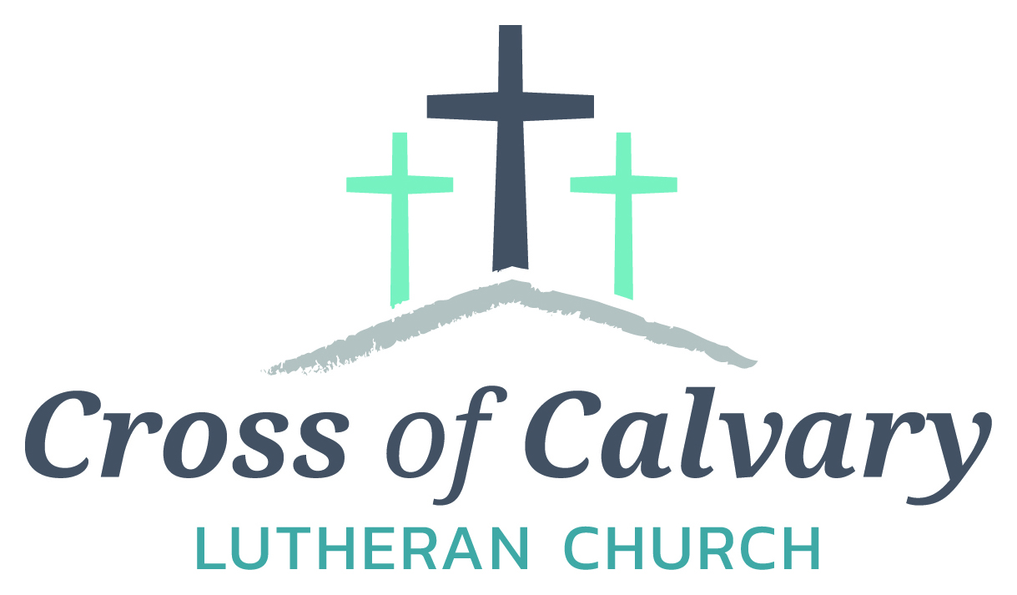

**WorshipTimes**

**Thursday: 6:00**

**Sundays: 9:00**

**Coffee Hour**

**After service**

**Sunday School**

**Resumes: September**

**Building Hours**

**Mon-Thurs**

**8:30-7:00**

**Fri-Sun 8:30-2:00**

**Office Hours**

**Mon, Tues, and Thurs.; 8:30-3:00**

**Wednesday**

**8:30-4:00**

**Friday 8:30-2:00**

**Pastor**

***Matt Hausken***

***hauskenmatt8@gmail.com***

**Admin. Assist.**

**Sue Altmann**

**crossofcalvary@gmail.com**

**Cross of Calvary Lutheran Church**

**1103 W. Chestnut Ave. Olivia, MN 320-523-1574**



**July 23, 2017**

**Weekly Announcements**

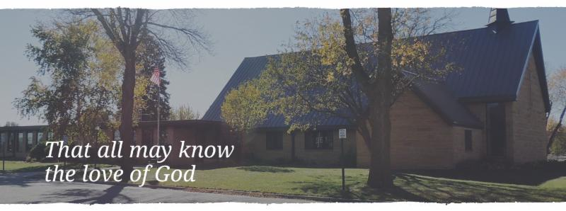

Cross of Calvary is the ELCA church in Olivia. We are an intergenerational (fancy word for young and old) community that follows Jesus out the building to where we live. We are all learners (disciples) here. This is a safe place to practice worship. And, believe us, it takes practice. Your questions, critical thinking, doubts and imperfect lives are welcome here.

**Holy Communion**

Holy Communion is open to all who are baptized and trust that Christ is present in the meal, regardless of your tradition or affiliation.

Wine (red)/grape juice (white).

**Participation**

**Bold type means all of us read or pray together. Out loud.**

* Please stand as you are able.

**Children in Church**

They belong here! They are hearing God’s Word, music and prayers. We don’t mind fidgeting and chatter! If you like, there are activity bags available in the entry.

**Announcements**

They are as printed or any new information please give to Pastor Matt prior to worship, please hand a note to Pastor with any announcements, including prayer requests.

**Restrooms**

They are located in the hallway to the left of the stairs. Changing table located in the Women’s bathroom.

**COMMUNITY and CHURCH Events**

**CHECK THE BULLETIN BOARD or east bulletin board for more information /details**

Fairview Place Pie & Ice Cream Social: Thursday, July 27th from 2:00-4:00 pm. They will be serving pie & ice cream, lemonade and coffee. They hope you will join them!!!!

(Fairview Place 603 E. Fairview Ave Olivia, MN

**JULY VOLUNTEERS**

COMMUNION 9:00 – Curt Sather

USHERS 9:00 – Mark Thiesse, Clayton Erickson, Randy Marguth, Curt Schroer

ACOLYTES: Will Hanson & NEED Help!!!!!

ALTAR GUILD: Sandy Gay & Cheryl Mallak

**Things happening at Cross of Calvary in July**

July 25 – August 2 – Sue out of office (I will be in Ireland)

**AUGUST VOLUNTEERS**

Communion 9:00 – Jill Hanson

USHERS: Curt Sather, Wally Stucke & Chet Boen, Need one more?

ACOLYTES: Tucker Amberg & Brady Stovern

ALTAR GUILD: Amanda Malvin & Angela Cole

Start saving those little aluminum tabs from your beverage containers and you could be a

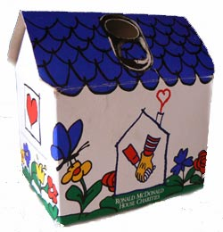winner of one of three cash prizes. The **Sons of the American Legion** are sponsoring a contest for the purpose of collecting as many Aluminum tabs as possible. The tabs will be turned over to the Ronald McDonald Homes of Minnesota. These tabs generate funds to assist operating these homes which are made available to family members while children and adults are being treated at hospitals in MN. You can find these little tabs on beverage and soup cans. The tabs will weighed on Saturday, September 9th at the Legion in Olivia during the Fire Departments Annual Rib Fest. Cash prizes are as follows: first place $50, Second place $30 and third place $20.

**Prayer Concerns**

*Prayer Matters! Please take your bulletin home and pray for those listed.*

*Prayer concerns are listed for one month.*

Emergency/Pastoral Care-Please have a family member or friend notify the church. You may also request hospital staff to call on your behalf. Call day or night at 523-1574. Never feel as though you are bothering Pastor or the staff. We are here to serve as a comfort and as a resource.

*Diana Adkins *Greg & Evelyn Rosenow *Jill Revolinski

*Leslie Sagedahl *Jenna Reynolds *Vonna Ledeboer

*Emily Reetz *Warren Mitchell *Barb Gomarko

*Bert Budd *Donna Greenwell *Nancy Krumheuer

*Bill Miller *Family of Bethel Fahse * Uva Hahn



***Use this resource at home to guide your household’s daily devotions***

Pray: Light a candle and open your devotion time with a prayer.

**One true God, we are your dwelling place. Brought close to you by grace, may we reflect the unity which ours in Christ, in the Church and in the world. Amen.**

**Read:** Read the key verse from Sunday’s reading.

*17So he came and proclaimed peace to you who were far off and peace to those who were near;*

*18for through him both of us have access in one Spirit to the Father.*

*(Ephesians 2:17-18)*

****Reflect:** Reflect on the scripture summary.

**The believers in Ephesus are given a monumental task: to live as though the age-old divisions of culture and religion no longer exist, for Jesus has made such distinctions irrelevant. Are these new Christians up to the challenge?**

**Connect:** Connect in conversation with others in yourhousehold.

**What was a high point of your day? What was a low point?**

**What kinds of people are you most afraid of, or do you dislike**

**the most? Why? What could you do to understand them better?**

**Wonder: Who might God dislike? Why?**

**Bless:** Close your devotion with a blessing.



**May God make us all one in Christ. Amen.**

**Do:** By acting on what we learn, we make God’s word come alive.

****Do the following activity this week.

**Learn three new facts about someone or a group that you dislike. Does growing in understanding help you move from hate to love?**

** Go Deeper:** Go to clergystuff.com/daily-devotions for devotions on the daily readings.

**Sunday, Ephesians 2:11-22, One in Christ**

**Monday, Ephesians 3:1-6, Paul’s Ministry**

**Tuesday, Ephesians 3:7-12, Paul’s Ministry**

**Wednesday, Ephesians 3:13, Paul’s Prayer**

**Thursday, Ephesians 3:14-15, Paul’s Prayer**

**Friday, Ephesians 3:16-19, Paul’s Prayer**

**Saturday, Ephesians 3:20-22, Paul’s Prayer**

**Mission**

Paraguay Missionaries

The Kevin & Rebekah Howell family

Bolivia Missionaries

Paul and Jay Mikaelson