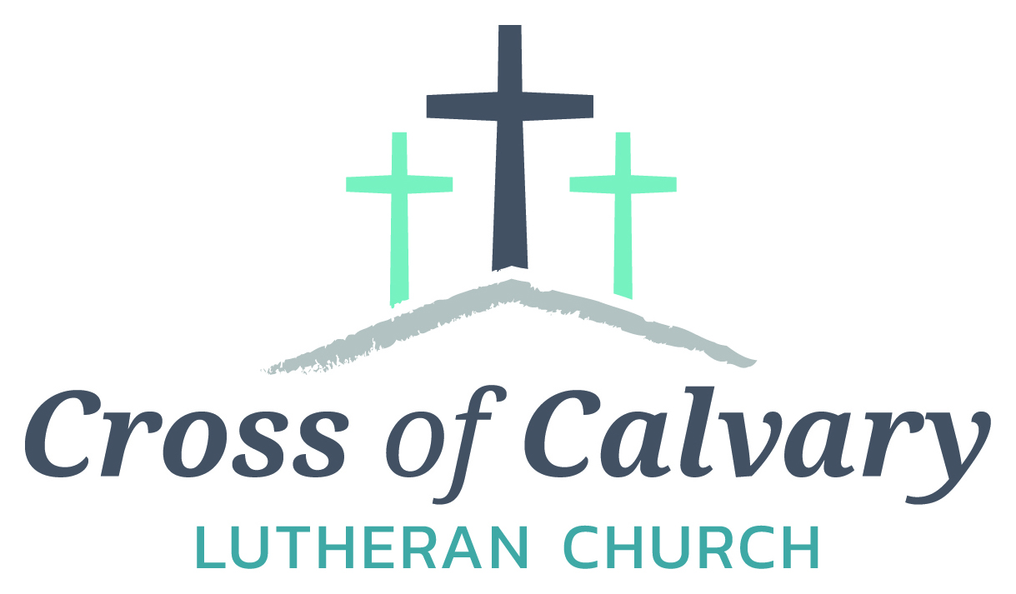

**WorshipTimes**

**Saturday: 5:30 PM**

**Sunday: 8:30 & 10:30**

**Coffee Hour**

**Sunday: 9:30 AM**

**Sunday School**

**Sunday: 9:30 AM**

**Building Hours**

**Mon-Thurs**

**8:30-7:00**

**Fri-Sun 8:30-2:00**

**Office Hours**

**Mon, Tues, and Thurs.; 8:30-3:00**

**Wednesday 8:30-4:00**

**Friday 8:30-2:00**

**Pastor: Matt Hausken**

[***hauskenmatt8@gmail.com***](mailto:hauskenmatt8@gmail.com)

***Parish* Ministers*:***

**Sarah Hausken**

[**sarah.hausken@gmail.com**](mailto:sarah.hausken@gmail.com)

**Jeni Skeie**

[**jeniskeie@gmail.com**](mailto:jeniskeie@gmail.com)

**Youth Email**

[**crossofcalvaryouth@gmail.com**](mailto:crossofcalvaryouth@gmail.com)

**Admin: Sue Altmann**

**crossofcalvary@gmail.com**

**Cross of Calvary Lutheran Church**

**1103 W. Chestnut Ave. Olivia, MN 320-523-1574**



**October 1, 2017**

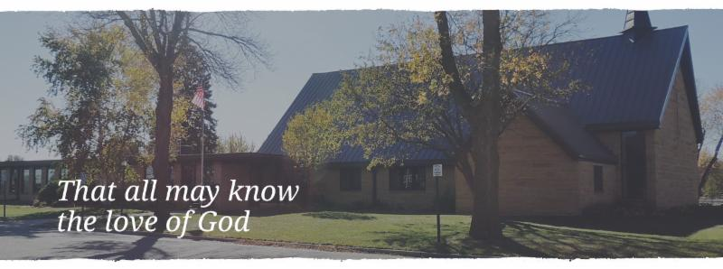

Cross of Calvary is the ELCA church in Olivia. We are an intergenerational (fancy word for young and old) community that follows Jesus out the building to where we live. We are all learners (disciples) here. This is a safe place to practice worship. And, believe us, it takes practice. Your questions, critical thinking, doubts and imperfect lives are welcome here.

**Holy Communion**

Holy Communion is open to all who are baptized and trust that Christ is present in the meal, regardless of your tradition or affiliation.

Wine (red)/grape juice (white).

**Participation**

**Bold type means all of us read or pray together. Out loud.** * Please stand as you are able.

**Children in Church**

They belong here! They are hearing God’s Word, music and prayers. We don’t mind fidgeting and chatter! If you like, there are activity bags available in the entry.

**Announcements**

They are as printed or any new information please give to Pastor Matt prior to worship, please hand a note to Pastor with any announcements, including prayer requests.

**Restrooms**

They are located in the hallway to the left of the stairs.

**OCTOBER WORSHIP VOLUNTEERS**

**COMMUNION 8:30 – Curt Sather**

**10:30 – DeeAnne Newville**

**USHERS 8:30 – Dick & Gladie Hagen**

**10:30 – Steve & Lynn Johnson**

**ACOLYTES: Kya Young & Maddi Jensen**

**ALTAR GUILD: Eleanor Ziesmer, Edith Vogt & Sheila Pietig**

**VOLUNTEER: Would you like to lead a Children’s message** **or read the Bible readings during worship? Please, sign up on “The Board” in the Narthex,**

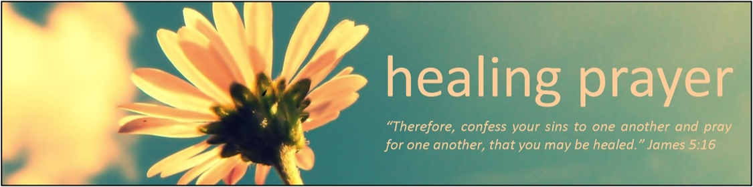

**Prayer Concerns**

Prayer Matters! Please take your bulletin home and pray for those listed.

Prayer concerns are listed for one month.

Emergency/Pastoral Care-Please have a family member or friend notify the church. You may also request hospital staff to call on your behalf. Call day or night at 523-1574. Never feel as though you are bothering Pastor or the staff. We are here to serve as a comfort and as a resource.

*Diana Adkins *Jill Revolinski *Leslie Sagedahl

*Jenna Reynolds *Vonna Ledeboer *Emily Reetz

*Warren Mitchell *Barb Gomarko *Cleve Fults

*Charles W. Brown *Stan Matti *Barb Miller

*Rosalie Sheggeby *Janice Gass *Kent Kircher

*Emily Schueler *Clayton Erickson *Bert Budd

*Florence Malecek *Cheryl Mallak *Pastor Maggie Cumings

*Berle Boese *Mike & Brittney Harrell and their new baby Hope Marie

*McKenna Lilja

**Things happening at Cross of Calvary: October 1-8**

October 1 – Blue Jean Sunday

October 2-4 – Pastor Matt, Jeni and Sarah gone to Lifelong learning (Preaching Workshop)

October 4 – New Member Orientation from 7:30-8:30

October 8 – New Member Sunday and Youth Band plays

October 8 – 3rd Grade Bible Class (during Sunday school hour)



10/01 – Sr. High Youth Group, Grades 9-12, 5:30-7:30 pm

10/04 – WOW (Wonders on Wednesdays) Grades 4-6, 3:15 – 5:00 pm

10/04 – 1st Communion classes start at 4:00 pm (5th Grade)

10/04 – Confirmation 5:30 meal & 6:30 class

10/05 – Breakfast Club, Grades 10-12, 7:07 am (this week at Master’s)

10/08 – Youth Band playing during both services

10/10 – 1st-3rd Graders monthly after school program, 3:15 – 5:00 pm

**Opportunities to Serve**

We invite you to consider offering your time and talent in Jesus’ name through one of these opportunities to serve:

• Provide a snack for 20 WOW kids

• Provide breakfast for 10 Breakfast Club youth on a Thursday morning

• Provide supper for 25 Confirmation students on a Wednesday evening

• Help with the 1-3rd grade after school program the 2nd Tuesday of the month from 3-5 pm

**October 1, 2017**



***God’s Name Is Revealed***

***Use this resource at home to guide your household’s daily devotions***

**Pray**: Light a candle and open your devotion time with a prayer.



**Holy God, your promises stand fast forever. Make us bold to**

**trust where you lead, and put our unfailing hope in your**

**faithfulness. In the name of Jesus, Amen.**

**Read:** Read the key verse from Sunday’s reading.



*13But Moses said to God, “If I come to the Israelites and say to*

*them, ‘The God of your ancestors has sent me to you,’ and they*

*ask me, ‘What is his name?’ what shall I say to them?”14God said to Moses, “I AM WHO I AM.” (Exodus 3:13-14)*

**Reflect:** Reflect on the scripture summary.



The God of enslaved Israel is about to make good on an ancient

promise, and has a special job for his servant Moses. This would-be hero,

however, is less than enthusiastic.

**Connect:** Connect in conversation with others in yourhousehold.

**What was a high point of your day? What was a low point?**

**Tell of a time you had to wait a really long time for an answer**

**from God. What happened when the answer finally came? If**

**you are still waiting, what answer are you hoping for?**

**Wonder: What did God mean by, “I Am Who I Am”? Consider**

**that “I Am” is a state of being, not a state of doing.**

 **Bless:** Close your devotion with a blessing.

**May God answer your prayers. Amen.**



**Do:** By acting on what we learn, we make God’s word come alive.

Do the following activity this week.

**Go to polarisproject.org to learn more about human trafficking**

**in our world today. Take the quiz, “How much do you**

**know…” Learn as much as you can about what it is and how**

**you can help stop it.**

**Go Deeper:** Go to clergystuff.com/daily-devotions for devotions on the daily readings.

**Sunday, Exodus 2:23-25; 3:10-15; 4:10-17, God’s Name Is Revealed**

**Monday, Exodus 6:28-7:7, Moses and Aaron Obey God’s Commands**

**Tuesday, Exodus 12:1-13, The First Passover**

**Wednesday, Exodus 12:29-42, Death of the Firstborn**

**Thursday, Exodus 13:17-22, The Pillars of Cloud and Fire**

**Friday, Exodus 14:1-25, Crossing the Red Sea**

**Saturday, Exodus 14:26-31, Pursuers Drowned**

**“Your church offering information”**

Thru August 2017

Year-to-date receipts given $129,954

Year-to-date receipts needed for our budget $178,304

Year-to-date parish expenses $144,190

Year-to-date budgeted expenses $180,000

General Fund checking balance as of 1-1-17 $59,904

General Fund checking balance as of 8-31-17 $45,667

**We are grateful for the help to meet our weekly ministry needs.**

**Thank you for sharing your blessings in all the ways you do.**

**GIVING ONLINE @ Cross of Calvary**

**Cross of Calvary provides online offering & donations! Giving online is easy. It allows you to set up automatic recurring contributions, make one-time gifts and review your giving history online.**

**Simply follow these easy steps:**

**1) Visit the church website at crossofcalvary.net**

**2) Click on the GIVE button**

**3) Click on HERE TO GIVE**

**4) Follow the instructions to create a profile and schedule your contributions.**

**Thank you for your offering!**

**Please pray for our Missionaries**

Paraguay Missionaries

The Kevin & Rebekah Howell family

Bolivia Missionaries

Paul and Jay Mikaelson House

**COMMUNITY EVENTS**

**CHECK THE BULLETIN BOARD or east bulletin board for more information /details**

**United Lutheran Church in Lake Lillian** is hosting its annual Fall Festival on Thursday, Oct. 5th from 5:00 – 7:00 pm. Swedish meatball supper, plus: produce, crafts & bake sale. Adults: $10.00, 6-12 yrs.: $3.00 & 5 years and under Free. Menu: Swedish meatball, potatoes, vegetables, beverage, coleslaw, rolls, desserts.

**Adult Grief Support Group** will begin meeting on October 2, 2017. (Meetings will be every Monday until November 6th.)For more information on the support group or to register, please call Lacey Bruns at the Redwood Area Hospital at 507-637-4617. There is also a brochure on the east entrance board.

**Safe Avenues** annual fundraiser “Make a Difference” Event is on Friday, November 17th at 6:00 pm at Max’s Grill in Olivia! The fundraiser is held to raise awareness and support efforts to assist victims of domestic and sexual violence in our Renville Count Outreach Program.

You are invited to attend our **“Scandinavian” Smorgasbord** at First Lutheran Church of Renville, 316 SW 3rd St on Sunday, October 8 from 11:15 am – 1:00 pm. Cost: $11 Adults, $5 – Ages 5-12, Under 5 FREE. Menu: Ham Meatballs, Mashed potatoes & Gravy, Corn, Squash, Pea Salad, Glorified Rice, Baked Rice, Deviled Eggs, Rommegrat, Lefse, Flat bread, Krumkaka, Kringla, Kringler, Spirtz cookies, Kransakaka, Fattigman, Rosettes, Sandbakkels, Cranberry relish, fruit soup and Cloverleaf Rolls.

**Faith United Methodist Church of Olivia** is hosting a Roast Beef Supper on Wednesday, Oct. 4, 2017. They will be serving from 4:30 – 7:00pm. Menu features: roast beef, real potatoes, homemade gravy, buttered corn, coleslaw, rolls, pumpkin dessert & beverage. Adults: $12.00, Ages 5-12: $6.00 and preschool – free (4 & under) Dine in and take available!!

**St. Aloysius Church** in Olivia invites you to join us on Sunday, October 15, 2017 for our annual **Fall Festival.** Our event begins with Mass at 10:00 am. Then continues your day with a home-made fried chicken dinner that includes mashed potatoes and gravy, candied carrots, cranberries, coleslaw, dinner roll, pumpkin dessert and beverage served from 11:00 am to 1:30 pm. The cost is $11.00 for adults or take-outs and $6.00 for children 10 & under. The day also includes a Pumpkin Patch, Farmers’ Market, Bakers’ Corner, Quilt Ladies Booth, Silent Auction, Cake Walk, Bingo and Church Raffle.

**Olivia Community Blood Drive** at St. Aloysius Catholic Church on Tuesday, October 17, 2017 from 1:00 – 7:00 PM, Please call 1-800-RED –CROSS or visit recrossblodd.org and enter OliviaMN to schedule an appointment. (Jubilee Center 302 S 10th St. Olivia, MN)

**BLUE JEAN SUNDAY**



**It’s that time of year to do some fall cleaning!**

**Everyone is welcome to help clean the church and enjoy some fellowship while doing a good deed.**

**Most of the cleaning can be done between services and the rest can be finished after the second service.**

**Go to the Fellowship Hall to find out where to clean and get supplies, plus Angie and Craig Boen will be around to answer any questions.**