The Follower
October 2017
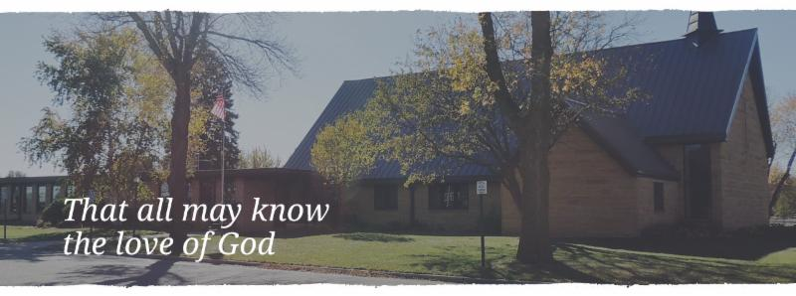
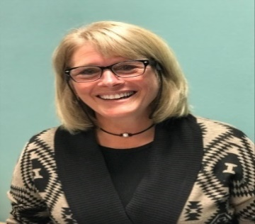
“How good, Lord, to be here!!!” This is the first line of Hymn #315 in our hymnal, but it has been my theme song ringing in my head since August 1st and starting this new ministry position. There is fear and excitement running through my veins. Programs to start, volunteers to call, and sermons to write…these are all exciting and stressful at the same time.

While all the programs and ministry at Cross of Calvary are important, I am especially motivated to start more women’s Bible studies. The study that will start in October will be on a book called Having a Mary Heart in a Martha World. It is “an invitation for every woman who has ever felt she isn’t godly enough isn’t loving enough, isn’t doing enough”…or maybe is doing too much.
The story of Mary and Martha is about two women who feel differently about how to serve Jesus. Martha is going to put on the best spread, have the house spotless, be the best waitress/hostess to her guest and feels fulfilled in her role. Mary, well she is supposed to be helping Martha but she gets sidetracked by her interest in Jesus’ teaching. While we are living in different times, we are the same. We busy ourselves with so many of life’s distractions and isn’t it crazy? Life feels crazy, until we stop. Until we stop and listen. Until we stop and listen at the feet of Jesus…and receive the rest and comfort we need in His teaching and forgiveness. How often do we remember to stop and feel the grace and love and forgiveness that Jesus gives? I mean, the list goes on...why wouldn’t we want this in our lives?
I know that you are all busy. So am I. But if you are going to add something to your day, your week, or your month, wouldn’t it be good to add “rest”? Whether it is weekly or monthly, please join me for a look at Having a Mary Heart in a Martha World. Let’s rediscover together the rest that Jesus gives through his teaching.
“Martha, Martha,” the Lord answered, “you are worried and upset about many things, there is need of only one thing. Mary has chosen the better part, which will not be taken away from her.” Luke 10:41-42
In Christ,

Jeni Skeie
Parish Minister

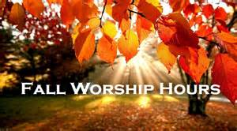Worship Times

Saturdays 5:30 pm
Sundays at 8:30 & 10:30
Sunday School 9:30 am

OCTOBER VOLUNTEERS

COMMUNION 8:30 – Curt Sather
10:30 – DeeAnne Newville
USHERS 8:30 – Dick & Gladie Hagen
10:30 – Steve & Lynn Johnson
ACOLYTES: Kya Young & Maddi Jensen
ALTAR GUILD: Eleanor Ziesmer, Edith Vogt & Sheila Pietig

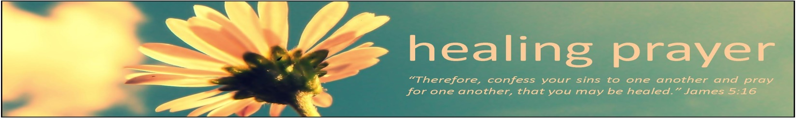

Prayers for:

Vonna Ledeboer Barb Miller Janice Gass
Diana Adkins Charles W. Brown Cleve Fults
Jill Revolinski Rosalie Sheggeby Stan Matti
Leslie Sagedahl Pastor Maggie Cumings Berle Boese
Florence Malecek Cheryl Mallak
Jenna Reynolds Clayton Erickson
Warren Mitchell Bert Budd
Emily Reetz Kent Kircher
Barb Gomarko Emily Schueler
Mike & Brittney Harrell - Hope Marie Harrell (daughter of Mike & Brittney)
Congregation News
God’s Work. Our Hands. Day – September 10
We had a great first annual God’s Work. Our Hands. Day of dedicated service in our community. 47 children, youth and adults served at Olivia’s House of Hope, Renville County Back the Pack, Renville County Food Shelf, people’s homes and made fleece blankets for Lutheran World Relief. We give thanks for all the ways Cross of Calvary members serve others in Christ’s name on this day and in their daily lives.

Women’s Bible Study
Our new women's bible/book study will begin the week of October 16th. If you are interested to be a part of the study Having a Mary Heart in a Martha World, please text or email me. 320-579-0406, or jeniskeie@gmail.com. Books will be provided. There will be three meeting times. Sunday at 9:30am, Tuesday night at 7:30 pm, or Thursday morning at 8:15. If you miss one, you can attend another. Can't wait to dive into this study with you!

Sunday School
Thank you to everyone who has chosen to teach Sunday School! You are making a difference sharing the love of Christ with our children and youth!

Junior High Youth Gathering
6-9th Graders will be participating in the Synod’s Jr. High Gathering November 17-18. Registration was due Sept. 27. If you missed the deadline and still want to go please call Jeni

WOW (Wonders on Wednesdays)
4-6th graders are invited to join us for WOW! BOLD students can ride bus 3 to church on Wednesdays. We have a snack, enjoy some free time together, sing, act out Bible stories and experience interactive prayer. WOW ends at 5:00 pm.

1-3rd Grade After School Program
We will start our new monthly after school program for 1-3rd graders on Tuesday, October 10. It will take place the 2nd Tuesday of the month and go until 5:00 pm. BOLD students can take bus 3 to church for snack, games, Bible stories, songs and more!

Breakfast Club
Breakfast club is meeting with 10-12 graders every Thursday morning at 7:07 am at Cross of Calvary. First Thursday of every month will meet at Masters.

◄ | October Calendar 2017 |  |  |  |  |  |  |  | ►
Sun | Mon |  | Tue | Wed | Thu |  |  | Fri | Sat
1 Blue Jean Sunday  Worship 8:30 & 10:30  Communion  Jeni, Sarah & Pastor Matt at Preaching Conference | 2  Jeni, Sarah & Pastor Matt at Preaching Conference |  | 3  Jeni, Sarah & Pastor Matt at Preaching Conference | 4  Jeni, Sarah & Pastor Matt at Preaching Conference  WOW – 3:15  Confirmation 5:30meal  Class 6:30  1st Communion Class 4:00  New Member Orientation  7:30 – 8:30 pm | 5 |  |  | 6 | 7  Worship 5:30
8  Worship 8:30 & 10:30  Youth Band plays  3rd Grade Bible class  New Member Sunday | 9  Library Reserved  6:00-8:00 pm |  | 10  Men’s Bible Study  6:15 am and 7:00 am  1-3 graders after school program at 3:15 | 11  WOW 3:15  Confirmation  Council Mtg 7:30  1st Communion Class 4:00 | 12  Breakfast Club  7:07 am |  |  | 13 | 14  Worship 5:30  Bridal Shower 10-2  (Flemming)  Ashley Schmidt wedding-offsite
15  Worship 8:30 & 10:30  3rd Grade Bible Class  Communion | 16  Library Reserved  6:00-8:00 pm | 17  Men’s Bible Study  6:15 am and 7:00 am |  | 18  No WOW  No Confirmation |  | 19  Breakfast Club  7:07 am | 20 |  | 21  Worship 5:30
22  Worship 8:30 & 10:30 am  Baby Shower – Meints  2-4 pm | 23  Library Reserved  6:00-8:00 pm  Youth Worker Retreat (Jeni & Sarah) |  | 24  Men’s Bible Study  6:15 am and 7:00 am  Youth Worker Retreat  (Jeni & Sarah) | 25  WOW 3:15  Confirmation Banquet  Dorcas 9:30 | 26  Breakfast Club  7:07 am  Craft Retreat |  |  | 27  Craft Retreat | 28  Worship 5:30  Craft Retreat
29  Worship 8:30 & 10:30  Confirmation Sunday Communion at 10:30 only | 30  Library Reserved  6:00-8:00 pm  Ruth 1:30 |  | 31  Men’s Bible Study  6:15 am and 7:00 am | 1  WOW 3:15  Confirmation | 2  Breakfast Club  7:07 am at Masters |  |  | 3 | 4  Worship 5:30

10/01 – Lora Mathison 10/11 – Cheryl Hennen 10/23 – Timothy Opdahl
10/01 – Bruce Mages 10/11 – Tonia Ridler 10//24 – Maureen Hanson
10/01 – Kristi O’Neill 10/11 – Brian Schultes 10/24 – Mary Doering
10/01 – Deborah Grannes 10/11 – Chelsey Bellig 10/25 – MaryAnne Bentley
10/01 – Kathy Altmann 10/11 – Timothy Wallert 10/25 – Bob Erickson
10/01 – Sevarii Jimenez 10/12 – Thomas Newville 10/25 – Julian Christian
10/03 – Kailynn Vait 10/12 – Steve Torkelson 10/26 – Brian Boen
10/05 – Lilly Kern 10/12 – Matt Hennen 10/26 – Sandra Whited
10/05 – Pam Jacobson 10/12 – Jennifer Olson 10/26 – McKenna Steffel
10/05 – Randy Steffel 10/13 – Jim McDowell 10/27 – Richard Sigurdson
10/05 – Elliot Opdahl 10/14 – Kelsey Thorpe 10/27 – Dave Altmann
10/06 – Marlene Bratsch 10/15 – LeAnn Maurice 10/27 – Jon Hawkinson
10/06 – Mark Thiesse 10/15 – Jake Evenson 10/28 – Charles Morse
10/06 – Keela Grund 10/15 – Finn Stratton 10/28 – Bethanie Johnson
10/07 – Joshua Mages 10/16 – Sharlene Baumgartner 10/30 – David Lindquist
10/07 – Logan Erickson 10/16 – Jodi Vesterby 10/30 – Jim Doering
10/07 – Tyler Flom 10/16 – Sarah Johnson-Stafford 10/30 – Mike Grund
10/08 – Barbara Miller 10/16 – Edgar Kopel 10/30 – Troy Honzay
10/08 – Shauna Wagner 10/17 – Tami Stovern 10/30 – Mike Benson
10/10 – Marie Rauenhorst 10/18 – Tyler Slagter 10/30 – Hunter Ridler
10/10 – Peggy Boehme 10/19 – Lowanda Frank 10/31 – June Grannes
10/10 – Sarah Helmer 10/21 – Jennifer Grund 10/31 – Cindy Thiesse
10/10 – Cory Hebrink 10/22 – Paul Hanson 10/31 – Reed Nelson
10/10 – Lillian Christian 10/22 – Aaron Blem 10/31 – Addelyn Malvin
10/22 – Hadley Weis 10/31 – Lincoln Robideau

Please pray for our Missionaries
Paraguay Missionaries
The Kevin & Rebekah Howell family

Bolivia Missionaries
Paul and Jay Mikaelson

Community Events

United Lutheran Church in Lake Lillian is hosting its annual Fall Festival on Thursday, Oct. 5th from 5:00 – 7:00 pm. Swedish meatball supper, plus: produce, crafts & bake sale. Adults: $10.00, 6-12 yrs.: $3.00 & 5 years and under Free. Menu: Swedish meatball, potatoes, vegetables, beverage, coleslaw, rolls and desserts.

Adult Grief Support Group will begin meeting on October 2, 2017. (Meetings will be every Monday until November 6th.)For more information on the support group or to register, please call Lacey Bruns at the Redwood Area Hospital at 507-637-4617. There is also a brochure on the east entrance board.

Safe Avenues annual fundraiser “Make a Difference” Event is on Friday, November 17th at 6:00 pm at Max’s Grill in Olivia! The fundraiser is held to raise awareness and support efforts to assist victims of domestic and sexual violence in our Renville County Outreach Program.

You are invited to attend our “Scandinavian” Smorgasbord” at First Lutheran Church of Renville, 316 SW 3rd St on Sunday, October 8 from 11:15 am – 1:00 pm. Cost: $11 Adults, $5 – Ages 5-12, Under 5 FREE. Menu: Ham Meatballs, Mashed potatoes & Gravy, Corn, Squash, Pea Salad, Glorified Rice, Baked Rice, Deviled Eggs, Rommegrat, Lefse, Flat bread, Krumkaka, Kringla, Kringler, Spirtz cookies, Kransakaka, Fattigman, Rosettes, Sandbakkels, Cranberry relish, fruit soup and Cloverleaf Rolls.

St. Aloysius Church in Olivia invites you to join us on Sunday, October 15, 2017 for our annual Fall Festival. Our event begins with Mass at 10:00 am. Then continues your day with a home-made fried chicken dinner that includes mashed potatoes and gravy, candied carrots, cranberries, coleslaw, dinner roll, pumpkin dessert and beverage served from 11:00 am to 1:30 pm. The cost is $11.00 for adults or take-outs and $6.00 for children 10 & under. The day also includes a Pumpkin Patch, Farmers’ Market, Bakers’ Corner, Quilt Ladies Booth, Silent Auction, Cake Walk, Bingo and Church Raffle.

Olivia Community Blood Drive at St. Aloysius Catholic Church on Tuesday, October 17, 2017 from 1:00 – 7:00 PM, Please call 1-800-RED –CROSS or visit recrossblodd.org and enter OliviaMN to schedule an appointment. (Jubilee Center 302 S 10th St. Olivia, MN)

Cross of Calvary Lutheran Church
COUNCIL MEETING
Minutes for: Wednesday, September 20, 2017 @ 7:30pm

COUNCIL MEMBERS

( ) Dana Boen 2020 (X) Jon Hawkinson 2018 (X) Eric Skeie 2019*
(X) Curt Sather 2020 (X) Bobbi Kopel 2018 (X) Natasha Johnson 2019*
(X) Jill Hanson 2020 ( ) Paul Buhr 2019 (_) Michelle Jensen resigned
(X) DeeAnne Newville 2020* (X) Gordon Blem 2019 ( ) Lisa Meints 2018
(X) Steve Altmann 2018 Terms end at Annual Meeting (Jan.)*Second term
STAFF
(X) Pastor Matt Hausken (X) Jeni Skeie, Parish Minister (X) Sarah Hausken, Parish Minister
(X) Sue Altmann, Council Recorder

AGENDA

1. Meeting called to order- President Eric Skeie
2. Devotions – Bobbi Kopel
3. Approve minutes of the August meeting – Motion to approve the minutes by Steve Altmann, seconded by Natashia Johnson, motion passed.
4. Financial Secretary and Treasurer Reports – August - Motion to approve the treasurer/secretary report by Jill Hanson, seconded by Gordy Blem, motion passed.
5. Pastor’s report - Pastor Matt presented to council to have the committees revamped. Ideas were to get more people on the committees and to get them more involved in church happenings. Presented to have new council member asked to be on a committee from the nominating committee. Also, to see the committees meet more and report to council.
- Equipping the Congregation meeting will be Wednesday, Oct. 11, before the Church Council meeting.
- November is Stewardship month – would like to see the staff and committee to get this up and running
- Barb Miller gifted a piano to the church
- Church will need a new volunteer for the food shelf delivery of items
-2nd Sunday in October will be New Member Sunday
6. Parish Minister Report
- Written reports are on file: contact office for a copy

COMMITTEE REPORTS AND RECOMMENDATIONS
1. Youth Ministry- the committee meets and had a great discussion, nothing was reported but will be meeting on regular bases now
2. Equipping the Congregation – Will be meeting on Oct. 11 at 7:00 pm
3. Outreach – Duffle bags have been delivered, thanks to the congregation for the wonderful involvement
- $500.00 to ELCA Disaster Relief and $500.00 to Red Cross disaster relief – a motion to approve by Jill Hanson and seconded by Bobbi Kopel – motion passed
4. Administration – We will be putting a financial statement in the bulletin weekly from Curt Sather – with the hope of generating
more income to the church
5. AED Maintence – Steve checked.

OLD BUSINESS
• Shingling is done
• Painting is being done, by Jill Kramin/Stacey Larson has been helping

NEW BUSINESS
• Jeni, Sarah and Pastor Matt will be gone Sept. 24-26 at the Fall Theological Conference
• Jeni, Sarah and Pastor Matt will be gone Oct. 2 & 3 at Luther Seminary for a conference on Preaching
• Reminder: Council will meet on Oct.11 – due to MEA the following week
• Restructure Council committees – discussion
- Jill, Jon, DeeAnne & Gordy will be working on reconstructing the current committee description.
• Report on meeting with Rick from PACT - great meeting

Next Council meeting: Wednesday, October 11 at 7:30 pm
October Communion: 8:30 – Curt Sather & 10:30 – DeeAnne Newville
October Devotion – Jill Hanson
Adjourn / Close in prayer.

