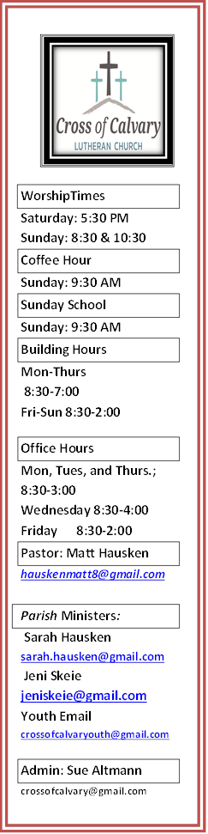

**Cross of Calvary Lutheran Church**

**1103 W. Chestnut Ave. Olivia, MN**

**320-523-1574**



**January 14, 2018**

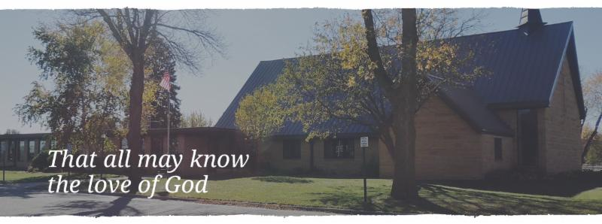

Cross of Calvary is the ELCA church in Olivia. We are an intergenerational (fancy word for young and old) community that follows Jesus out the building to where we live. We are all learners (disciples) here. This is a safe place to practice worship. And, believe us, it takes practice. Your questions, critical thinking, doubts and imperfect lives are welcome here.

**Holy Communion**

Holy Communion is open to all who are baptized and trust that Christ is present in the meal, regardless of your tradition or affiliation. Wine (red)/grape juice (white).

**Participation**

**Bold type means all of us read or pray together. Out loud.** * Please stand as you are able.

**Children in Church**

They belong here! They are hearing God’s Word, music and prayers. We don’t mind fidgeting and chatter! If you like, there are activity bags available in the entry.

**Announcements**

They are as printed or any new information please give to Pastor Matt prior to worship, please hand a note to Pastor with any announcements, including prayer requests.

**Restrooms**

They are located in the hallway to the left of the stairs.

**Offering Envelopes are here!**

**If you don’t have envelopes and would like a set, leave a note in the office.**

**The week of January 14-21, 2018**

**Today**  Worship 8:30 & 10:30 am

Baptism 10:30 am

**Monday** Library reserved 6:00-8:00 pm

Annual Meeting Reports and Information due

**Tuesday** Men’s Bible Study 6:15/7:00 am

Jesus Justice League 3:15

**Wednesday** WOW 3:15 pm

Confirmation 6:30 pm

Church Council Meeting 7:30 pm

**Thursday** Quilters 9:00 am

**Friday**  Pizza Sales end

**Saturday** Service 5:30 pm

**Sunday**  Service 8:30 & 10:30 am



**Prayer Request**

Prayer Matters!

Please take your bulletin home and pray for those listed.

Emergency/Pastoral Care-Please have a family member or friend notify the church. You may also request hospital staff to call on your behalf. Call day or night at 523-1574. Never feel as though you are bothering Pastor or the staff. We are here to serve as a comfort and as a resource.

*Diana Adkins *Jill Revolinski *Leslie Sagedahl *Family of Shelly Linde

*Jenna Reynolds *Emily Reetz *Kent Kircher

*Barb Gomarko *Cleve Fults *Laura Wacek

*Donna Greenwell *Janice Gass *Mike Abrahamson

*Jolynda Luckey *Bob Erickson *Ron Hamborg

*Jen Beckler *Isabella (Izzy) Sullivan *Mal Steffel

**Annual Congregational Meeting**

**January 21, 2018 at 9:30 am**

**Please have all reports to the office by January 15th. Thank you!**

**Annual Report Committee & Financial Reports**

I’m writing to make sure everyone is getting ready for the Annual Meeting which will be held on Sunday, January 21st.

I need the following reports from the following committees:

**Committee Review Reports**

Youth Board and Family Ministry

Equipping the Congregation

Outreach

Administration

**Financial Reports**

Financial Secretary

Altar Guild

Snowflake Bazaar -received (Dana Boen)

Endowment Fund

Lutheran Church Men –received (Chet Boen)

Youth Account – received (Dawn Mertens)

Memorial Fund

I truly appreciate your cooperation in getting these reports to me by January 15th so that I have time to prepare the full packets. I would also appreciate it if whomever will be the responsible person for these reports, please email/call me so that I may be aware. That way if things come up, I’ll know who to go too directly.

Thank you so very much and I anxiously wait to hear from you all. Remember, preferred deadline – January 15th.

Sue Altmann

Office Administrator

**Several Elected Positions need filling**

With the Annual Meeting later this month, the nominating committee is seeking individuals who might be interested in a variety of positions within the church setting. Please prayerfully consider serving on Church Council, Auditing Committee, Nominating Committee, Endowment Fund, Congregational Representatives to the Synod Assembly, or as representatives to the annual meeting of Gustavus College Member Congregations. If you would like more information or your name on the ballot, please contact Heather Thompson [(320-894-3041](tel:(320)%20894-3041) or [hmthompson2@gmail.com](mailto:hmthompson2@gmail.com)), Tami Stovern [(320-295-6925](tel:(320)%20295-6925) or [tlstovern3@hotmail.com](mailto:tlstovern3@hotmail.com)) or Jessie Lothert [(320-894-8919](tel:(320)%20894-8919) or [jessica_dresser@yahoo.com](mailto:jessica_dresser@yahoo.com)).

**Women’s Bible Study:** Days to meet are Sunday at 9:30 am, Tuesdays at 7:**30 pm and Thursdays at 8:15 am.**

**Storage needed:** We are looking for someone to store the benches on the south/western side of the building. If you are able to move and store them for the winter, please let Sue know who took them & stored them.

**Come join the Quilters each Thursday, starting at 9:00 am**

**Green Lake Lutheran Ministries Middle School Lock In**

6-8th graders are invited to join staff at Green Lake Bible Camp for a lock-in at the Chrysalis House! The plans include: door prizes, a Minute to Win It competition, tie dye and crafts, a snowman building contest, a movie, devotionals, night games, pizza and a song-fest worship. Bring your friends for a fun night at camp! - Fee: $45 to register, contact Karen at (320)796-2181 to register online, visit www.gllm.org and click on "Register for Camp" - sign in and click the retreats registration. You may access your youth account to pay for this retreat.

**Grades 9-12 Lock-In**

Date: January 21-22

Anyone is invited to attend, even if you are not a member of Cross of Calvary

TIM Team is looking for 6 chaperones: 2 per shift (8:30-11:00 PM) (11:00-3:00 AM) and (3:00-5:30 AM)

Please contact Jeni Skeie if you would like to volunteer!!!

Sign-up sheet is on the “Youth Board”, forms must be turned in by January 14 (Youth Office).

**Are you ready for the Super Bowl?**

It may be time for pizza! It’s an easy and delicious food to serve as you watch the greatest game of football!

Order forms and money must be turned into the church office by Friday, January 19th at noon.

**PIZZA PICK UP**

**Date: February 2nd**

**Time: 5:00 to 6:30 pm**

**Place: Cross of Calvary**

**January 14 **



**Use this resource at home to guide your household’s daily devotions.**



**Pray: Light a candle and open your devotion time with a prayer.**

God of celebration, you are our hope when disaster seems imminent. Give us the calm confidence which your own mother showed, knowing that things are safe in your hands. Amen.

Read: Read the key verse from Sunday’s reading.

*11Jesus did this, the first of his signs, in Cana of Galilee, and revealed his glory; and his disciples believed in him. (John 2:11)*

**Reflect: Reflect on the scripture summary.**

Jesus and those close to him find themselves at a wedding where the hosts are soon to be disgraced by a shortage of wine. But surely this matter is too trifling for the attention of the great teacher? Don’t be so certain.

**Connect: Connect in conversation with others in your household.**

**What was a high point of your day? What was a low point?**

Tell of a time you were challenged to act before you were ready. Did you act anyway? How did it go?

Wonder: Did Jesus have fun at the wedding? Did he dance? Did he laugh?



**Bless: Close your devotion with a blessing.**

May God bless all your milestones. Amen.

**Do: By acting on what we learn, we make God’s word come alive. Do the following activity this week.**

Celebrate your nearest milestone with cake. If you don’t have one coming up, celebrate anyway! Here are some upcoming holidays you could celebrate:

Jan 14, Dress Up Your Pet Day Jan 15, Martin Luther King, Jr. Day Jan 16, Appreciate a Dragon Day Jan 17, Ditch New Year’s Resolutions Day Jan 18, Winnie the Pooh Day Jan 19, National Popcorn Day



**Go Deeper: Go to clergystuff.com/daily-devotions for devotions on the daily readings.**

**Sunday, John 2:1-11, Wedding at Cana**

**Monday, John 2:12, Jesus Goes to Capernaum**

**Tuesday, Psalm 104:1-9, God the Creator and Provider**

**Wednesday, Psalm 104:10-23, God the Creator and Provider**

**Thursday, Psalm 104:24-26, God the Creator and Provider**

**Friday, Psalm 104:27-30, God the Creator and Provider**

**Saturday, Psalm 104:31-35, God the Creator and Provider**

**JANUARY WORSHIP VOLUNTEERS**

COMMUNION 8:30 – Jill Hanson

10:30 – DeeAnne Newville

USHERS 8:30 – Greg Mertens, Trey Mertens, Bill Kopel & Jeff Keltgen

10:30 – **HELP NEEDED: 2 Ushers for the 10:30 am service in January!!**

ACOLYTES: Jack Iverson & Noah Boen

ALTAR GUILD: Ronda Berg & Tami Stovern



**Food Shelf has an urgent need of additional volunteers**

At least 5-6 current volunteers representing 88 volunteer hours per month are experiencing a variety of health issues that prevent them from helping at the FS or driving to get there. If any of your members would consider, as Mary Ann Lewis, FS officer said, "stand in the gaps", they may contact Mary Ann at 320-523-5339 or email: mlewis1@mediacombb.net. It can be overwhelming to the current staff and your prayers are also asked for.

If you could present this information by announcements at church services and/or in your newsletters it would be appreciated. Volunteer’s hours are flexible (some helping one/month, some once/week) and would fall into the Food Shelf Hours listed below:

Mondays: 12:45pm - 3:15pm

Tuesdays: 9:45am - 3:15pm

Wednesdays: 9:45am - 3:15pm

Thursdays: 4:45pm -7:15pm

Fridays: 12:45pm - 3:15pm

Reminder: Cross of Calvary is in charge of “Meals on Wheels**” in March. If you would be willing to serve, please let Sue know in the office which** week you can help. Thank you!

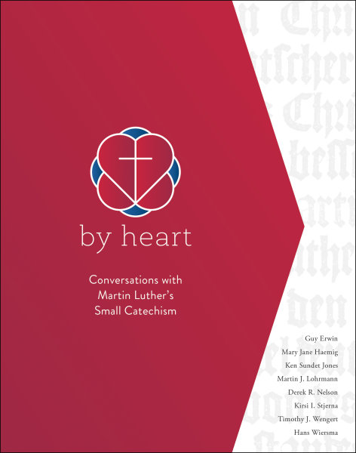

**2018 Lenten Study**

**This study will be an in-depth exploration of the Small Catechism. The guide will generate meaningful conversations about the biblical and historical context of the Small Catechisms, its link to the church’s faith, and its connection to Luther’s life and your life today.**

**Dates: February 14 (Ash Wednesday) - March 28 (7sessions)**

**Time: 6:00 PM on Wednesday**

**Location: Church Library**

**Please sign up to attend and for a book.**

**(On “The Board”)**

***Coming Soon: Lenten Soup Suppers*** – Lenten Soup Suppers will begin on Ash Wednesday, February 14, and continue every Wednesday (serving 5:30-6:30 pm) through March 21st. A sign-up sheet is on the church bulletin board for any group who wishes to sponsor a supper.