**Welcome to Cross of Calvary Lutheran Church**

**1st SundayAfter Pentecost**

**May 24 & 27, 2018**

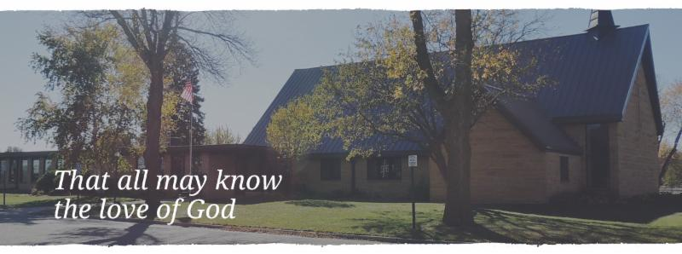

Cross of Calvary is the ELCA church in Olivia. We are an intergenerational (fancy word for young and old) community that follows Jesus out the building to where we live. We are all learners (disciples) here. This is a safe place to practice worship. And, believe us, it takes practice. Your questions, critical thinking, doubts and imperfect lives are welcome here.

**Holy Communion**

Holy Communion is open to all who are baptized and trust that Christ is present in the meal, regardless of your tradition or affiliation. Wine (red)/grape juice (white).

**Participation**

**Bold type means all of us read or pray together. Out loud.** * Please stand as you are able.

**Children in Church**

They belong here! They are hearing God’s Word, music and prayers. We don’t mind fidgeting and chatter! If you like, there are activity bags available in the entry.

**Announcements** They are as printed or any new information please give to Pastor Matt prior to worship, please hand a note to Pastor with any announcements, including prayer requests

**Restrooms** they are located in the hallway to the left of the stairs.

**Worship Times Pastor: Matt Hausken**

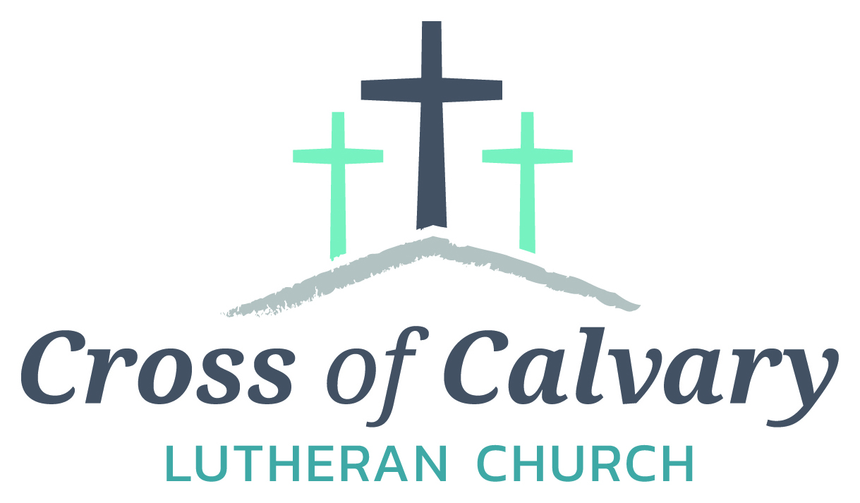Thursday: 7:00 pm hauskenmatt8@gmail.com

Sunday: 9:00 am  **Parish Ministers**

**Building Hours**  Sarah Hausken

Mon-Thurs 8:30-7:00 sarah.hausken@gmail.com

Fri-Sun 8:30 -2:00 Jeni Skeie

**Office Hours** jeniskeie@gmail.com

Mon, Tues and Thurs: 8:30-3:00 **Admin: Sue Altmann**

Wednesday: 8:30 -4:00 crossofcalvary@gmail.com

Friday 8:30 – 2:00

**MAY VOLUNTEER**

COMMUNION 8:30 – Alex Gay 10:30 – Tashia Johnson

USHERS 8:30 – Jon Hawkinson, Nate Cole & Rod Osthus

10:30 – Duane & Karen Flom & David Torgelson

ACOLYTES: Jerson Kopka & Carson Kubesh

ALTAR GUILD: Karen van der Hagen & Angie Boen

**The week of May 27 – June 3**

**Today**  Worship 9:00 am

**Monday** Library reserved 6:00-8:00 pm

**Tuesday** Men’s Bible Study 6:15/7:00 am

Clean up on the SW side of the church 6:30 pm

**Wednesday** Stephen Ministry Training 6:00 – 8:30 pm

**Thursday** Worship 7:00 pm

**Sunday** Worship 9:00 am

Larson Graduation Party Using church 12-9

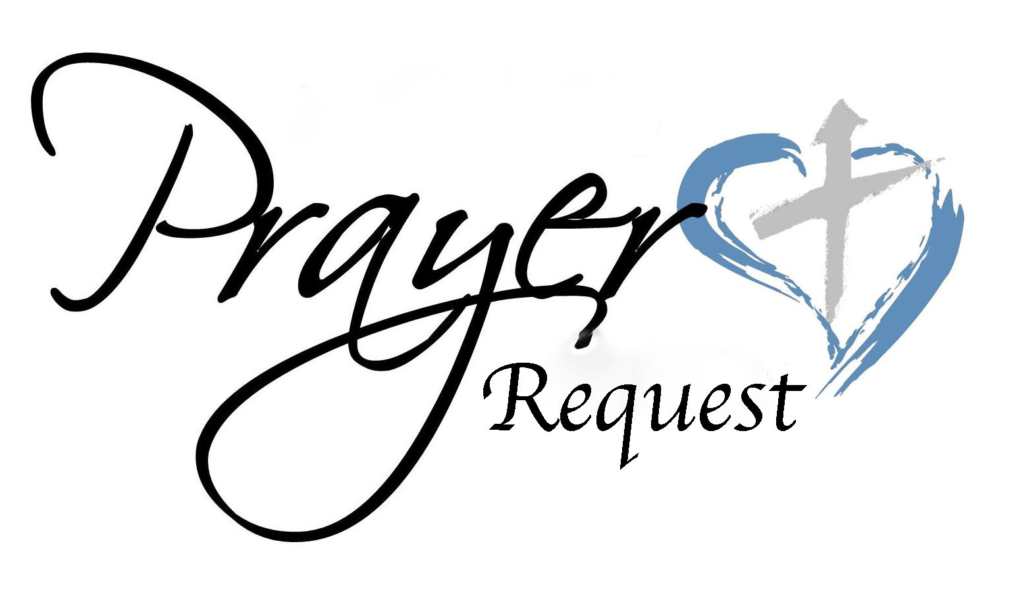

**Prayer Request**

Prayer Matters!

Please take your bulletin home and pray for those listed.

Emergency/Pastoral Care-Please have a family member or friend notify the church. You may also request hospital staff to call on your behalf. Call day or night at 523-1574. Never feel as though you are bothering Pastor or the staff. We are here to serve as a comfort and as a resource.

*Diana Adkins *Jill Revolinski *Leslie Sagedahl *Barb Gomarko

*Jenna Reynolds *Betsy Hennen *Laura Wacek *Dave Pedersen

*Mike Abrahamson *Alexa Fischer *Caryn Behr

*Izzy Sullivan *Jen Beckler *Pastor Ron Hackmann

* Sonia Grasmon *Jodi Bakke *Corinne Skogen

**Youth Events/News**

**Day Camp** Day camp for youth who have finished grades K-6 will be Sunday

Location: Cross of Calvary ALL ARE WELCOME!!!!!

July 8-Thursday, July 12. Cost is $30 per student or $75 per family.

Sunday = 3pm-8pm (with a Campfire worship at 7:15)

Monday = 1pm-6pm

Tuesday = 1p-6pm (Tie Dye day)

Wednesday = 1pm-6pm (Program at 5:30)

Thursday = 1pm - 6pm

Evening meals provided each day

*Please bring a pillowcase or t-shirt labeled with your name on Sunday or Monday for the tie dye project on Tuesday.

*We will be feeding the campers every night before 6, so we will be asking for food donations.

Below is the link for registration. **Registration closes July 6.**

<https://goo.gl/forms/OZnpGxBmdh4aNEHD3>

**Summer Bible Camp**

Camp information is on the table beneath Youth Board.

Register at www.gllm.org and fill out our info sheet.

Cross of Calvary youth get $100 in scholarships. Contact: Sarah or Jeni

**Vacation Bible School**

Location: Our Saviors Lutheran Church 510 Dogwood Ave, Bird Island

Dates: June 25-29

Time: 6-8:30 pm

Ages 3 years old – 6th Grade

All Denomination Welcome

Call the church for more information 320-365-3996

Cost: $20 and additional $10 if you would like to have a meal before class begins

Registration forma on the Youth table

**Cross of Calvary Events/News**



**Stephen ministry**

One-to-one caring ministry planting a seed of hope and healing

For more information talk to Jeni Skeie, Carole Buhr, or Pastor Matt

**Financial Update**

Needed each week to meet budget - $5325

Needed to meet though April 30 - $90,625

Actual receipts through April 30 - $67,528

**"Better Together Redwood Falls"** will provide 120,000 meals for local food shelves, backpack programs and disabled/homeless veterans, as we build community by working side by side. We will be “better together!” There are opportunities to volunteer from 7 am to 5 pm, sign up on “The Door” or online. Make sure to sign up here as space is limited to 150 volunteers per shift. <http://www.signupgenius.com/go/20f0548a8a82ea6f94-better> **Date: June 8th**

**Faith Club** Hello to all. Our women's study has taken a break for the month of May. But I am anxious to get back together. Our book for the summer is not so much of a Bible study, but a study of faiths. It is a conversation between a Muslim, a Christian, and a Jew, three women searching for understanding. This book was recommended by a member who has read it 3 times and was willing to read it again. It is called The Faith Club by Ranya Idliby, Suzanne Oliver, and Priscila Warner.

We will have two formats. One group will meet on Thursday mornings at 8:15 am beginning June 7, (with no meeting on July 5). Thursday group please read pages 300 to the end and the first 2 chapters before we meet.

The other group will meet at my house 3 times over the summer on a Tuesday night at 6pm, June 26, July 24, and August 28. Tuesday group will read pages 300 to the end and thru chapter 7 by June 26.

If these times don’t work, please still feel free to join in reading the book. Enjoy!!!! Spread the word. All are welcome.

Peace to you,

Jeni Skeie

**Church Outside Clean-up** on Tuesday, May 29 starting at 6:30 pm. We will be cleaning the SW side of the church property. “God’s work, our hands.”

**May is Cross of Calvary’s** month to help the CCOC. We are asked to bring healthy snack to the CCOC. The program runs Monday thru Friday all month. There are about 20 to 30 students. Please drop off snacks before 3:00pm on which day that works best for you.

Midsummer Festival: Friday – June 15, 2018, Chicken Dinner at United Lutheran Church in Lake Lillian. Menu: Don Boll’s Fried Chicken, Potatoes, Green Beans, Coleslaw, Ostkaka, Bread, Beverage and Dessert. Time: 5-7 pm Cost” Adults: $11, 12 yrs. and under: $5.00

Olivia American Legion Breakfast: Sunday, June 10, Serving from 9:00 – 1:00; Pancakes, eggs, sausage, ham, biscuits & gravy. Adults: $100, kids under 12: $10. Little guys & gals: FREE

**Men’s Group Project**

New Storage shed

See board in the Narthex,

for more information on how to give!

To date: donations are $6,500.00

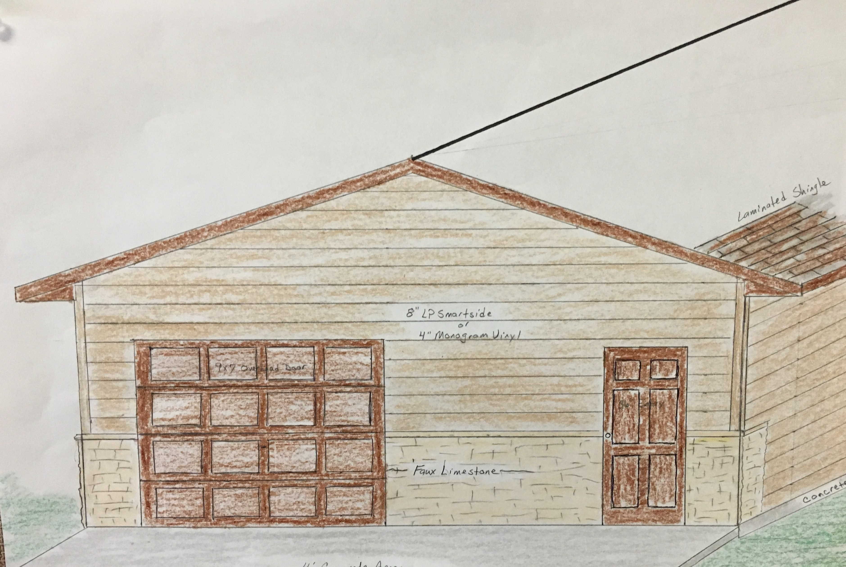

**May 27, 2018**

**TRINITY SUNDAY**

**HYMN OF THE WEEK**

**Come, All YOU People**

*We are children of God and heirs with Christ.*

**DAILY BIBLE READINGS**

These passages are related to the Lectionary texts for this Sunday.

|  |  |  |
| --- | --- | --- |
| **Sunday** | **John 3:1-17** | **Born of the Spirit** |
| **Monday** | **Isaiah 6:1-8** | **A vision of God** |
| **Tuesday** | **Romans 8:12-17** | **Life in the Spirit** |
| **Wednesday** | **Galatians 3:29–4:7** | **Heirs of promise** |
| **Thursday** | **Isaiah 44:1-8** | **God pours out the Spirit** | |
| **Friday** | **Titus 3:1-7** | **God saved us** | | |
| **Saturday** | **Psalm 29** | **The voice of God** | | |
| **Sunday** | **Mark 2:23–3:6** | **A question about the Sabbath** | | |

**SCRIPTURE VERSE FOR THIS WEEK**

It is that very Spirit bearing witness with our spirit that we are children of God, and if children, then heirs of God and joint heirs with Christ. **Romans 8:16-17a (NRSV)**

**PRAYERS AND BLESSING**

**A Prayer for the Week:**

Holy Trinity, we thank you for giving us new birth and making us your children and heirs of promise forevermore. Amen.

**Mealtime Prayer:**

Praise God, from whom all blessings flow; praise God, all creatures here below; praise God above, you heavenly host; praise Father, Son, and Holy Ghost. Amen.

**A Blessing to Give:**

May the Lord strengthen you and bless you with peace. (Psalm 29:11)

**CARING CONVERSATIONS**

Discuss in your home or small group:

• Talk about a time you felt powerless in a situation.

• Slaves in the time of Christ had no legal power, no legal identity as a parent, and no hope of inheritance. What would it be like to be a slave?

• We did not receive a spirit of slavery to fall back into fear but a spirit of adoption (Romans 8:15). What does it mean to you to be adopted by God?

**DEVOTIONS**

*Read:* Romans 8:12-17 and John 3:1-17.

The Holy Trinity of God the Father, Son, and Holy Spirit, one God in three persons, is a difficult idea to understand. However, it is best described through relationship and story, our story as people who have been “born from above” (John 3:3). John 3 and Romans 8 both focus on the love of God that adopts us, gives us a new birth and makes us children of promise, children with an inheritance with Christ. Instead of being slaves to sin and death, we are freed for a new life in Christ. However, the glory of this new life still experiences suffering with Christ (Romans 8:17). Reflect on how suffering connects us to God’s love for this present world.

*Pray:* **Holy Trinity, we thank you for giving us new birth and making us your children and heirs of promise forevermore. Amen.**

**SERVICE**

In Isaiah 6:1-8 the prophet Isaiah is terrified by being in God’s holy presence because Isaiah is unclean. That changes when an angel brings a flaming coal from the altar and cleanses Isaiah from his sin. Then, in response to God’s question, “Whom shall I send?”, Isaiah is ready to say, “Here I am, send me”. God continues today to call and send us out into the world with the good news of Christ and his forgiveness. The one qualification Isaiah needed to be sent was to be forgiven. We are all qualified to be sent through that same power of forgiveness. Consider ways to be a servant of God’s love this week by offering an act of love, a caring conversation, and/or a word of prayer that expresses trust and hope in the Triune God, Father, Son, and Holy Spirit.

**RITUALS AND TRADITIONS**

A longstanding Christian tradition is to recall one’s baptism and being born from above by reciting the words for the Trinity: “In the name of the Father, Son, and Holy Spirit.” This week begin and end your days by making the sign of the cross on your forehead or over your heart and say: **“In the name of the Father, Son, and Holy Spirit.”** Consider making this a daily practice.

**Community Events/News**

**SAL (SAL: Sons of the American Legion) Pop-Tab Contest:** Cash Prizes, start saving those little aluminum tabs from you beverage containers and you could be winner of one of three cash prizes. The SAL is sponsoring a contest for the purpose of colleting as many Aluminum tabs as possible. The tabs will be turned over the Ronald McDonald home of MN. These tabs generate funds to assist operating these homes which are made available to family members while children and adults are being treated at hospitals in MN. You can find these little tabs on beverage and soup cans. The tabs will be weighed on Saturday, September 8th at the Legion in Olivia during the Fire Departments Annual Rib Fest. Cash prizes are as follows: 1st prize: $50.00, 2nd prize: $30.00 and 3rd prize: $20.00

On Sunday, June 10th from 4:00 – 7:00 pm **Calvary Lutheran Church** of Willmar will be having their Annual 50’a Drive In. This is a fundraiser for our youth activities and trips which includes: good food, classic cars and sock hop music!

**Renville County Human Services is** currently seeking individuals who are willing to be foster parents to children who are in need of a home. Foster parents can be blended families, one or two parent families, retired or single.

The most important aspects of fostering a child is your willingness to provide a loving, save and stable environment. Foster parents are considered part of a team of individuals who are working to make a better life for a child. Foster parents help a child through a difficult time, share their gifts and talents and receive reimbursement for their dedication and service to children. Is it time to share your gifts and talents and become a foster parent?

Please call Bonnie Lund or Stacie Roxberg, Renville County Human Services at 320-523-2202 to find out more about how to become a foster parent for Renville County.