

***The Follower***

**April 2019**



***Blessings on the beginning of the month of April. I’ve been watching what seems to have been an insurmountable amount of snow melt away. Spring is here! The days are getting longer and life is springing up all around us.   
  
It has gotten me to think about the days in February when the snow seemed endless. What my thoughts would wander to was knowing that spring was coming. I know that I am not alone in this and many of you took heart in this amazing truth.   
  
Imagine what life would be like as a perpetual winter with no hope of Spring. Then my thoughts wandered to the promises we have received from Christ. As we go though life, we know that the cold and bitterness of suffering and death do not have the last word. We go forward with hope and confidence, knowing that Christ is constantly working new life.   
  
As Christians it is our privilege to worship every week because every service is a celebration of Christ’s victory for us. So no matter the season outside or in our lives, the light and warmth of Christ draws us forward in joy.  
  
Blessings for a grace filled Holy Week and Easter!  
  
CHRIST IS RISEN! HE IS RISEN INDEED!  
  
In Christ,  
Pastor Matt***

**No Sunday School:**

**April 7th Ham Dinner**

**and April 21st – Easter Sunday**



**Senior High Youth Gathering** is April 5-6 for 9-12 graders.

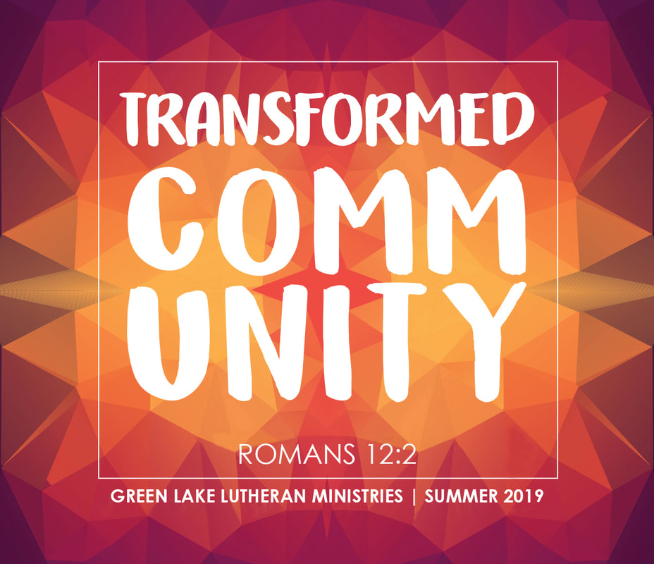

**Day Camp** will be July 7-11 @ Cross of Calvary this year. This program brings in staff from Green Lake Bible Camp for the week. We start Sunday evening with a campfire and continue Monday-Thursday 1-6 pm, with a meal to conclude each day. There will be ty-dying, crafts, games, songs, bible stories and loads of friends. All of this is centered on the theme of Transformed Community and Romans 12:2. Youth who have finished grades K-6 are encouraged to register online. Cost is $45.

**Breakfast Club** is for Youth in grades 10-12 and will begin at 7:07 am on Thursdays at Cross of Calvary

**Wonders on Wednesday (WOW)** are our weekly after school program for 4-6th graders. Students can ride bus 3 to church on Wednesdays for snack, free time, games, Bible dramas, Cooking club, serving at the Food shelf, singing, and interactive prayer time. Kids can be picked up at 5 pm.

**Jesus Justice League** is our monthly after school program for 1-3 graders. Students can ride bus 3 to church the 2nd Tuesday of the month for snack and an opportunity to “play" Bible stories through games, drama, science, art and singing. Kids can be picked up at 5 pm.

**April Coffee Hour**

**April 7 Ham Dinner**

**April 14 Palm Sunday Breakfast**

**April 21 Easter – no Coffee Hour**

**April 28 Brain and Heather Weis**

**Richard Sigurdson**

**Randy and Tami Steffel**

Coffee hour is a time for God’s people at Cross of Calvary to minister to each other through caring conversation. All members with youth in grades 1-12 are scheduled one time during the year. Please bring 3 doz. Treats. Directions are posted on the kitchen cupboard. Thank you for serving in this way.

|  |
| --- |
|  |

**Cross of Calvary Church News/Events**

**The movie "Break Through”** is having a special showing for Cross of Calvary members at the Millennium Theatre in Montevideo on Saturday, April 20th at 10 am.  Please sign up on 'The Door' and indicate if you would like to drive as we would be carpooling to this event.  Space is limited to 65 people, and cost is free, as the Bazaar committee is treating you to your ticket!  Deadline to sign up is Wednesday, April 17th.  "Break Through" is based on true events and is a Christian drama about a teen boy, who in 2015, broke through an icy lake and was without a pulse for 45 minutes. See what the power of prayer did for this family!  NBA basketball player Stephen Curry is executive producer.

**Stephen Ministry**: What exactly is the Stephen Ministry we’ve been hearing about? Stephen Ministry is lay caring ministry. Stephen Minters are not counselors or therapists: rather, they are caring Christian friends who can offer a listening ear to help others through the tough time in life. Stephen Ministers are trained and supervise in their ministry. If you are going through a tough time and could use a caring friend…please contact Jeni Skeie, Carole Buhr, or Pastor Matt. Stephen Ministers offer caring Christian friendship and concerned listening to people when they need it most.

**Bible Studies**

**Dorcas Bible Study** will meet the 4th Wednesday of the month at 9:30 am. Please meet in the Fellowship Hall.

**Ruth Bible Study** will meet the 4th Monday at 1:30 pm. Please meet at Parkview place.

**Men’s Bible Study:** Tuesday at either 6:15 am or 7:00 am. Please meet in the Church Library.

**Theology on Tap** will meet Wednesdays at 8:00 pm (except the 3rd Wed. of the month) at Max’s, a young adult Bible Study and discussion group with Pastor Matt.



**New Group Starting: This Women’s Bible Study**. Books can be ordered online. You can join at any time. This takes us into the Bible to look at the women who spoke in the Bible and what they said. Crazy the stuff you find in the Bible….Please join us! If you need help getting your book please contact Jeni.

**Hosted by the Men’s Group in support of youth scholarships for camps and mission**

**Cross of Calvary Church**

**Wednesday, May 1st from 5pm-7pm**

**Adults: $7.00 - Children: ages 4 to 12 - $4.00**

**Children 4 and under are free**

**Serving: Spaghetti, Garlic Toast, Veggie Tray, Dessert and Beverage**

**Please make checks payable to Cross of Calvary Men’s Group**

**Living Lutheran Magazine (**After April, the magazine will no longer be delivered to your homes. If you are interested in reading the magazine, 10 copies will be available at church for you to take home and read and then return for others to enjoy! A second option would be to go online and google Living Lutheran magazine, Official site): this allows you to read the magazine online (scroll to the bottom of the page to find the magazine, current issue) [www.livinglutheran.org](http://www.livinglutheran.org)

You can also subscribe to receive some Living Lutheran articles via email.

[**https://www.livinglutheran.org/subscribe/**](https://www.livinglutheran.org/subscribe/)



**Prayer Request**

Please take your bulletin home and pray for those listed. Emergency/Pastoral Care-Please have a family member or friend notify the church. You may also request hospital staff to call on your behalf. Call day or night at 523-1574. Never feel as though you are bothering Pastor or the staff. We are here to serve as a comfort and as a resource

**Prayers of Healing and Strength**

Susie Lothert – Family & Friends

Brandon Ochs – Steve & Sue Altmann’s friend

Gary Melin – Joanne Balgaard

Kathy Brown – Emy Elbert mother

Pat Swanson – sister of Ken Ziesmer

Jim Doering – Friend of Ken Ziesmer

Linda Cole – Nate Cole’s Mother

Barb Miller – Friends and Family

Autumn Stryker – Family and Friends

Bob Smith – Casey Elfering grandfather

Lesley Sagedahl – Daren Sagedahl’s sister

Julie O’Halloran – Doug & Jody Steffel

Brian Reese – Kathy Reese son

Larry Amberg – Pete Amberg

Lori Peterson – Angie Metteer’s friend

Brian Hanson – Wally Stucke’s uncle

Lyn Tesch – George Tesch daughter

Donnie Hagen – Dick Hagen brother

Family of Eleanor Sander – Gladie Hagen sister

Family of Paula Waldron – Todd Gay sister

Note: Persons will be removed at the end of a month. Please contact the office if you would like the individual to remain on the list longer. Thanks!



04/01 Eleanor Ziesmer 04/17 Edith Vogt

04/01 Mark Schlomann 04/18 Ron Beckler

04/02 Keith Larson 04/18 Annie Mittelstadt

04/02 Jacob Hennen 04/19 Ben Johnson

04/03 Sandy Kubesh 04/19 Cash Larson

04/03 Brody Siems 04/20 Nolan Link

04/03 Reed Kopel 04/21 Keely Jo Prokosch

04/04 Colin Berg 04/22 Austin Einerson

04/04 Hayli Garcia 04/22 William Hanson

04/04 Tanner Amsden

04/04 Winnie Blem 04/22 Haylie Binnebose

04/04 Charlotte Nelson 04/22 Drew Tuthill

04/05 Bobbi Jo Abrahamson 04/23 Deloris Abraham

04/05 Carrie Jo Gass 04/23 Joshua Wertish

04/06 Terry Jacobson 04/24 Carol Senkyr

04/07 Clare Cooper 04/24 Barb Wertish

04/08 Josselyn Mertz 04/24 Noah Boen

04/08 Cole Sander 04/24 Deacon Osthus

04/08 Jaelyn Brustuen 04/25 Joe Youngkrantz

04/09 Ben Balderston 04/25 Tim Lingl

04/09 Lanie Altmann 04/25 Taylor Lingl

04/09 Connor Hebrink 04/25 Moira Revier

04/10 Sarah Iverson 04/25 Wyatt Gilberts

04/10 Brady Stovern 04/26 Howard Erickson

04/10 Lane Helmer 04/27 Elisha Garcia

04/11 Richard Alton 04/27 Camille Weber

04/11 Braydon Fuoss 04/27 Eva Larson

04/12 Claire Neubauer 04/27 Cole Visser

04/14 Katie Erickson

04/14 Makenzie Gartner 04/28 Naomi Wertish

04/14 Emersyn Herdina 04/28 Mallarie Steffel

04/15 Mitchell Johnson 04/29 Karen van der Hagen

04/15 Kyler Kemnitz 04/29 Scott Johnson

04/16 Lyle Norris 04/29 James Handt Jr.

04/16 Kathy Slagter 04/29 Kathy Blackwell

04/16 Christine Flemming 04/29 Keeghan Aeikens

04/16 Nellie Borer 04/29 Alen Helmer

04/16 Beckett Kemnitz 04/29 Erick Wussw

**APRIL VOLUNTEERS**

COMMUNION: 8:30 – Nathan Cole

10:30 – Jon Hawkinson

USHERS 8:30 – Eric Skeie, Cheryl Mallak,

Ron & Linda Fahse

10:30 – Need Ushers

ACOLYTES 8:30 – Abby Stovern & Madeline RIdler

10:30 – Daylea Stryker & 1 more needed

ALTAR GUILD: Stacey Larson & Sarah Iverson

**Cross of Calvary Lutheran Church COUNCIL MEETING**

**Minutes for: Wednesday, March 20, 2019 at 7:30 pm**

**COUNCIL MEMBERS**

Dana Boen# 2020 Jon Hawkinson 2021* Reggie Lothert 2022

Curt Sather 2020 Laurence Stratton 2021 Nathan Cole 2022

Jill Hanson 2020 Elaine McDowell# 2022 Alex Gay 2021

DeeAnne Newville 2020* Gordon Blem 2022 Sam Welchance – Youth member

Steve Altmann 2021* Terms end at Annual Meeting (Jan.)

*Second term/# absent

**STAFF**

Pastor Matt Hausken #Jeni Skeie, Parish Minister Sarah Hausken, Parish Minister Sue Altmann, Council Recorder

**AGENDA**

1. Meeting called to order
2. Devotions – *Jon Hawkinson*
3. Approve minutes of the ***February meeting*** – Motion to approve the minutes by Steve Altmann, seconded by Alex Gay, motion passed.
4. Financial Secretary and Treasurer Reports *–* ***February-*** Motion to approve the treasurer/secretary report by Jill Hanson, seconded by Steve Altmann, motion passed.
5. Pastor’s report - Lent season is in full swing and everything is going wonderfully. Wednesday tend to be a very busy day! Visits are going great with Fairview having extra sermons. There are a regular 8 young people in attendance for the Theology on Tap bible study!
6. Parish Ministers report – Jeni submitted a report. Sarah: Summer Stretch is in the planning with registration in May. Sarah has been invited in the Deaconess community. She was asked to join in September. This means she will be Sister Sarah in September.

**COMMITTEE REPORTS AND RECOMMENDATIONS (2018)**

1. Administration – Alex Gay & Nathan Cole - none

2. Children, Youth and Family-Reggie Lothert - none

3. Equipping –Laurence Stratton - none

4. Missions –Alex Gay - $2000.00 to Green Lake Camp

5. Worship and Music –Jill Hanson – Jeni and Pastor Matt have been meeting for worship music.

6. Care Team – DeeAnne Newville – none, but a prayer chain has been set up. If you are interested in joining there is a

sign-up sheet on the board.

7. Parish Life – Dana Boen & Elaine McDowell- notes given

8. Outreach – Jon Hawkinson & Jill Hanson- There mission is to get members into the church then passing the person on to Parish Life.

The committee is looking into helping with a concert at Park during Corn Capital days, with Rachel Kurtz. Hopefully getting

some grant money to cover the cost.

9. Technology – Steve Altmann & Nathan Cole – New Copy machine has been installed.

*10. AED Maintenance – Steve Altmann*

**OLD BUSINESS**

* Copy machine has been purchased – **and installed**
* Discuss: Summer Service hours (suggested by staff: Sunday at 9:00 and Sunday evening at 5:30) Begins May 19 – Sept. 1st – will be revisited at the April meeting of summer worship times.
* Locks for Sunday school rooms – has this been purchased? – On hold until a later date.
* Living Lutheran Magazine was discussed. There will be 10 copies available at church/also the magazine can be read

On line for free [www.livinglutheran.org](http://www.livinglutheran.org)

**NEW BUSINESS**

* New Lawn mower has been purchased with trade in of old mower.
* Synod Assembly cost: $180 for facilities/meals per person before 5/17/19 - $230 after date listed (Cross of Calvary sends 3 people) (Pastor Matt will call to see if there is a need to send someone to the Assembly)
* The council would like give a HUGE thank you to all who have help clear the parking lot. Your time and equipment are greatly appreciated by all the Cross of Calvary member and staff.

Next Council meeting: Wednesday, April 24th at 7:30 pm (Due to Holy week)

April Communion: 8:30 – Nathan Cole 10:30 – Jon Hawkinson

April Devotion – DeeAnne Newville

**Adjourn / Close in prayer.**