**Cross of Calvary Lutheran Church**

**1103 W. Chestnut Ave. Olivia, MN**

**320-523-1574**

[**crossofcalvary@gmail.com**](mailto:crossofcalvary@gmail.com)

**May 19, 2019**

Cross of Calvary is the ELCA church in Olivia. We are an intergenerational (fancy word for young and old) community that follows Jesus out the building to where we live. We are all learners (disciples) here. This is a safe place to practice worship. And, believe us, it takes practice. Your questions, critical thinking, doubts and imperfect lives are welcome here.

**Holy Communion**

Holy Communion is open to all who are baptized and trust that Christ is present in the meal, regardless of your tradition or affiliation. Wine (red)/grape juice (white).

**Participation:**

**Bold type means all of us read or pray together. Out loud.**

**Children in Church**

They belong here! They are hearing God’s Word, music and prayers. We don’t mind fidgeting and chatter! If you like, there are activity bags available in the entry.

**Announcements**

They are as printed or any new information please give to Pastor Matt prior to worship, please hand a note to Pastor with any announcements, including prayer requests

**Restrooms** they are located in the hallway to the left of the stairs.

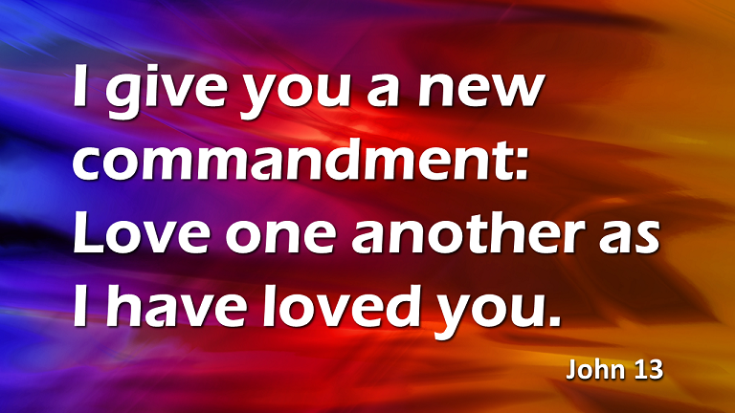

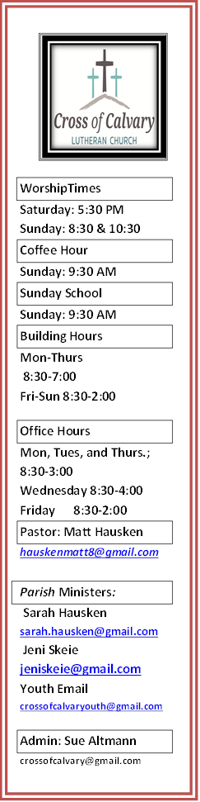

**May 19-26**

**Sunday 5/19 Services 9:00 am & 5:30 pm**

**Monday 5/20** Library reserved 6:00–8:00

Ruth Bible Study noon

**Tuesday 5/21** Men’s Bible Study 6:15/7:00

**Wednesday 5/22** WOW (last day) 3:15-5:00

Altar Guild Meeting 7:00 pm

Dorcas Bible Study

**Thursday 5/23** Breakfast Club 7:07 am

Women’s Bible Study 8:15 am

Stephen’s Ministry 6-8

**Friday 5/24**

**Saturday 5/25**

**Sunday 5/26 Worship 9:00 am & 5:30 pm**

**MAY VOLUNTEERS**

COMMUNION: 8:30 – Elaine McDowell

10:30 – DeAnne Newville

USHERS 8:30 – Jon Hawkinson, Nathan Cole & Rod Osthus

10:30 – Duane & Karen Flom,

David Torgelson

ACOLYTES Craig Lothert Jr. & Juliana Kopka

ALTAR GUILD: Karen van der Hagen & Angie Boen

**Ring found, please claim in the office.**

**Prayer**

**Request** 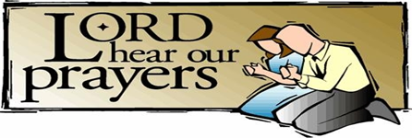

Please take your bulletin home and pray for those listed. Emergency/Pastoral Care: Please have a family member or friend notify the church. You may also request hospital staff to call on your behalf. Call day or night at 320- 523-1574. Never feel as though you are bothering Pastor or the staff. We are here to serve as a comfort and as a resource.

Kathy Brown – Emy Elbert mother

Family of Barb Miller

Mike Abrahamson – Bobbi & Tim

Lane Wacek – Marcella Wacek

Adam Bleck – Elaine McDowell nephew

Brandon Ochs – Altmann’s friend

Tami Steffel –Family

Sandy Kubesh – Family

Family of Bob Smith

Linda Cole – Nate Cole’s mother

**Cross of Calvary Events for May**

|  |  |  |  |  |  |  |  |
| --- | --- | --- | --- | --- | --- | --- | --- |
| |  |  |  |  |  |  |  | | --- | --- | --- | --- | --- | --- | --- | | |  |  |  |  |  |  | | --- | --- | --- | --- | --- | --- | | |  |  |  |  |  | | --- | --- | --- | --- | --- | | |  |  |  |  | | --- | --- | --- | --- | | |  |  |  | | --- | --- | --- | | |  | | --- | | **May 19 - Start of Summer Services hours (9:00 am and 5:30 pm)**  May 19 – Equipping Meeting at 10:00 am  May 20 - Ruth Bible Study  May 22 - Dorcas Bible Study  May 22 - WOW (last day)  May 22 - Altar Guild Meeting at 7:00 pm  May 23 - Breakfast Club 7:07 am  May 30 - Last day for Breakfast Club | |  | | | | | | |

**The Equipping Team** has a VERY BRIEF survey about what you might like to learn at Cross of Calvary! Would you please take our survey? **(Cross of Calvary Members)**

<https://www.surveymonkey.com/r/8VSDR33>

**Cross of Calvary Youth**

**Camp at Green Lake:** Register online and fill out The CofC info sheet on the Youth Board.<http://www.gllm.org/uploads/3/1/5/9/31596405/general_insert_2019.pdf>

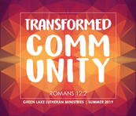**Day Camp:** Registration for Day Camp at Cross of Calvary for this summer!!! Don't miss out!!! This is for youth who have finished Kindergarten - 6th grade. Bring your friends too! July 7-11 (Sunday - Thursday)   
[https://forms.gle/9LEdqwmLtfmT7SLp8](https://forms.gle/9LEdqwmLtfmT7SLp8?fbclid=IwAR1bqdqW74N1-VycgQ9NzEel0-amFyOhkDenaWxqJvT4wWfrSbxR6fT6XZ8)

**Registration opens on May 8th**

**Coffee Hour**

**Summer Coffee Hour (Hosts needed) sign up on “The Board” and thank you in advance!!**

**Community News**

**Fundraiser for Green Lake Lutheran Ministries Camper Scholarship’s:** Golf Tournament will be held on June 1, 2019. For more information check the East entrance board.

**PGA Memorial Golf Tournament**: Saturday, May 25: registration at 10:00 am, shotgun starts at 11:11am – A tournament to raise money for the Ronald McDonald House. All are welcome to play!!! Contact Steve & Sue Altmann if interested in playing or donating either money or a silent auction item. Thanks!!!! 320-522-0048 or 320-522-0049.

**Renville County Human Services** is currently seeking individuals who are willing to be foester parents to children who are in need of a home. Foster parents can be belended families, one or two parent families, retired or single. The most important aspects of fostering a child is you willingness to povide a loving, safe and stable environment. Foster parents are considered part of a team of individuals who are working to make a better life for a child. Foster parents help a child through a difficult time, share their gifts and talents and receive reimbursement for their dedication and servcie to children. It is time to share your gifts and talents and become a foster parent? Please call Renville County Human Services at 320-523-2202 to find out more abouit fostering a child.

**2019 Graduates**

**An Invitation**

**to the Congregation**



Spencer Reinhold Helmer Dawn Helmer & Steve Helmer

Open House: Sunday, June 2nd from 1-4 pm

Lake Lillian Community Center

Jake Jaron Evenson Shad & Jenny Evenson

Open House: Sunday, May 26th from 4-7 pm

1003 W. Chestnut Ave, Olivia

Shelby Lynn Stovern Derek & Tami Stovern

Open House: Sunday, May 26th from 4-8 pm

420 S. 4th St. Bird Island

Emma Maureen Thompson Heather & Aaron Thompson

Open House: Saturday, June 1st from 4-7 pm

Cross of Calvary Church

Megan Elise Ridler Roger & Tonia Ridler

Open House: Sat., May 18th from 12-3 pm

405 S. 4th St. Olivia

Trey Michael Mertens Greg & Dawn Mertens

Open House: Sat., June 1st from 6:30 -10 pm

34522 830th Ave Olivia

Hayli Marie Garcia George & Elisha Garcia

Open House: Saturday, June 8th from 3-7 pm

Cross of Calvary Chruch

Cade Aldon Morse Mark & Jaime Morse

Open House: Sunday June 2nd form 1-4 pm

Olivia American Legion

Joseph Robert Mikosch Jeff Mikosch & Danna Stamer

Open House: Sun. June 9th from 1-5 pm

1415 Fairacre Lane SW, Willmar

Daniel James Newville Tom & DeeAnne Newville

Open House: Sat., June 1st from 6:30 -10 pm

34522 830th Ave Olivia

Alexandra Lila Revier Dave & Chris Revier

Makenna Rae Steffel Randy & Tami Steffel

Open House: Sun. June 2nd from 3-6 pm 650 Ranchwood Dr., Bird Island

**Reminder to Cross of Calvary members:** readers needed for Sundays, if you are interested please sign up on the “Board”. Thanks!!!

**Christian Community Outreach Center**

**After School Enrichment Coordinator:** Faith based organization seeking candidate to plan and implement activities for after school program located in Olivia. Candidate will direct service projects, train volunteers, supervise homework time, and teach morals and values through daily Jesus time. Successful candidate must have experience working with children in educational or faith setting. Hours are 2:30-6:00 M-F. Program follows BOLD School calendar. Send cover letter and resume listing 3 references to Christian Community Outreach Center, 815 E Lincoln,Olivia MN 56277. Closing date, July 1, 2019 at 4:00 pm.

**Renville County TZD Safe Roads Coalition Message**



**May 19, 2019**

**FIFTH SUNDAY of EASTER**

**HYMN OF THE WEEK**

******Listen, God Is Calling

***The church expands to include Gentiles.***

**DAILY BIBLE READINGS**

**These passages are related to the Lectionary texts for this Sunday.**

|  |  |  |
| --- | --- | --- |
| **Sunday** | **John 13:31-35** | **Love one another** |
| **Monday** | **Acts 11:1-18** | **Peter reports to the church** |
| **Tuesday** | **Revelation 21:1-6** | **New heaven and earth** |
| **Wednesday** | **Acts 4:1-4** | **Peter and John growing the church** |
| **Thursday** | **Ephesians 4:1-16** | **Unity in the body of Christ** |
| **Friday** | **Acts 6:1-7** | **Seven leaders for the church** |
| **Saturday** | **Psalm 148** | **Praise for God’s universal glory** |
| **Sunday** | **John 14:23-29** | **The sending of the Counselor** |

**SCRIPTURE VERSE FOR THIS WEEK**

When [the apostles and the believers] heard [the testimony of Peter], they were silenced. And they praised God, saying, “Then God has given even to the Gentiles the repentance that leads to life.” **Acts 11:18 (NRSV)**

**PRAYERS AND BLESSING**

**A Prayer for the Week:**

Dear God, you who are the Alpha and the Omega, open our eyes and our hearts to those around us that all may know Easter joy. Amen.

**Mealtime Prayer:**

Lord, we ask that you bless our food this day. As we use our spoon, our fork, and our knife, let us remember the repentance that leads to life. Amen. (Acts 11:18))

**A Blessing to Give:**

As Jesus has loved you, may you go out to love one another. (John 13:34)

**CARING CONVERSATIONS**

Discuss in your home, small group, or use for personal reflections:

• What does the word outreach mean to you?

• Being a home or a congregation that receives new people changes that home or congregation. How is that hard to do? How is that a blessing?

• What is the mission field that God may be calling you to be a part of?

**DEVOTIONS**

*Read:* Acts 11:1-18.

This story is about one of the most important developments in the early church. Followers of Jesus now included Gentiles as well as Jews. There were objections from the early church believers in Judea (vv. 1-3). Peter’s response was that it was not his doing, but God’s. Peter was sent to the home of Cornelius (Acts 10) through a vision and an invitation from Gentiles. Interestingly, the real objection was not Peter’s preaching, but his fellowship and eating with Gentiles. Establishing relationships, having fellowship, and being a guest in another’s home are all hallmarks of the expanding mission field of outreach in the church, both then and now. The Gentiles end up having a similar response to the preached word by receiving the Holy Spirit as Jewish believers did in Acts 2. The believers in Judea hear all this and are silenced in a way that must have led to a repentance that turned to praise of God for what has now happened. Is there a difference in what you do and say when you are host and when you are a guest? What are those differences? Where might God be leading you to fellowship with others?

*Pray:* **Loving God, help me and all who claim Jesus Christ as Savior and Lord be empowered by the Holy Spirit to share the Easter faith and reach out to others with love. Amen.**

**SERVICE**

Jesus tells the disciples, “Just as I have loved you, you also should love one another” (John 13:34). There are many ways you can show love to others through your actions and words. Loving one another is a Christian way of life. In what ways do you show love towards others? What does it look like when loving one another becomes a way of life?

**RITUALS AND TRADITIONS**

Rituals hold families and faith communities together. Psalm 148 highlights a Christian ritual to give praise to the Lord. We do this in worship through praying, singing, reading scripture, and communing together. What faith related rituals do you have in your home? Create a notebook of rituals done in your home to capture these traditions as a faith heritage for future generations.