The Follower 2022

Cross of Calvary Lutheran Church
1103 W. Chestnut Ave.
Olivia, MN 56277

As we begin our season of Advent we prepare for the coming of Christ. But, sometimes the way we think about Christmas can obscure us from recognizing Christ in our midst. The way this happens in the way we tell the story. Of course this in not intentional on our parts at all. It is all what we have grown up with. And it has to do with one little word that was mistranslated years ago.

κατάλυμα is the greek word that we have come to know as “inn” in the Christmas story. However, the writer of the Gospel of Luke had a different meaning in mind. He uses the common word for “inn” during the parable of the Good Samaritan. Does Luke ever use the word κατάλυμα anywhere else? Yes! When the disciples meet in the upper room or the guest room when Jesus celebrates the Last Supper.

So, what difference does this make? A big difference where we look for Christ. Jesus was literally born in an average home. There were too many people in the guest room for this house. They were in the main living area that was about 3 feet above where the animals were kept for the night. The mangers were in the floor. The way we tell it with it happening in a barn it makes it this otherworldly, extraordinary event. But, instead it was a normal event in a normal house born with a normal family.

When we realize this, we can recognize that Jesus is here with us in the most normal and average of events. We start looking for him in the everyday. Christ has come, is here, and will come again for us. May we see the extraordinary grace of God in the everyday and may this message of grace strengthen us not only at Christmas but all year long.

Blessings for a wonderful month of December and a grace filled Christmas!

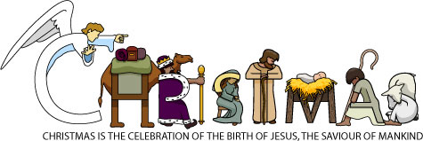
In Christ,

Pastor Matt

Council & Committee Meeting Dates
Church Council: December 14th at 7:45 PM
Devotions & Communion: Stacey Larson
All committees are looking for members; if anyone is interested please contact the church office at crossofcalvary@gmail.com or 320-523-1574

December Worship Assistants
Ushers: Nate Bahl, Keith Larson, Steve Altmann, Daren Sagedahl
Acolytes: Melissa Adamski & Will Stratton
Clicker:
Camera:
Communion Helper: Stacey Larson
Altar Guild: Lisa Meints & Natashia Johnson

Christmas Eve Worship
Join us for Christmas Eve worship on
Saturday, December 24th
4:30 PM and 9:00 PM

Cross of Calvary Holiday (Snowflake) Bazaar
Sunday, December 18, 2022
Breakfast and Bake sale from 8:00 – 11:00 AM
Sign up to bring baked goods is on the “Door”

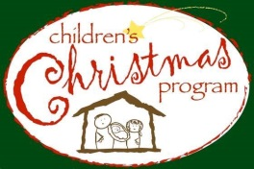
Sunday school Christmas Program
December 18th at 11:00 AM
Children should go to their classrooms at 10am that day for preparation.

Church committees
Coffee hour sign up is in need of volunteers!
Asking council members to pair up and take a Sunday if possible.

Community "Christmas in our Corner” Concert
will take place at Cross of Calvary, Thursday, December 8 at 7:30 pm. There is a community choir, a hymn sing-a-long, and various community solos and ensembles. Coffee and refreshments to follow in the fellowship hall. There will be a free will donation taken for a local charity or two.
Come join in the singing and ringing in the holiday!

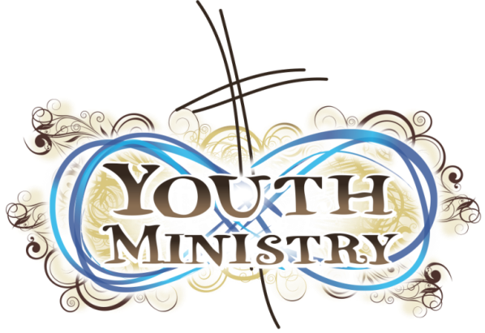

Confirmation Information
7th Grade class meets December 7th
8th-9th grade classes meet December 14th
All grades meet on December 21st
No Confirmation December 28th

Confirmation - We prayed the psalms of thanksgiving in the Labyrinth for spiritual practice and tied fleece blankets for Santa’s Closet for service. We will hear a faith talk from Gordy Blem in December.

Elementary Youth Programs
WOW: 5-6 grades meet Wednesdays: 12/7, 12/14
Jesus Justice League: -2nd grade meet on Thursday: 12/1
GLUE: 3-4th grade also meet on Thursday: 12/15

Elementary Youth Programs: The theme was “A million dreams” We talked about the future that God wants and promises for us as we pray His Kingdom comes on earth as it is in Heaven.
Jesus Justice League for 1-2nd grade will meet December 1. In November we did some yard cleanup for a service project and we will ty fleece blankets this week. They are learning about serving others without expecting anything in return. They also served coffee for Sunday school and raised money and collected food for the food shelf.
G.L.U.E. for 3-4th grade will meet December 15. They also tied fleece blankets last month.
Wow for 5-6 grade will meet December 7 and 14. In November they put up chairs for the the craft retreat and stuffed popcorn bags for Santa’s closet. They will also ty fleece blankets for Santa’s Closet. All together our youth tied 28 fleece blankets that will find a home for Christmas

Breakfast Club
Breakfast Club for 10-12 graders continues every week if there is school.
Alumni Breakfast Club is December 22 at 7:07, Cross of Calvary.
This is for our current 10-12 grade youth but also anyone who has been a part of Breakfast Club in the past!!! Monkey bread and scrambled eggs!

The new drinking fountain is in!
Feel free to send a water bottle with your child to youth functions to save on plastic cups.

Game night for 7-9 grade 16 kids showed up in November. We will continue this monthly on December 21 from 7:30-8:30.

NO SUNDAY SCHOOL
December 25 or January 1 for Christmas Break

Cross of Calvary had 19 youth attending the junior high youth gathering on November 18-19.
Thank you for your prayers that they would be led by the Spirit to grow in faith

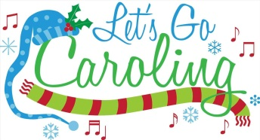

Caroling and soup supper for all adults and youth together! - Sunday, December 18 at 3:30pm
Meet at church to carol and ride the “wagon”. Soup supper following! If you can help with the soup supper, please sign up on the “BOARD.”

All Area youth grades 7-12 Ski nights will be January 15 and February 19. BOLD and RCW will have no School the following day. We will leave from Cross of Calvary at 12 noon and return at 9:30ish. Cost is $60. This includes the bus ride. Youth under age 21 may NOT drive themselves. Money must be paid and permission form turned in when signing up. Family account money can be used.

Camp Sunday will be January 22. If you attended camp last year, we would love to have you help lead or share about your time at camp and how it helped you learn about the love of God. Talk to Jeni - 320-579-0406 or jeniskeie@gmail.com. Camp registration opens in December.

Mark your calendar - 2024 National Youth Gathering will be in New Orleans, July 16-20. Registration will open September 15, 2023 and down payment is $150. Total cost will be around $1500 depending on how we travel. If you graduate in 2024-2027 you are welcome to attend. Click here for more information. https://www.elca.org/YouthGathering?_ga=2.44891746.777536322.1666640275-499798659.1666640275

There will also be a Young Adult National Youth Gathering in New Orleans, July 16-20, 2024 for ages 18-35. Cost will be similar. If you are interested in more info, please talk to Jeni or search https://www.elca.org/YouthGathering?_ga=2.44891746.777536322.1666640275-499798659.1666640275

.
Annual Meeting
January 15th after 9:00 AM worship service
All Annual reports are due to the office by December 26th.
________________________________________
1st Communion Classes (5th Graders)
March 15, 22 and 29, 2023
Worship Services: April 6th or 16th at 9:00 AM
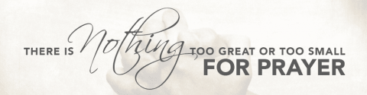

In December 2022 we pray…..
1. As we begin this month with joy and anticipation, let us be silent and hear your voice.
2. For our church staff as they prepare for the many worship services and events of the season.
3. Help me to show kindness and love when feeling frustration and impatience.
4. On this 2nd Sunday of Advent, bless our worship together and bless those who worship in their homes.
5. We give you thanks for the families celebrating their first Christmas with a new baby.
6. We thank you for the gift of food. At this time of the year when so many have so much, there are those among us who suffer from food insecurity. Guide us to help them with our time, our donations and our prayers.
7. Lord, thank you for your presence in my life and the lives of those I love.
8. For those in Long Term Care, Assisted Living and Group Homes. Help us show them your love.
9. For our healthcare workers working to keep us healthy among many challenges.
10. Today we thank you for the Santa’s Closet volunteers and ask you to bless the families receiving gifts.
11. On this 3rd Sunday in Advent, we pray for those struggling with their faith.
12. We thank you for the gift of shelter. Help those who are struggling financially to find adequate shelter.
13. We pray for those who grieve the loss of a loved one this past year.
14. For those who struggle with addiction. We know that for many the holidays can be a difficult time. Help to recognize those among us who need encouragement and understanding.
15. Help us to remember “The Reason for the Season”
16. That we will find ways to share your love with others, now and in the future.
17. We thank you for the volunteers in our church. Today we especially thank you for those preparing for our church bazaar tomorrow.
18. For our Sunday School students, their teachers and volunteers as they share the Christmas Story with us at their program.
19. For the safety of those traveling during this holiday season. May our college students arrive home safely and have a chance to rest and recharge for the next semester.
20. We pray for those who must be separated from their loved ones at this time. We thank you for the means available to stay connected.
21. We thank you for the children in our lives. Let our faith be childlike.
22. For unity in our relationships and in our community during the Holiday season and in the New Year.
23. As the Holiday weekend begins, we pray for safety and peace in our lives.
24. Bless us as we worship and celebrate together today.
25. Thank you for the gift of your son Jesus.
26. May we show your love to others during this season and in the New Year.
27. We pray for those who are searching for change in their lives…gives them guidance.
28. We thank you for the work of our church leaders this past year. For their guidance, time, and
leadership.
29. We pray for those struggling with health issues and we pray for their caregivers.
30. We pray for those who suffer abuse or betrayal. Help them to find safety and security in this troubled world.
31. As this year comes to an end, we thank you for our many blessings.
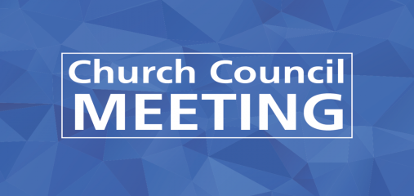

Cross of Calvary Lutheran Church
Council Meeting
Wednesday, November 16, 2022 at 7:45 PM

COUNCIL MEMBERS Terms end at Annual Meeting in Jan. * Second term
2023 2024 2025
Sandra Gay 2023 Alex Gay 2024* Elaine McDowell 2025*
George Tesch 2023 Kathy Reese 2024 Nathan Cole 2025*
Stacey Larson 2023 Robert Erickson 2024 Trent Athmann 2025
Jill Hanson 2023* Scott Johnson 2024 Keith Larson 2025
Resigned: Jeff Keltgen
STAFF
Pastor Matt Hausken Jeni Skeie, Parish Minister
Sue Altmann, Recorder Craig Boen, Janitor

President: Nathan Cole Vice President: Keith Larson Treasurer: Curt Sather

MINUTES

MEETING - Call to Order (President)
- Devotions – Jill Hanson
- Approve minutes of the October meeting – Motion to approve the minutes by Elaine McDowell, seconded by Jill Hanson, motion passed.
- Treasurer Report –October meeting - Motion to approve the treasurer/secretary report by Bob Erickson, seconded by Sandy Gay, motion passed.
- Post financial information in the announcements.
- Synod & LSS haven’t been paid yet; wait until December for payment amount.
- Pastor’s Report
- Worship Service & Confirmation: getting ready for Advent
- Grief Lectionary is going very well.
- Busy with Baptisms
- Parish Minister
- Drinking Fountain has been installed: needs electrical work.
- Working on more service projects each month.
- Sunday school kids will be singing at the Thanksgiving service.
- Spiritual practice with the kids is a priority.
- Office Report (Sue) none
- Maintenance Update (Craig) none
- Committee Reports

Administration -
  - Care Team –Jeni Skeie & Stacey Larson: They are hoping to start a elder people food club.
Meal train is being used as needed.
  - Children, Youth & Family –Jeni Skeie &Elaine McDowell: none
  - Equipping –Pastor Matt & Keith Larson: Grief Lectionary (Nov. 13 – Dec. 18)
  - Missions –Alex Gay: none
  - Outreach –Pastor Matt & Jill Hanson: none

  - Parish Life – Elaine McDowell, Sandra Gay & Jeni Skeie: Planning - caroling in December,
Valentine, Dinner, Palm Sunday activities, games plus other dates to be announced.

  - Technology –Nathan Cole & Pastor Matt Hausken: none

  - Worship & Music – Jeni Skeie, Jill Hanson &Kathy Reese: planned through February
  - AED Maintenance – Sue (Ok) 11/16/2022

- Old Business
- Cement work in the prayer garden. (waiting on bids)
- Money will come out of designated funds only. The council will need to be informed when and what will take place in the prayer garden.

- A new water fountain has been purchased and installed.

- New Business
- Annual meeting information needed by beginning of January. Nominating committee will start ASAP.
- Christmas Bazaar/Snowflake will be Sunday, December 18th from 8-11 AM.

- Adjourn – Closing Prayer

NEXT COUNCIL MEETING INFO
Next month: December 14th at 7:45 PM
December Devotions – Kathy Reese
December Communion – Stacey Larson

January council meeting will be January 11th.
Annual meeting will be January 15th, after 9:00 AM service.

